**GOOGLE CLOUD STORAGE**

**NAME :- LAKSHIKA VIJAYVARGIYA**

**ROLL NO :- 15**

**Introduction**:

Google Cloud Storage (GCS) is a highly scalable, durable, and secure object storage service offered by Google Cloud Platform. It allows you to store and retrieve any amount of data at any time from anywhere on the web. GCS is ideal for serving website content, storing data for backup and recovery, archiving long-term data, or distributing large data objects to users via direct download. It is widely used by enterprises, developers, and researchers for data analytics, media content delivery, and mobile applications.

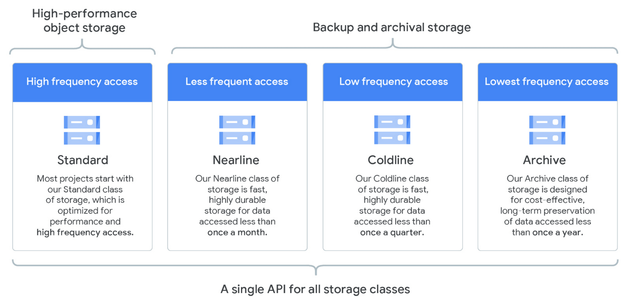

**Key Features:**

* **Object Storage:** Stores unstructured data as objects in buckets, ideal for documents, images, videos, and backups.
* **Global Accessibility:** Access your data from anywhere over HTTPS with low-latency delivery.
* **Scalability:** Seamlessly scales from gigabytes to petabytes without performance degradation.
* **Storage Classes:** Includes Standard, Nearline, Coldline, and Archive for cost-effective tiered storage based on access frequency.
* **Versioning:** Keeps multiple versions of objects to prevent accidental deletion or overwrite.
* **Lifecycle Management:** Automatically moves or deletes data based on user-defined rules to optimize costs.
* **Strong Security:** Data is encrypted at rest and in transit, with IAM policies, bucket-level permissions, and audit logs.
* **Integration:** Easily integrates with BigQuery, Cloud Functions, Dataflow, AI/ML services, and other GCP tools.
* **Resumable Uploads:** Supports uploading large files reliably, even over unstable connections.
* **Uniform Bucket-Level Access:** Simplifies permission management and enhances security.

**Benefits:**

* **High Durability:** Designed for 99.999999999% (11 9's) annual durability, using multi-regional and regional redundancy.
* **Cost Efficiency:** Choose appropriate storage classes and automate lifecycle policies to reduce storage costs.
* **Fast Performance:** Delivers high-throughput and low-latency access to data when needed.
* **Data Protection:** Versioning, access control, and redundancy features minimize the risk of data loss.
* **Flexibility:** Suitable for a wide range of use cases like backups, big data analytics, app hosting, multimedia storage, and disaster recovery.
* **Ease of Use:** Managed through Google Cloud Console, gsutil CLI, client libraries, and RESTful API.
* **Secure Access:** Fine-grained access control, audit logs, and support for compliance certifications ensure data privacy and enterprise-level security.
* **Multi-region Support:** Store data close to users across multiple global locations to improve availability and performance.

**Use Cases:**

* Hosting static website content such as images, CSS, and JavaScript files.
* Backup and disaster recovery solutions for enterprises.
* Archiving data for compliance or long-term storage.
* Storing training datasets for machine learning and artificial intelligence models.
* Distributing large software packages or media files globally.
* Storing logs and sensor data for big data analytics using BigQuery or Dataflow.

**Comparison with Other Services:**

* **Amazon S3:** Comparable in features, GCS often provides simpler pricing and strong integration with other Google Cloud tools.
* **Azure Blob Storage:** Similar object storage offering from Microsoft Azure; GCS is preferred in Google-based environments and offers strong support for hybrid cloud workflows.

**Conclusion:** Google Cloud Storage is a powerful, flexible, and secure storage solution that caters to a wide range of use cases. With high durability, global access, tiered storage classes, and seamless integration with Google Cloud services, GCS empowers developers and organizations to store and manage their data efficiently and cost-effectively.