**AZURE MIGRATE**

**Azure Migrate is a suite of tools and services that facilitates the assessment and migration of on-premises workloads, applications, and data to the Microsoft Azure cloud platform. It aims to streamline and simplify the cloud migration process by offering a unified approach to managing the entire migration lifecycle.**

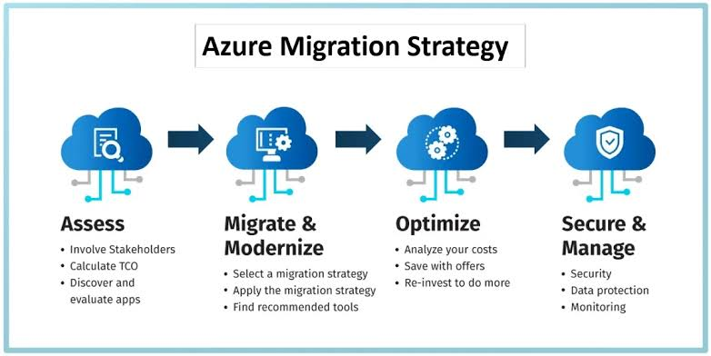

**How It Works:-**

**1. Discovery and Assessment:**

**- Discovery: Azure Migrate begins by discovering your on-premises infrastructure, including servers, databases, and applications. This is typically done using the Azure Migrate: Server Assessment tool or via agents installed on your machines.**

**- Assessment: After discovery, the tool assesses the collected data to evaluate the suitability of your workloads for Azure. It provides recommendations on the right Azure resources and configurations needed based on your current setup.**

**2. Migration:**

**- Server Migration: The Azure Migrate: Server Migration tool handles the actual migration of virtual machines (VMs) and physical servers to Azure. It supports both agent-based and agentless migrations.**

**- Database Migration: For databases, the Azure Database Migration Service helps in moving databases to Azure SQL Database or other Azure database services.**

**- Application Migration: Azure App Service Migration Assistant is available for web apps to transition them smoothly to Azure App Services.**

**3. Optimization:**

**- Cost Management: Post-migration, Azure Migrate helps monitor and manage costs, optimizing the usage of Azure resources based on performance and budget.**

**- Performance Monitoring: Tools and integrations are available to monitor the performance and health of your migrated workloads, ensuring they meet the desired performance criteria.**

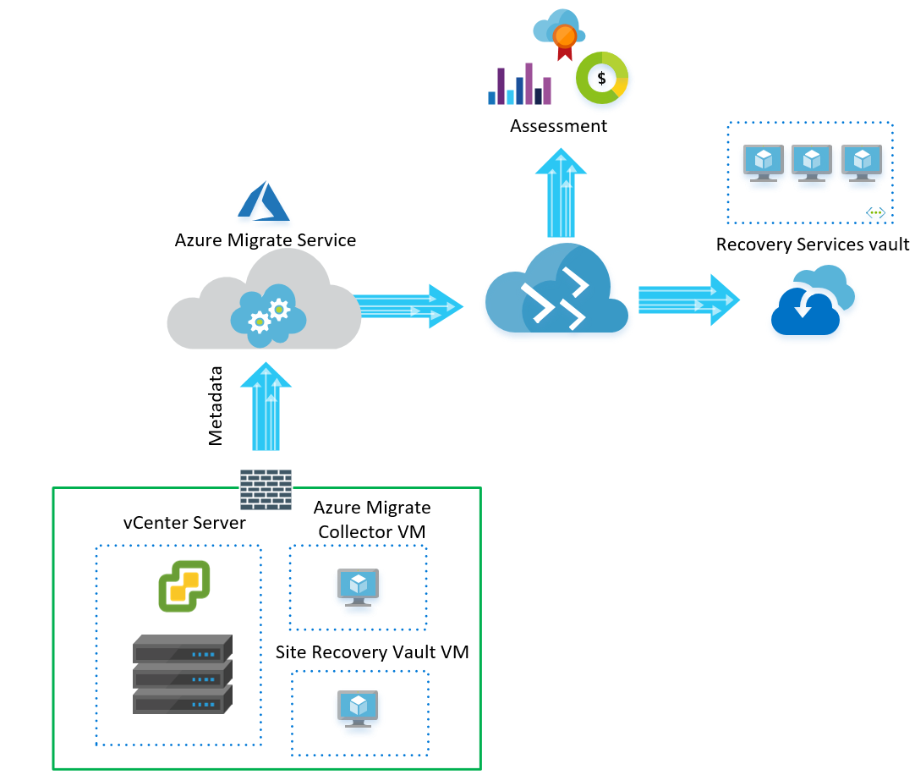

* **vCenter Server: This is the on-premises platform where the VMs are currently hosted.**
* **Azure Migrate Collector VM: This virtual machine, installed on the vCenter Server, collects data about the VMs, such as their configuration, operating system, and applications.**
* **Site Recovery Vault VM: This virtual machine acts as a repository for the collected data and facilitates the migration process.**
* **Azure Migrate Service: This service orchestrates the entire migration process, analyzing the collected VM data, recommending suitable Azure resources, and performing the actual migration.**
* **Assessment: Before migration, the service assesses the VMs, providing insights into their compatibility with Azure and estimating the migration costs.**
* **Metadata: The collector VM gathers metadata about the VMs to be migrated.**
* **Recovery Services vault: This is the Azure storage where the migrated VMs are stored.**

**Advantages :-**

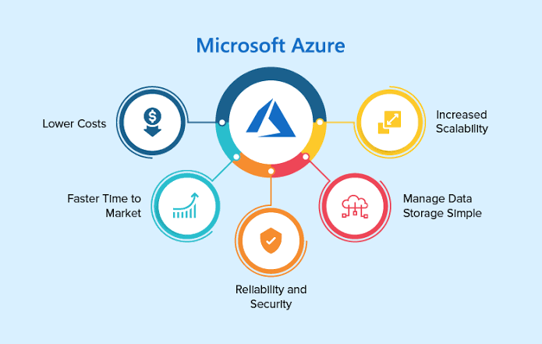

**1. Centralized Management: Provides a single pane of glass for managing the entire migration process, simplifying the complexity associated with moving to the cloud.**

**2. Cost Efficiency: Helps in identifying the most cost-effective Azure resources and configurations, potentially reducing cloud expenditure.**

**3. Minimized Downtime: Tools like Azure Site Recovery can facilitate minimal downtime during the migration of critical workloads.**

**4. Risk Mitigation: Comprehensive assessment tools identify potential issues and provide actionable recommendations to address them before migration.**

**5. Scalability: Azure Migrate supports a wide range of workloads and can scale to accommodate small projects to large-scale enterprise migrations.**

**Disadvantages:-**

**1. Complexity: While the tool aims to simplify migration, the process can still be complex, particularly for large and heterogeneous environments.**

**2. Learning Curve: There is a learning curve associated with understanding and utilizing the full capabilities of Azure Migrate, which may require specialized training.**

**3. Cost Overruns: If not managed properly, the transition to Azure could result in unforeseen costs, especially if the initial assessments are not accurate.**

**4. Dependency Mapping Challenges: Accurately mapping dependencies between applications and services can be challenging, potentially leading to issues post-migration.**

**Real-Life Implementations:-**

**1. Retail Industry:**

**- Example: A large retail chain migrated its on-premises inventory management and point-of-sale systems to Azure. This migration improved scalability and provided real-time analytics capabilities, leading to better inventory management and customer insights.**

**2. Healthcare Sector:**

**- Example: A healthcare provider used Azure Migrate to move its electronic health records (EHR) system to Azure. This transition ensured compliance with data protection regulations and enhanced accessibility for healthcare professionals.**

**3. Financial Services:**

**- Example: A financial services firm migrated its critical trading platforms to Azure. The migration leveraged Azure’s high availability and disaster recovery features to ensure minimal disruption and high performance.**

**4. Education Sector:**

**- Example: An educational institution migrated its e-learning platforms and administrative systems to Azure. This move enabled better collaboration tools, scalability, and remote access for students and faculty.**

**Types of Azure Migrate Tools:-**

**1. Azure Migrate: Server Assessment: Evaluates on-premises servers for migration suitability and provides recommendations.**

**2. Azure Migrate: Server Migration: Facilitates the actual migration of virtual machines and physical servers.**

**3. Azure Database Migration Service: Assists in migrating databases to Azure.**

**4. Azure App Service Migration Assistant: Helps in migrating web apps to Azure App Services.**

**5. Azure Migrate: Web Application Assessment: Provides insights into the readiness of web applications for migration.**

**Conclusion**

**Azure Migrate offers a robust set of tools and services designed to make the migration to Azure as smooth and efficient as possible. By providing comprehensive assessment, migration, and optimization features, it helps organizations leverage the benefits of the cloud, such as scalability, cost-efficiency, and advanced capabilities. However, successful migration requires careful planning and management to mitigate potential risks and ensure the desired outcomes.**