**VIDEO AI**

**Key GCP Video AI Services**

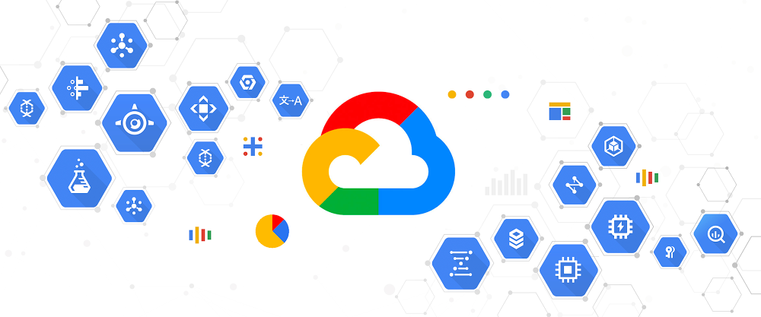

**1. Google Cloud Video Intelligence API**

* **Overview: This API enables you to analyze video content and extract useful information, such as objects, activities, and scenes.**
* **Key Features:**
  + **Label Detection: Identifies objects and activities within the video.**
  + **Shot Change Detection: Detects transitions between shots.**
  + **Explicit Content Detection: Identifies potentially inappropriate content.**
  + **Speech-to-Text: Converts spoken words in the video into text.**
  + **Text Detection: Extracts text from video frames.**
* **Use Cases:**
  + **Content Moderation: Automatically flag inappropriate content.**
  + **Metadata Generation: Add metadata to videos for easier search and organization.**
  + **Enhanced Search: Improve video search capabilities with automated tagging.**

**2. Google Cloud AutoML Video**

* **Overview: AutoML Video allows you to create custom machine learning models tailored to specific video analysis tasks.**
* **Key Features:**
  + **Custom Labeling: Train models to recognize specific objects or actions.**
  + **Video Classification: Classify video content into predefined categories.**
  + **Object Detection: Identify and track objects within videos.**
* **Use Cases:**
  + **Custom Surveillance: Develop models to monitor specific types of activity or objects.**
  + **Specialized Media Analysis: Analyze videos for niche content or specific features.**

**3. Google Cloud AI Platform**

* **Overview: AI Platform provides tools for building, training, and deploying machine learning models. It supports TensorFlow, PyTorch, and other frameworks.**
* **Key Features:**
  + **Custom Training: Train models on your own video datasets.**
  + **Model Deployment: Deploy models for real-time video analysis.**
  + **Integration with Video Intelligence API: Use custom models in conjunction with pre-built video analysis capabilities.**
* **Use Cases:**
  + **Custom Video Processing: Develop and deploy advanced models for specific video processing needs.**

**4. Google Cloud Storage**

* **Overview: While not an AI service per se, Cloud Storage is essential for managing large video datasets and integrating with other video AI services.**
* **Key Features:**
  + **Scalability: Store and manage large volumes of video data.**
  + **Integration: Seamlessly integrates with other GCP services for video analysis.**
* **Use Cases:**
  + **Data Management: Store video files before and after analysis.**

**Resources and Support**

* **Documentation: Links to GCP Video Intelligence API, AutoML Video, and AI Platform documentation.**
* **Support: Overview of support options and how to get help.**
* **Community and Forums: Links to Google Cloud community forums and discussion groups**