***Cloud Build***

AWS CodeBuild is a fully managed continuous integration service in the cloud, simplifying and automating the software build process.

It compiles source code, runs tests, and produces ready-to-deploy software packages, eliminating the need to provision, manage, or scale your own build servers.

EXAMPLE:-

Imagine you're a baker and you want to bake a cake (your software).

AWS CodeBuild is a tool that automatically builds your software.

**1) Provide the recipe:** Supply the code and instructions on how to build it (a "buildspec file").

**2) Use the right equipment:** CodeBuild offers pre-set environments for different programming languages (like Python or Java), or you can use your own specialized tools (Docker images).

**3) Bake the cake:** It compiles the code, runs tests, and packages it.

**4) Clean up:** After the process, the environment is removed, avoiding idle costs.

**5) Pay for Baking Time:-**Costs are incurred only during active building.

***How it works:***

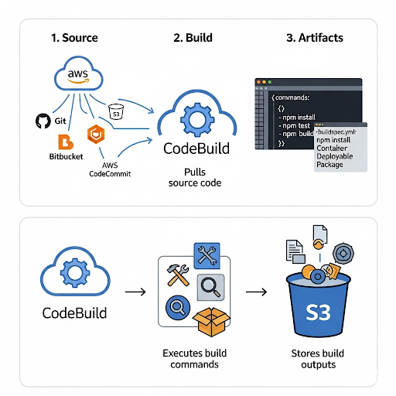

**1. Source:-**

CodeBuild pulls your source code from a repository (e.g., AWS CodeCommit, GitHub, Bitbucket, S3).

**2. Build:**

It then executes the build commands you've defined (in a buildspec.yml file or through the console). This includes compiling, testing, and creating artifacts.

**3. Artifacts:**

CodeBuild stores the build outputs (artifacts) in an S3 bucket or other artifact repository.

***CodeBuild Integration:-***

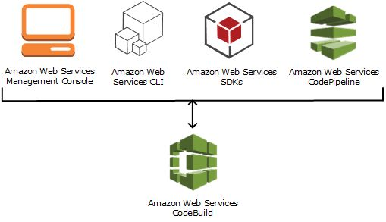

• **Amazon Web Services Management Console:** A web-based interface used to manually configure and monitor AWS services, including CodeBuild.

• **Amazon Web Services CLI:** A command-line tool for scripting and automating interactions with AWS services like CodeBuild.

• **Amazon Web Services SDKs:** Libraries that allow developers to programmatically control and integrate CodeBuild within their applications.

• **Amazon Web Services CodePipeline:** A service that orchestrates automated release pipelines, frequently triggering CodeBuild as a build step.

• **Amazon Web Services CodeBuild:** A fully managed service that compiles source code, runs tests, and produces deployable software packages.

***FEATURES:-*** 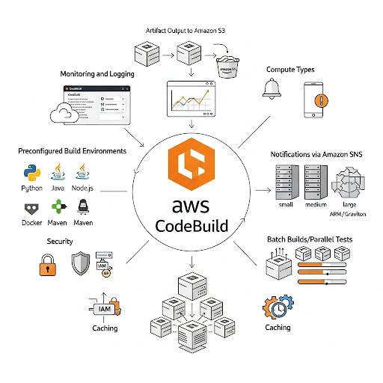

• **Artifact Output:** Stores compiled code, test reports, and other build outputs in Amazon S3 or other defined locations.

• **Monitoring and Logging:** Provides detailed build logs and metrics through the CodeBuild console and Amazon CloudWatch for troubleshooting and analysis

**Preconfigured Build Environments:** Ready-to-use environments with common programming languages and build tools (e.g., Java, Python, Node.js, Maven, Gradle).

• **Security:** Builds run in isolated environments, and access is controlled via AWS IAM. Build artifacts are encrypted.

• **Notifications:** Configure notifications for build events (e.g., success, failure) via Amazon SNS.

• **Compute Types:** Offers different compute options (e.g., small, medium, large, ARM/Graviton) to tailor CPU and memory to your project's needs.

• **Batch Builds/Parallel Tests:** Supports running multiple builds concurrently and parallelizing test execution for faster feedback.

• **Caching:** Improves build performance by caching dependencies locally or in Amazon S3.

***Benefits :-***

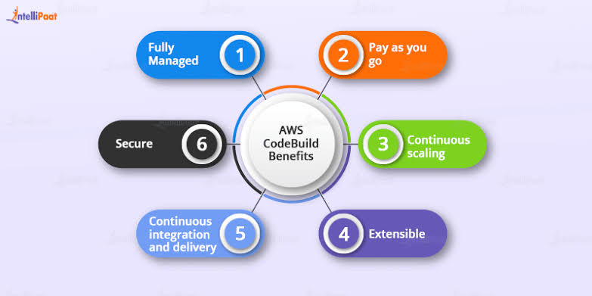

• **Fully Managed:** AWS handles all the underlying infrastructure, meaning you don't have to provision, manage, or scale servers for your builds.

• **Pay as you go:** You only pay for the compute time consumed during the build process, without any upfront costs or minimum fees.

• **Continuous scaling:** CodeBuild automatically scales its compute resources up or down to meet the demands of your build workloads, ensuring fast builds even with high concurrency.

• **Extensible:** You can customize CodeBuild to fit your specific needs by using custom build environments, integrating with other tools, and running a variety of build commands.

• **Continuous integration and delivery:** It seamlessly integrates into CI/CD pipelines, automating the build and test phases of your software release process.

• **Secure:** CodeBuild runs your builds in isolated environments, and integrates with AWS Identity and Access Management (IAM) for secure access control.

***Limitations:-*** 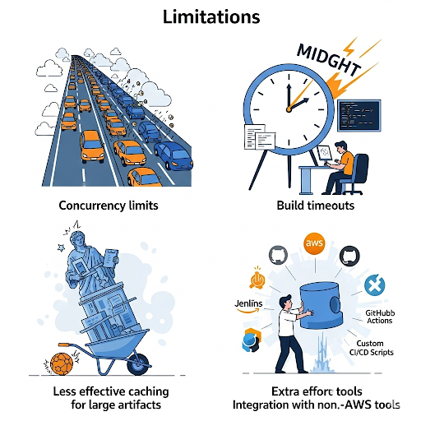

* **Concurrency limits:** There's a default limit on how many builds can run at the same time.
* **Build timeout:** Long build processes might exceed the maximum time allowed.
* **Caching:** Caching built components might be less effective for large or rarely rebuilt artifacts.
* **Integration with non-AWS tools:** Connecting tools outside of AWS may require extra effort.