***Cloud Run***

Cloud Run is a fully managed platform in Google Cloud Platform (GCP) that enables you to run your code directly on top of Google's scalable infrastructure.

It is a server less, container-based platform offered by Google Cloud that allows users to deploy and scale containerized applications without managing the underlying infrastructure.

Example:-

Imagine you have a small shop, like a coffee shop.

1. You only pay when you have customers

* **No idle space**: You wouldn't rent a huge building for your coffee shop if you only get a few customers a day, right?
* **Pay-as-you-go**: Similarly, with Cloud Run, you only pay for the computer resources (like the tables, chairs, and coffee machines in your shop) when your application is actively handling requests (like when customers are in your coffee shop).
* **Scaling to zero**: When your shop is empty, you don't pay anything! Cloud Run does the same - if no one is using your application, it can even "shut down" to zero, saving you money.

2. Google manages everything else

* **No landlord worries**: You don't have to worry about the building's maintenance, electricity, or security.
* ***Google handles it***: Cloud Run is a "fully managed" service, meaning Google takes care of all the behind-the-scenes work, like setting up and maintaining servers, scaling up or down based on traffic, and keeping everything secure.

3. You bring your own "shop in a box" (containers)

* **Ready-to-go business**: You can build your coffee shop (your application) and package everything it needs to run (code, ingredients, decorations, instructions) into a portable "box" (a container).
* **Runs anywhere**: This "shop in a box" can then be easily moved and opened in any Cloud Run location, or even on your computer or other platforms, ensuring it works consistently everywhere.

So, Cloud Run is like having a ready-to-go business that:

* Automatically adjusts to the number of customers you have.
* You only pay for what you actually use.
* Google takes care of all the server management and scaling.
* You can easily move your "shop" to other places if needed.

There are two ways to exploit the code on cloud run. With this option, you can leverage a code that responds to a web request or an event .Here are some concrete examples of using this option:

**1)Websites and web applications:** You can build an app using all your usual tools, access a SQL database, and create dynamic HTML pages.

**2) APIs and Microservices:** With Cloud Run Services, you can design a RESTful, gRPC, or GraphQL API. These can be made public or private.

**3) Streaming data processing:** You can receive messages from Cloud Pub/Sub, requests from Cloud Tasks, and events.

Even though Cloud Run is a container-based solution, you can still use the source based option. This allows you to create containers for yourself from the various languages you use

***How it Works:-***

1. **Container Image:** You package your application code into a container image.
2. **Deployment:** You deploy the container image to Cloud Run.
3. **Request Handling:** Cloud Run receives incoming HTTP requests and routes them to your application's container instances.
4. **Scaling:** Cloud Run automatically scales the number of container instances based on the traffic load.
5. **Management:** Google Cloud manages the infrastructure, scaling, and routing, so you don't have to.

***Features:-***

• **Server less and Fully Managed:** You don't manage servers; Google handles all the infrastructure, scaling, and maintenance automatically.

• **Container-Based:** Deploy any application packaged as a container image, giving you complete flexibility over your code environment.

• **Language and Framework Agnostic:** Since it uses containers, you can use any programming language or framework you prefer, like Python, Node.js, Java, or Go.

• **Automatic Scaling (from zero to planet-scale):** Cloud Run scales your application up automatically during traffic spikes and scales down to zero when idle, saving costs.

• **Pay-per-use Pricing:** You only pay for the exact CPU, memory, and requests consumed when your code is actively running, making it very cost-effective.

• **HTTP/HTTPS Support:** Services are exposed via secure HTTPS endpoints with automatic TLS, supporting standard web protocols like HTTP/2 and WebSockets.

• **Cloud Run Services and Jobs:** Two ways to run your code On Cloud Run, your code can either run continuously as a service or as a job. Both services and jobs run in the same environment and can use the same integrations with other services on Google Cloud. 1) **Services:** Used to run code that responds to web requests, or events.

A Cloud Run service provides you with the infrastructure required to run a reliable HTTPS endpoint. Your responsibility is to make sure your code listens on a TCP port and handles HTTP requests

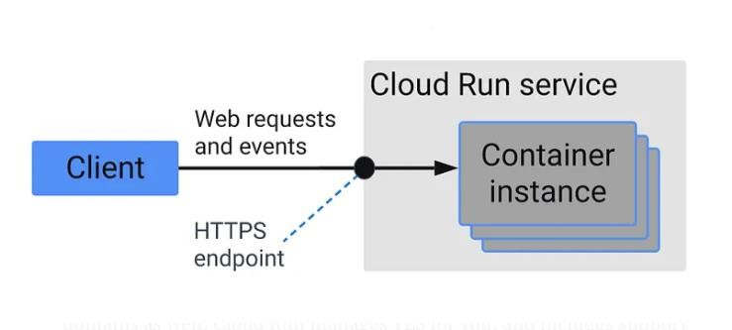

**2) Jobs:** Used to run code that performs work (a job) and quits when the work is done. Cloud Run services.

***Benefits:-***

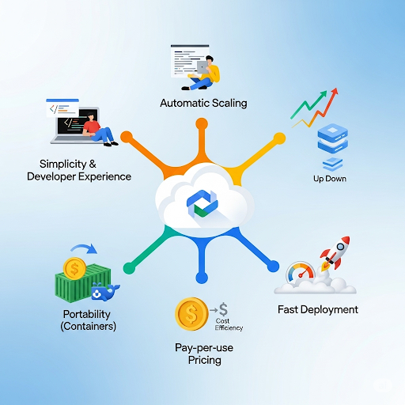

**1.Simplified Development:** Focus on writing code, not managing infrastructure.

**2.Automatic Scaling:** Pay only for the resources you use, scaling up or down as needed.

**3.Fast Deployments:** Deploy changes quickly with container-based deployments.

**4. Cost-Effective:** Pay only for the resources used, making it a cost-effective solution for many workloads.

**5 .Portability:** Container-based deployments make it easy to move your application to other platforms if needed.

**6.Management:** Google Cloud manages the infrastructure, scaling, and routing, so you don't have to.