WEEK 4 – PREDICTIVE MODELING AND OPTIMIZATION IN LOGISTICS SYSTEMS
E-Commerce Last-Mile Delivery Optimization
Prepared by: Vishal R | B.E. Computer Science and Engineering
Dataset: Synthetic educational logistics data (300 simulated delivery orders)

1. Executive Summary
This Week 4 assignment develops and evaluates predictive models to estimate e-commerce delivery time in minutes. The analysis uses the cleaned synthetic dataset prepared during Week 2. Distance, delivery zone, traffic level, vehicle type and weather are used as input features. Linear Regression, Decision Tree and Random Forest models are compared using a held-out test set and five-fold cross-validation on the training data.
In this run, Linear Regression produced the lowest held-out MAE (10.97 minutes). However, the low R-squared values and unusually large RMSE values indicate that prediction quality is limited and the model is not ready for operational deployment. The report therefore emphasizes honest validation, data-quality checks and practical pilot recommendations rather than claiming guaranteed savings.

2. Problem Definition
A last-mile delivery team needs an estimate of how long an order may take to reach the customer. Better estimates can support customer notifications, dispatch planning and early identification of potentially delayed orders.
Prediction question: Given an order's distance, delivery zone, traffic level, vehicle type and weather, what is its estimated delivery time in minutes?
Target variable: Delivery_Time_Min.
Input features: Distance_KM, Delivery_Zone, Traffic_Level, Vehicle_Type and Weather.
The Order_ID is an identifier and is excluded from training. Delivery_Status is also excluded because it may be derived from delivery time or an operational threshold and could leak target information. Scaled versions of the target, outlier flags and other engineered columns are excluded to avoid leakage.

3. Dataset Description and Preparation
The verified Week 2 dataset contains 300 records. The target variable has a mean of 49.76 minutes, median of 46.00 minutes, standard deviation of 29.57 minutes, minimum of 10.00 and maximum of 420.00 minutes.
A notable data-quality warning is the maximum delivery time of 420 minutes, which is much higher than the median. This extreme value can strongly affect squared-error metrics such as RMSE. It should be checked against source records in a real project, not removed automatically merely because it is large.
The data is divided into 80% training and 20% testing using random_state=42. Numeric distance is median-imputed and standardized. Categorical variables are mode-imputed and one-hot encoded. These transformations are placed inside a scikit-learn Pipeline so they are fitted only on training folds, reducing data leakage during cross-validation.

4. Model Selection

4.1 Linear Regression
Linear Regression is used as an interpretable baseline. It estimates a linear relationship between the encoded input features and delivery time. It is fast and provides a useful benchmark, but may underfit nonlinear traffic or distance effects.

4.2 Decision Tree Regressor
A Decision Tree can represent nonlinear relationships and feature interactions through decision rules. It is easy to explain, but an unrestricted tree can overfit a small dataset.

4.3 Random Forest Regressor
Random Forest averages predictions from multiple decision trees. It can model nonlinear patterns and is generally more stable than a single tree, although it is less directly interpretable and still depends on representative training data.

5. Training, Validation and Evaluation
The models are trained on the same training partition. Five-fold cross-validation is applied within the training data using MAE as the scoring metric. The held-out test partition is then used to calculate MAE, RMSE and R-squared.
Model | 5-fold CV MAE (min) | Test MAE (min) | Test RMSE (min) | Test R²
Linear Regression | 4.44 | 10.97 | 48.46 | 0.105
Decision Tree | 6.21 | 12.88 | 49.23 | 0.077
Random Forest | 4.90 | 11.46 | 48.11 | 0.118
MAE is the average absolute prediction error and is easy to interpret in minutes. RMSE penalizes large errors more strongly, making it sensitive to extreme delays. R-squared indicates the proportion of target variance explained relative to a mean baseline; values near zero indicate limited explanatory performance.
Based on the lowest five-fold cross-validation MAE on the training data, Linear Regression is selected for the illustrative prediction output. The held-out test set is retained for final evaluation rather than model selection. The Random Forest has the lowest test RMSE in this run, showing that model ranking depends on the metric. Model selection should also consider operational error costs and validation on future time periods.

6. Visual Evaluation
Figure 1 compares actual and predicted delivery times. Points close to the diagonal represent more accurate predictions; large deviations indicate substantial errors.
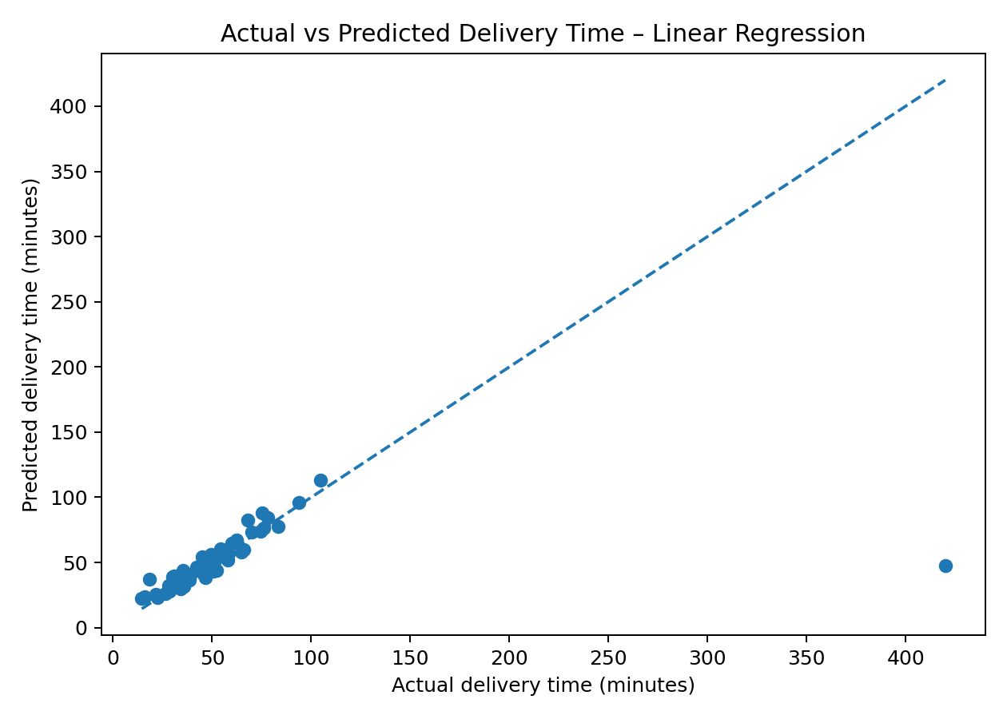
Figure 1. Actual versus predicted delivery time on the held-out test set.
Figure 2 shows the distribution of prediction errors (actual minus predicted). Positive values indicate under-prediction; negative values indicate over-prediction.
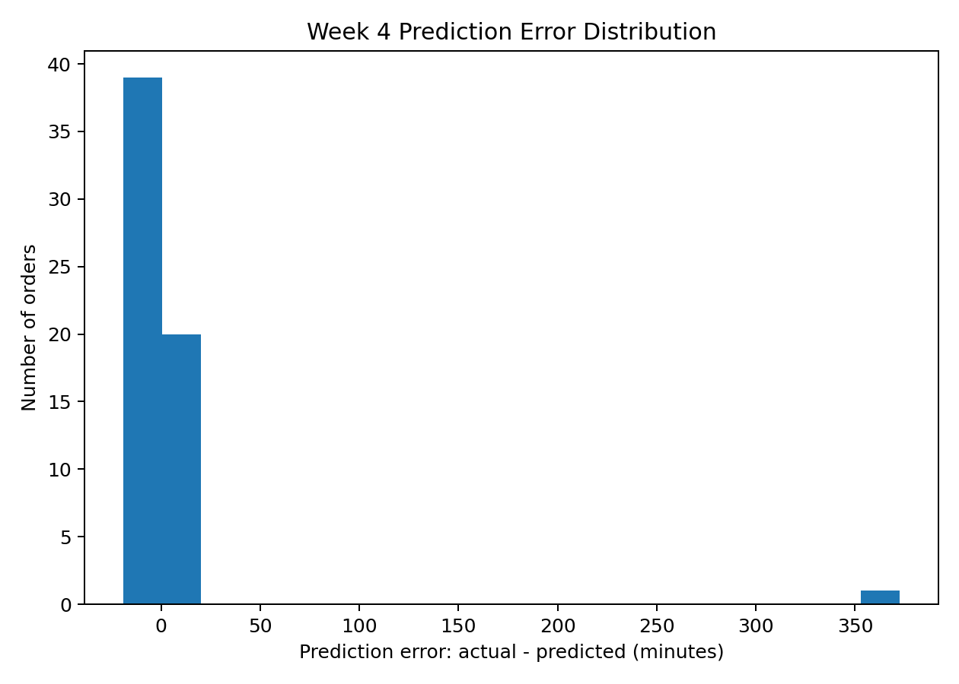
Figure 2. Prediction error distribution for the selected model.

7. Interpretation and Real-World Logistics Applications
The model provides an estimated delivery duration, not a guaranteed arrival time. A dispatcher could compare an estimate with the promised delivery window and flag orders that appear at risk. For example, if a hypothetical order has a predicted duration close to or beyond its remaining service window, the team could review its route, traffic conditions and dispatch priority.
Traffic challenge: Congestion can create variable travel times. A practical system could refresh traffic inputs before dispatch and re-estimate arrival time. This project's dataset contains a categorical traffic level, not live traffic feeds, so it cannot demonstrate real-time rerouting.
Rural and long-distance challenge: Orders covering longer distances may need different route grouping or dispatch planning. A pilot could group nearby rural stops where delivery windows permit. The model's predictions should be checked against actual route maps and stop sequence data before such grouping is adopted.
Customer communication challenge: If a prediction indicates a possible delay, a delivery operation could send an updated estimated arrival window. This requires a calibrated prediction interval and reliable timestamp data, neither of which is established by this small synthetic exercise.

8. Optimization Recommendations
- Risk-based dispatch review: Flag orders whose predicted delivery time approaches or exceeds the remaining promised delivery window. A human dispatcher should verify the flag before changing priorities.
- Route planning pilot: Combine predicted durations with road-network distance, stop locations, delivery time windows and live traffic in a routing optimizer. Those additional data are not present in the current dataset.
- Vehicle allocation: Compare vehicle suitability, capacity, operating cost and route length before assignment. The current model includes vehicle type as a feature but does not optimize fleet capacity or cost.
- Operational dashboard: Track predicted versus actual delivery time, MAE by zone and traffic category, late-delivery rate and model drift.
- Data improvement: Collect timestamped dispatch, pickup, arrival, failed-attempt, route, weather and traffic observations. Record the reason for delays and validate unusual values before model retraining.

9. Limitations and Responsible Use
- All records are synthetic educational data, not actual company or customer data.
- Only 300 records are available, which is too small to establish reliable operational performance.
- The extreme target value (420 minutes) strongly affects RMSE and should be investigated in a real dataset.
- A random split may not reflect future time periods. A chronological validation split would be more realistic when timestamps are available.
- The features do not include GPS routes, stop count, parcel size, driver experience, service windows or live traffic.
- The model estimates an average point prediction and does not provide calibrated uncertainty intervals.
- The results do not prove that any optimization strategy reduces cost or delivery time.

10. Conclusion
This assignment demonstrates a complete introductory predictive-modeling workflow: problem definition, feature selection, preprocessing, model comparison, cross-validation, test evaluation and operational recommendations. The results show that the current synthetic dataset does not support a dependable production predictor. The appropriate next step is to improve data quality and volume, validate chronologically on real delivery records, and run a controlled pilot before using predictions for dispatch decisions.

11. Python Implementation and Reproducibility
The accompanying file week4_predictive_modeling.py contains the complete runnable implementation, including preprocessing pipelines, train/test split, three model comparisons, five-fold cross-validation, metric calculation, prediction export and chart generation.
Install dependencies:
python -m pip install pandas numpy matplotlib scikit-learn
Run from the repository directory:
python week4_predictive_modeling.py
Expected outputs: week4_test_predictions.csv, week4_actual_vs_predicted.png and week4_prediction_error_distribution.png. Keep the Week 2 verified CSV in the same folder.

12. References
- Pandas documentation: https://pandas.pydata.org/docs/
- Scikit-learn Pipeline: https://scikit-learn.org/stable/modules/compose.html
- Scikit-learn model evaluation: https://scikit-learn.org/stable/modules/model_evaluation.html
- Scikit-learn cross-validation: https://scikit-learn.org/stable/modules/cross_validation.html
- Scikit-learn Linear Regression: https://scikitlearn.org/stable/modules/generated/sklearn.linear_model.LinearRegression.html
- Scikit-learn Decision Tree Regressor: https://scikitlearn.org/stable/modules/generated/sklearn.tree.DecisionTreeRegressor.html
- Scikit-learn Random Forest Regressor: https://scikitlearn.org/stable/modules/generated/sklearn.ensemble.RandomForestRegressor.html

