Advanced Data Analysis and Visualization in Logistics
E-Commerce Last-Mile Delivery Optimization
YuvaIntern — Week 3 Advanced Data Analysis and Visualization in Logistics
Prepared by: Vishal R | B.E. Computer Science and Engineering

1. Executive Summary
This report analyzes 300 unique simulated delivery orders using Python, pandas, NumPy-compatible numerical operations, and Matplotlib. The analysis examines delivery-time and shipping-cost distributions, delivery-zone and traffic differences, relationships between distance, time and cost, and delivery-status composition. The dataset is synthetic and is intended only for educational demonstration; results must not be interpreted as actual company performance or causal evidence.
In this dataset, mean delivery time is 49.76 minutes and median delivery time is 46.00 minutes. Mean simulated shipping cost is ₹82.83 and mean delivery distance is 16.22 km. 83 orders are labelled Delayed (27.7%), while 217 are labelled On Time (72.3%).

2. Dataset Structure and Methodology
The analysis reuses the verified Week 2 synthetic dataset. It contains order identifier, delivery zone, distance in kilometres, traffic level, vehicle type, weather, delivery time in minutes, shipping cost in INR, and delivery status. The verified file also contains engineered outlier flags and scaled columns; these additional fields were not treated as separate orders. The analysis uses the original operational measurement columns to avoid double-counting transformed versions of the same variables.
The analysis sample contains 300 rows after selecting the required fields and checking numeric values. No new real-world data was introduced. Group averages are descriptive and may be affected by group size, synthetic assumptions, and other variables not represented in the dataset.

3. Exploratory Data Analysis

3.1 Descriptive statistics
Mean describes the arithmetic average, median gives the middle observation and is less sensitive to extreme values, standard deviation describes spread, and minimum/maximum show the observed range. Using both mean and median helps reveal whether a small number of long deliveries pull the average upward.
Metric | Count | Mean | Median | Std. dev. | Minimum | Maximum
Distance_KM | 300 | 16.22 | 13.15 | 12.06 | 1.09 | 63.76
Delivery_Time_Min | 300 | 49.76 | 46.00 | 29.57 | 10.00 | 420.00
Shipping_Cost_INR | 300 | 82.83 | 73.83 | 79.51 | 20.00 | 1,250.00
Delivery-time mean (49.76 min) is higher than its median (46.00 min), which suggests some longer deliveries may be pulling the average upward.

3.2 Delivery status composition
Status counts provide a direct operational snapshot of the simulated sample. The delayed share is 27.7% (83 of 300); the on-time share is 72.3% (217 of 300). These labels are treated as supplied categories; the report does not infer a service-level target because no promised delivery-time threshold was provided.

4. Visual Analysis, Rationale and Interpretation
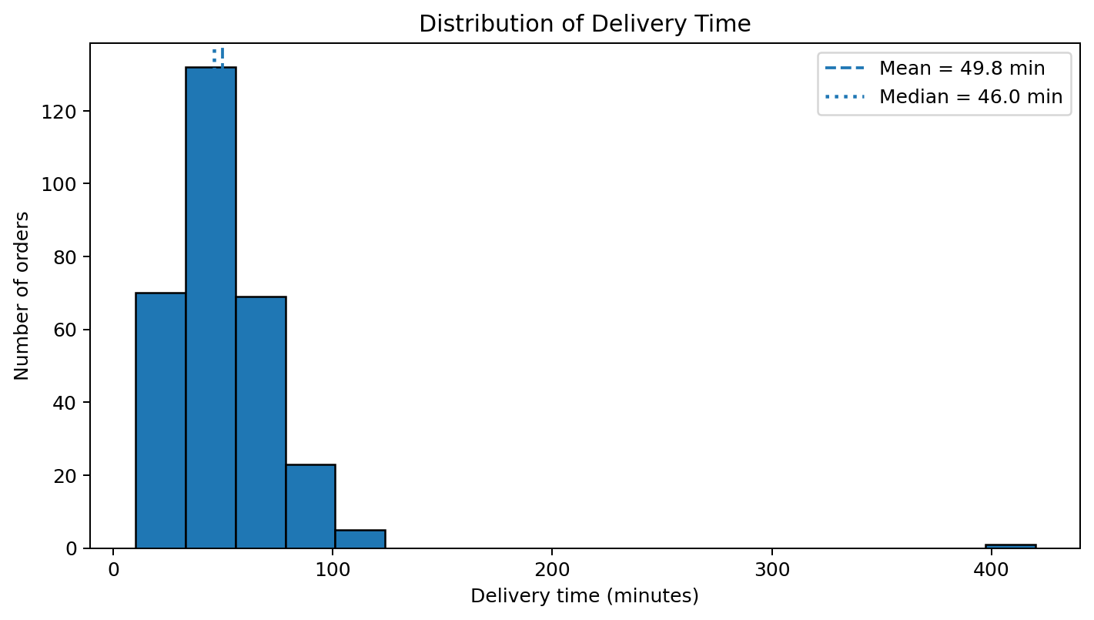
Figure 1. Delivery-time distribution
A histogram is appropriate for a continuous numeric variable because it groups observations into intervals and shows concentration, spread and possible skew. The mean and median reference lines help compare the centre of the distribution. Operationally, a wide or right-tailed distribution can indicate inconsistent delivery experience and a small set of long-running orders that deserve investigation.
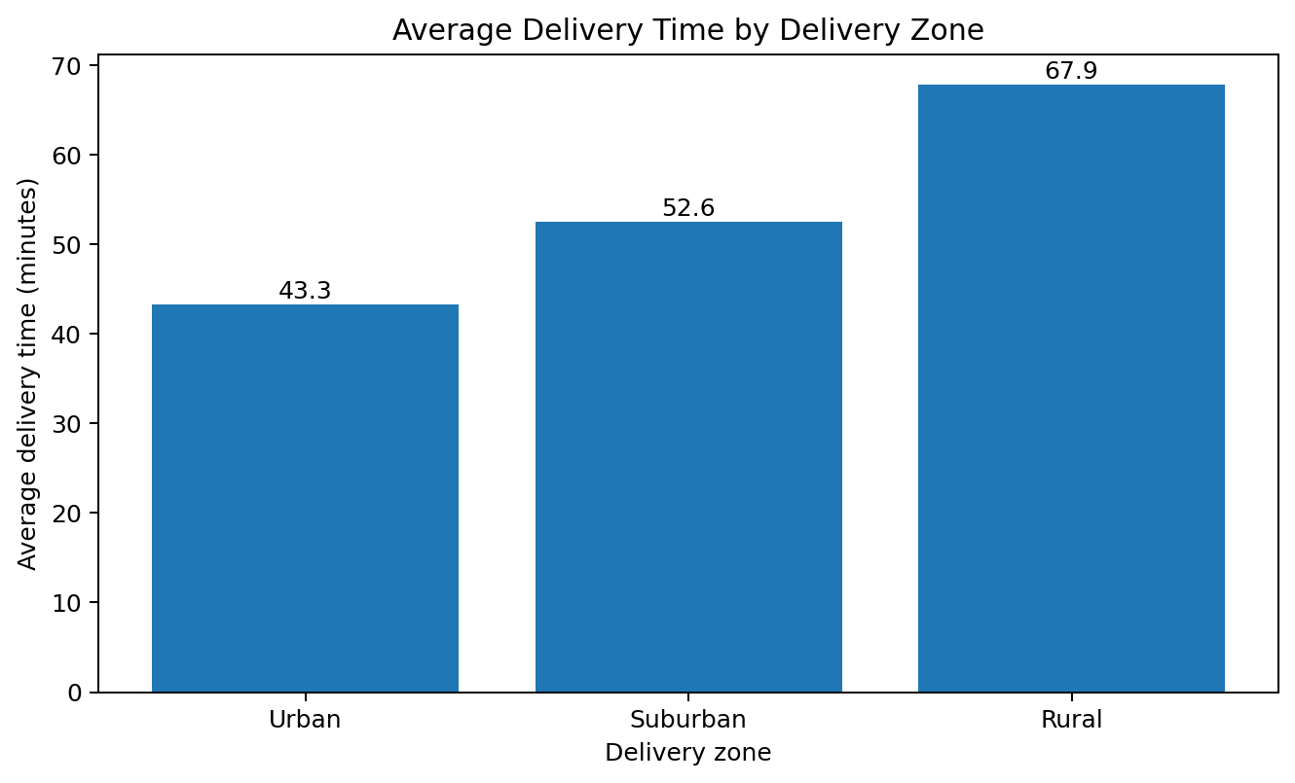
Figure 2. Average delivery time by zone
A bar chart is suitable for comparing a numeric summary across discrete categories. The zone with the highest sample mean is Rural (67.88 minutes); the lowest is Urban (43.27 minutes). This comparison can help prioritize zone-level route review, but it does not prove that the zone itself causes longer delivery times.
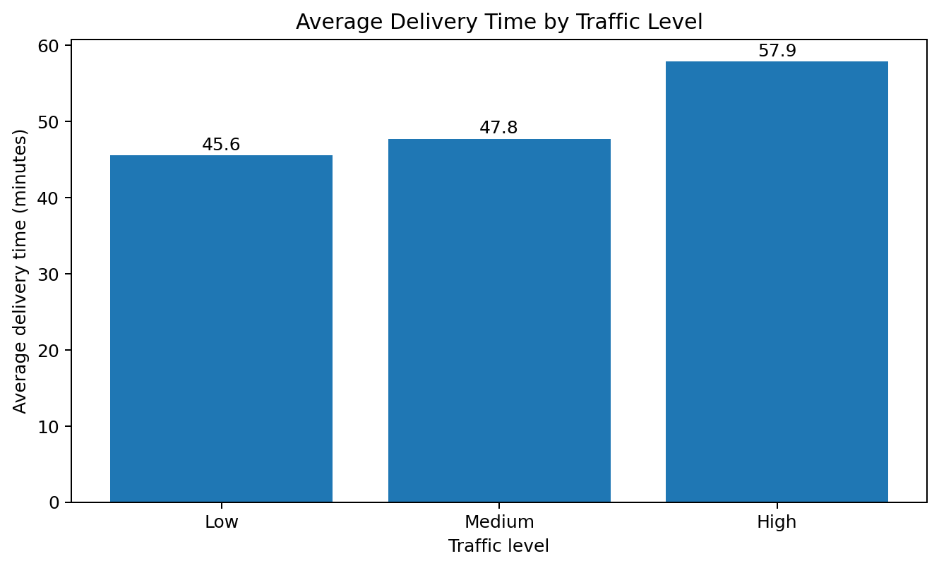
Figure 3. Average delivery time by traffic level
A bar chart makes differences between traffic categories easy to compare. It helps assess whether high-traffic orders in this simulated dataset tend to have longer average delivery times. Traffic groups may differ in distance, zone and vehicle mix, so the chart should be treated as an initial diagnostic rather than an isolated traffic effect.
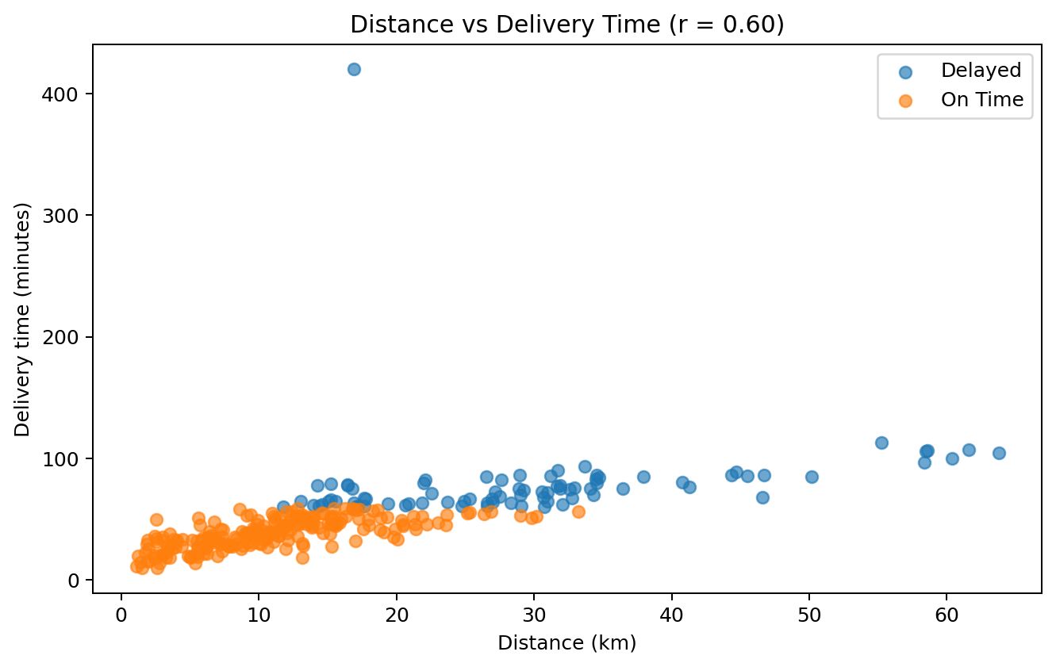
Figure 4. Distance versus delivery time
A scatter plot is suitable for two continuous variables because each point represents one order and reveals direction, spread, clusters and unusual observations. Pearson correlation is 0.60. A positive value indicates that longer distances tend to be associated with longer delivery times in this sample; correlation does not establish causation. Separate status labels help visually compare delayed and on-time orders.
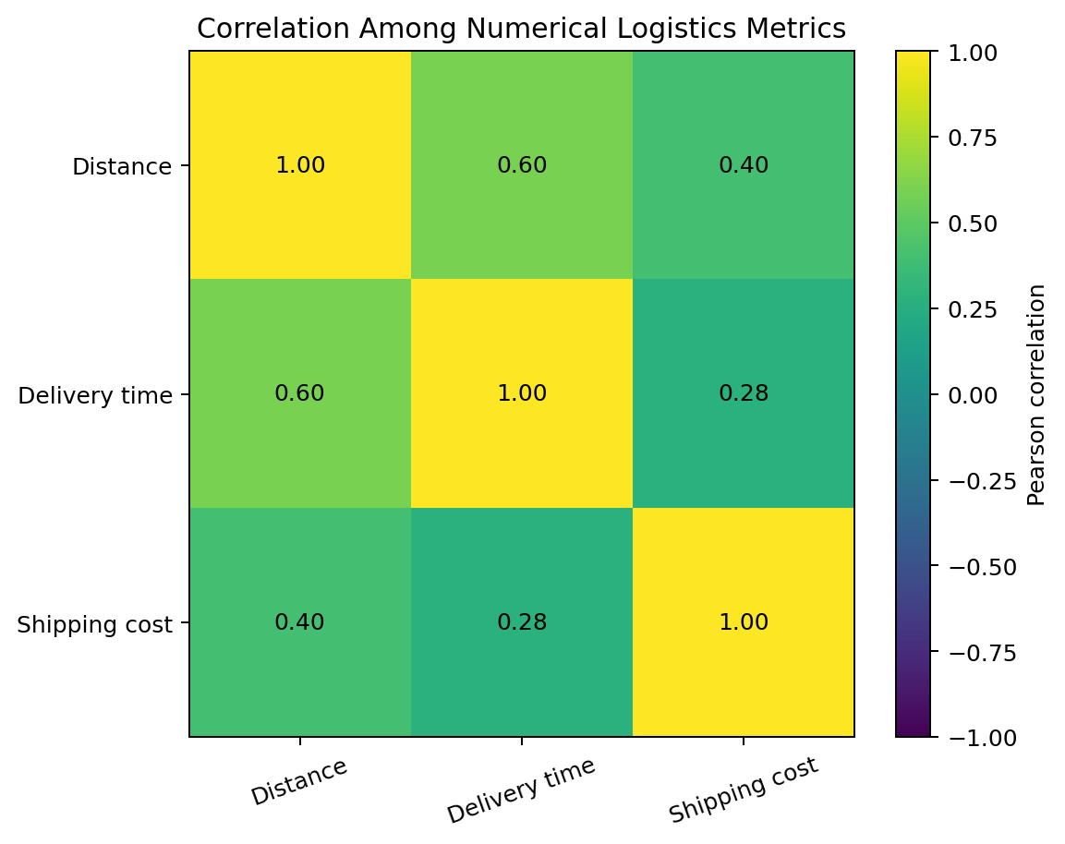
Figure 5. Correlation heatmap
A heatmap encodes pairwise Pearson correlations using colour and annotated values, making the strength and direction of linear associations easier to scan. Distance–delivery time correlation is 0.60; distance–cost is 0.40; and delivery time–cost is 0.28. These are linear associations only and may be influenced by outliers or hidden factors.
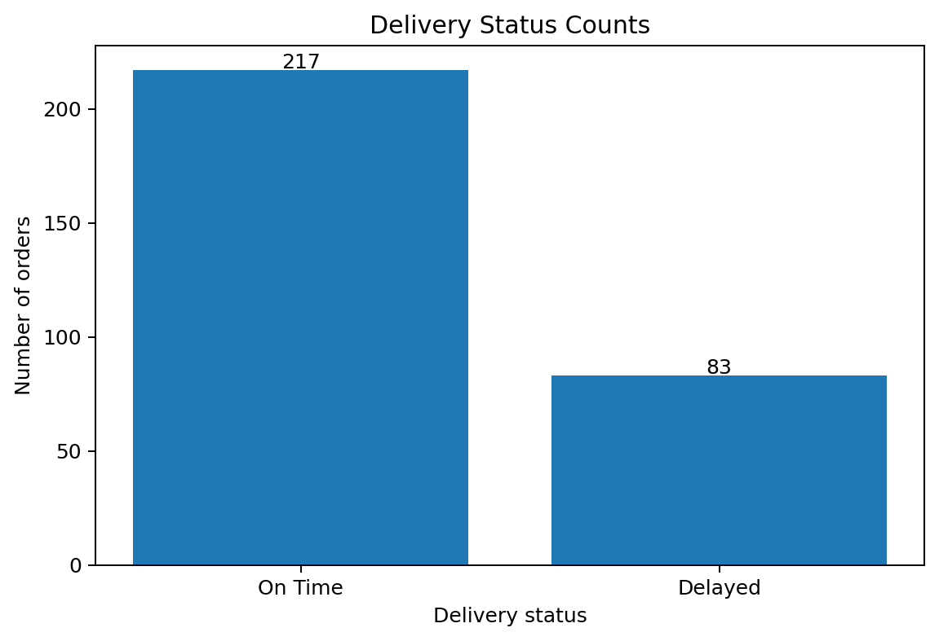
Figure 6. Delivery status counts
A count bar chart is appropriate for categorical outcomes because it shows the number of orders in each status without implying a continuous scale. It highlights the delayed share and gives managers a simple service-performance snapshot. It does not measure delay severity because actual lateness duration is not supplied.
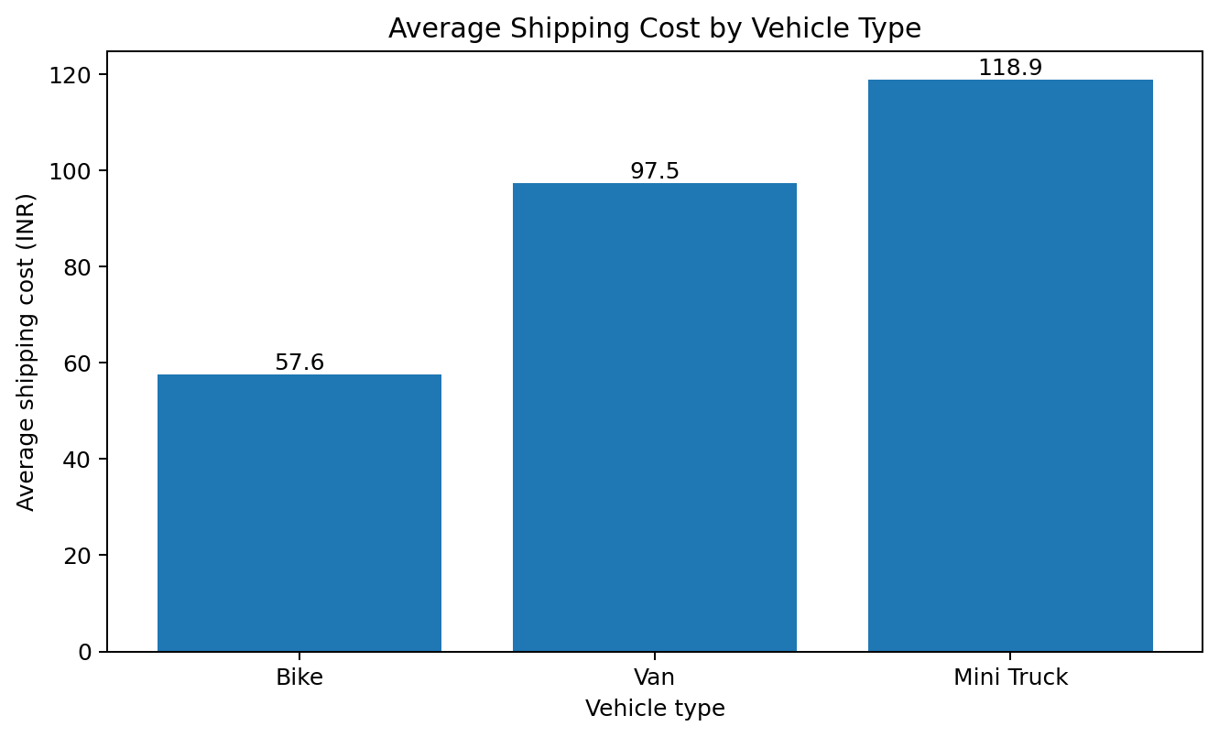
Figure 7. Average shipping cost by vehicle type
A bar chart compares average simulated cost across vehicle categories. This can identify categories for further cost-efficiency investigation. However, vehicle groups may serve different distances and zones; a fair comparison should control for distance, payload, route and service requirements before making fleet-allocation decisions.

5. Group-Level Results

5.1 Delivery zone summary
Zone | Orders | Avg time (min) | Median time (min) | Avg cost (₹)
Rural | 39 | 67.88 | 64.10 | 133.52
Suburban | 106 | 52.58 | 52.20 | 85.39
Urban | 155 | 43.27 | 39.20 | 68.33

5.2 Traffic summary
Traffic | Orders | Avg time (min) | Avg cost (₹)
High | 77 | 57.93 | 95.44
Low | 83 | 45.57 | 75.24
Medium | 140 | 47.75 | 80.40

5.3 Vehicle summary
Vehicle | Orders | Avg time (min) | Avg cost (₹)
Bike | 136 | 48.25 | 57.62
Mini Truck | 48 | 48.60 | 118.91
Van | 116 | 52.00 | 97.46

6. Key Findings and Operational Recommendations
- The overall delayed share is 27.7%. A useful next step is to review delayed orders by zone, traffic and distance, then compare them with on-time orders.
- The observed correlation between distance and delivery time is 0.60. Route length is therefore a useful variable to investigate in delivery-time planning, but traffic, route layout, weather and vehicle capacity should also be considered.
- Zone-level averages differ: Rural has the highest mean delivery time in this sample. Operations teams could inspect route density, access constraints and dispatch patterns in that zone before changing resources.
- Traffic-level comparisons can help identify when congestion may be associated with longer delivery times. Collecting timestamped traffic and route data would support stronger analysis.
- Vehicle-level cost comparisons should be normalized by distance or cost per kilometre before drawing fleet-efficiency conclusions. Average cost alone can be misleading when vehicle types serve different route lengths.

7. Limitations
- All records are synthetic and do not represent actual customers, couriers, routes or company operations.
- The dataset contains 300 unique orders, which is suitable for practice but too small and simplified for robust operational decisions.
- No timestamps, promised delivery windows, route geometry, payload weights, fuel use, driver shifts or traffic measurements are available.
- Correlation and group averages describe association only; they do not establish causality.
- Delivery status is a supplied category. The dataset does not provide the exact number of minutes late or the service-level agreement.
- The data may embed simulated patterns; conclusions should be validated using a larger, representative real-world dataset.

8. Conclusion
This Week 3 analysis demonstrates how exploratory statistics and visualizations can convert a structured logistics dataset into interpretable operational summaries. Histograms describe delivery-time variation; bar charts compare zones, traffic, status and vehicle categories; scatter plots examine relationships; and a correlation heatmap summarizes linear associations. The findings identify areas for further review, not definitive causes or guaranteed savings. The next analytical step should be validation with real delivery records and additional variables such as timestamps, route distance, promised delivery windows, payload and fuel consumption.

9. Tools and Reproducibility
Python; pandas for data handling and grouping; Matplotlib for chart generation; NumPy-compatible numerical calculations; Microsoft Word for documentation.

Run instructions:
- 1. Place week3_logistics_eda_visualization.py and week2_logistics_cleaned_dataset_verified.csv in the same folder.
- 2. Install dependencies: python -m pip install pandas matplotlib
- 3. Run: python week3_logistics_eda_visualization.py
- 4. The script prints descriptive statistics, grouped summaries and correlations, and saves the visualization PNG files.
GitHub project: https://github.com/vishal-r-cse/logistics-data-analytics-yuvaintern
Data provenance: synthetic educational dataset created for the Week 2 project; no real customer or company records were used.

10. Selected Python Code Excerpts
The complete runnable implementation is supplied separately as week3_logistics_eda_visualization.py. The excerpts below show representative analysis steps.

Descriptive statistics and correlations
numeric = ["Distance_KM", "Delivery_Time_Min", "Shipping_Cost_INR"]
print(data[numeric].describe().round(2))
print(data[numeric].corr().round(3))

Grouped delivery-time comparison
zone_summary = data.groupby("Delivery_Zone")["Delivery_Time_Min"].agg(
["count", "mean", "median"]
)
print(zone_summary.round(2))

Delivery-time histogram
plt.hist(data["Delivery_Time_Min"], bins=18, edgecolor="black")
plt.title("Distribution of Delivery Time")
plt.xlabel("Delivery time (minutes)")
plt.ylabel("Number of orders")
plt.tight_layout()
plt.savefig("week3_delivery_time_distribution.png", dpi=180)

Distance and delivery-time scatter plot
for status, group in data.groupby("Delivery_Status"):
plt.scatter(group["Distance_KM"], group["Delivery_Time_Min"],
alpha=0.65, label=status)
plt.xlabel("Distance (km)")
plt.ylabel("Delivery time (minutes)")
plt.legend()
plt.tight_layout()

