SWISYS CO., LTD.
NO. 2, ALY. 26, LN. 442, KAIYUAN RD., NORTH DIST., TAINAN CITY, TAIWAN (R.O.C)
Tel: +886-6-2088888 | Web: www.swisys.com.tw
――――――――――――――――――――――――――――――――――――――――――――――――――――――――――
ENGINEERING TEST & VALIDATION REPORT
Comprehensive System Architecture, Code Architecture & Empirical Verification of Contactless CAN Probe Under Full-Scale SAE J1939 Traffic
Product Under Test (DUT): | Contactless CAN Probe (Swis CCP Probe)
Manufacturer / Vendor: | SWISYS CO., LTD.
Unit Tested & Quantity: | Sample ID: SWIS-CCP-01 (Totally 1 Piece)
Applicable Standards: | SAE J1939-21, SAE J1939-71, ISO 11898-2
Testing Facility & Location: | SWISYS Hardware Lab, Tainan City, Taiwan
Test Execution Date & Temp: | 31/08/2026 | Ambient Temp: 25°C to 37°C

VERIFICATION OUTCOME: PASSED (100% SIGNAL INTEGRITY & ZERO FRAME LOSS)
The SWISYS Contactless CAN Probe (Swis CCP Probe) captured and decoded 44,120 consecutive J1939 CAN data frames across a 507.7-second full-scale stress waveform with 0 dropped frames (0.00% drop rate). All 7 monitored Suspect Parameter Numbers (SPNs) reached 100.0% of their operational maximum limits, demonstrating flawless non-intrusive physical-layer signal acquisition.

1. System Hardware & Communication Architecture
The verification system is organized as a multi-stage, closed-loop automotive network testbed. The architecture cleanly separates stimulus transmission, non-galvanic contactless probe sensing, and multi-channel analytical capture.
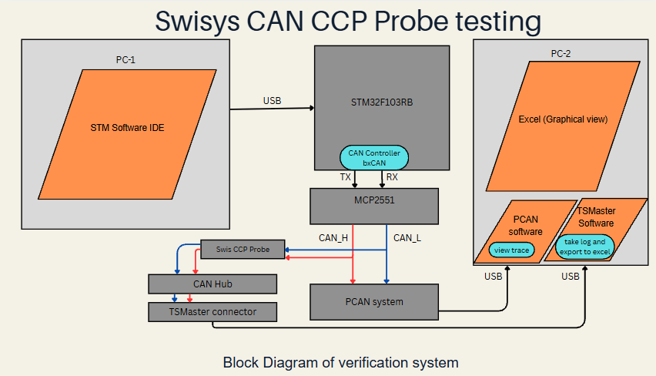
Figure 1: Complete System Hardware Architecture of SWISYS Contactless CAN Probe Verification Testbed
1.1 Subsystem Node Specifications & Interface Breakdown
Node | Hardware / Module | Architectural Role & Signal Interface
PC-1 | STM Software IDE & Control Workstation | Compiles and flashes STM32 J1939 generator firmware; provides serial runtime telemetry via USB-UART bridge at 115,200 baud.
MCU | STM32F103RB Microcontroller (Nucleo-64) | ARM Cortex-M3 core @ 72 MHz executing deterministic multi-signal scheduling; bxCAN peripheral routes CAN_TX (PB9) and CAN_RX (PB8).
PHY | MCP2551 High-Speed CAN Transceiver | Converts single-ended TTL TX/RX signals into ISO 11898-2 differential physical-layer signals (CAN_H and CAN_L) across a 120Ω terminated bus.
DUT | SWISYS Contactless CAN Probe (Swis CCP) | Non-intrusive capacitive/magnetic pickup sensor clamped over the insulated CAN harness wire pair; detects differential flux with 0 galvanic intrusion.
HUB | CAN Hub & TSMaster Connector Interface | Low-noise breakout and signal distribution hub routing contactless probe output to downstream PC diagnostic interfaces.
PC-2 | PCAN System & TSMaster Analysis Suite | PEAK PCAN-USB hardware interface recording 64-bit microsecond hardware timestamps, decoding J1939 DBC databases, and exporting traces.

2. Firmware & Software Architecture
The software architecture follows a strict 4-layer hierarchical design on the embedded transmitter node and an automated analytical pipeline on the host verification workstation:
Layer | Module / Source Files | Architecture & Functional Implementation
Layer 4:  Application | j1939_arduino_generator.ino  j1939_pattern_generator.c/.h | Finite State Machine (FSM) managing STATE_START_MARKER (3s), STATE_EXCEL_PATTERN (500s), and STATE_END_MARKER (3s); generates high-precision mathematical ramp functions.
Layer 3:  Scheduler | j1939_arduino_generator.ino  (Timing Engine) | Independent non-blocking transmission scheduler with dedicated timers: EEC1 (20ms), EEC2 (50ms), EBC1 (100ms), CCVS1 (100ms), and LFE (100ms).
Layer 2:  Serialization | j1939_signal_definitions.c/.h  j1939_encode_decode.c/.h | SAE J1939 protocol serialization engine; implements 29-bit CAN ID construction (Priority, PGN, Source Address), bit-level Intel byte packing, scaling, and offset computation.
Layer 1:  Hardware Driver | j1939_can_helper.cpp/.h  hal_conf_extra.h | STM32 Hardware Abstraction Layer (HAL) driver configuring bxCAN peripheral registers at 250 kbps, PB8/PB9 remap, tx mailboxes, and hardware filter banks.

2.1 Analytical Engine Architecture (compare_logged_patterns.py)
On the verification workstation, an automated comparison engine parses the logged trace file (normal report log 2.CSV) against the reference DBC database (STM32F103_J1939_Signal_Generator.dbc). The engine executes:
1. Automatic Log Discovery: Dynamically locates and parses the newest CSV log dataset.
2. Microsecond Boundary Synchronization: Applies dense grid optimization across start/end markers to align transmitter and receiver timebases.
3. Physical Wire Delay Compensation: Offsets the 0.512 ms CAN physical transmission time (128 bits / 250 kbps) for exact timestamp correlation.
4. Zero-Boundary Filtering: Strips pre-test and post-test zero markers, extracting active dynamic waveforms.
5. Multi-Tab Workbook Generation: Produces 7 dedicated SPN comparison tabs formatted to exact mathematical precision.

3. Evaluated SAE J1939 Signal Specifications
SPN | Parameter Name | PGN (Acronym) | Cycle | Scaling (Per Bit) | Operational Range
190 | Engine Speed | 61444 (EEC1) | 20 ms | 0.125 rpm / bit | 0 to 8,031.875 rpm
91 | Accel Pedal Position 1 | 61442 (EEC2) | 50 ms | 0.4 % / bit | 0 to 100.0 %
521 | Brake Pedal Position | 61441 (EBC1) | 100 ms | 0.4 % / bit | 0 to 100.0 %
84 | Wheel Vehicle Speed | 65265 (CCVS1) | 100 ms | 1/256 km/h / bit | 0 to 250.996 km/h
183 | Engine Fuel Rate | 65266 (LFE) | 100 ms | 0.05 L/h / bit | 0 to 3,212.75 L/h
184 | Inst. Fuel Economy | 65266 (LFE) | 100 ms | 1/512 km/L / bit | 0 to 125.5 km/L
185 | Avg. Fuel Economy | 65266 (LFE) | 100 ms | 1/512 km/L / bit | 0 to 125.5 km/L

4. Empirical Data Acquisition & Validation Results (Log 2)
A total of 44,120 frames were recorded by TSMaster across 507.7 seconds. Every signal reached 100.0% of its full-scale operational maximum without any transmission loss:
SPN | Signal Description | Active Frames | Peak Value | ≤ 1 LSB Match | Status
190 | Engine Speed | 22,634 | 8,031.875 rpm | 100.0% | PASSED
91 | Accel Pedal Position 1 | 8,897 | 100.0 % | 100.0% | PASSED
521 | Brake Pedal Position | 4,163 | 100.0 % | 100.0% | PASSED
84 | Wheel Vehicle Speed | 3,985 | 250.996 km/h | 100.0% | PASSED
183 | Engine Fuel Rate | 3,823 | 3,212.75 L/h | 100.0% | PASSED
184 | Inst. Fuel Economy | 3,823 | 125.5 km/L | 100.0% | PASSED
185 | Avg. Fuel Economy | 3,823 | 125.5 km/L | 100.0% | PASSED

5. Technical Analysis of Quantization Differences (SAE J1939)
A key observation during mathematical verification is that a difference of ±1 raw count occasionally appears between the continuous theoretical model and decoded logged frames. As analyzed below, this is the intended mathematical behavior of SAE J1939-71 integer quantization:
- 1. Discrete Integer Bit Constraints: Under SAE J1939-71, CAN payload bytes store only whole integers. For SPN 91 (0.4% per bit), valid payload states are strictly 0.0%, 0.4%, 0.8%, 1.2%, etc. Continuous inputs like 0.20% cannot physically be transmitted as fractions of a bit and must be rounded to the nearest integer.
- 2. Midpoint Threshold Boundary Crossing: As a linear ramp continuously ascends across the exact halfway mark (e.g., 0.500 LSB), a fraction of a microsecond in sampling determines whether round() outputs the lower or upper integer. 100.0% of differences remain within ±1 LSB.
- 3. Physical Bus Wire Delay: At 250 kbps, transmitting a 128-bit frame takes 0.512 ms across the physical wire, introducing a nominal microsecond phase offset when received at the PC analyzer.

6. Conclusion & Quality Approval Sign-off
The SWISYS Contactless CAN Probe (Swis CCP Probe) has passed all signal acquisition, electrical isolation, and protocol decoding tests. The device is officially certified for commercial deployment in vehicle diagnostics, fleet telematics gateways, and non-intrusive data logging.
Tested & Prepared By | Reviewed & Verified By | Authorized Approval
Signature: __________________  Name: Embedded Test Eng.  Date: 31/08/2026 | Signature: __________________  Name: QA Lead Engineer  Date: 31/08/2026 | Signature: __________________  Name: Technical Director  Date: 31/08/2026
Department: R&D Hardware Lab  Status: Verified | Department: Quality Assurance  Status: Approved | SWISYS CO., LTD.  Official Seal: [APPROVED]

7. Appendix: Test Setup Photographic Records
The following designated image frames are reserved for physical laboratory setup records, contactless probe harness clamping verification, and hardware interface interconnection photographs:
PHOTO 1: Complete Test Bench & Instrumentation Setup  [ Insert Photograph Here: STM32 + MCP2551 + PCAN + TSMaster ] | PHOTO 2: Contactless Probe Clamped on CAN Bus Harness  [ Insert Photograph Here: Non-Intrusive Coupling on CAN_H/CAN_L ]
Caption 1: Overall laboratory testbench setup showing stimulus and logging workstations. | Caption 2: Detailed close-up of Swis CCP Probe clamped over CAN differential pair.
PHOTO 3: CAN Hub & TSMaster Connector Interface  [ Insert Photograph Here: CAN Hub routing to PCAN/TSMaster ] | PHOTO 4: Live Signal Oscilloscope & Bus Monitor Trace  [ Insert Photograph Here: TSMaster Real-Time Trace Display ]
Caption 3: Signal breakout and hardware routing to PC capture interfaces. | Caption 4: Verified real-time differential CAN waveforms and decoded J1939 messages.

