|  |
| --- |
| Gungahlin College |
| Instruction Booklet: PokePet |
| IT: Intermediate Programming Assignment |
|  |
| **Alex Tran** |
| **11/11/2013** |

|  |
| --- |
|  |

The Interface of PokePet

The Start Up Menu

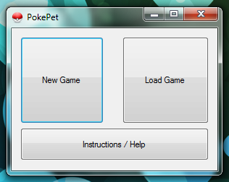

Main Game

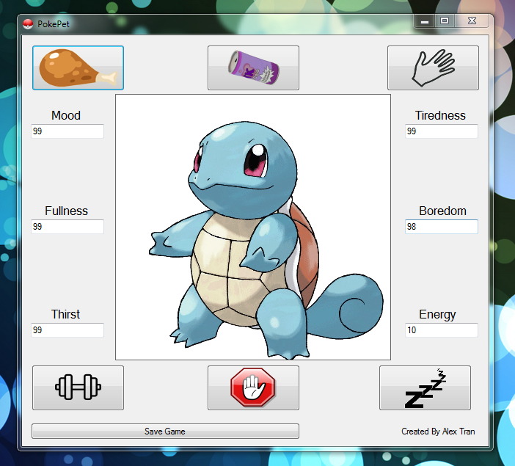

Button Functions



* Start a new game

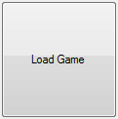

* Load a Previous Save Game



* Load Instruction Booklet



* Feed Pet



* Give pet a drink



* Pat/Play with the pet



* Make Pet Exercise



* Ignore Pet

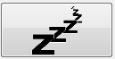

* Make pet go to sleep



* Save current game (over the old if there is one)

Playing the Game

To start a new game you press the new game button and if you wanted to play from a saved file you press the load button, this will take you to the main interface where you play the game of a virtual pet or otherwise none as “PokePet”. As it can be seen that there are 6 different labels for the stats of the pet, these include Mood, Hunger, Thirst, Boredom, Sleep and Energy. There are also 6 different buttons for different functions (refer to Button Functions).

To feed your pet, so that its hunger level doesn’t deplete press the feed button and it will start eating and add 10 points each time to the status for 5 seconds. However if it reaches 100 it will stop eating and will prompt a message saying that the pet is full.

This is the same for most of the buttons when you press it, the button will add status points to the certain attribute. However if you ignore the Pet it will decrease your pet’s mood by 3 each second it goes on for. All actions except the sleep and ignore buttons will cause an energy decrease, and will cause an energy decrease of three if exercise is chosen. Exercising will also decrease the tiredness level making it more tired. If the tiredness level reaches 0 the pet automatically falls to sleep.

Once the pet is in sleep mood, nothing can be done for a minute as all the buttons are disabled.

The Pet will be happier if its fitness level is higher and each time you make the pet exercise it gains 2 levels of fitness level.

The game is designed to allow you to have fun and take care of a pet, and the aim is to keep the pet from running away which only happens if the mood reaches 0.