# Futures Contracts

## STIR Futures – NLX Only

28 EURIBOR

26 Short Sterling

44 Eurodollar (assuming NLX launches the same contracts as the CME)

**Total = 98 contracts**

## Government Bond Futures – NLX Only

3 Long Gilt

3 Euro-Schatz

3 Euro-Bobl

3 Euro-Bund

3 US Treasury (assuming NLX launches the same contracts as the CME)

**Total = 15 contracts**

## DSF – NLX & LSEDM

LSEDM – 4 EUR contracts (2Y, 5Y, 10Y, 30Y), 4 USD contracts (2Y, 5Y, 10Y, 30Y) and 1 GBP contract (10Y) => 9 contracts corresponding to a single expiry quarter. Contracts for a second expiry quarter will be listed just prior to the demise of the front quarter’s contracts. Hence there could be 9 x 2 = 18 contracts at any one time.

NLX – 3 currencies (USD, GBP and EUR), 3 maturity tenors (2Y, 5Y, 10Y) and 3 expiry tenors (from 3 quarters) => 3 x 3 x 3 = 27 contracts

**Total = 45 contracts**

So that makes **158** different contracts in total, although many simply won’t ever trade.

# SwapClear and ListedDervatives Portfolios.

## SwapClear

#### Total portfolios

|  |  |
| --- | --- |
|  |  |
| PTF_STATUS | ACTIVE |
|  |  |
| Count of CPTY_LCHID |  |
| PORTFOLIO_TYPE | Total |
| FCM | 16 |
| FCM Affiliate | 2 |
| FCM Client | 28566 |
| SCM | 86 |
| SCM Client | 1095 |
| SD | 98 |
| Grand Total | 29863 |
|  | | |

#### Active Portfolios

|  |  |
| --- | --- |
|  |  |
| **Row Labels** | **Count of Portfolio** |
| C | 1383 |
| H | 146 |
| **Grand Total** | **1529** |

## ListedDervatives

#### Total portfolios

|  |  |
| --- | --- |
| **Row Labels** | **Count of PARTICIPANT_ID** |
| **C** | **248** |
| OSA | 248 |
| **H** | **78** |
| House | 78 |
| **Grand Total** | **326** |

# Portfolio Balancer

The portfolio balancer currently only balances the IM (ES) on the SwapClear and Listed portfolios it completely ignores the effect of add-ons.

Let us assume that we have as inputs:-

|  |  |
| --- | --- |
| $$S_{\begin{aligned}SC\end{aligned}}$$ | The set of SwapClear (2500) scenarios under the SwapClear methodology |
| $$S_{\begin{aligned}L\end{aligned}}$$ | The set of Listed (1250) scenarios under the Listed methodology |
| $$φ_{s}^{SC}$$ | The SwapClear Portfolio PnL on the scenario $s$. |
| $$F$$ | The set of listed future contracts. |
| $$P_{f}$$ | The long or short position in future contract $f$. |
| $$u_{sf}$$ | The unit PnL for the future contract under the scenario $s$ methodology. |
| $$δ_{p}^{φ}$$ | The SwapClear portfolio delta for sensitivity p. |
| $$δ_{p}^{f}$$ | The unit delta for sensitivity p on future contract $f$. |

These can be produced using a combination of SMART and a modified version of Linton. Let

|  |  |
| --- | --- |
| $$x_{f}$$ | Be the position in the future contract $f$ to move into the SwapClear portfolio. |

We wish to choose the ${ x}_{f}$’s such that we maximise the sum of the expect shortfalls in the SwapClear and Listed portfolios while maintaining the constraints

$$\min\left(0,P_{f}\right)≤x_{f}≤\max\left(0,P_{f}\right) ∀ f∈F$$

## Implemented Algorithms

### Maximise Worst Case Loss (Simplex WCL)

Consider the model

|  |  |
| --- | --- |
| Maximize | $$O=\min_{s∈S_{\begin{aligned}SC\end{aligned}}}\left(φ_{s}+\sum_{f∈F}{u_{sf}x_{f}}\right)+\min_{s∈S_{\begin{aligned}L\end{aligned}}}\left(\sum_{f∈F}{u_{sf}{(P_{f}-x}_{f}})\right)$$ |
| Subject to | $\min\left(0,P_{f}\right)≤x_{f}≤\max\left(0,P_{f}\right) ∀ f∈F$ (the min and max are constants) |
| $$O$$ | The sum of worst case losses. |

Such an objective, which requires a minimum to be maximized, is known as a *maximini objective*.

Say we introduce additional decision variables $y$ and $z$ which we want to represent the WCL on the listed side and swap clear respectively:-

$$\min_{s∈S_{\begin{aligned}L\end{aligned}}}\left(\sum_{f∈F}{u_{sf}{(P_{f}-x}_{f}})\right)$$

$$\min_{s∈S_{\begin{aligned}SC\end{aligned}}}\left(φ_{s}+\sum_{f∈F}{u_{sf}x_{f}}\right)$$

In order to establish this relationship, the following extra constraints must be imposed:-

$$y≤\sum_{f∈F}{u_{sf}{(P_{f}-x}_{f}})$$

$$z≤φ_{s}+\sum_{f∈F}{u_{sf}x_{f}}$$

Now when z is maximised, these constraints will ensure that $z$ will be less than or equal to $φ_{s}+\sum_{f∈F}{u_{sf}x_{f}}$ for all s. However the optimal value $z$ will be no smaller than the minimum of all $φ_{s}+\sum_{f∈F}{u_{sf}x_{f}}$ because $z$ has been maximised. Therefore the value of z will be both as large as possible and exactly equal to WCL. The argument also works for $y$.

So the equivalent linear program is:-

|  |  |
| --- | --- |
| Maximize | $$y+ z$$ |
| Subject to | $$\min\left(0,P_{f}\right)≤x_{f}≤\max\left(0,P_{f}\right) ∀ f∈F$$ |
|  | $$y≤\sum_{f∈F}{u_{sf}{(P_{f}-x}_{f}}) ∀ s∈S_{\begin{aligned}L\end{aligned}}$$ $$z≤φ_{s}^{SC}+\sum_{f∈F}{u_{sf}x_{f}} ∀ s∈S_{\begin{aligned}SC\end{aligned}}$$ |

While this does not directly optimise the expected shortfall IM, as this is an average of the top n WCLs, it will hopefully still produce good result. The problem above can be solved efficiently in practise using Dantzig’s Simplex algorithm.

### Maximise Expected Shortfall (Simplex ES)

Let us write the sorted PnL vectors for listed as

$${\text{PnL}}_{(1)}^{\text{Listed}}≤{\text{PnL}}_{(2)}^{\text{Listed}}≤{\text{PnL}}_{(3)}^{\text{Listed}}≤{\text{PnL}}_{(4)}^{\text{Listed}}≤…$$

And the PnL vectors for swap clear as

$${\text{PnL}}_{(1)}^{\text{Swap}}≤{\text{PnL}}_{(2)}^{\text{Swap}}≤{\text{PnL}}_{(3)}^{\text{Swap}}≤{\text{PnL}}_{(4)}^{\text{Swap}}≤{\text{PnL}}_{(5)}^{\text{Swap}}≤{\text{PnL}}_{(6)}^{\text{Swap}}…$$

For a given solution $x_{f}$ $∀ f∈F$

Then we can write the overall short fall as

$$\frac{1}{6}{\sum_{s=1}^{6}{\left(φ_{(s)}^{SC}+\sum_{f∈F}{u_{\left(s\right)f}x_{f}}\right)}}+\frac{1}{4}\sum_{s=1}^{4}{\left(\sum_{f∈F}{u_{\left(s\right)f}{(P_{f}-x}_{f}})\right)}$$

Note that

$$\sum_{s=1}^{t}{\left(φ_{(s)}^{SC}+\sum_{f∈F}{u_{\left(s\right)f}x_{f}}\right)}≤ \sum_{s∈ρ_{SC}}{\left(φ_{(s)}^{SC}+\sum_{f∈F}{u_{sf}x_{f}}\right)}$$

$$\sum_{s=1}^{t}{\left(\sum_{f∈F}{u_{\left(s\right)f}{(P_{f}-x}_{f}})\right)}≤ \sum_{s∈ρ_{L}}{\left(\sum_{f∈F}{u_{sf}{(P_{f}-x}_{f}})\right)}$$

$ρ_{SC}$ is indexed over all the possible subset of $S_{\begin{aligned}SC\end{aligned}}$ where $\left|ρ_{SC}\right|=t$

$ρ_{L}$ is indexed over all the possible subset of $S_{\begin{aligned}L\end{aligned}}$ where $\left|ρ_{L}\right|=t$

Introducing 6 new optimisation variables $H_{(i)}$

Introducing 4 new optimisation variables $I_{(i)}$

The problem below is equivalent to maximising the total expected shortfall

|  |  |
| --- | --- |
| Maximize | $$O=\frac{1}{6}{\sum_{s=1}^{6}{\left(H_{(s)}\right)}+\frac{1}{4}\sum_{s=1}^{4}{\left(I_{(s)}\right)}}$$ |
| Subject to | $$\sum_{s=1}^{6}{H_{(s)}}≤\sum_{s∈ρ_{SC}}{\left(φ_{i}^{SC}+\sum_{f∈F}{u_{sf}x_{f}}\right)}$$ $$\sum_{s=1}^{4}{I_{(s)}}≤\sum_{s∈ρ_{L}}{\left(\sum_{f∈F}{u_{sf}{(P_{f}-x}_{f}})\right)}$$ |
|  | $$\min\left(0,P_{f}\right)≤x_{f}≤\max\left(0,P_{f}\right) ∀ f∈F$$ |

The sum of the worst swap clear and worst listed PnLs as it appears in the objective function is in fact the solution to the linear optimisation problems:-

|  |  |
| --- | --- |
| *Minimise* | $$O=\sum_{s=1}^{2500}{B_{s}^{SC}H_{s}}{}$$ |
| Subject to |  |

|  |  |
| --- | --- |
| *Minimise* | $$O=\sum_{s=1}^{1250}{B_{s}^{L}I_{s}}$$ |
| Subject to | $$\sum_{i=1}^{1250}{B_{i}^{L}}=4 0≤B_{i}^{L}≤1$$ |

By apply strong duality with the dual variables $Y_{}^{SC}, Y_{}^{L}$ and the slacks $Z_{i}^{SC}$ and $Z_{i}^{L}$ gives

|  |  |
| --- | --- |
| *Maximise* | $O= 6Y^{SC}+\sum_{i=1}^{2500}{Z_{i}^{SC} }$ |
| Subject to |  |

|  |  |
| --- | --- |
| *Maximise* | $O= 4Y_{}^{L}+\sum_{i=1}^{1250}{Z_{i}^{L} }$ |
| Subject to | $Y^{L}+Z_{i}^{L}≤I_{i} Z_{i}^{L}≤0 i=1,…,1250$ |

We can use these to rewrite the original optimisation

|  |  |
| --- | --- |
| Maximize | $$O=\frac{1}{6}{\text{max}\left({6Y}^{SC}+\sum_{i=1}^{2500}{Z_{i}^{SC} }\right)+\frac{1}{4}\text{max}\left(4Y^{L}+\sum_{i=1}^{1250}{Z_{i}^{L} }\right)}$$ |
| Subject to | $$Y^{SC}+Z_{i}^{SC}≤φ_{i}^{SC}+\sum_{f∈F}{u_{if}x_{f}} Z_{i}^{SC}≤0 i=1,…,2500$$ $$Y^{L}+Z_{i}^{L}≤\sum_{f∈F}{u_{if}{(P_{f}-x}_{f}}) Z_{i}^{L}≤0 i=1,…,1250$$ |
|  | $$\min\left(0,P_{f}\right)≤x_{f}≤\max\left(0,P_{f}\right) ∀ f∈F$$ |

Which we can write as

|  |  |
| --- | --- |
| Maximize | $$O=Y^{SC}+\frac{1}{6}{\sum_{i=1}^{2500}{Z_{i}^{SC} }+Y^{L}+\frac{1}{4}}\sum_{i=1}^{1250}{Z_{i}^{L} }$$ |
| Subject to | $$Y^{SC}+Z_{i}^{SC}≤φ_{i}^{SC}+\sum_{f∈F}{u_{if}x_{f}} Z_{i}^{SC}≤0 i=1,…,2500$$ $$Y^{L}+Z_{i}^{L}≤\sum_{f∈F}{u_{if}{(P_{f}-x}_{f}}) Z_{i}^{L}≤0 i=1,…,1250$$ |
|  | $$\min\left(0,P_{f}\right)≤x_{f}≤\max\left(0,P_{f}\right) ∀ f∈F$$ |

## Constant entries on the Listed Side

Let us assume that there are some futures on the listed side that cannot be moved they will contribute to a constant PnL vector on the listed side that does not vary.

|  |  |
| --- | --- |
| $$S_{\begin{aligned}SC\end{aligned}}$$ | The set of SwapClear (2500) scenarios under the SwapClear methodology |
| $$S_{\begin{aligned}L\end{aligned}}$$ | The set of Listed (1250) scenarios under the Listed methodology |
| $$φ_{s}^{SC}$$ | The SwapClear Portfolio PnL on the scenario $s$. |
| $$φ_{s}^{L}$$ | The Listed Portfolio PnL on the scenario $s$ for contracts that do not move. |
| $$F$$ | The set of listed future contracts. |
| $$P_{f}$$ | The long or short position in future contract $f$. |
| $$u_{sf}$$ | The unit PnL for the future contract under the scenario $s$ methodology. |
| $$δ_{p}^{φ}$$ | The SwapClear portfolio delta for sensitivity p. |
| $$δ_{p}^{f}$$ | The unit delta for sensitivity p on future contract. |

|  |  |
| --- | --- |
| Maximize | $$O=Y^{SC}+\frac{1}{6}{\sum_{i=1}^{2500}{Z_{i}^{SC} }+Y_{}^{L}+\frac{1}{4}}\sum_{i=1}^{1250}{Z_{i}^{L} }$$ |
| Subject to | $$Y^{SC}+Z_{i}^{SC}- \sum_{f∈F}{u_{if}x_{f}}≤φ_{i}^{SC} Z_{i}^{SC}≤0 i=1,…,2500$$ $$Y_{}^{L}+Z_{i}^{L}+\sum_{f∈F}{u_{if}x_{f}} ≤φ_{i}^{L}+\sum_{f∈F}{u_{if}P_{f}} Z_{i}^{L}≤0 i=1,…,1250$$ |
|  | $$\min\left(0,P_{f}\right)≤x_{f}≤\max\left(0,P_{f}\right) ∀ f∈F$$ |

## Optimal solution with no position constraints

Let us assume we can pick the future positions to place on the Listed and SwapClear side without constraint we can write the problem as:-

|  |  |
| --- | --- |
| $$x_{f}^{SC}$$ | Be the position in the future contract $f$ to place into the SwapClear portfolio. |
| $$x_{f}^{L}$$ | Be the position in the future contract $f$ to place into the Listed portfolio. |

|  |  |
| --- | --- |
| Problem 1 |  |
| Maximize | $$O=Y^{SC}+\frac{1}{6}{\sum_{i=1}^{2500}{Z_{i}^{SC} }+Y^{L}+\frac{1}{4}}\sum_{i=1}^{1250}{Z_{i}^{L} }$$ |
| Subject to | $$Y^{SC}+Z_{i}^{SC}- \sum_{f∈F}{u_{if}}x_{f}^{SC}≤φ_{i}^{SC} Z_{i}^{SC}≤0 i=1,…,2500$$ $$Y^{L}+Z_{i}^{L}-\sum_{f∈F}{u_{if}x_{f}^{L}} ≤φ_{i}^{L} Z_{i}^{L}≤0 i=1,…,1250$$ |

The problems can now be decoupled as the solutions to the SwapClear and listed problems are independent and you can compose them to get the final result.

## Some solutions to the above problem have a tendency to go very long some futures contracts and short some other highly correlated futures contracts.

I speculate that this is due to the fact there are multiple equivalent optional solutions to the above problem. Some of which are better than others to try and ferret out the good the solutions we further constraint the solved problems to minimise the absolute sum of the future contract positions.

|  |  |
| --- | --- |
| Problem 2 |  |
| Minimise | $$O=\sum_{f∈F}{\left(a_{f}^{SC}+a_{f}^{L}\right)}$$ |
| Subject to | $${\overset{̿}{Y}}^{SC}+{\overset{̿}{Z}}_{i}^{SC}-φ_{i}^{SC}≤\sum_{f∈F}{u_{if}}x_{f}^{SC} i=1,…,2500$$ $$a_{f}^{SC}≥ x_{f}^{SC} \text{and} a_{f}^{SC}≥ -x_{f}^{SC} \text{ for all } f∈F$$ $${\overset{̿}{Y}}^{L}+{\overset{̿}{Z}}_{i}^{L}-φ_{i}^{L} ≤ \sum_{f∈F}{u_{if}x_{f}^{L}} i=1,…,1250$$ $$a_{f}^{L}≥ x_{f}^{L} \text{and} a_{f}^{L}≥ x_{f}^{L} \text{ for all } f∈F$$ |

Where the $\overset{̿}{*}$ are the optimal solutions to Problem 1

## Deterministic Nonlinear Integer Optimisation (DNIO)

Algorithm:

1. Set initial future portfolio to be netted against the OTC portfolio (e.g. 50% of all future positions).

Loop

1. Calculate PnL vector for net portfolio (OTC + Net_fut_port)
2. Calculate PnL vector for remainder future portfolio in NLX (NLX_fut_port)
3. Calculate Total_IM (OTC_IM + NLX_IM) and locate indices of worst 6 and 4 P&L’s respectively.
4. Calculate the IM_Direction for each future contract as:  
      
   sign( Sum(Step_2(index_step4)) - Sum(Step_3(index_step4)) )
5. New future portfolio = prev future portfolio + IM_Direction (Step 5).

Here some constrains will be required to make sure we don’t exceed the maximum and minimum number of contracts.

Also the IM_ Direction vector can be multiplied by some integer factor to increase the step increments.

Repeat until number of iterations, tolerance, etc is achieved.

Here are some results of this approach compared against the core nonlinear optimisation in R and the Variance minimisation.

Average IM reduction compared to the sum of standalone IM’s on 100 random portfolios (single currency)

|  |  |  |
| --- | --- | --- |
| Nonlinear | Variance | DNIO |
| 25.5% | 16.3% | 25.1% |

### Non linear optimisation (NLopt)

NLopt (http://ab-initio.mit.edu/wiki/index.php/NLopt ) is a free/open-source library for nonlinear optimization. We maximise the sum of Expected Shortfalls directly.

For the global optimisation phase we use Controlled Random Search (CRS) with local mutation and for the local optimisation we use subplex algorithm (SBPLX)

### Delta Reduction

Here we assume that each individual futures contract is completely characterised by pillar with the largest absolute delta (largest pillar delta LPD). We iterate through the SwapClear portfolio from the longest pillar to shortest using the available LPDs to reduce as much of the delta as possible.

## DNIO with adaptive step size (DNIO2)

DNIO suffers from a decrease in speed as the position sizes in the future contracts increase we introduce DNIO2 which uses an adaptive step size to mitigate this issue.

1. Set StepSize equal to the maximum absolute position size.
2. Run DNIO with this step size if the improvement stops half the size of StepSize and loop else set StepSize max of maximum absolute position size and StepSize doubled. Loop Step 2

# Data source

|  |  |  |
| --- | --- | --- |
| **Short Name** | **Description** | **Source** |
| $$S_{\begin{aligned}SC\end{aligned}}$$ | The set of SwapClear (2500) scenarios under the SwapClear methodology | Generated by Smart using Deltas generated by Linton |
| $$S_{\begin{aligned}L\end{aligned}}$$ | The set of Listed (1250) scenarios under the Listed methodology | Generated by Linton using FHS |
| $$φ_{s}$$ | The SwapClear Portfolio PnL on the scenario $s$. | Generated by Smart using TDG |
| $$F$$ | The set of listed future contracts. | Supplied |
| $$P_{f}$$ | The long or short position in future contract $f$. | Supplied |
| $$u_{sf}$$ | The unit PnL for the future contract $f$ under the scenario $s$ methodology. | Source by $S_{\begin{aligned}SC\end{aligned}}$  or $S_{\begin{aligned}L\end{aligned}}$ |
| $$δ_{p}^{φ}$$ | The SwapClear portfolio delta for sensitivity p. | Smart Reports |
| $$δ_{p}^{f}$$ | The unit delta for sensitivity p on future contract $f$. | Linton |

# Simulation

We use the DSS house and client portfolios as SwapClear portfolios for simulation as of 23/10/2014.

|  |  |
| --- | --- |
| **Count** | **Account** |
| 1 | House |
| 2 | BKJULIUSBAER |
| 3 | DEAM0111069X |
| 4 | ILLMMUTPENIN |
| 5 | NETAPGTCDDDC |
| 6 | NETKBCDSSXXX |
| 7 | NETWESTPACBC |
| 8 | POHJOLABKPLC |
| 9 | RLAMRLMISXXX |
| 10 | STANDARDBKJG |
| 11 | STANDARDBKLN |
| 12 | UNIRENTAXXXX |
| 13 | UNIWRTASPRNT |

We generate random positions in 78 future contracts a position in each contract such that $\text{–positionScale} < \text{position} <\text{ positionScale}$. We then run the various algorithms on the combination of SwapClear portfolio and the randomly generated futures positions in the 78 futures contracts listed below.

|  |  |  |
| --- | --- | --- |
| DSF_PRICE-201412-EUR-201612-0.01 | F-NLX-FUT-NINI-20170600 | F-NLX-FUT-NLNL-20180300 |
| DSF_PRICE-201412-EUR-201912-0.015 | F-NLX-FUT-NINI-20170900 | F-NLX-FUT-NLNL-20180600 |
| DSF_PRICE-201412-EUR-202412-0.02 | F-NLX-FUT-NINI-20171200 | F-NLX-FUT-NLNL-20180900 |
| DSF_PRICE-201412-EUR-204412-0.025 | F-NLX-FUT-NINI-20180300 | F-NLX-FUT-NLNL-20181200 |
| DSF_PRICE-201412-GBP-201612-0.01 | F-NLX-FUT-NINI-20180600 | F-NLX-FUT-NLNL-20190300 |
| DSF_PRICE-201412-GBP-201912-0.015 | F-NLX-FUT-NINI-20180900 | F-NLX-FUT-NLNL-20190600 |
| DSF_PRICE-201412-GBP-202412-0.03 | F-NLX-FUT-NINI-20181200 | F-NLX-FUT-NLNL-20190900 |
| DSF_PRICE-201412-GBP-204412-0.0375 | F-NLX-FUT-NINI-20190300 | F-NLX-FUT-NLNL-20191200 |
| DSF_PRICE-201412-USD-201612-0.01 | F-NLX-FUT-NINI-20190600 | F-NLX-FUT-NLNL-20200300 |
| DSF_PRICE-201412-USD-201912-0.015 | F-NLX-FUT-NINI-20190900 | F-NLX-FUT-NLNL-20200600 |
| DSF_PRICE-201412-USD-202412-0.03 | F-NLX-FUT-NINI-20191200 | F-NLX-FUT-NLNL-20200900 |
| DSF_PRICE-201412-USD-204412-0.0375 | F-NLX-FUT-NINI-20200300 | F-NLX-FUT-NRNR-20141200 |
| F-NLX-FUT-NBNB-20141200 | F-NLX-FUT-NINI-20200600 | F-NLX-FUT-NRNR-20150300 |
| F-NLX-FUT-NBNB-20150300 | F-NLX-FUT-NINI-20200900 | F-NLX-FUT-NRNR-20150600 |
| F-NLX-FUT-NBNB-20150600 | F-NLX-FUT-NLNL-20141100 | F-NLX-FUT-NSNS-20141200 |
| F-NLX-FUT-NINI-20141100 | F-NLX-FUT-NLNL-20141200 | F-NLX-FUT-NSNS-20150300 |
| F-NLX-FUT-NINI-20141200 | F-NLX-FUT-NLNL-20150100 | F-NLX-FUT-NSNS-20150600 |
| F-NLX-FUT-NINI-20150100 | F-NLX-FUT-NLNL-20150300 | F-NLX-FUT-NUNU-20141200 |
| F-NLX-FUT-NINI-20150200 | F-NLX-FUT-NLNL-20150600 | F-NLX-FUT-NUNU-20150300 |
| F-NLX-FUT-NINI-20150300 | F-NLX-FUT-NLNL-20150900 | F-NLX-FUT-NUNU-20150600 |
| F-NLX-FUT-NINI-20150400 | F-NLX-FUT-NLNL-20151200 |  |
| F-NLX-FUT-NINI-20150600 | F-NLX-FUT-NLNL-20160300 |  |
| F-NLX-FUT-NINI-20150900 | F-NLX-FUT-NLNL-20160600 |  |
| F-NLX-FUT-NINI-20151200 | F-NLX-FUT-NLNL-20160900 |  |
| F-NLX-FUT-NINI-20160300 | F-NLX-FUT-NLNL-20161200 |  |
| F-NLX-FUT-NINI-20160600 | F-NLX-FUT-NLNL-20170300 |  |
| F-NLX-FUT-NINI-20160900 | F-NLX-FUT-NLNL-20170600 |  |
| F-NLX-FUT-NINI-20161200 | F-NLX-FUT-NLNL-20170900 |  |
| F-NLX-FUT-NINI-20170300 | F-NLX-FUT-NLNL-20171200 |  |

# Presentation of simulation results

The results are presented as violin plots. They are a combination of a box plot and a kernel density plot. Let :-

1. Q1 = quantile(0.25)
2. Q3 = quantile(0.75)
3. IQR = Q3-Q1

Then the box plot contains a combination of

1. Min
2. Q1–1.25*IQR
3. Q1
4. median
5. Q3
6. Q3+1.25*IQR
7. Max

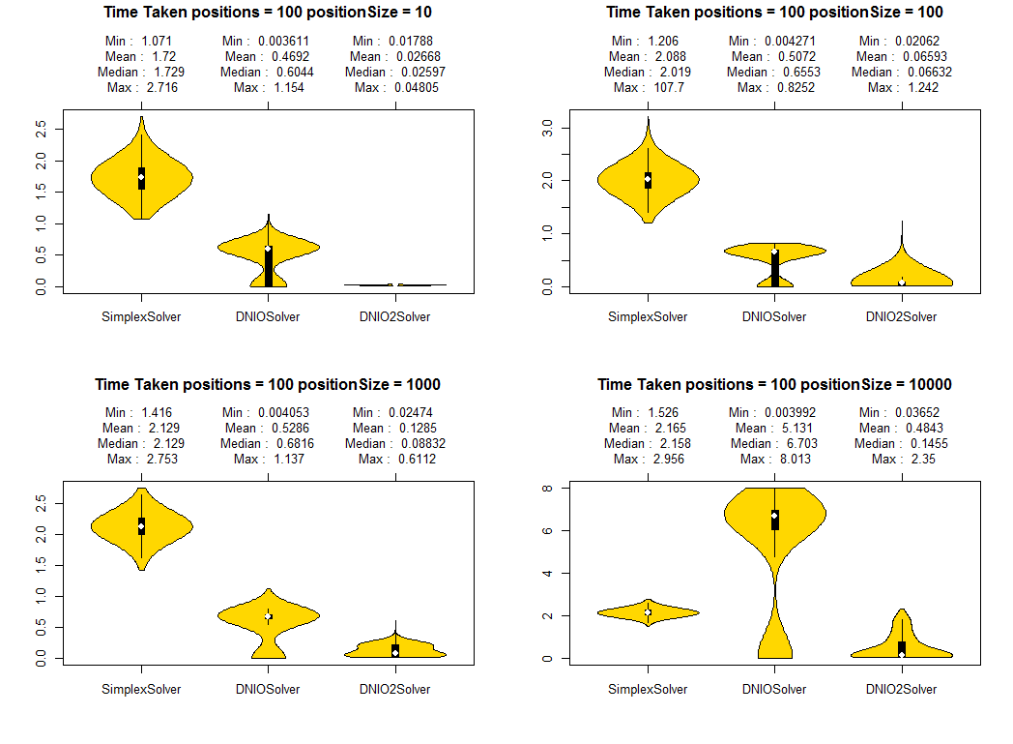

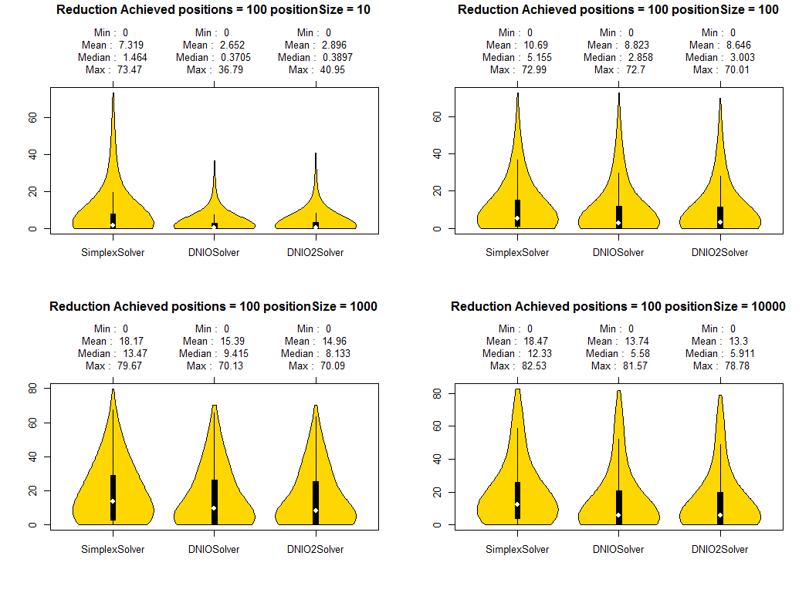









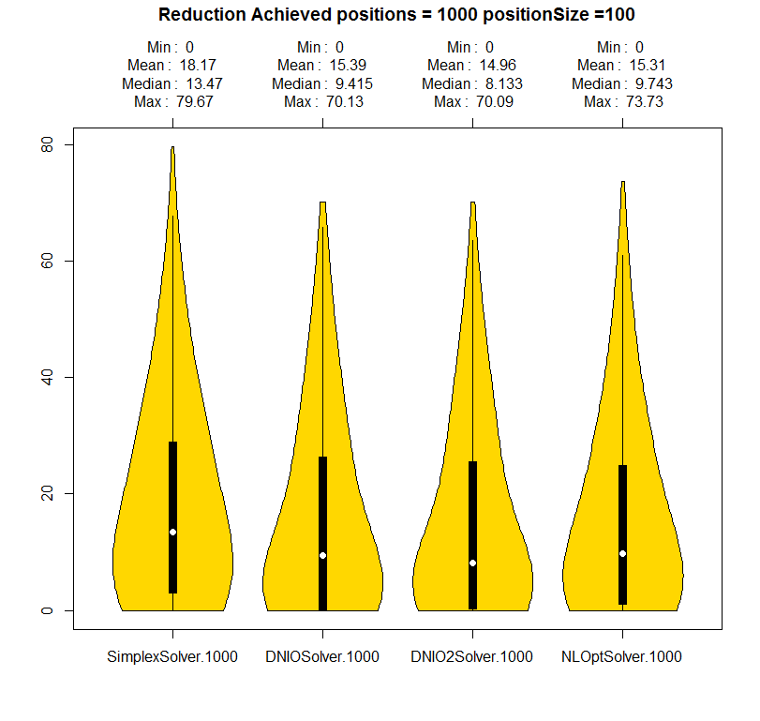

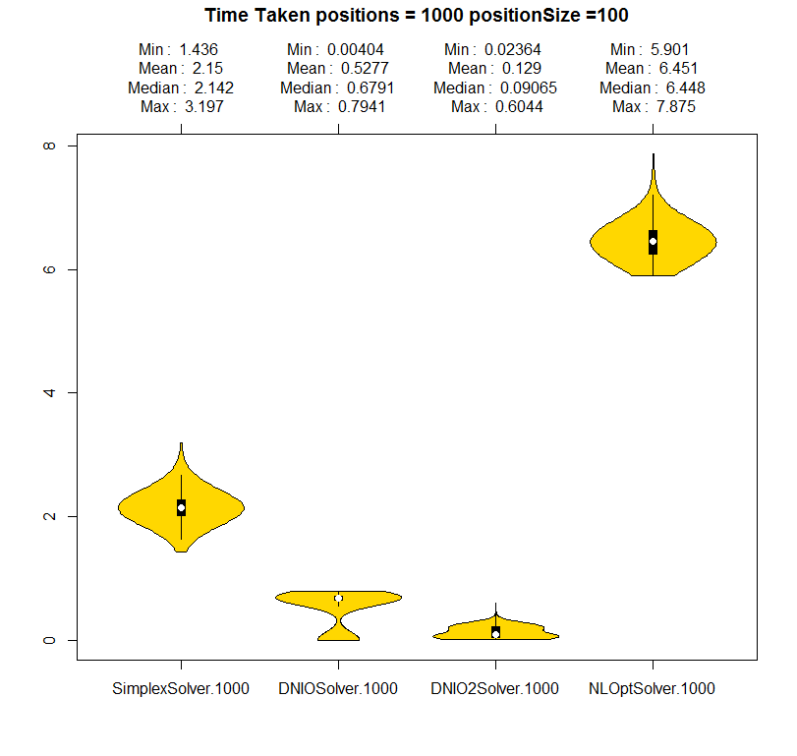

# Specific portfolio results

## DB portfolio as of 23/10/2014

|  |  |  |  |  |  |
| --- | --- | --- | --- | --- | --- |
| **Contract** | **Initial Size** | **Moved DNIO2** | **Moved DNIO** | **Moved Simplex** | **Moved NLOpt** |
| F-NLX-FUT-NBNB-20141200 | 927 | 927 | 927 | 927 | 927 |
| F-NLX-FUT-NINI-20141200 | 3430 | 3430 | 3430 | 3430 | 3430 |
| F-NLX-FUT-NINI-20150300 | -13490 | 0 | 0 | -8368 | 0 |
| F-NLX-FUT-NINI-20150600 | -14040 | 0 | 0 | 0 | 0 |
| F-NLX-FUT-NINI-20150900 | -8100 | 0 | 0 | 0 | -8100 |
| F-NLX-FUT-NINI-20151200 | -18142 | 0 | 0 | -10020 | 0 |
| F-NLX-FUT-NINI-20160300 | 4399 | 4399 | 4399 | 4399 | 4399 |
| F-NLX-FUT-NINI-20160600 | 13868 | 13868 | 13868 | 13868 | 13868 |
| F-NLX-FUT-NINI-20160900 | 5571 | 5571 | 5571 | 5571 | 5571 |
| F-NLX-FUT-NINI-20161200 | 11744 | 11744 | 11744 | 11744 | 11744 |
| F-NLX-FUT-NINI-20170300 | -516 | 0 | 0 | 0 | 0 |
| F-NLX-FUT-NINI-20170600 | -3218 | 0 | 0 | 0 | 0 |
| F-NLX-FUT-NINI-20170900 | -1720 | 0 | 0 | 0 | 0 |
| F-NLX-FUT-NINI-20171200 | -2 | 0 | 0 | 0 | 0 |
| F-NLX-FUT-NINI-20180300 | -2 | 0 | 0 | 0 | 0 |
| F-NLX-FUT-NINI-20180600 | -2 | 0 | 0 | 0 | -2 |
| F-NLX-FUT-NLNL-20141200 | -4520 | 0 | 0 | 0 | 0 |
| F-NLX-FUT-NLNL-20150300 | -22475 | -17159 | -16592 | -22475 | -22475 |
| F-NLX-FUT-NLNL-20150600 | -22626 | -18574 | -16592 | -22626 | 0 |
| F-NLX-FUT-NLNL-20150900 | -9760 | 0 | 0 | 0 | 0 |
| F-NLX-FUT-NLNL-20151200 | -13736 | 0 | 0 | 0 | 0 |
| F-NLX-FUT-NLNL-20160300 | -11154 | 0 | 0 | 0 | 0 |
| F-NLX-FUT-NLNL-20160600 | -4800 | -190 | -4800 | -4800 | 0 |
| F-NLX-FUT-NLNL-20160900 | 11262 | 11262 | 11262 | 11262 | 11262 |
| F-NLX-FUT-NLNL-20161200 | -5589 | 0 | 0 | 0 | 0 |
| F-NLX-FUT-NLNL-20170300 | -896 | 0 | 0 | 0 | 0 |
| F-NLX-FUT-NLNL-20170600 | -3601 | 0 | 0 | 0 | 0 |
| F-NLX-FUT-NRNR-20141200 | -859 | 0 | 0 | 0 | 0 |
| F-NLX-FUT-NSNS-20141200 | -220 | 0 | 0 | 0 | 0 |
| F-NLX-FUT-NUNU-20141200 | -4355 | 0 | 0 | 0 | 0 |
| F-NLX-FUT-NUNU-20150300 | 683 | 683 | 683 | 683 | 0 |

|  |  |  |  |
| --- | --- | --- | --- |
| **Type** | **Listed** | **SwapClear** | **Total** |
| Before | - 23,657,594.16 | - 1,052,441,535.73 | - 1,076,099,129.89 |
| After DNIO2 | - 30,056,782.16 | - 1,030,320,221.57 | - 1,060,377,003.72 |
| After DNIO | - 29,235,900.91 | - 1,031,180,613.86 | - 1,060,416,514.76 |
| After Simplex | - 24,383,086.39 | - 1,038,587,118.57 | - 1,062,970,204.96 |
| After NLopt | - 28,993,241.41 | - 1,033,342,677.64 | - 1,062,335,919.04 |
|  |  | **Max Reduction DNIO2 %** | 1.46 % |

## DB Hedge portfolio (Using DNIO2)

|  |  |  |  |  |  |
| --- | --- | --- | --- | --- | --- |
| **Contract** | **Initial Size** | **Moved DNIO2** | **Moved DNIO** | **Moved Simplex** | **Moved NLOpt** |
| DSF_PRICE-201412-EUR-201612-0.01 | - 17,898.00 | - 106.00 | - 4,193.00 | - | - |
| DSF_PRICE-201412-EUR-201912-0.015 | - 59,559.00 | - 28,321.00 | - 30,374.00 | - 25,944.00 | - 34,265.00 |
| DSF_PRICE-201412-EUR-202412-0.02 | - 58,111.00 | - | - | - 20,070.00 | - |
| DSF_PRICE-201412-EUR-204412-0.025 | - 23,326.00 | - 9,553.00 | - 11,636.00 | - 17,340.00 | - 11,728.00 |
| DSF_PRICE-201412-GBP-202412-0.03 | - 86,959.00 | - 42,752.00 | - 56,332.00 | - 53,527.00 | - 55,242.00 |
| DSF_PRICE-201412-USD-201612-0.01 | - 70,847.00 | - | - | - | - |
| DSF_PRICE-201412-USD-201912-0.015 | 10,185.00 | 10,185.00 | 10,185.00 | 10,185.00 | 10,185.00 |
| DSF_PRICE-201412-USD-202412-0.03 | 1,941.00 | 1,941.00 | 1,941.00 | 1,941.00 | 1,941.00 |
| DSF_PRICE-201412-USD-204412-0.0375 | 152,178.00 | 92,251.00 | 100,661.00 | 111,512.00 | 101,136.00 |

|  |  |  |  |
| --- | --- | --- | --- |
| **Type** | **Listed** | **SwapClear** | **Total** |
| Before | - 285,278,616.32 | - 1,052,441,535.73 | - 1,337,720,152.04 |
| After DNIO2 | - 137,917,105.82 | - 216,366,327.14 | - 354,283,432.95 |
| After DNIO | - 121,953,128.72 | - 229,489,557.33 | - 351,442,686.04 |
| After Simplex | - 92,900,997.18 | - 298,674,276.64 | - 391,575,273.82 |
| After NLopt | - 121,043,071.20 | - 230,116,966.91 | - 351,160,038.10 |
|  |  | **Max Reduction NLOpt %** | 73.75% |

## CITI portfolio

## GS portfolio

## Barclays portfolio

## UBS portfolio