Table of Contents

**Payer/Receiver Swaptions1**

**VolModels**2

**VegaUnit**3

**FxOptions**………………………………………………………………………………………………………………………………………4

Options 5

Risk Neutral 6

* Although your reasoning is strong that a payer fixed, (receiving float) benefits from an increase in rates and hence should be call, in the interest market being long as in a swap or in a bond means benefitting from declining rates not rising rates, therefore the alternative reasoning is that it’s the receivers that are calls as they are the ones that benefit from declining rates!

Don’t ever say long or short when it comes to swaps/swaptions, if you do, you specify long market (bond terminology) or long rates.

Therefore in the interest rate market for swaps and swaptions the terminology is payer and receiver and that is always a reference to fixed leg.

Swaptions vol cube is built of high strike payers and low strike receivers.

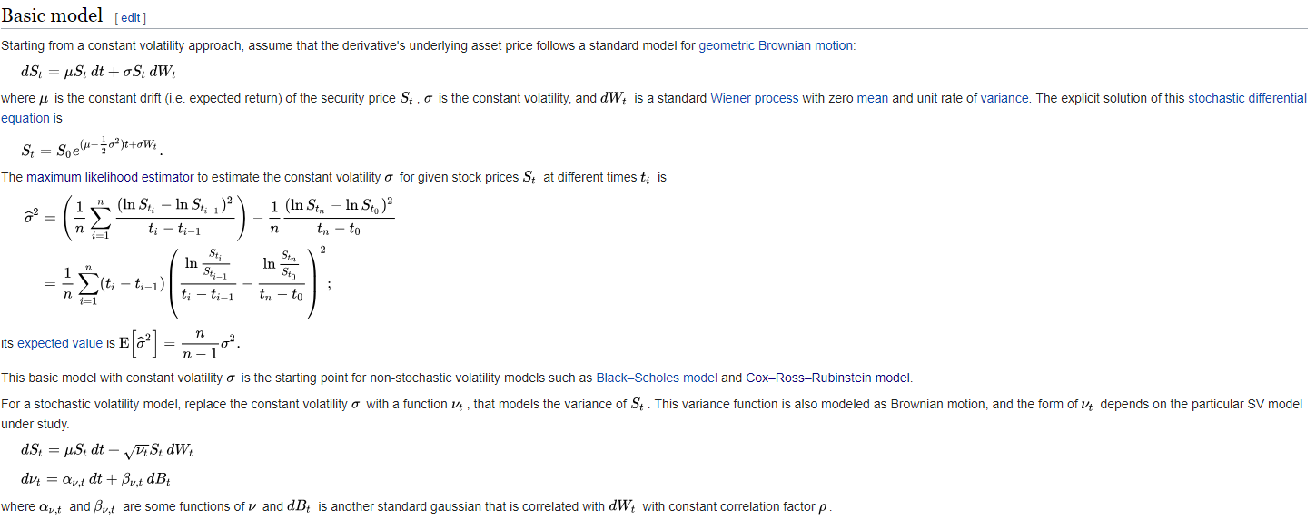

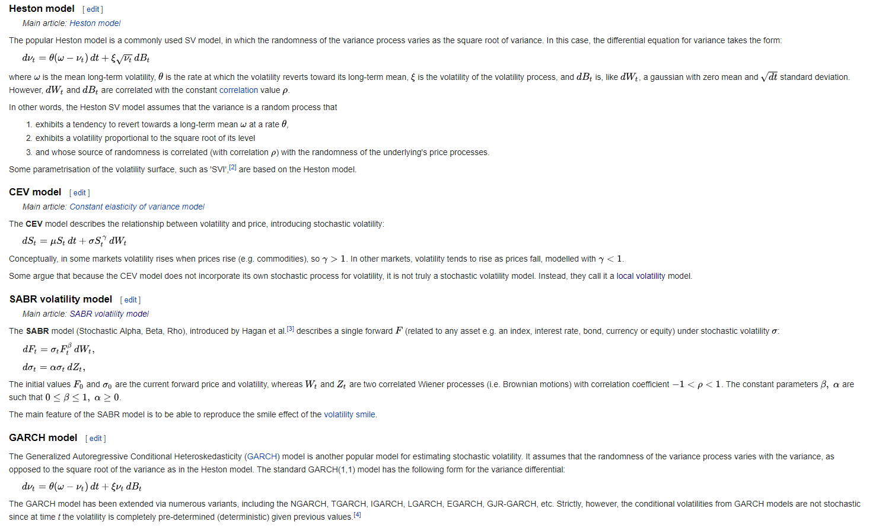

* When you calculate the partial derivative of the option price V w.r.t. σ, then you get a first order approximation of the change in V for a unit change in σ. A unit change is e.g. σ increasing from 0.2 (20%) to 1.2 (120%). If you want the vega for a one percentage point change in volatility, then divide by 100.
* The delta of an option is the percentage of the foreign notional one must buy when selling the option to hold a hedged position (equivalent to buying stock). For instance, a delta of 0.35 = 35% indicates buying 35% of the foreign notional to deltahedge a short option. In foreign exchange markets we distinguish the cases spot delta for a hedge in the spot market and forward delta for a hedge in the FX forward market. Furthermore, the standard delta is a quantity in percent of foreign currency. The actual hedge quantity must be changed if the premium is paid in foreign currency, which would be equivalent to paying for stock options in shares of stock. We call this type of delta the premium-adjusted delta. In the previous example the value of an option with a notional of 1,000,000 EUR was calculated as 73,669 EUR. Assuming a short position with a delta of 60% means, that buying 600,000 EUR is necessary to hedge. However the final hedge quantity will be 526,331 EUR which is the delta quantity reduced by the received premium in EUR. Consequently, the premium-adjusted delta would be 52.63%.
* 
 