A
PROJECT REPORT ON
ONLINE ADVERTISING AGENCY

Submitted to:

Nootan Polytechnic College,Visnagar.
Affiliated to
Gujarat Technological University, Ahmadabad.
Submitted by:
Patel Nisarg D. Enrollment No:- 086500307543
Soni Kunal D. Enrollment No:- 086500307558
Guide Details:
Internal: External:
1. Mr.Ghansham Shah. 1.______________
2. Mr.Chandresh Patel. 2.______________

INDEX
Sr. No | Contents | Page No:
1. | Preface | 3
2. | Acknowledgment | 4
3. | Project Profile | 5
4. | Feasibility Study | 7
5. | System Profile | 11
6. | Tools & Technology | 15
 | - Software Requirement
 | - Hardware Requirement
7. | System Design | 28
 | - Data Flow Diagram
 | - ER – Diagram
 | - Data Dictionary
 | - Form Design
8. | System Testing | 60
8. | Scope of our System | 63
7. | Future Implementation | 64
8. | Bibliography | 65

Preface

Computer is an inherent part of the life today. Virtually, in every walk of life, a person in expected to be able to use computers. The impact of computer technology in several aspect of accounting profession and practice has been pronounced over the last two decades in India.

Now, we are in hyper technology area. There are several revolutions in any field. We are got more and more machine support in any kind of work in the world. In the medical science we are more efficient equipments available having all more facility, so computerization becomes a powerful factor behind this technology. And we can do any work faster and time consumed all this process become very less than ancient area.

We are doing a project named “ONLINE ADVERTISING AGENCY” The project has maintained all types of information of the exam report information

Acknowledgment

It gives as a great pleasure and satisfaction in present in this report on our Project work as a part of partial fulfillment for the Diploma Computer in sincere gratitude to several people, it would have been impossible for us to carry out the desired work

We would like to express our sincere thanks to Mr. Ghanshyam R. Shah , Mr. Chandresh D. Patel and Mr. Mukesh P. Purani for their Guidance throughout the project. We would like to acknowledge the Staff a Online Advertising Agency for their co-operation and contributions that played an important role in the successful accomplishment of the Project.

We would like to express our heartfelt thanks to Mr. Parth G. Patel (H.O.D.) for their constant support and Encouragement during this phase and forgive us valuable suggestions time to time.

Last but not least we are thankful to our FAMILY members and Friends for their silent co-operation and passion, and to all others known and unknown person who helped us in this duration.

Project Profile

System information
System definition : Online Travels Reservation System

Type of the application : Web application

Time duration : January 2011 – May 2011

Internal system guide : Mr. Ghanshaym Shah
Mr. Chandresh Patel
Mr. Mukesh Purani

Submitted by : Jatin Khimani (086500307513)
Hardik Nakarani (086500307516)

Submitted to : Department of computer
Engineering,
Nootan polytechnic collage,(SSPC, 2nd shift)
Visnagar-384315

Introduction

The Online Advertising Agency is to automate all operation . generally it includes the order processing, Reservation management and Schedule management. before automating Reservation we have to understand the concept of Online Advertising Agency. Of any operation we make a system which do work automatically as the respective events occurs, for which it is meant. These are best examples of the management system.

Here we are try to developed such type of system is provide the automation on any type of Reservation. That means a Agency which has the type system which provide the facility to the User of the reserve for advertising in different media without any complexity.

For example any customer wants to register in listed newspaper from the system than first of all customer choose the day from/to he/she can see the more than one type of there and then he.

Feasibility Study
Time Feasibility Study

Depending on the results of the initial investigation the survey is now expanded to a more detailed feasibility study. “FEASIBILITY STUDY” is a test of system proposal according to its workability, impact of the organization, ability to meet needs and effective use of the resources. It focuses on these major questions:

1. What are the user’s demonstrable needs and how does a candidate system meet them?
2. What resources are available for given candidate system?
3. What are the likely impacts of the candidate system on the organization?
4. Whether it is worth to solve the problem?

During feasibility analysis for this project, following primary areas of interest are to be considered. Investigation and generating ideas about a new system does this.

Steps in feasibility analysis

Eight steps involved in the feasibility analysis are:
_ Form a project team and appoint a project leader.
_ Prepare system flowcharts.
_ Enumerate potential proposed system.
_ Define and identify characteristics of proposed system.
_ Determine and evaluate performance and cost effective of each proposed system.
_ Weight system performance and cost data.
_ Select the best-proposed system.
_ Prepare and report final project directive to management.

3.1) Technical feasibility

A study of resource availability that may affect the ability to achieve an acceptable system. This evaluation determines whether the technology needed for the proposed system is available or not.
• Can the work for the project be done with current equipment existing software technology & available personal?
• Can the system be upgraded if developed?
• If new technology is needed then what can be developed?

This is concerned with specifying equipment and software that will successfully satisfy the user requirement. The technical needs of the system may include:

Front-end and back-end selection

An important issue for the development of a project is the selection of suitable front-end and back-end. When we decided to develop the project we went through an extensive study to determine the most suitable platform that suits the needs of the organization as well as helps in development of the project. The aspects of our study included the following factors.

Front-end selection:

1. It must have a graphical user interface that assists employees that are not from IT background.
2. Scalability and extensibility.
3. Flexibility.
4. Robustness.
5. According to the organization requirement and the culture.
6. Must provide excellent reporting features with good printing support.
7. Platform independent.
8. Easy to debug and maintain.
9. Event driven programming facility.
10. Front end must support some popular back end like Ms Access..

Back-end Selection:

1. Multiple user support.
2. Efficient data handling.
3. Provide inherent features for security.
4. Efficient data retrieval and maintenance.
5. Stored procedures.
6. Popularity.
7. Operating System compatible.
8. Easy to install.
9. Various drivers must be available.
10. Easy to implant with the Front-end.

According to above stated features we selected Ms-Access as the backend.
The technical feasibility is frequently the most difficult area encountered at this stage. It is essential that the process of analysis and definition be conducted in parallel with an assessment to technical feasibility. It centers on the existing computer system (hardware, software etc.) and to what extent it can support the proposed system.

3.2) Economical feasibility

Economic justification is generally the “Bottom Line” consideration for most systems.
Economic justification includes a broad range of concerns that includes cost benefit analysis. In this we weight the cost and the benefits associated with the candidate system and if it suits the basic purpose of the organization i.e. profit making, the project is making to the analysis and design phase.
The financial and the economic questions during the preliminary investigation are verified to estimate the following:

• The cost to conduct a full system investigation.

• The cost of hardware and software for the class of application being considered.
• The benefits in the form of reduced cost.
• The proposed system will give the minute information, as a result the
performance is improved which in turn may be expected to provide increased profits.
• This feasibility checks whether the system can be developed with the available funds.

The Online Advertising Agency does not require enormous amount of money to be developed. This can be done economically if planned judicially, so it is economically feasible. The cost of project depends upon the number of man-hours required.

3.3) Operational Feasibility

It is mainly related to human organizations and political aspects. The points to be considered are:

• What changes will be brought with the system?
• What organization structures are disturbed?
• What new skills will be required? Do the existing staff members have
these skills? If not, can they be trained in due course of time?
The system is operationally feasible as it very easy for the End users to operate it. It only needs basic information about Windows platform.

3.4) Schedule feasibility

evaluation is the most important consideration in the development of project. The time schedule required for the developed of this project is very important since more development time effect machine time, cost and cause delay in the development of other systems. A reliable Online railway reservation can be developed in the considerable amount of time.

System Profile

- OVERVIEW :
- SCOPE OF SYSTEM:
- MODULES:
- MODULES AFTER LOGIN BY USER:
- MODULES AFTER LOGIN BY ADMINISTRATOR:

Overview

The system named as “Online Advertising Agency” is the website which deals with the online reservation of the advertisement.

ATS Advertising Agency provide s the best and latest reservation system all over the world and also the good journey of them.

It also provide the source a reservation facility for the admin.

ATS Advertising Agency also provide all type of reservation in which like as : online, newspaper etc..

ATS Advertising Agency also provide the general reservation in anu type of media.

Scope of System

Online Advertising Agency System is a system design for Reservation the advertisement.

The scope of the system definition the system on which the system works. The system has a wide but out of the scope system is not work.

The system is a made up of web application. But for web application computer must have window operating system and APACHE server and flash player installed to run this system. The user computer also requires drivers for the video.

This system is used by all type of users. Users can register online on this site.
All his detail can also see by them. He can see Schedule of travels.
In this website you can create your login.
Here u can show all advertisement Time -table.

Tools and Technology
The organizations in which all the works are done manually. During the study of existing system following Points are observed.
- As the current system is totally manual.
- Due to manually process is requires more time for completion of any work
- Existing system is manual. So it increases the chances of errors.
- Lot of time consumed for each report generation.
- More man Power is require and timely updating complicated.
- Immediate responses to the queries are difficult and time consuming.

Software and Hardware Requirement

- HARDWARE REQUIREMENT FOR DEVLOPEMENT:-
-> 256 MB of RAM
-> Pentium 4(2.40 GHz) processor
-> 40 GB HDD
- SOFTWARE REQUIREMENT FOR DEVLOPEMENT:-
->Microsoft visual studio 2008
-> Microsoft SQL server Express Edition
-> Platform support:
(i)Microsoft Windows XP or
(ii)Microsoft Windows Vista or
(iii)Microsoft Windows 7
- HARDWARE REQUIREMENT FOR CLIENTSIDE:-
-> 256 MB of RAM
-> Pentium 3(2.40 GHz) processor
-> 40 GB HDD
- SOFTWARE REQUIREMENT FOR CLIENTSIDE:-
->.NET framework 3.5
-> Platform support:
(i)Microsoft Windows XP or Vista or 7
Modules

The different types of modules of this site are as follows:
- Reservation modules:

This modules gives a reservation from to the registration. In this module which ever user wants to reserve seat from this site.

- Modules after reservation by user:

- Personal information

In this module, personal information is arranged in a place and user can access the information .

In the search box, in the case we put the information of the personal related to the particular organization and any one can retrieve the information from this module, just like the various offices web site.

- Modules after login by administrator:

- Administrator:

Administrator controls all the details of the project. In other words it controls over all working of the project.

- Personal information:

This module stores the personal information of the person and facilitate the user that he can access the details. In this module entry editing and deletion of the new and old details can be done be only by the admin.

- Security module:

This module handles the security of software. it checks for unauthorized login/accesses ,unauthorized deletion/editing , defining the access permissions to users, etc.

- Reporting modules:

This modules handles the process of all types of reports generation. By this module the user/admin can got the print of the user desired queries like for personal information, cricket, tourism, movies and books.

These reports are very beneficial for both user and the admin.

Roles and Responsibility

We can classify site users in to main three categories.
- administrator
- authorized user
- unauthorized user

Administrator:
Admin has the main functionality. He has all rights. In the system authorized user can see their own profile. Admin has also responsibility of managing the reservation order which is given by the user. He has to check that if payment and order not delivered that if payment received and order not delivered than get information on about that order and delivered tickets and the change the status of seat.
Authorized user:
In the system authorized users can see their own profile. he can update detail. he can see travels detail and also update his own detail.
Than he can continue with shopping and his shopping is finished that he can checked out and can select different payment method and at last he can checkout.
Unauthorized user:
In the system unauthorized users can only see the regular news, details
and many more. But he can register as new user in the shop by filling required details.

Risk Analysis

Risk analysis is the important aspect of the system planning, whenever planning the website, programmer always has to consider the risks of the systems which he might face in the future during designing the website.
Risks are of two types
- Proactive Risk.
- Reactive Risk.

Risk identification
During the system plan we have consider all the proactive which we have think we will face during the system period. Here I have listed the risks which we have considered during the system plan:
Possibility that the components are not available during the system period.

- Possibility that products purchased was not compatible.

- Possibility that the hardware resources are not available during the system period.

- Possibility that any module of software get corrupted.

- Possibility that website inter-compatibility may not be there.

Risk impact

Proactive risk assessment table

This are the proactive risks which we can consider during the system plan period so we can cop up with them and we can find the solution easily but we can find other proactive risks which we haven’t considered in the system plan:

Table:
Risk | Risk Management
Possibility of getting illness. | We will provide some more time to prepare the software
Possibility of the components is not available. | We will check for other components.
Possibility of components not effective. | We will manage for the new components of that kind.

Reactive Risk Assessment Table

Proactive risks are most dangerous risks which we haven’t considered during the system period and to cop u with them is not easy. These kinds of risks are risks, so programmer must have been active to cop up with them smartly.

Risk Management

After estimating all the risks and risk effects, we will look how to manage this kind of risks:

With the kind of proactive risks we will prepare the plan for how to manage these risks, we will think about their options, if their kinds of risks are facing and if they are reactive risks we have to manage them on the spot to avoid their dangerous effects:

Process Model

To solve actual problems in systems developing, a system developer or a team of developers must incorporate a development strategy that encompasses the process, methods and tools layers. This strategy is referred to as a process model. A website process model is chosen based on the mature of the system and application, the methods and tools to be used, and the controls and the controls and delivers those are required.

Incremental Model

This website is based on incremental software process model.
The incremental model combines elements of the linear sequential model with the iterative philosophy of prototyping. The incremental model applies linear sequences in a staged fashion as calendar time progresses.

The plan addresses the modification of the core product to better meet the needs of the customer and the delivery of additional features and functionalities. But unlike prototyping, the incremental model focuses on the delivery of an operational product with each increment. Early increments are stripped down versions of final product.

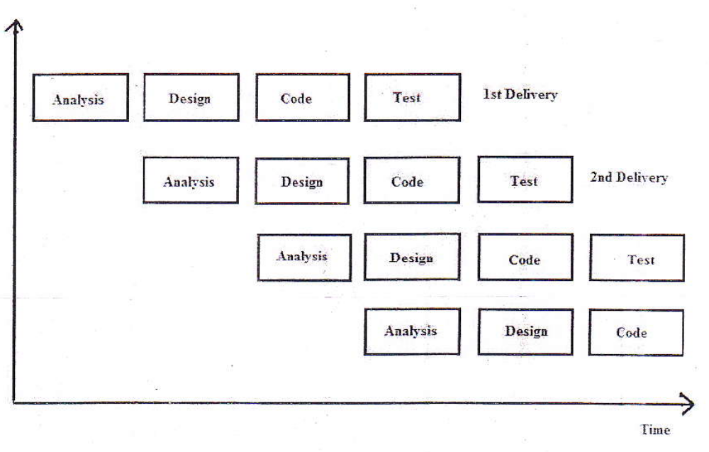
Each linear sequence produces a deliverable “increment” of the software. It should be noted that the process flow for any increment could incorporate the prototyping paradigm.

When an incremental model is used, the first increment is often a core product. That is, basic requirements are addressed, but many supplementary features remain undelivered. The core product is used by the student. As a result of use and/or evaluation, a plan is developed for next increment. The plan addresses the modification of the core product to better meet the needs of the customer and the delivery of additional features and functionalities. This process is repeated following the delivery of each increment, until the complete product is produced.

The Incremental process model, like prototyping and other evolution approaches, is iterative in nature. But unlike prototyping, the incremental model focuses on the delivery of an operational product with each increment. Early increments are stripped down versions of final product, but they do provide capability that serves the user and also provide a platform for evaluation by the user.

The reason for choosing it as process model for this system is that, since all the requirements are available at initial stage we can rely on this model for further step by step implementations and also the system includes leveling. Therefore, after the complete implementations of first level, we can go for the next easily using this model.


SYSTEM DESIGN


SYSTEM FLOW DIAGRAM

SYSTEM FLOW FOR ADMIN

START

User ID/Password for LOGIN

VALID
NO

YES
Activate Registration

A

A

Update User

Update AD

Update Price

END

SYSTEM FLOW FOR User/Client
START

Registered

NO

YES
User ID/Password for LOGIN
Valid
B
Registration
Active Registration

B

Update Information

Apply for Advertisement
END
Context Level Diagram

Online Advertising Agency
View Details View Details
ADMIN
User/Client

Update ad update user, info, advertisement

First Level DFD For Admin

Give ID and Password
UID and password

Acknowledgement
Login
1.0 LOGIN
Admin_master
Info User Detail
User_master
status

Update profile

Profile Details

View Details
2.0 User Activation
3.0 Update Profile
4.0 Report
ADMIN
Admin_master

First Level DFD for User/Client
1.0 Registration
User/Client
Registration
Reg. info Reg. info

2.0 Login
Reg. info
UID and Password Info

3.0 Update Profile

Profile Info

View Details
4.0 Report

E-R Diagram

User Name
Password

AR
ADMIN
1 M
User Id
Update Details
Registration
1

User Name
M
E-mail
Password
AU
User ID

Password
User

User Id
User name

SYSTEM TESTING

- Testing Principles
- Modules Of Testing
- Test Strategy
- Test Cases

Testing Principles

- Testing is a process of executing a program with the intent of finding an error.
- A good test case is one that has a high probability of finding an as yet undiscovered error.
- A successful test s one that uncovered error.

Principal #1:- All tests should be traceable to student requirements.

Principal #2:- Tested should be planned long before testing begins.

Principal #3:- The pare to principal applied to website testing.

Principal #4:- Testing should begin in the small and progress toward testing in large.

Principal #5:- Exhaustive testing is not possible.

Module of Testing

Analyze and check system representation such as the requirement document, design diagram and the program source code. They may be applied at all stages of the process

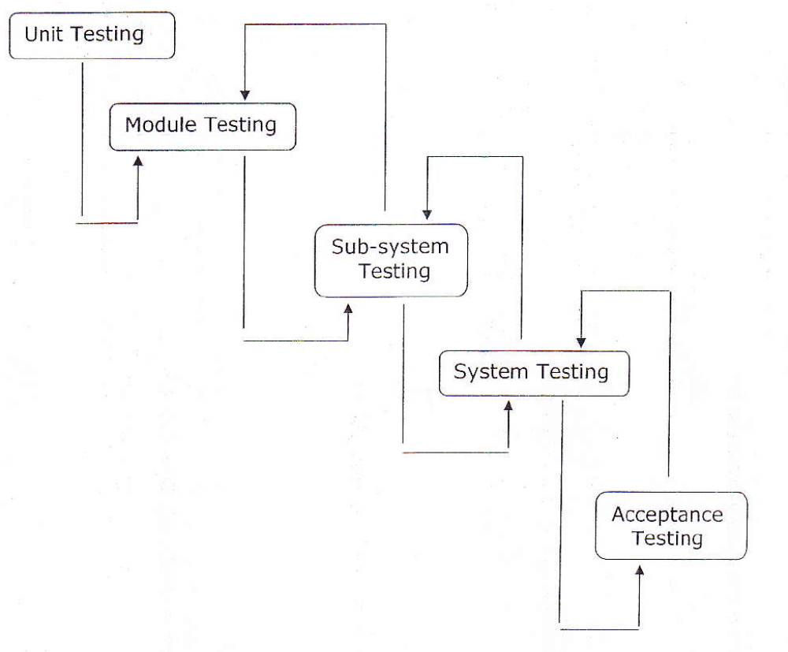

There are different Modules of testing. On the basis of testing methods there are two types of testing:

- White-box testing.
- Black-box testing.

1). WHITE-BOX TESTING

White-box testing sometimes called Glass-Box Testing, is a test case design methods that users the control structure of the procedural design to drive the test case.

- Logical errors and incorrect assumption are inversely proportional to the probability that a program will be executed. Errors tend to creep into our work we design and implement function; condition that is out of the mainstream tends to be well understood.

- We often believe that a logical path is not likely to be executed when in fact it may be executed on a regular basis. The logical flow of a program times counter intuitive.

2).BLACK-BOX TESTING:

For our system periodically we have tested our website using black-box testing. Thinking as a client we have evaluated the website for its easy going and convenience.

- Unit testing:

During the programming stages each and every form, modules and class treated unit has been put into the test data. Every module is tested independently. The steps are follows.

- Manually code is tested like spelling checkes, logics and errors.

- Once the manual checking is over the complication has been done. Syntactical errors if any have to be corrected.

- After the clean completion the program, some dummy data, as specification, has been used for testing of the module to see if it works as specified.

- Integration testing:

After the individual’s modules were tested out we go the integrated to create a complete system. This integration process involves building the system and testing the resultant system for problems that arise from component interaction.

- Performance testing

Performance testing is designed to test the runtime performance of the system within the system context of the system. These tests were performed as module level as well as system level. Individual modules were tested for required performance.

- Condition testing:

Performance testing is the test case design method that exercises the logical conditions.

- Interface testing:

Interface sting is integral part of integration. We examined the code to be tested and explicitly list each call to an external component. Performance testing is the test case design method that exercises the logical conditions. int the system standards tests for GUIs have been performed, which are as follows:

- The position and related for all controls were checked.

- Validations for all inputs were done.

- Pull down controls was verified for proper functionality.

- Whether the non-editable text controls disabling and it was also verified that it doesn’t exceed the maximum allowed length.

Testing Strategy

Unit Testing:

Unit testing focuses verification effort on the smallest unit of software design – the software component or module. Using the component level design description as a guide, important control paths are tested to uncover errors within the boundary of the module. The unit test focuses on the internal processing logic and data structures within the boundaries of the component.

Integration testing:

Integration testing is a systematic technique for constructing the website architecture while at the same conducting test to uncover errors associated with interfacing. During the programming stages each and every form, modules and class treated unit has been put into the test data. The objective is to take unit tested components and a program structure that has been dictated by design.

Context Level Diagram

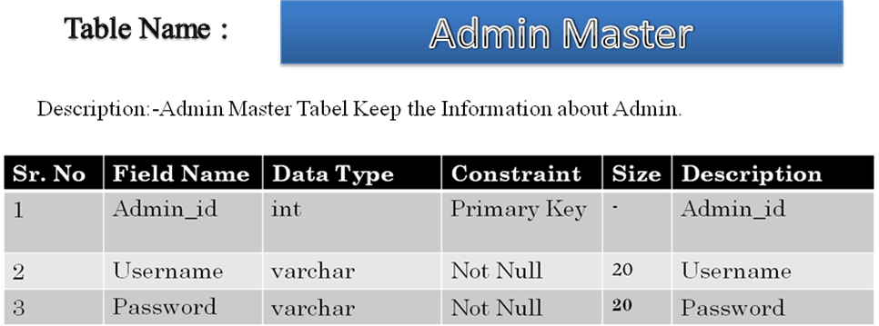

LOGIN

Log In
Sr. NO | FIELD NAME | Data Type | Constraint | Description
1 | U_id | Int | Primary Key | User ID
2 | User Name | Varchar | Not Null | User Name
3 | Password | Varchar | Not Null | Password

Sr. no | Field Name | Data Type | Constraint | Description
1 | C_id | Int | Primary Key |  | Id
2 | User_name | Varchar | Not Null | User Name
3 | Pass_word | Varchar | Not null | Pass Word
4 | Name | Varchar | Not Null | Name
5 | Address | Varchar | Not Null | Address
6 | Pin_code | Varchar | Not Null | Pin Code
7 | Mobile_no | Numeric | Not Null | Mobile no.

Resume
Registration

Sr. No | Field Name | Data Type | Constraint | Description
1 | Resume_id | Int | Primary Key | Id
2 | First_name | Varchar | Not Null | First Name
3 | Middle Name | Varchar | Not Null | Middle name
4 | Last_name | Varchar | Not Null | Last Name
5 | Gender | Varchar | Not Null | Gender
6 | Birth_date | Datetime | Not Null | Birth Date
7 | Home_town | Varchar | Not Null | Home Town
8 | City | Varchar | Not Null | City
9 | State | Varchar | Not Null | State
10 | Contact_no | Int | Not Null | Contact no
11 | Email_id | Varchar | Not Null | Email ID

Television Master

Sr No. | Field Name | Data Type | Constraint | Description
1 | C_id | Int | Primary key | Customer ID
2 | Dfrom | Datetime | Not Null | Date from
3 | Dto | Datetime | Not Null | Date To
4 | Ad_size | Text | Not Null | Ad size
5 | Price | Int | Not Null | Price
6 | Upload_file | Text | Not Null | Upload file

Internet Master

Sr No. | Field Name | Data Type | Constraint | Description
1 | C_id | Int | Primary key | Customer ID
2 | Dfrom | Datetime | Not Null | Date from
3 | Dto | Datetime | Not Null | Date To
4 | Ad_size | Text | Not Null | Ad size
5 | Price | Int | Not Null | Price
6 | Upload_file | Text | Not Null | Upload file

Magazine Master

Sr No. | Field Name | Data Type | Constraint | Description
1 | C_id | Int | Primary key | Customer ID
2 | Dfrom | Datetime | Not Null | Date from
3 | Dto | Datetime | Not Null | Date To
4 | Ad_size | Text | Not Null | Ad size
5 | Price | Int | Not Null | Price
6 | Upload_file | Text | Not Null | Upload file



FORM LAYOUT

Home Page

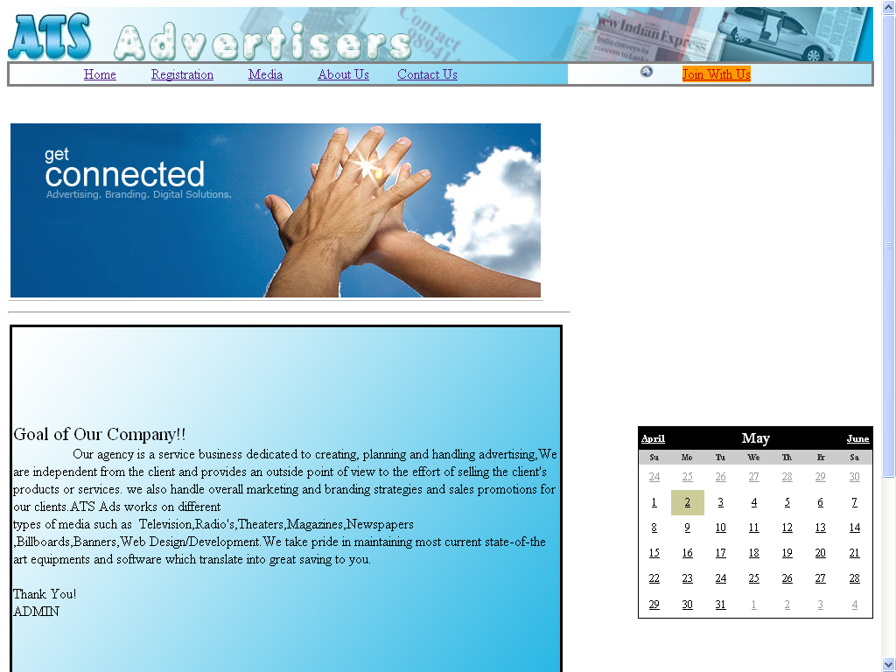

Registration Page

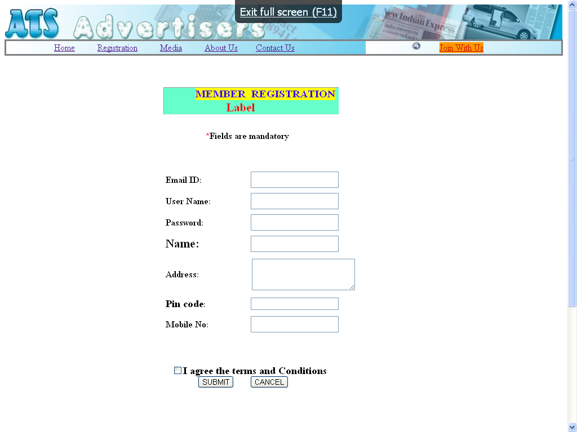

About Us Page

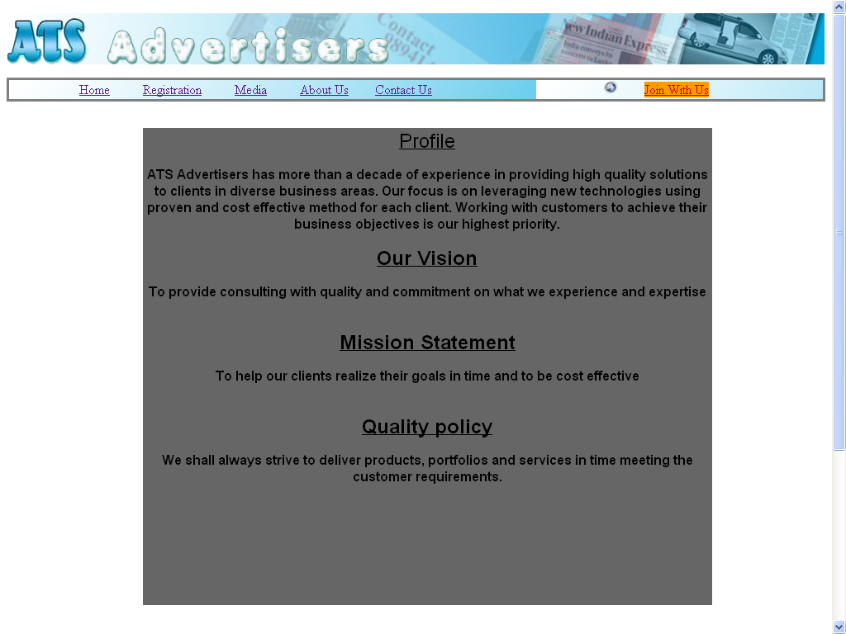

Magazine Master

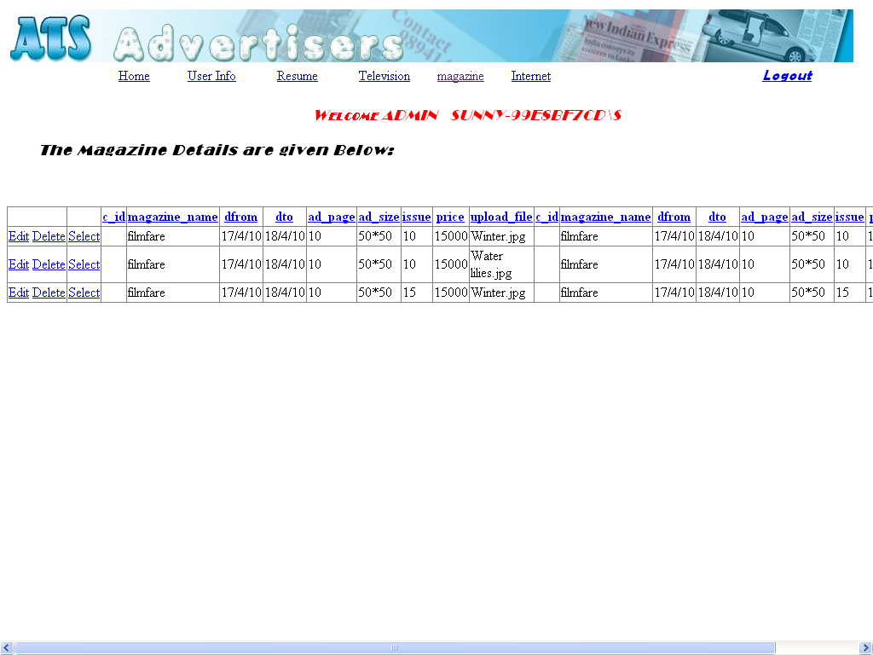

Media Selection
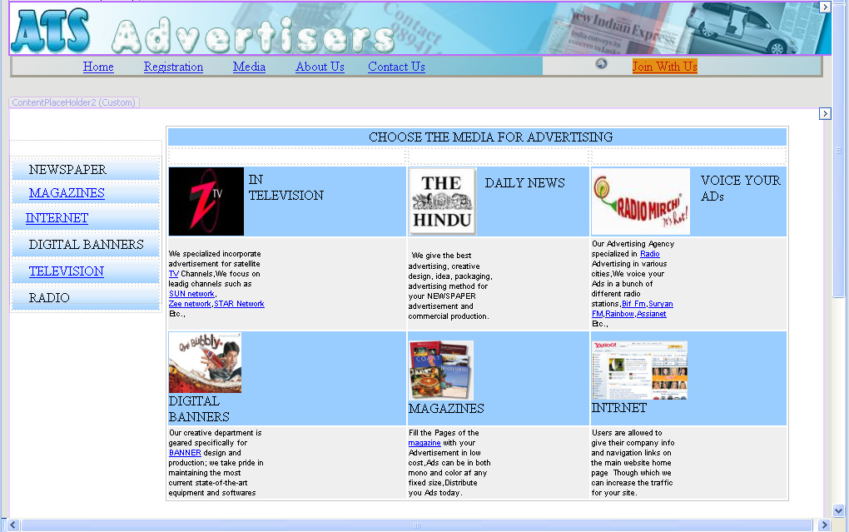

Resume Detail

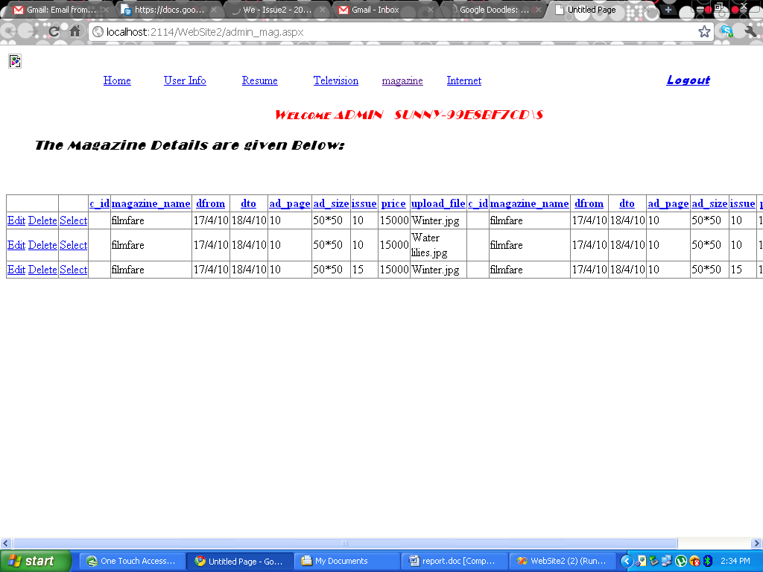

Contact Us

