NAME: TEJAS NALAWADE PRACTICAL NO: 7 ROLL NO: TCOD01

Assignment Title: Implementation of concept called Paging, using simulation.
Problem Statement: Write a Java Program (using OOP features) to implement paging simulation using
1. Least Recently Used (LRU)
2. Optimal algorithm.

CODE:

FIFO

import java.io.*;
public class FIFO {
public static void main(String[] args) throws IOException {
BufferedReader br = new BufferedReader(new InputStreamReader(System.in));
int frames, pointer = 0, hit = 0, fault = 0, ref_len;
int buffer[];
int reference[];
int mem_layout[][];

System.out.println("Enter the Number of Frames: ");
frames = Integer.parseInt(br.readLine());

System.out.println("Enter the Length of Reference String: ");
ref_len = Integer.parseInt(br.readLine());

reference = new int[ref_len];
mem_layout = new int[ref_len][frames];
buffer = new int[frames];

for (int j = 0; j < frames; j++)
buffer[j] = -1;

System.out.println("Please enter the reference string: ");
for (int i = 0; i < ref_len; i++) {
reference[i] = Integer.parseInt(br.readLine());
int search = -1;

for (int j = 0; j < frames; j++) {
if (buffer[j] == reference[i]) {
search = j;
hit++;
break;
}
}

if (search == -1) {
buffer[pointer] = reference[i];
fault++;
pointer++;
if (pointer == frames)
pointer = 0;
}

for (int j = 0; j < frames; j++) {
mem_layout[i][j] = buffer[j];
}
}

System.out.println("\nMemory Layout:");
for (int i = 0; i < frames; i++) {
for (int j = 0; j < ref_len; j++) {
System.out.printf("%3d ", mem_layout[j][i]);
}
System.out.println();
}

System.out.println("\nThe number of Hits: " + hit);
System.out.println("Hit Ratio: " + (float) hit / ref_len);
System.out.println("The number of Faults: " + fault);
}
}

LRU

import java.io.*;

public class LRU {
public static void main(String[] args) throws IOException {
BufferedReader br = new BufferedReader(new InputStreamReader(System.in));

int frames, hit = 0, fault = 0, ref_len;
int buffer[];
int reference[];
int mem_layout[][];
int counter[];

System.out.print("Enter the Number of Frames: ");
frames = Integer.parseInt(br.readLine());

System.out.print("Enter the Length of Reference String: ");
ref_len = Integer.parseInt(br.readLine());

reference = new int[ref_len];
mem_layout = new int[ref_len][frames];
buffer = new int[frames];
counter = new int[frames];

for (int j = 0; j < frames; j++) {
buffer[j] = -1;
counter[j] = 0;
}

System.out.println("Please enter the reference string: ");
for (int i = 0; i < ref_len; i++) {
reference[i] = Integer.parseInt(br.readLine());
int search = -1;
for (int j = 0; j < frames; j++) {
if (buffer[j] == reference[i]) {
search = j;
hit++;
counter[j] = i + 1;
break;
}
}
if (search == -1) {
int min = 0;
for (int j = 1; j < frames; j++) {
if (counter[j] < counter[min]) {
min = j;
}
}
buffer[min] = reference[i];
counter[min] = i + 1;
fault++;
}

for (int j = 0; j < frames; j++) {
mem_layout[i][j] = buffer[j];
}
}
System.out.println("\nMemory Layout:");
for (int i = 0; i < frames; i++) {
for (int j = 0; j < ref_len; j++) {
System.out.printf("%3d ", mem_layout[j][i]);
}
System.out.println();
}
System.out.println("\nThe number of Hits: " + hit);
System.out.println("Hit Ratio: " + (float) hit / ref_len);
System.out.println("The number of Faults: " + fault);
}
}

OPTIMAL

import java.io.*;

public class Optimal {
public static void main(String[] args) throws IOException {
BufferedReader br = new BufferedReader(new InputStreamReader(System.in));

int frames, hit = 0, fault = 0, ref_len;
int buffer[];
int reference[];
int mem_layout[][];

System.out.print("Enter the Number of Frames: ");
frames = Integer.parseInt(br.readLine());

System.out.print("Enter the Length of Reference String: ");
ref_len = Integer.parseInt(br.readLine());

reference = new int[ref_len];
mem_layout = new int[ref_len][frames];
buffer = new int[frames];

for (int j = 0; j < frames; j++)
buffer[j] = -1;

System.out.println("Please enter the reference string: ");
for (int i = 0; i < ref_len; i++) {
reference[i] = Integer.parseInt(br.readLine());
int search = -1;
for (int j = 0; j < frames; j++) {
if (buffer[j] == reference[i]) {
search = j;
hit++;
break;
}
}

if (search == -1) {
int pos = -1, farthest = i;
for (int j = 0; j < frames; j++) {
int next_use = -1;
for (int k = i + 1; k < ref_len; k++) {
if (buffer[j] == reference[k]) {
next_use = k;
break;
}
}
if (next_use == -1) {
pos = j;
break;
}
if (next_use > farthest) {
farthest = next_use;
pos = j;
}
}
buffer[pos] = reference[i];
fault++;
}

for (int j = 0; j < frames; j++) {
mem_layout[i][j] = buffer[j];
}
}

System.out.println("\nMemory Layout:");
for (int i = 0; i < frames; i++) {
for (int j = 0; j < ref_len; j++) {
System.out.printf("%3d ", mem_layout[j][i]);
}
System.out.println();
}

System.out.println("\nThe number of Hits: " + hit);
System.out.println("Hit Ratio: " + (float) hit / ref_len);
System.out.println("The number of Faults: " + fault);
}
}

OUTPUT:

FIFO
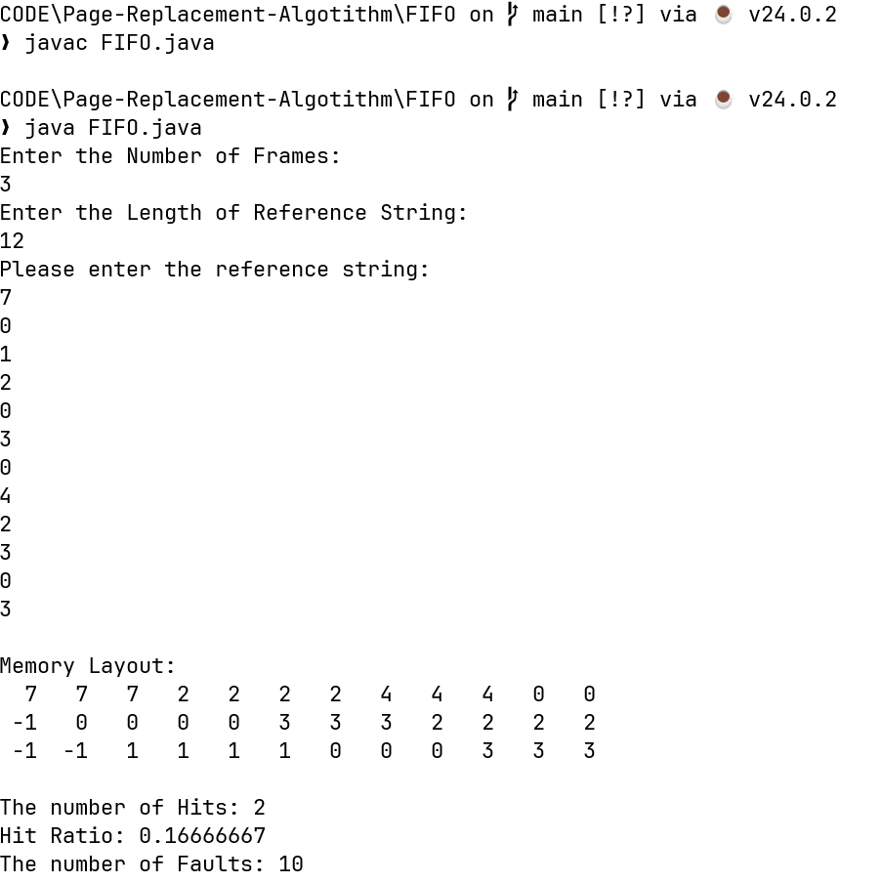

LRU
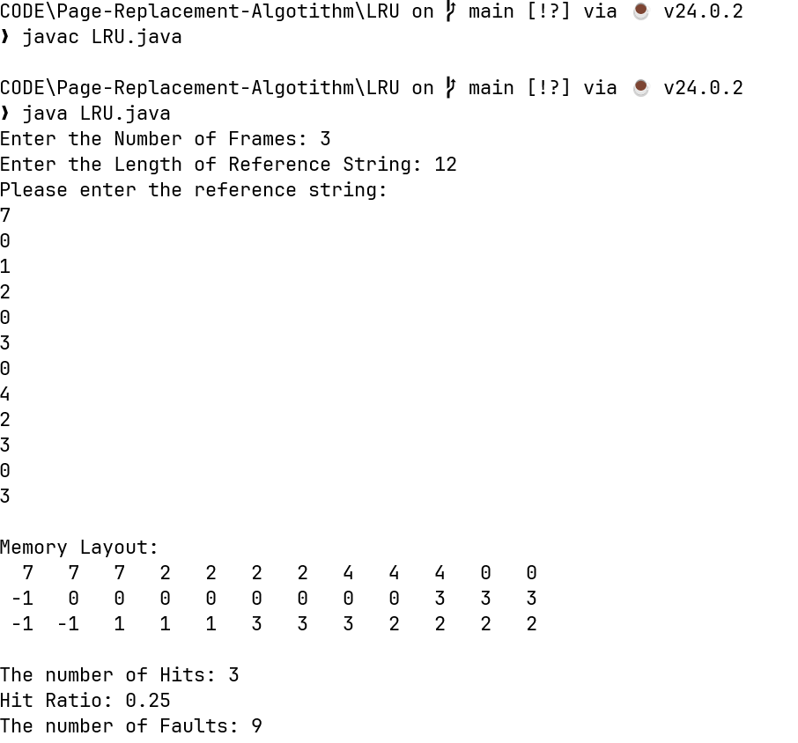

OPTIMAL

