NAME: TEJAS NALAWADE PRACTICAL NO: 8 ROLL NO: TCOD01

Assignment Title: Implement a program to simulate Memory placement strategies – best fit, first fit, next fit and worst fit.
Problem Statement: Write a program to simulate Memory placement strategies – best fit, first fit, next fit and worst fit.

CODE:

First Fit

import java.util.Scanner;
public class FirstFit {
public static void firstFit(int blockSize[], int m, int processSize[], int n, int allocation[]) {
for (int i = 0; i < n; i++) {
allocation[i] = -1;
}
for (int i = 0; i < n; i++) {

for (int j = 0; j < m; j++) {
if (blockSize[j] >= processSize[i]) {
allocation[i] = j;
blockSize[j] -= processSize[i];
break;
}
}
}
}

public static void main(String[] args) {
Scanner sc = new Scanner(System.in);
System.out.print("Enter number of memory blocks: ");
int m = sc.nextInt();
int[] blockSize = new int[m];
int totalMemory = 0;

System.out.println("Enter size of each memory block: ");
for (int i = 0; i < m; i++) {
int size = sc.nextInt();
blockSize[i] = size;
totalMemory += size;
}
System.out.print("Enter number of processes: ");
int n = sc.nextInt();
int[] processSize = new int[n];
int[] allocation = new int[n];

for (int i = 0; i < n; i++) {
System.out.print("Enter size of process " + (i + 1) + ": ");
processSize[i] = sc.nextInt();
}
firstFit(blockSize, m, processSize, n, allocation);

System.out.println("\n--- First Fit Allocation Results ---");
System.out.println("Process No.\tProcess Size\tBlock No.");

int usedMemory = 0;
for (int i = 0; i < n; i++) {
System.out.print(" " + (i + 1) + "\t\t" + processSize[i] + "\t\t");
if (allocation[i] != -1) {
System.out.println(allocation[i] + 1);
usedMemory += processSize[i];
} else {
System.out.println("Not Allocated");
}
}
int totalFragmentation = totalMemory - usedMemory;
double memoryUsage = (totalMemory > 0) ? ((double) usedMemory / totalMemory) * 100 : 0.0;
System.out.println("\nTotal Initial Memory: " + totalMemory);
System.out.println("Total Allocated Memory: " + usedMemory);
System.out.println("Total Fragmentation: " + totalFragmentation);
System.out.printf("Memory Usage: %.2f%%\n", memoryUsage);

sc.close();
}
}

Best Fit

import java.util.Scanner;

public class BestFit {
public static void bestFit(int blockSize[], int m, int processSize[], int n, int allocation[]) {
for (int i = 0; i < n; i++) {
allocation[i] = -1;
}

for (int i = 0; i < n; i++) {
int bestIdx = -1;

for (int j = 0; j < m; j++) {
if (blockSize[j] >= processSize[i]) {
if (bestIdx == -1 || blockSize[j] < blockSize[bestIdx]) {
bestIdx = j;
}
}
}

if (bestIdx != -1) {
allocation[i] = bestIdx;
blockSize[bestIdx] -= processSize[i];
}
}
}

public static void main(String[] args) {
Scanner sc = new Scanner(System.in);

System.out.print("Enter number of memory blocks: ");
int m = sc.nextInt();
int[] initialBlockSize = new int[m];
int[] blockSize = new int[m];
int totalMemory = 0;

System.out.println("Enter size of each memory block: ");
for (int i = 0; i < m; i++) {
int size = sc.nextInt();
initialBlockSize[i] = size;
blockSize[i] = size;
totalMemory += size;
}

System.out.print("Enter number of processes: ");
int n = sc.nextInt();
int[] processSize = new int[n];
int[] allocation = new int[n];

for (int i = 0; i < n; i++) {
System.out.print("Enter size of process " + (i + 1) + ": ");
processSize[i] = sc.nextInt();
}

bestFit(blockSize, m, processSize, n, allocation);

System.out.println("\n--- Best Fit Allocation Results ---");
System.out.println("Process No.\tProcess Size\tBlock No.");

int usedMemory = 0;
for (int i = 0; i < n; i++) {
System.out.print(" " + (i + 1) + "\t\t" + processSize[i] + "\t\t");
if (allocation[i] != -1) {
System.out.println(allocation[i] + 1);
usedMemory += processSize[i];
} else {
System.out.println("Not Allocated");
}
}

int totalFragmentation = totalMemory - usedMemory;
double memoryUsage = (totalMemory > 0) ? ((double) usedMemory / totalMemory) * 100 : 0.0;

System.out.println("\nTotal Initial Memory: " + totalMemory);
System.out.println("Total Allocated Memory: " + usedMemory);
System.out.println("Total Fragmentation: " + totalFragmentation);
System.out.printf("Memory Usage: %.2f%%\n", memoryUsage);

sc.close();
}
}

Worst Fit

import java.util.Scanner;

public class WorstFit {
public static void worstFit(int blockSize[], int m, int processSize[], int n, int allocation[]) {
for (int i = 0; i < n; i++) {
allocation[i] = -1;
}

for (int i = 0; i < n; i++) {
int worstIdx = -1;

for (int j = 0; j < m; j++) {
if (blockSize[j] >= processSize[i]) {
if (worstIdx == -1 || blockSize[j] > blockSize[worstIdx]) {
worstIdx = j;
}
}
}

if (worstIdx != -1) {
allocation[i] = worstIdx;
blockSize[worstIdx] -= processSize[i];
}
}
}

public static void main(String[] args) {
Scanner sc = new Scanner(System.in);

System.out.print("Enter number of memory blocks: ");
int m = sc.nextInt();
int[] blockSize = new int[m];
int totalMemory = 0;

System.out.println("Enter size of each memory block: ");
for (int i = 0; i < m; i++) {
int size = sc.nextInt();
blockSize[i] = size;
totalMemory += size;
}

System.out.print("Enter number of processes: ");
int n = sc.nextInt();
int[] processSize = new int[n];
int[] allocation = new int[n];

for (int i = 0; i < n; i++) {
System.out.print("Enter size of process " + (i + 1) + ": ");
processSize[i] = sc.nextInt();
}

worstFit(blockSize, m, processSize, n, allocation);

System.out.println("\n--- Worst Fit Allocation Results ---");
System.out.println("Process No.\tProcess Size\tBlock No.");

int usedMemory = 0;
for (int i = 0; i < n; i++) {
System.out.print(" " + (i + 1) + "\t\t" + processSize[i] + "\t\t");
if (allocation[i] != -1) {
System.out.println(allocation[i] + 1);
usedMemory += processSize[i];
} else {
System.out.println("Not Allocated");
}
}
int totalFragmentation = totalMemory - usedMemory;
double memoryUsage = (totalMemory > 0) ? ((double) usedMemory / totalMemory) * 100 : 0.0;

System.out.println("\nTotal Initial Memory: " + totalMemory);
System.out.println("Total Allocated Memory: " + usedMemory);
System.out.println("Total Fragmentation : " + totalFragmentation);
System.out.printf("Memory Usage: %.2f%%\n", memoryUsage);

sc.close();
}
}

Next Fit

import java.util.Scanner;

public class NextFit {
public static void nextFit(int blockSize[], int m, int processSize[], int n, int allocation[]) {
int lastAllocatedIndex = 0;
for (int i = 0; i < n; i++) {
allocation[i] = -1;
}
for (int i = 0; i < n; i++) {
int count = 0;
boolean allocated = false;

int j = lastAllocatedIndex;

while (count < m) {
if (blockSize[j] >= processSize[i]) {
allocation[i] = j;
blockSize[j] -= processSize[i];
lastAllocatedIndex = j;
allocated = true;
break;
}

j = (j + 1) % m;
count++;
}

if (!allocated) {
allocation[i] = -1;
}
}
}

public static void main(String[] args) {
Scanner sc = new Scanner(System.in);
System.out.print("Enter number of memory blocks: ");
int m = sc.nextInt();
int[] blockSize = new int[m];
int totalMemory = 0;

System.out.println("Enter size of each memory block: ");
for (int i = 0; i < m; i++) {
int size = sc.nextInt();
blockSize[i] = size;
totalMemory += size;
}
System.out.print("Enter number of processes: ");
int n = sc.nextInt();
int[] processSize = new int[n];
int[] allocation = new int[n];

for (int i = 0; i < n; i++) {
System.out.print("Enter size of process " + (i + 1) + ": ");
processSize[i] = sc.nextInt();
}
nextFit(blockSize, m, processSize, n, allocation);
System.out.println("\n--- Next Fit Allocation Results ---");
System.out.println("Process No.\tProcess Size\tBlock No.");

int usedMemory = 0;
for (int i = 0; i < n; i++) {
System.out.print(" " + (i + 1) + "\t\t" + processSize[i] + "\t\t");
if (allocation[i] != -1) {
System.out.println(allocation[i] + 1);
usedMemory += processSize[i];
} else {
System.out.println("Not Allocated");
}
}

int totalFragmentation = totalMemory - usedMemory;
double memoryUsage = (totalMemory > 0) ? ((double) usedMemory / totalMemory) * 100 : 0.0;

System.out.println("\nTotal Initial Memory: " + totalMemory);
System.out.println("Total Allocated Memory: " + usedMemory);
System.out.println("Total Fragmentation: " + totalFragmentation);
System.out.printf("Memory Usage: %.2f%%\n", memoryUsage);

sc.close();
}
}

OUTPUT:

First Fit
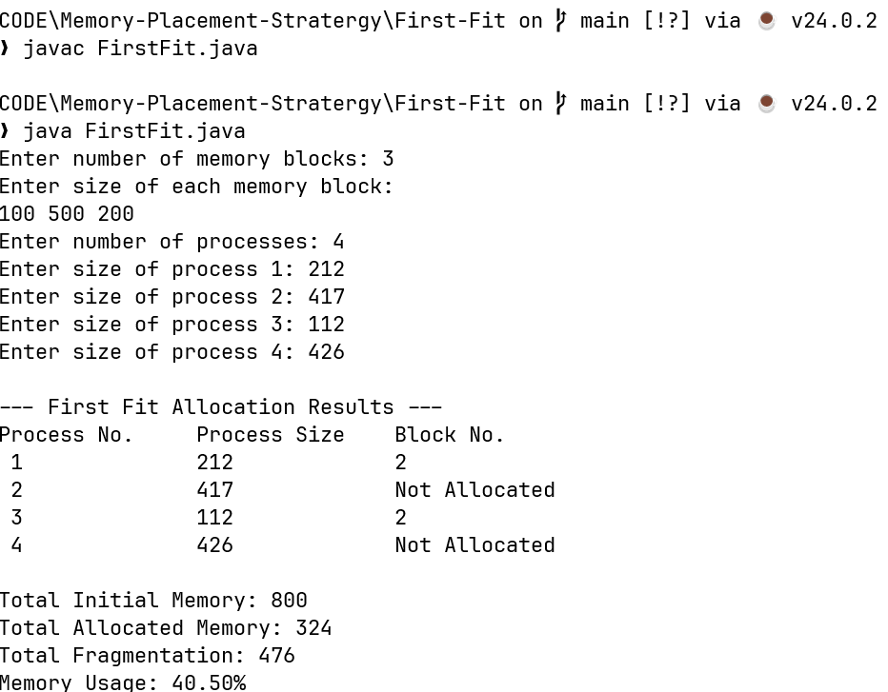

Best Fit

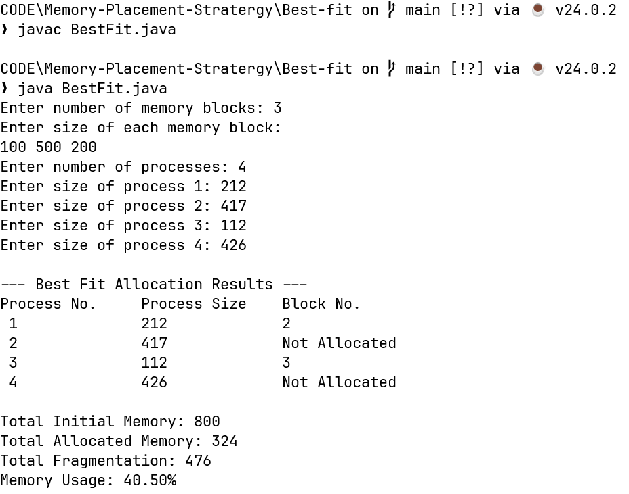

Worst Fit

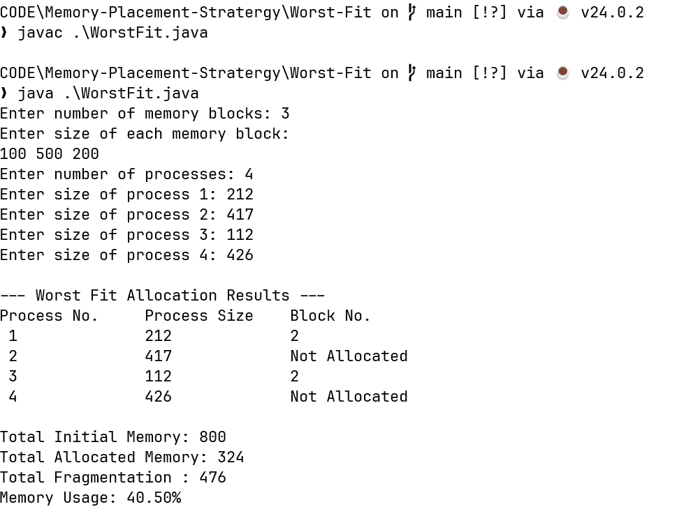

Next fit

