**Next Gen Hub Assessment**

**Introduction 2**

**Prerequisite 2**

**Procedure 2**

**Common Troubleshooting 3**

# **Introduction**

* Purpose: We need to create a web application, host it on Kubernetes, and use Traefik Proxy and Helm Chart for deployment.

# **Prerequisite**

* Tools and Resources:
  + Azure Cloud Account
  + Azure AKS Service
  + Azure ACR Service
  + Java on Local System
  + STS (Spring Tool Suite)
  + Docker
  + Helm
  + Traefik
  + GitHub

# **Procedure**

1. First, we created an Azure account.
2. We set up an AKS cluster named "testing" in Azure.
3. Created a Spring Boot project to run a "Hello World" application.
4. Used Maven to build the Spring Boot project:
   1. **mvn clean package -DskipTests -X**
5. Created a Dockerfile to run the Java application in a container.
   * 1. 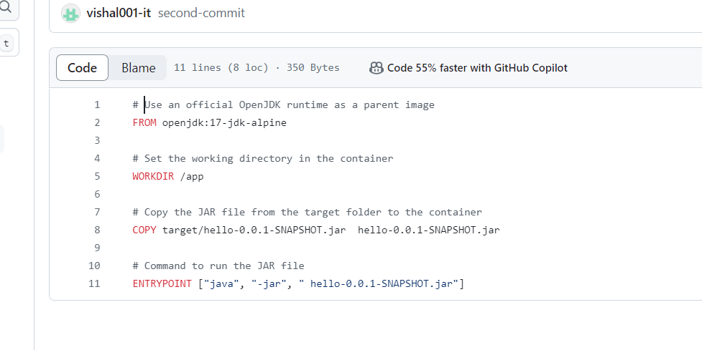
6. We pushed the Docker image to Azure Container Registry (ACR).
7. Connected AKS to ACR so AKS can pull images from ACR.
8. Used Azure CLI to create a Helm chart for our backend application.
   1. You can review the Helm chart for the backend application on our GitHub repo.
9. Exposed port 8080 for the backend service.
10. Installed Traefik in AKS using a Helm chart.
11. Used the Traefik Ingress Controller as a LoadBalancer to distribute traffic.
12. Created an Ingress Controller manifest file to connect the backend application to the Traefik Load Balancer.
13. You can check the GitHub repo for the ingress configuration at testing/templates/ingress.yaml.
14. Installed Prometheus in the AKS cluster to expose metrics.

# **Common Troubleshooting**

1. Scaling: If you want to scale the application, you can do so in Kubernetes by running:
   1. kubectl scale deployment testing -n testing --replicas 3
2. To access the application, visit the IP of the Traefik load balancer:
   1. <https://testing.mountsmy.com/>

Note: You can troubleshoot by checking logs, events, and describing Kubernetes pods and services.

Git Rep : **https://github.com/vishal001-it/nextgenhub-testing**