Risk Assessment & Security Strategy Planning
Food-processing data systems | Week 1
Prepared as a technical learning project. All operational data and measured results in this package are simulated unless explicitly identified as external guidance.

Executive summary
Food-processing data systems can connect business applications, laboratory and quality records, production planning, sensors, and operational technology. A security incident can affect confidentiality, record integrity, availability, traceability, and potentially production continuity. This assessment uses a simple, transparent risk register to prioritize discussion; it is not a formal audit.

Scope and assumptions
The assumed environment includes an ERP or production application, quality/lab records, supplier and batch traceability data, OT/IoT sensors, employee endpoints, remote vendor access, backups, and analytics/reporting. No actual organization, network scan, incident log, or production dataset was supplied. All likelihood and impact values are hypothetical.

Literature review and framework
NIST CSF 2.0 organizes cybersecurity outcomes around Govern, Identify, Protect, Detect, Respond, and Recover. NIST SP 800-30 provides a risk-assessment process; NIST SP 800-82 addresses OT-specific safety, reliability, and availability considerations. CISA Cross-Sector Cybersecurity Performance Goals provide baseline practices. These sources are used as frameworks, not as proof that any particular control is already implemented.

Risk scoring method
Threat scenario | Likelihood (1–5) | Impact (1–5) | Score | Illustrative band
Unauthorized access to production/quality records | 4 | 5 | 20 | High
Ransomware disrupts production scheduling | 4 | 5 | 20 | High
Sensor data tampering | 3 | 5 | 15 | High
Unencrypted transfer of supplier data | 3 | 4 | 12 | Medium
Insider misuse of batch/traceability data | 3 | 4 | 12 | Medium
Lost/compromised endpoint | 3 | 3 | 9 | Medium
Backup failure or untested restoration | 3 | 5 | 15 | High
Third-party remote access compromise | 3 | 5 | 15 | High
Data quality error causing false alert | 3 | 3 | 9 | Medium
Denial of service against reporting service | 2 | 3 | 6 | Low
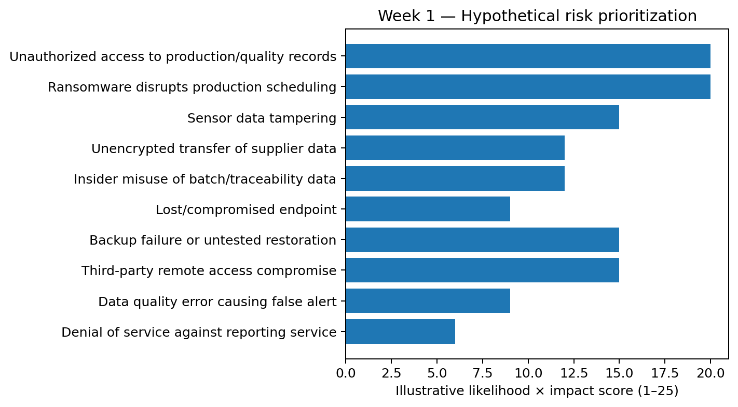

Risk prioritization and findings
The initial register highlights several scenarios with high illustrative scores: unauthorized access to critical records, ransomware disrupting production, sensor-data tampering, unencrypted transfers, insider misuse, backup recovery failure, and compromised vendor access. A score of likelihood × impact is intentionally simple and does not quantify annualized loss. The highest scores should trigger workshops to validate business impact and existing safeguards.

Proposed security strategy
- Identity: enforce MFA for remote and privileged access; use named accounts, least privilege, time-bound vendor access, and periodic access reviews.
- Segmentation: separate enterprise IT, OT control networks, guest Wi-Fi, and external vendor pathways; document and approve necessary conduits.
- Data integrity: apply schema/range checks, source identity, timestamps, versioning, audit trails, and approval gates for critical record changes.
- Resilience: maintain offline or immutable backups; define recovery time and recovery point objectives; test restoration rather than relying on backup-job success alone.
- Detection: centralize authentication, endpoint, network, and application logs; alert on unusual privileged actions, repeated failures, and unexpected OT communications.
- Response: prepare playbooks for ransomware, suspected sensor tampering, data disclosure, and vendor-account compromise; assign decision owners and preserve evidence.
- People and suppliers: train staff, verify supplier access, set contract security requirements, and review incident notification paths.

Illustrative roadmap
Phase | Target window | Actions | Evidence
Stabilize | 0–30 days | Inventory critical assets; enable MFA on remote/admin accounts; verify backups | Approved inventory, MFA report, restore-test record
Harden | 31–90 days | Segment IT/OT; remove shared accounts; centralize key logs; define incident roles | Network diagram, account review, log coverage
Validate | 3–6 months | Run tabletop exercises; test restore; review supplier access; tune alerting | Exercise report, recovery timings, action log
Improve | 6–12 months | Repeat risk assessment; test controls; measure remediation aging | Updated risk register and management review

Python implementation
The script computes a score and a transparent band from the supplied synthetic CSV. Run it from the code directory with pandas installed.
"""Week 1: illustrative risk scoring. Synthetic scenarios only."""
import pandas as pd

df = pd.read_csv("risk_register.csv")
df["risk_score"] = df["Likelihood_1_5"] * df["Impact_1_5"]
def band(score):
if score >= 15: return "High"
if score >= 8: return "Medium"
return "Low"
df["calculated_band"] = df["risk_score"].map(band)
print(df[["Threat", "risk_score", "calculated_band", "Recommended_Control"]]
.sort_values("risk_score", ascending=False).to_string(index=False))
df.to_csv("risk_register_scored.csv", index=False)

Conclusion
Treat the register as a starting hypothesis. Confirm business-critical assets, safety dependencies, regulatory duties, and actual control maturity before setting final risk acceptance or investment decisions.

Submission description (200+ words)
This report presents a structured, hypothetical cybersecurity risk assessment for data systems used in a food-processing environment. It frames the system around production and quality records, operational technology (OT), sensor telemetry, supplier information, traceability records, endpoints, backups, and third-party access. The report begins with a concise literature and standards review, using NIST Cybersecurity Framework 2.0, NIST SP 800-30, NIST SP 800-82, and CISA baseline guidance as reference points. It then defines a transparent likelihood-and-impact scoring method and applies it to a risk register containing plausible threat scenarios. Scores are prioritization aids rather than measured probabilities; the document explains this limitation and calls for validation through interviews, asset discovery, and business-impact analysis. The accompanying Python script reads the CSV risk register, calculates scores, assigns illustrative severity bands, sorts the findings, and exports a scored register. A generated bar chart makes the relative priorities easier to communicate to technical and non-technical readers. Recommended controls cover identity and access management, multi-factor authentication, network segmentation, secure transfer, logging, backup resilience, vendor access, data validation, and incident response. The report also outlines a phased security roadmap with ownership and evidence of completion. All scenarios and risk scores are hypothetical; they do not claim to describe an actual food company or a real breach. The purpose is to demonstrate a reproducible method that can be adapted to a real environment after the scope, assets, regulatory obligations, and risk appetite have been confirmed.

References and further reading
- NIST, Cybersecurity Framework (CSF) 2.0, 2024. https://www.nist.gov/cyberframework
- NIST SP 800-30 Rev. 1, Guide for Conducting Risk Assessments, 2012. https://csrc.nist.gov/pubs/sp/800/30/r1/final
- NIST SP 800-82 Rev. 3, Guide to Operational Technology (OT) Security, 2023. https://csrc.nist.gov/pubs/sp/800/82/r3/final
- CISA, Cross-Sector Cybersecurity Performance Goals. https://www.cisa.gov/cross-sector-cybersecurity-performance-goals
- NIST SP 800-53 Rev. 5, Security and Privacy Controls for Information Systems and Organizations, 2020 (updates may apply). https://csrc.nist.gov/pubs/sp/800/53/r5/upd1/final
- NIST FIPS 197, Advanced Encryption Standard (AES), updated 2023. https://csrc.nist.gov/pubs/fips/197/final
- NIST SP 800-57 Part 1 Rev. 5, Recommendation for Key Management, 2020. https://csrc.nist.gov/pubs/sp/800/57/pt1/r5/final
- scikit-learn documentation, Model evaluation and classification metrics. https://scikit-learn.org/stable/modules/model_evaluation.html
- Python cryptography documentation, Fernet and AEAD recipes. https://cryptography.io/en/latest/
- FDA, Food Traceability Final Rule (FSMA Section 204) overview. https://www.fda.gov/food/food-safety-modernization-act-fsma/fsma-final-rule-requirements-additional-traceability-records-certain-foods

Limitations and responsible use
This is a reproducible educational prototype, not a production security assessment or certification. The scenario data are synthetic, do not represent a named company, and must not be interpreted as evidence of real incident rates or system performance. Production deployment requires asset inventory, stakeholder interviews, legal/regulatory review, threat modeling, independent testing, and qualified security review.

