Intrusion Detection Model Development
Food-processing data systems | Week 3
Prepared as a technical learning project. All operational data and measured results in this package are simulated unless explicitly identified as external guidance.

Executive summary
A Random Forest baseline was trained on 2,400 seeded synthetic events. The held-out test set contains 600 events. This is a demonstration of evaluation methodology, not evidence of production detection capability.

Threat model and detection objective
Potential events include credential guessing, unusual data exfiltration, privilege changes, abnormal sensor readings, and unusual destination fan-out. The target label means 'simulated intrusion' under the generator's assumptions; it is not a verified real-world attack label.

Synthetic data methodology
Feature | How it is represented | Why it may help
failed_logins | Count of failed authentication attempts | Credential guessing or account misuse
bytes_out_mb | Synthetic outbound data volume | Possible unusual data transfer
off_hours | Binary activity-time indicator | Unexpected activity outside normal hours
privilege_change | Binary privilege-change indicator | Potential privilege escalation
sensor_deviation | Numeric deviation score | Unexpected OT/sensor behavior
unique_destinations | Count of destination endpoints | Possible scanning or lateral movement
label_intrusion | 0 normal / 1 simulated intrusion | Target generated from scenario label

Model design
A scikit-learn Pipeline uses median imputation followed by a RandomForestClassifier with 180 trees, maximum depth 8, class weighting, and a fixed random seed. A stratified 75%/25% train/test split preserves the class ratio. This is a baseline model; no hyperparameter search was used.

Evaluation results
Metric | Holdout result | Interpretation
Accuracy | 0.998 | Fraction of all predictions correct
Precision | 1.000 | Fraction of predicted intrusions that were simulated intrusions
Sensitivity / recall | 0.990 | Fraction of simulated intrusions detected
Specificity | 1.000 | Fraction of normal events correctly left unflagged
F1 | 0.995 | Harmonic mean of precision and recall
ROC-AUC | 1.000 | Ranking discrimination across thresholds
Confusion matrix | TN=499, FP=0, FN=1, TP=100 | Counts on the held-out synthetic test set

Visual analysis
The confusion matrix makes error types explicit. Feature importance describes how the fitted model used this generated dataset; it does not establish causality or general importance in real networks.
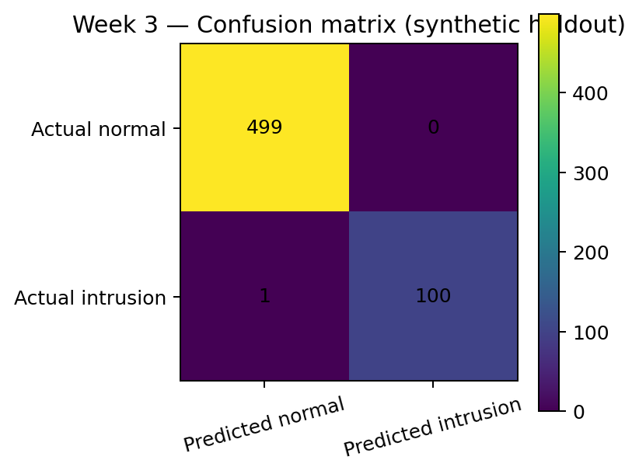
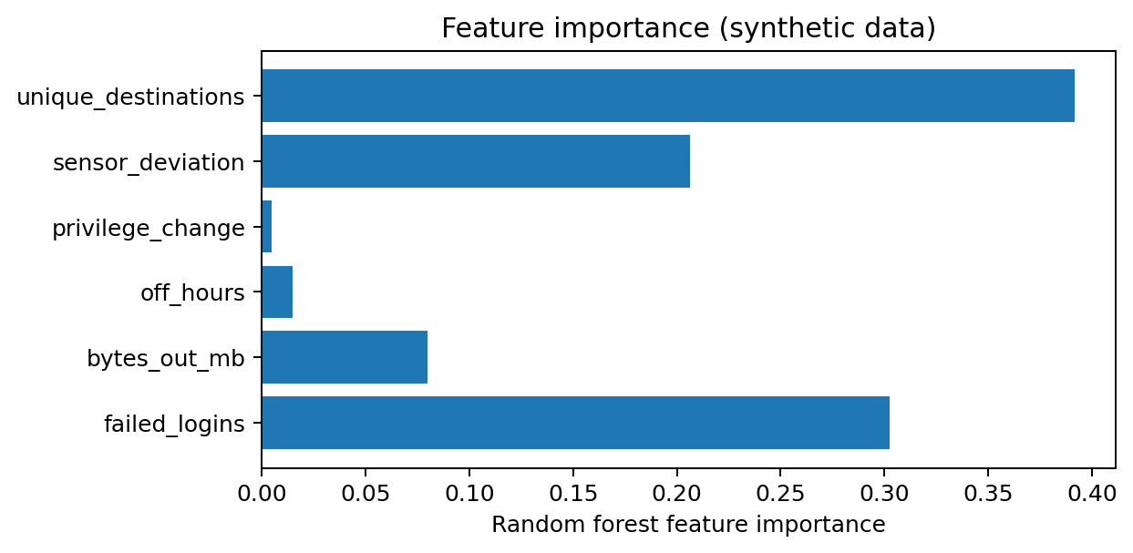

Reproducibility
Install the packages listed in requirements.txt, then run the script from this directory. It reads the included synthetic CSV and rewrites model_metrics.json.
"""Week 3: train and evaluate a baseline intrusion classifier on synthetic events."""
import json
import pandas as pd
from sklearn.model_selection import train_test_split
from sklearn.pipeline import Pipeline
from sklearn.impute import SimpleImputer
from sklearn.ensemble import RandomForestClassifier
from sklearn.metrics import (confusion_matrix, accuracy_score, precision_score,
recall_score, f1_score, roc_auc_score)

df = pd.read_csv("synthetic_security_events.csv")
target = "label_intrusion"
X, y = df.drop(columns=[target]), df[target]
X_train, X_test, y_train, y_test = train_test_split(
X, y, test_size=0.25, random_state=42, stratify=y)
model = Pipeline([
("imputer", SimpleImputer(strategy="median")),
("classifier", RandomForestClassifier(n_estimators=180, max_depth=8,
class_weight="balanced", random_state=42))
])
model.fit(X_train, y_train)
pred = model.predict(X_test)
prob = model.predict_proba(X_test)[:, 1]
tn, fp, fn, tp = confusion_matrix(y_test, pred).ravel()
metrics = {
"accuracy": float(accuracy_score(y_test, pred)),
"precision": float(precision_score(y_test, pred, zero_division=0)),
"sensitivity_recall": float(recall_score(y_test, pred, zero_division=0)),
"specificity": float(tn / (tn + fp)),
"f1": float(f1_score(y_test, pred, zero_division=0)),
"roc_auc": float(roc_auc_score(y_test, prob)),
"confusion_matrix": {"tn": int(tn), "fp": int(fp), "fn": int(fn), "tp": int(tp)}
}
with open("model_metrics.json", "w") as f:
json.dump(metrics, f, indent=2)
print(json.dumps(metrics, indent=2))

Limitations and next steps
- Synthetic data distributions may be easier to separate than genuine attacks; scores are not transferable to production.
- Use time-based splits and hold out sites/devices to test generalization and reduce leakage risk.
- Compare against transparent rules and a simple logistic regression baseline.
- Select alert thresholds using analyst capacity and the relative cost of missed detections versus false alarms.
- Monitor drift, missing telemetry, model version, data lineage, and analyst dispositions.
- Keep humans in the loop for any action that could interrupt safety-critical operations.

Conclusion
The experiment demonstrates a reproducible ML workflow and an evaluation vocabulary. A real intrusion-detection deployment needs representative telemetry, threat-informed labels, independent validation, and safe operational integration.

Submission description (200+ words)
This report develops a baseline intrusion-detection model for a hypothetical food-processing data environment. Because no real network telemetry or labeled incident dataset was provided, the experiment uses a seeded synthetic dataset of 2,400 events. Features represent failed logins, outbound data volume, off-hours activity, privilege changes, sensor deviation, and the number of unique destinations. Labels are generated using different distributions for normal and simulated intrusion events; this creates a controlled teaching scenario but can make classification easier than real-world detection. A train/test split is stratified and reproducible, and a scikit-learn pipeline imputes missing values before fitting a class-weighted Random Forest classifier. The evaluation reports accuracy, precision, sensitivity/recall, specificity, F1 score, ROC-AUC, and a confusion matrix. The report explains false positives and false negatives in operational terms: false positives create analyst workload, while false negatives may leave malicious activity undetected. Visuals show the holdout confusion matrix and feature importance. The included Python script reproduces the model training and writes metrics to JSON. The reported values are generated from this synthetic dataset and should be rerun from the included files; they are not benchmark claims about production networks. Before deployment, the model would require real, representative telemetry, careful label quality checks, temporal validation, threshold selection based on incident costs, drift monitoring, analyst feedback, and comparison with simpler rule-based baselines. The model is intended to support analysts, not autonomously block food production or safety-critical OT operations.

References and further reading
- NIST, Cybersecurity Framework (CSF) 2.0, 2024. https://www.nist.gov/cyberframework
- NIST SP 800-30 Rev. 1, Guide for Conducting Risk Assessments, 2012. https://csrc.nist.gov/pubs/sp/800/30/r1/final
- NIST SP 800-82 Rev. 3, Guide to Operational Technology (OT) Security, 2023. https://csrc.nist.gov/pubs/sp/800/82/r3/final
- CISA, Cross-Sector Cybersecurity Performance Goals. https://www.cisa.gov/cross-sector-cybersecurity-performance-goals
- NIST SP 800-53 Rev. 5, Security and Privacy Controls for Information Systems and Organizations, 2020 (updates may apply). https://csrc.nist.gov/pubs/sp/800/53/r5/upd1/final
- NIST FIPS 197, Advanced Encryption Standard (AES), updated 2023. https://csrc.nist.gov/pubs/fips/197/final
- NIST SP 800-57 Part 1 Rev. 5, Recommendation for Key Management, 2020. https://csrc.nist.gov/pubs/sp/800/57/pt1/r5/final
- scikit-learn documentation, Model evaluation and classification metrics. https://scikit-learn.org/stable/modules/model_evaluation.html
- Python cryptography documentation, Fernet and AEAD recipes. https://cryptography.io/en/latest/
- FDA, Food Traceability Final Rule (FSMA Section 204) overview. https://www.fda.gov/food/food-safety-modernization-act-fsma/fsma-final-rule-requirements-additional-traceability-records-certain-foods

Limitations and responsible use
This is a reproducible educational prototype, not a production security assessment or certification. The scenario data are synthetic, do not represent a named company, and must not be interpreted as evidence of real incident rates or system performance. Production deployment requires asset inventory, stakeholder interviews, legal/regulatory review, threat modeling, independent testing, and qualified security review.

