Security Infrastructure Evaluation & Future Roadmap
Food-processing data systems | Week 5
Prepared as a technical learning project. All operational data and measured results in this package are simulated unless explicitly identified as external guidance.

Executive summary
The hypothetical control review suggests focusing first on recovery readiness, privileged access, asset visibility, segmentation, and incident response. The scores are prioritization heuristics; a real assessment must verify evidence and account for safety and business context.

Assessment method and limitations
Each control area receives a hypothetical maturity score from 1 (weak) to 5 (well-established) and an impact score from 1 to 5. The illustrative priority score is (6 − maturity) × impact. It is not a recognized compliance score and must not be compared across organizations without a defined assessment method.

Control assessment
Control area | Maturity (1–5) | Impact (1–5) | Priority score | Scenario status
Asset inventory and ownership | 2 | 5 | 20 | Partial
MFA for privileged/remote access | 3 | 5 | 15 | Partial
IT/OT network segmentation | 2 | 5 | 20 | Partial
Encryption in transit | 3 | 4 | 12 | Partial
Encryption at rest and key governance | 2 | 4 | 16 | Partial
Centralized logs and alerting | 2 | 4 | 16 | Partial
Backup isolation and restore testing | 2 | 5 | 20 | Weak
Vulnerability and patch management | 3 | 4 | 12 | Partial
Incident response and exercises | 2 | 4 | 16 | Weak
Supplier/remote access governance | 2 | 4 | 16 | Partial
Data quality and integrity validation | 3 | 4 | 12 | Partial
Staff security awareness | 3 | 3 | 9 | Partial
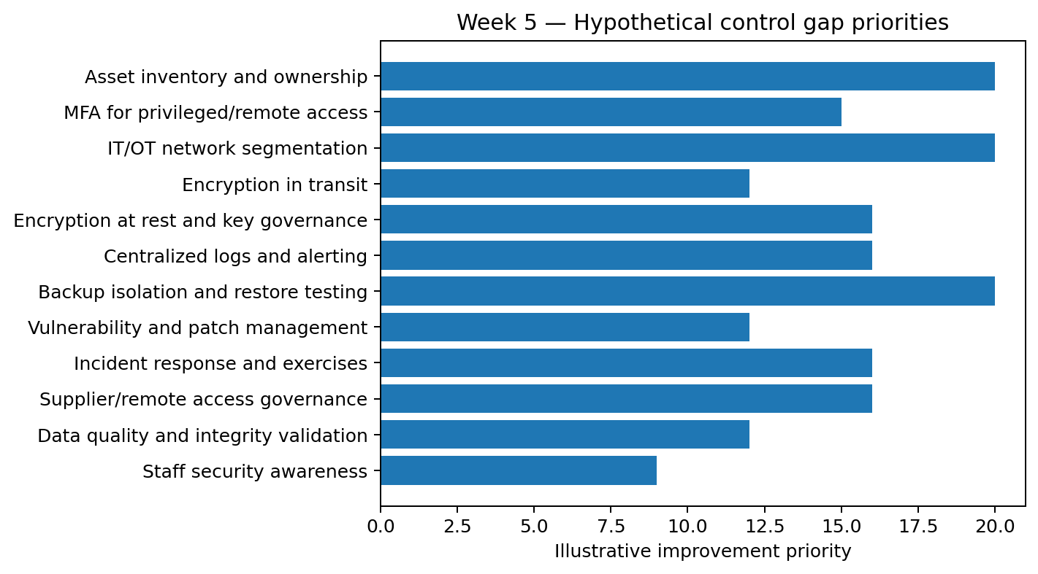

Strengths, weaknesses, opportunities, risks (SWOT)
Area | Hypothetical observations
Strengths | Several controls are assumed to exist in partial form, allowing a phased improvement plan rather than a complete redesign.
Weaknesses | Backup recovery testing and incident-response exercises are assumed weak; asset and OT dependencies may be incompletely documented.
Opportunities | Use centralized identity, common logging, repeatable validation, managed key services, and tested recovery procedures.
Risks | Ransomware, supplier compromise, sensor-data tampering, credential misuse, and production disruption may compound across connected systems.

Prioritized roadmap
Horizon | Workstream | Example owner | Evidence / KPI | Budget planning
0–30 days | Inventory crown-jewel assets; review admin accounts; verify backup isolation | IT/security lead + OT owner | Asset coverage; privileged accounts reviewed; restore-test scheduled | Low–medium: staff time and configuration
31–90 days | Enforce MFA; close critical exposed services; document incident playbooks | IAM/security + operations | MFA coverage; critical remediation aging; approved playbooks | Medium: identity tooling and implementation
3–6 months | Segment IT/OT; centralize priority logs; conduct tabletop and restore exercise | OT engineering + SOC/IT | Segmentation rules reviewed; log-source coverage; exercise actions closed | Medium–high: network work and monitoring integration
6–12 months | Tune detection; review suppliers; test key recovery; repeat risk assessment | Security governance + procurement | Alert precision review; supplier reviews; key recovery test | Medium: ongoing operations and testing
Continuous | Training, patching, access reviews, metrics, and lessons learned | Control owners | Monthly dashboard and quarterly governance review | Recurring operating expense

Integrated monitoring and metrics
- Identity: privileged accounts with MFA; stale accounts removed; access reviews completed on time.
- Vulnerability management: critical findings past due; median remediation age; exception age and owner.
- Detection: log-source coverage for critical assets; time to acknowledge; false-positive burden; validated missed detections.
- Recovery: backup success is not enough—track restore-test success, achieved recovery time, and data-loss window.
- Integrity and privacy: invalid-record rate, quarantine disposition time, sensitive exports reviewed, and key-rotation compliance.

Python evaluation
This script computes a simple improvement-priority heuristic for the synthetic control register.
"""Week 5: summarize hypothetical security control gaps."""
import pandas as pd

df = pd.read_csv("hypothetical_control_assessment.csv")
# Priority heuristic: lower maturity and higher impact increase the score.
df["priority_score"] = (6 - df["Maturity_1_5"]) * df["Impact_1_5"]
df = df.sort_values(["priority_score", "Impact_1_5"], ascending=False)
print(df[["Control_Area","Maturity_1_5","Impact_1_5","priority_score"]].to_string(index=False))
df.to_csv("prioritized_control_gaps.csv", index=False)

Governance and accountability
Assign a named owner and evidence artifact to every control. Review risk acceptance with business and OT safety stakeholders. Changes affecting production should use change control, staged testing, rollback plans, and authorized human approval. Conduct tabletop exercises and update the roadmap based on findings.

Conclusion
A practical roadmap combines immediate risk reduction with durable governance. Start with evidence gathering and recovery, then strengthen identity, segmentation, monitoring, supplier controls, and continuous testing.

Submission description (200+ words)
This final report combines the themes from the preceding four weeks into a hypothetical security-infrastructure evaluation for a food-processing organization. It assesses a set of control areas spanning asset ownership, privileged access, IT/OT segmentation, encryption, centralized monitoring, backup resilience, patching, incident response, supplier access, data integrity, and staff awareness. A transparent maturity-and-impact heuristic is applied to an illustrative control register to help prioritize improvement discussions. The maturity values are assumptions for a teaching scenario, not audit observations; the report explicitly avoids presenting them as the condition of a real organization. The accompanying Python script recalculates a priority score from the CSV and exports a prioritized list. A chart visualizes the relative scores. The roadmap translates the gaps into immediate, near-term, medium-term, and continuous actions with example owners, evidence, and budget considerations. It integrates risk assessment, secure pipeline design, intrusion-detection monitoring, encryption and privacy controls, and recovery planning. The report includes a compact SWOT-style view, a proposed governance cadence, and measurable indicators such as privileged-account MFA coverage, restore-test success, log-source coverage, remediation age, and incident exercise actions closed. Budget categories are intentionally expressed as relative planning bands rather than invented vendor quotes; actual costs depend on facility size, existing contracts, regulatory scope, and OT architecture. The final section recommends a staged implementation with operational safety and human approval preserved for changes affecting production. This is a synthesis exercise and a planning template, not a penetration test, compliance opinion, or assurance certification.

References and further reading
- NIST, Cybersecurity Framework (CSF) 2.0, 2024. https://www.nist.gov/cyberframework
- NIST SP 800-30 Rev. 1, Guide for Conducting Risk Assessments, 2012. https://csrc.nist.gov/pubs/sp/800/30/r1/final
- NIST SP 800-82 Rev. 3, Guide to Operational Technology (OT) Security, 2023. https://csrc.nist.gov/pubs/sp/800/82/r3/final
- CISA, Cross-Sector Cybersecurity Performance Goals. https://www.cisa.gov/cross-sector-cybersecurity-performance-goals
- NIST SP 800-53 Rev. 5, Security and Privacy Controls for Information Systems and Organizations, 2020 (updates may apply). https://csrc.nist.gov/pubs/sp/800/53/r5/upd1/final
- NIST FIPS 197, Advanced Encryption Standard (AES), updated 2023. https://csrc.nist.gov/pubs/fips/197/final
- NIST SP 800-57 Part 1 Rev. 5, Recommendation for Key Management, 2020. https://csrc.nist.gov/pubs/sp/800/57/pt1/r5/final
- scikit-learn documentation, Model evaluation and classification metrics. https://scikit-learn.org/stable/modules/model_evaluation.html
- Python cryptography documentation, Fernet and AEAD recipes. https://cryptography.io/en/latest/
- FDA, Food Traceability Final Rule (FSMA Section 204) overview. https://www.fda.gov/food/food-safety-modernization-act-fsma/fsma-final-rule-requirements-additional-traceability-records-certain-foods

Limitations and responsible use
This is a reproducible educational prototype, not a production security assessment or certification. The scenario data are synthetic, do not represent a named company, and must not be interpreted as evidence of real incident rates or system performance. Production deployment requires asset inventory, stakeholder interviews, legal/regulatory review, threat modeling, independent testing, and qualified security review.

