

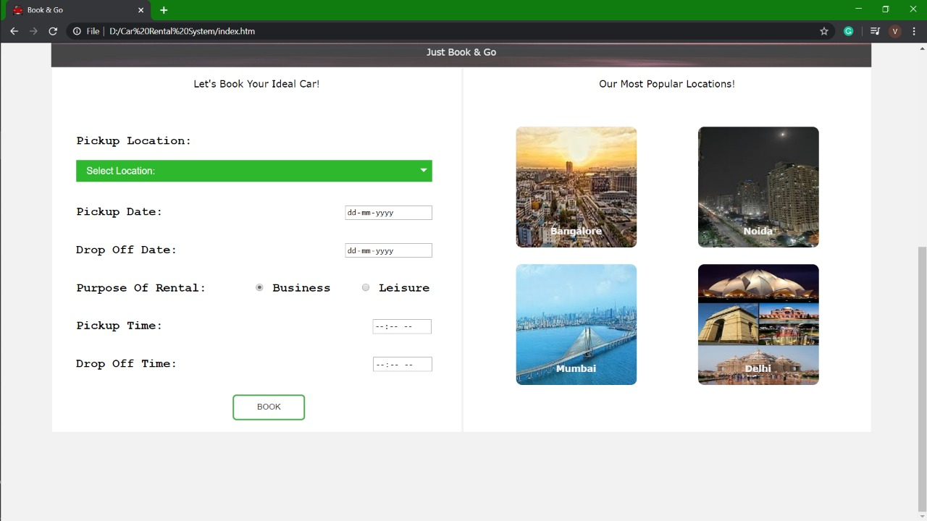

**CSE-326**

**REPORT**

**CAR RENTAL SYSTEM**

**Car Rental System**

Abstract

The car rental system is a project, which is all about hiring cars on rent via online mode. There are also the presence of various available offline modes for hiring a car on rent, but they demand a lot of time and documentations, as one is required to visit the place first, then is required to select the car, next to enquire about the car, then the documentation and the list goes on and on…

Moreover, the hiring of cars generally is for short duration or for a trip. We all know that today’s world is progressing at a very high pace and no one is having time to waste. In such kind of world, where the time is the ultimate ruler, going and spending a lot of time on hiring cars at the showrooms is somehow a bit time consuming. Therefore, our project take the whole scenario in the online mode.

Through this project, one can at home hire any car based on their choices. Moreover, the documentation can also be done online. This reduces a lot of time, which is spent in the alternative way, i.e. the offline mode.

This project is basically a Car Rental Website, which is designed by using various languages such as HTML, CSS, and JavaScript. In this project, a user can hire a car based on his inputs.

Contents

|  |  |  |
| --- | --- | --- |
| SERIAL NO. | TITLE | PAGE NO. |
| 1 | Cover Page | 1 |
| 2 | Abstract | 2 |
| 3 | Contents | 3 |
| 4 | Group Members | 4 |
| 5 | Objective | 4 |
| 6 | Introduction | 5 |
| 7 | Working of the Website | 6-7 |
| 8 | Conclusion | 8 |
| 9 | Acknowledgement | 9 |

**Group Members**

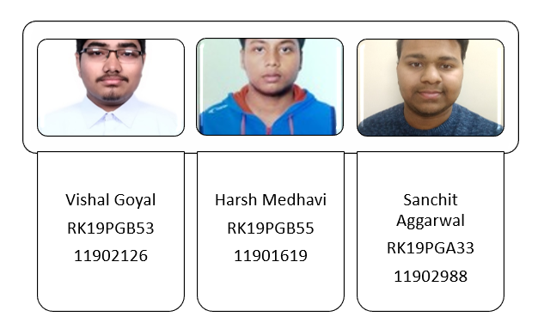

**Objective**

* To understand the basic working of a car rental website and to frame a rough idea
* Designing a Car Rental System
* Using various languages such as HTML, CSS, and JavaScript
* Designing the front-end profile of the website using HTML
* Creating the back-end profile of the website using CSS and JavaScript

**Introduction**

The “Car Rental Website” is the online platform to hire a car as per our requirement. This Car Rental System is a platform, which allow the user to get access of the cars on rent for limited period of time. We have been allotted a project to design a prototype of the same. The project website is including the necessary options like Login, Signup, Manage Booking, Popular locations, and the input section demanding various parameters such as pickup location, pickup date, pickup time, drop off location, drop off date, drop of time, etc. which will be provided to the server in form of the documentation. Hence, confirming the booking of the user. We have also provided the option to create as well as to alter the password of the user. Moreover, the website is having the option to manage as well as to cancel the desired booking of the user too. In addition, one can trace the details of their booking on the website too. The website is the combined result of front-end as well as basic back-end designing.

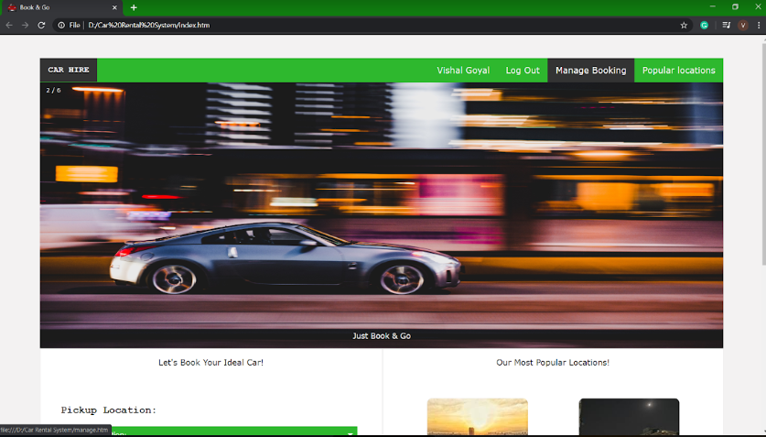

**Working of Website**

The main interface of the website comprises many options such as Log In, Sign Up, Manage Booking (including both creation and cancellation), updating password, available locations, etc.

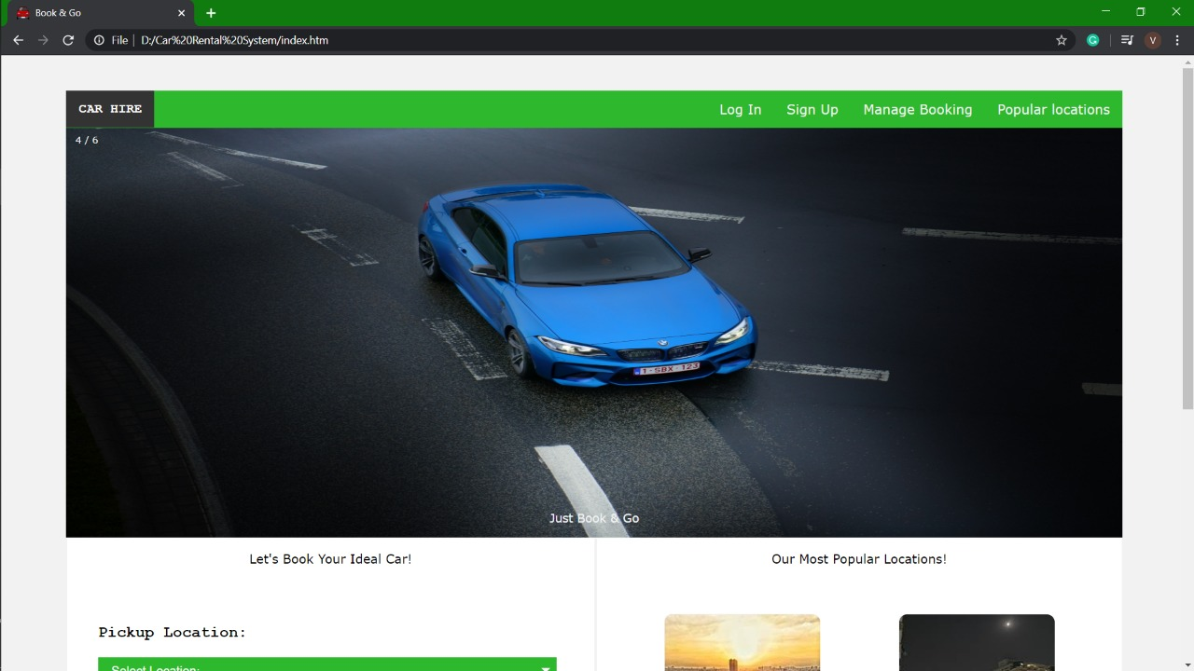

For confirmation of any booking, the user is first required to Log In. However, if the user is not having any previous Log in ID, then the user is required to Sign Up first.

As soon as the user clicks on the Sign up option, you are supposed to enter your details. After signing up, one has to enter details like pick-up location, pick-up date, pick-up time, type of car (Business or Leisure), Drop-off date, Drop-off time, etc.



After this, one can view his booking under the Manage Booking section. Moreover, there is also an option for cancellation of the booking there only.

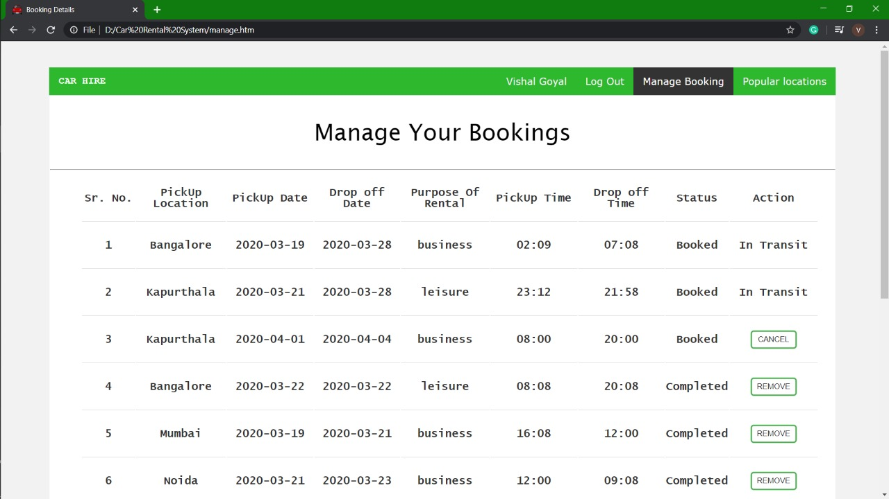

**Conclusion**

The completion of this website is the result of the rigorous efforts of our group members. We all distributed our work and tackled both the profiles: Front-End as well as of Back-End. We have used HTML, CSS, and JavaScript for its designing. The project very well displays the prototype of a car rental website by providing almost all of the similar necessary parameters for confirming the booking of cars on rent for a limited period of time. As soon as the user provides the requested inputs, one can get the display of their booking and all the various modification can be done under manage booking section.

This website is the need of the hour. This is a very efficient method of hiring a car on rent for a limited period of time as it is very much time saving and easy to feed. Moreover, we are very much thankful for getting this topic to work on for our assignment.



Title-Bar Icon

**Acknowledgment**

I cannot express enough thanks to my faculty sir for his continued support and encouragement: Dipen Saini. We offer our sincere appreciation for the learning opportunities provided by our faculty teacher.

The completion of this project could not have been accomplished without the support of our group members and our classmates too. We are very much thankful to them also.

Finally, to our caring, loving family members: our deepest gratitude. Your encouragement when the times got rough are much appreciated and duly noted. It was a great comfort and relief to know that they were willing to provide management of our household activities while we completed my work. Our heartfelt thanks to everyone.