**Car Rental System**

The Car Rental System is a platform, which allow the user to get access of the cars on rent for limited period of time. We have been allotted a project to design a prototype of the same.

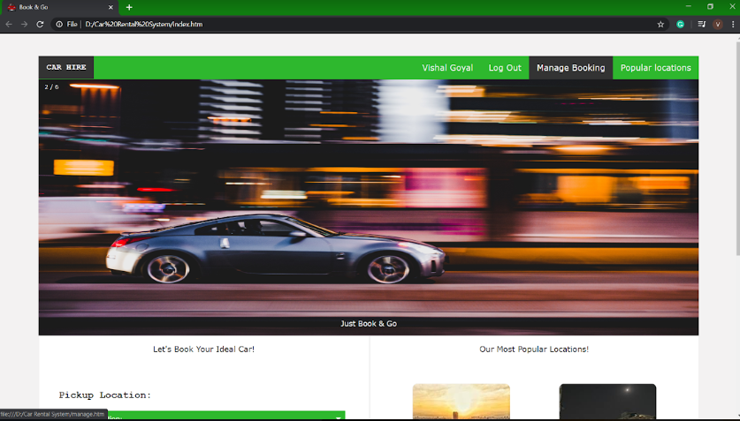

For this, we have used various languages such as HTML, CSS, and JavaScript for the completion of this Car Rental website. The HTML language handles the front-end of this website, whereas CSS tackles its designing portion. Moreover, the project includes the contribution of JavaScript for the creation of its back-end profile.

The successful completion of this project is a result of teamwork. For simplifying the process, we divided the tasks between our group members. Notably, Harsh Medhavi and Sanchit Aggarwal dealt with the the front-end and the designing process, whereas Vishal Goyal managed the basic back-end profile.

The main interface of the website comprises many options such as Log In, Sign Up, Manage Booking (including both creation and cancellation), updating password, available locations, and many more.

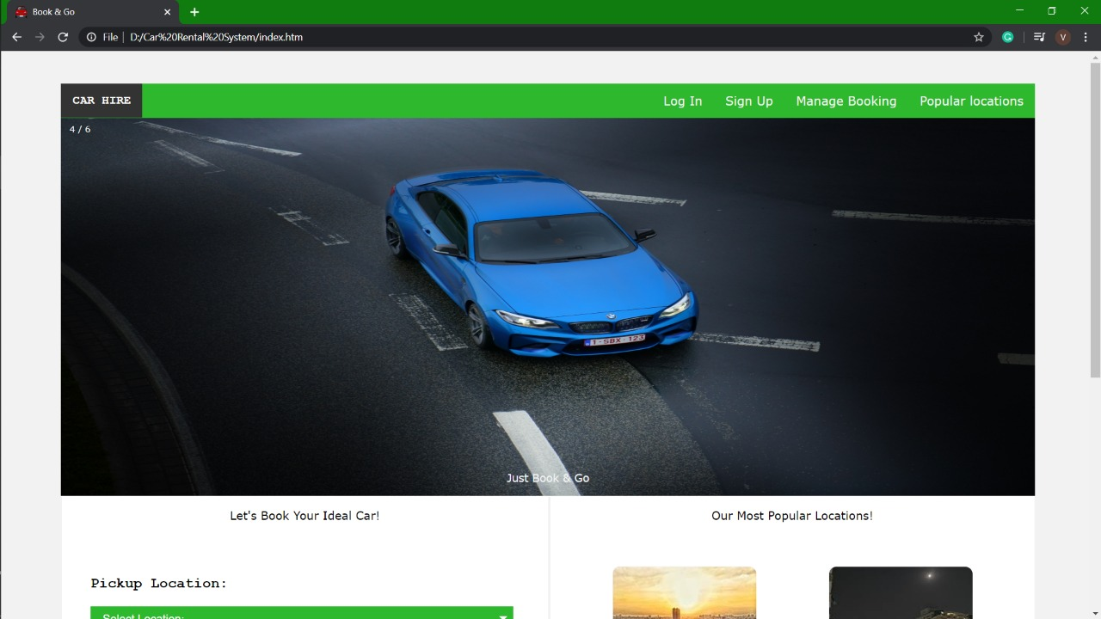

In order to make any booking, the user is first required to Log In. However, if the user is not having any previous Log in ID, then the user is required to Sign Up first. As soon as the user clicks on the Sign up option, you are supposed to enter your details. After signing up, one has to enter details like pick-up location, pick-up date, pick-up time, type of car (Business or Leisure), Drop-off date, Drop-off time, etc.

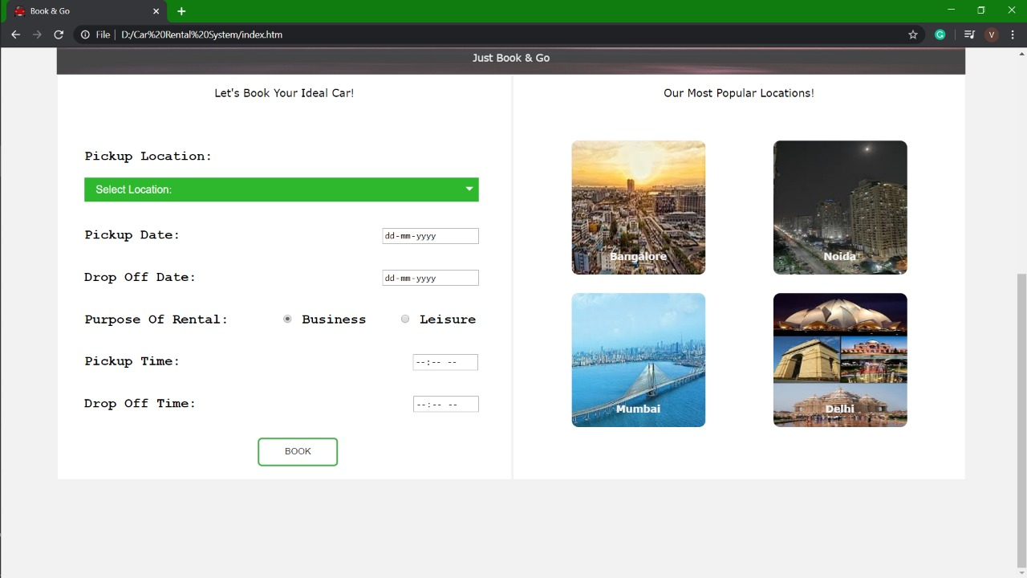

After this, one can view his booking under the Manage Booking section. Moreover, there is also an option for cancellation of the booking there only.

