Angular JS For JEE – 1.2

Lab Book

Document Revision History

|  |  |  |  |
| --- | --- | --- | --- |
| Date | Revision No. | Author | **Summary of Changes** |
| May 2016 | 1.2 | Rahul Vikash | Created new lab book as per revised course contents |
|  |  |  |  |
|  |  |  |  |
|  |  |  |  |

Table of Contents

*Getting Started..……..…………………………………………………………………………… 4*

Overview 4

Setup Checklist for AngularJS 4

Instructions 4

Learning More 4

*Lab 1. Introduction to Angular JS & Directives 5*

*Lab 2. Angular Filters 7*

*Lab 3: Angular UI web with Java middle ware application (Spring REST) 9*

*Appendices………………………………………………………………………………………… 11*

## *Appendix A: Table of Figures ………………………………………………………… 11*

Getting Started

## Overview

This lab book is a guided tour for learning Angular JS For JEE version 1.2 and above. It comprises ‘To Do’ assignments. Follow the steps provided to work out the ‘To Do’ assignments given.

## Setup Checklist for AngularJS

Here’s what is expected on your machine for the lab in order to work.

Minimum System Requirements

* Intel Pentium 90 or higher (P166 recommended)
* Microsoft Windows XP, Windows 7 or Windows 8
* Memory: 2GB of RAM (1GB or more recommended)
* Google Chrome 36.0 or Mozilla Firefox 31.0 or Internet Explorer 10 or above

Please ensure that the following is done:

* A text editor like Notepad or Notepad++ or Eclipse Luna is installed.

## Instructions

* Create a directory by your name in drive <drive>. In this directory, create a subdirectory angular_assgn. For each lab exercise create a directory as lab <lab number>.
* You may also look up the on-line help provided in <https://docs.angularjs.org/api>

## Learning More

* O’REILLY AngularJS by Brad Green & Shyam Seshadri
* APress Pro AngularJS by Adam Freeman
* PACKT Publishing Instant AngularJS Starter by Dan Menard
* PACKT Publishing Dependency Injection with AngularJS by Alex Knol
* PACKT Publishing AngularJS Directives by Alex Vanston

1. Introduction to Angular JS & Directives

|  |  |
| --- | --- |
| Goals | * Understand the process of creating an angular webpage and view in a browser window. * Understanding the fundamentals of Angularjs (model, view, controller, modules, rootscope, Directives, events) |
| Time | 60 minutes |

## 1: Creating a webpage to work with Angular Basic & Directives

Create a web page and display the results shown below.

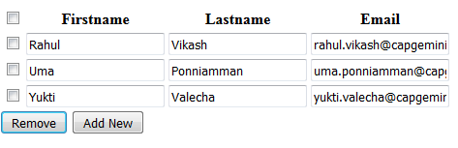

Figure 1

The rows could be added with help of 'Add New' as per the need. The rows are to be provided with the check boxes to facilitate the deletion process e.g., if any new row for the data entry is required, the Add New button is to be clicked on and the new row should appear.

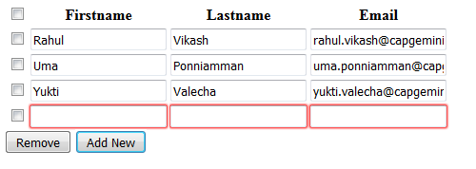

Figure 2

Note:

All fields are mandatory

For deleting a row just check the check box and click on Remove button, and the row should get deleted. If we select topmost checkbox all the rows will be selected & when Remove button is clicked, all the rows will get deleted.

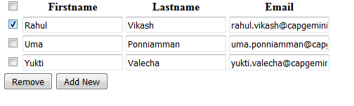

Figure 3

Removed Row

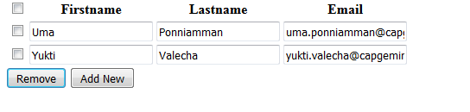

Figure 4

1. Angular Filters

|  |  |
| --- | --- |
| Goals | * Working with inbuilt filters & creating Custom filter |
| Time | 30 minutes |

## 2. Creating a webpage to work with angular inbuilt-filters

Create a web page and display the results shown below

## 

Figure 5

The data consists of 11 rows and 3 columns with the fields employee-ID, Name and Location.

Refer Below txt File

<Lab02.txt>

In the **Search field** we can search by Location such as, having letter 'B' anywhere in the string Location field. Result should appear as e.g, **'B**'angalore and Mum**'b'**ai.

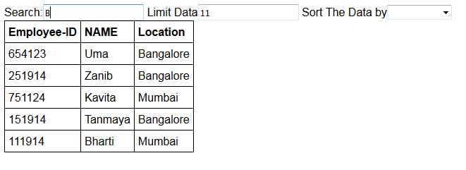**Figure 6**

In the **Limit field** we can limit the data eg how many number of rows we want .If we put 4 only first 4 rows will be displayed.

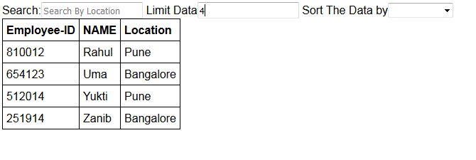

Figure 7

In the **Sort the Data by field** there are 3 options “**By employee-id**” ,”**By Name**”, ”**By Location**”, We can sort the data in ascending order by employeeid or by name or location eg sort by employee Id

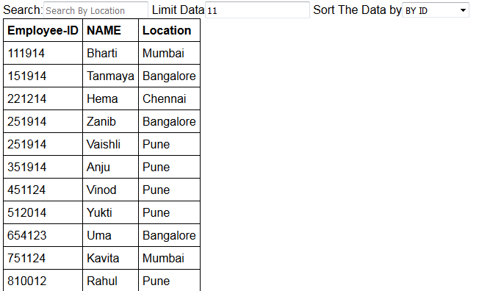

Figure 8

Lab 3: Angular UI web with Java middle ware application (Spring REST)

|  |  |
| --- | --- |
| Goals | * Understand the process of creating an angular webpage and view in a browser window ,with help of Spring RESTFUL Service |
| Time | 120 minutes |

## 3. Creating a webpage with angular Services & using Spring as Middleware with static data

1. Refer below Java files:

<Product.java>

<ProductDB.java>

Create a Product Spring RESTful web service that will display all products to the Web service consumer.

**Note:** Make use of the static DB given in ProductDB.java

Create a web page and display the results shown below

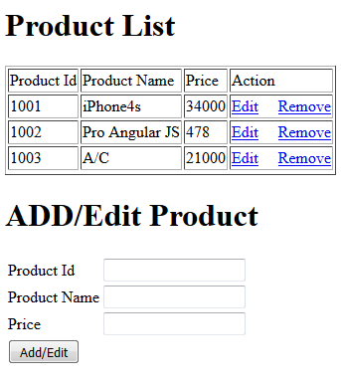

Figure 9

Get the data from static database with the help of RestFul API using the concept of Spring Webservice. (Note: Refer to ProductDb.java for static data)

Now When the user clicks on Remove link, the row data associated with that link is going to be deleted.

When clicking on Edit link, the data associated with that link is displayed below In Add/Edit Product & Product Id field becomes read only.

To Add the data in Product List we have to enter Product Id, Product Name and Price as shown -

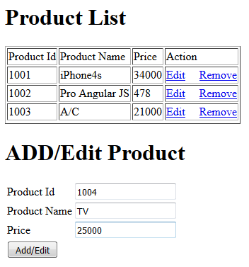

Figure 10

When Add/Edit button is clicked, Data will be added in static database using spring Restful API & data will get fetched from the static database with the help of RestFul API using the concept of Spring Webservice & displayed in the Product List.

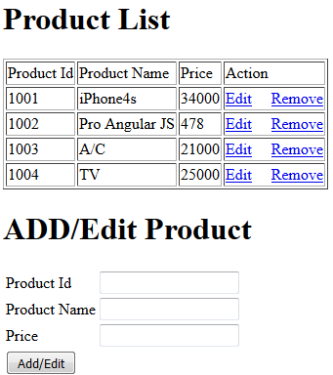

Figure 11

## Appendix A: Table of Figures

Figure 1 5

Figure 2 5

Figure 3 6

Figure 4 6

Figure 5 7

Figure 6 8

Figure 7 8

Figure 8 8

Figure 9 9

Figure 10 10

Figure 11 10