MDM Spread-Anchor Probe
Cached experiment report for the masked diffusion anchor probe.
Setup
For each prompt/completion pair, completion tokens are masked except for an anchor set. An anchor reveals the true token at its own token position. The experiment measures how revealing anchors changes the model distribution at the remaining masked token positions.
Greedy anchors are selected by entropy reduction after revealing the true token at candidate anchor position p, not by p_gt. For each target position q, H(q) is the entropy of the full vocabulary distribution at q. We report this gold-reveal metric as AggregatedIG_gt: sum_q [H_before(q) - H_after(q)], summed over remaining masked target positions q.
Because anchors are fixed to their ground-truth token values, AggregatedIG_gt is a gold-anchor entropy-change/influence measure rather than Shannon information gain, so it can be negative. True information gain would require averaging over all possible token values at the anchor position under P(X_p | z_A); implementing that expectation changes the probe cost from roughly K*T to K*T*V, adding a vocabulary-size factor, so we leave it as a later variant if needed.
The p_gt plots are diagnostic: they show teacher-forced gold-token confidence before anchors and after each layout at matched k. Black dotted vertical lines mark the greedy_ig anchor positions.
Models And Datasets
Model | Dataset | Prompts | Mean prompt tokens | Mean completion tokens
LLaDA-8B-Instruct | GSM8K | 20 | 73.9 | 113.9
LLaDA-8B-Instruct | HumanEval | 20 | 118.0 | 46.4
Dream-v0-Instruct-7B | GSM8K | 20 | 80.3 | 113.8
Dream-v0-Instruct-7B | HumanEval | 20 | 114.5 | 41.0
Layout-Control Scores
Each model/dataset has two tables. The first reports the entropy-reduction score used for anchor selection, AggregatedIG_gt = sum_q H_before(q) - H_after(q). The second reports the same result as gold entropy delta: sum_q H_after(q) - H_before(q). Negative entropy delta means the gold anchors made the model more certain.
LLaDA-8B-Instruct / GSM8K
AggregatedIG_gt: sum(H_before - H_after)
k | greedy_ig | max separated | prefix | suffix | middle cluster
1 | 105.34 | 28.85 | 5.71 | -33.36 | 21.26
2 | 171.18 | -22.06 | 16.01 | -23.17 | 27.63
3 | 214.78 | -0.44 | 17.84 | -9.43 | 45.97
4 | 249.30 | 37.67 | 16.75 | -2.18 | 46.43
5 | 273.09 | 57.22 | 22.07 | 9.96 | 54.17
6 | 289.61 | 98.32 | 21.96 | 14.71 | 58.83
7 | 297.04 | 122.08 | 26.35 | 22.80 | 69.16
8 | 302.24 | 124.04 | 30.54 | 22.62 | 74.48
9 | 305.46 | 169.28 | 31.76 | 26.00 | 76.50
10 | 305.11 | 179.01 | 44.02 | 29.25 | 80.27
Gold entropy delta: sum(H_after - H_before)
k | greedy_ig | max separated | prefix | suffix | middle cluster
1 | nan | nan | nan | nan | nan
2 | nan | nan | nan | nan | nan
3 | nan | nan | nan | nan | nan
4 | nan | nan | nan | nan | nan
5 | nan | nan | nan | nan | nan
6 | nan | nan | nan | nan | nan
7 | nan | nan | nan | nan | nan
8 | nan | nan | nan | nan | nan
9 | nan | nan | nan | nan | nan
10 | nan | nan | nan | nan | nan
LLaDA-8B-Instruct / HumanEval
AggregatedIG_gt: sum(H_before - H_after)
k | greedy_ig | max separated | prefix | suffix | middle cluster
1 | 88.27 | 33.07 | 16.16 | 10.12 | 29.04
2 | 117.34 | 18.34 | 29.82 | 25.93 | 48.81
3 | 130.29 | 38.74 | 42.94 | 31.75 | 66.15
4 | 135.29 | 72.13 | 47.59 | 41.22 | 74.53
5 | 143.31 | 83.50 | 48.08 | 47.06 | 75.84
6 | 149.70 | 105.90 | 56.96 | 48.49 | 75.04
7 | 150.79 | 117.97 | 58.53 | 52.01 | 81.68
8 | 165.59 | 138.83 | 63.51 | 58.24 | 98.89
9 | 163.54 | 148.81 | 65.25 | 53.81 | 97.20
10 | 160.89 | 150.09 | 69.31 | 56.11 | 104.82
Gold entropy delta: sum(H_after - H_before)
k | greedy_ig | max separated | prefix | suffix | middle cluster
1 | nan | nan | nan | nan | nan
2 | nan | nan | nan | nan | nan
3 | nan | nan | nan | nan | nan
4 | nan | nan | nan | nan | nan
5 | nan | nan | nan | nan | nan
6 | nan | nan | nan | nan | nan
7 | nan | nan | nan | nan | nan
8 | nan | nan | nan | nan | nan
9 | nan | nan | nan | nan | nan
10 | nan | nan | nan | nan | nan
Dream-v0-Instruct-7B / GSM8K
AggregatedIG_gt: sum(H_before - H_after)
k | greedy_ig | max separated | prefix | suffix | middle cluster
1 | 132.97 | 22.47 | 38.31 | 40.16 | 28.64
2 | 188.97 | 56.33 | 55.02 | 46.68 | 24.89
3 | 206.06 | 55.49 | 47.20 | 37.56 | 36.76
4 | 218.99 | 63.15 | 45.06 | 37.51 | 20.64
5 | 219.66 | 43.45 | 44.80 | 27.86 | 22.23
6 | 224.74 | 63.81 | 37.92 | 42.18 | 43.64
7 | 225.65 | 55.04 | 29.07 | 53.40 | 51.01
8 | 227.81 | 45.56 | 26.06 | 38.05 | 39.33
9 | 230.68 | 49.11 | 27.10 | 32.48 | 45.05
10 | 34.83 | 13.93 | 19.60 | 52.40 | 41.00
Gold entropy delta: sum(H_after - H_before)
k | greedy_ig | max separated | prefix | suffix | middle cluster
1 | nan | nan | nan | nan | nan
2 | nan | nan | nan | nan | nan
3 | nan | nan | nan | nan | nan
4 | nan | nan | nan | nan | nan
5 | nan | nan | nan | nan | nan
6 | nan | nan | nan | nan | nan
7 | nan | nan | nan | nan | nan
8 | nan | nan | nan | nan | nan
9 | nan | nan | nan | nan | nan
10 | nan | nan | nan | nan | nan
Dream-v0-Instruct-7B / HumanEval
AggregatedIG_gt: sum(H_before - H_after)
k | greedy_ig | max separated | prefix | suffix | middle cluster
1 | 24.71 | 14.76 | 14.74 | 10.83 | 13.02
2 | 28.12 | 13.51 | 15.13 | 12.77 | 13.27
3 | 29.75 | 12.14 | 9.30 | 13.12 | 12.95
4 | 30.61 | 10.49 | 9.33 | 14.49 | 11.98
5 | 32.56 | 11.31 | 12.15 | 13.46 | 11.02
6 | 32.84 | 14.43 | 13.22 | 12.69 | 13.44
7 | 33.28 | 12.52 | 12.53 | 11.64 | 9.11
8 | 37.30 | 11.50 | 16.85 | 12.57 | 10.39
9 | 37.81 | 13.30 | 17.15 | 12.13 | 10.33
10 | -0.14 | 0.43 | 15.80 | 12.19 | 11.35
Gold entropy delta: sum(H_after - H_before)
k | greedy_ig | max separated | prefix | suffix | middle cluster
1 | nan | nan | nan | nan | nan
2 | nan | nan | nan | nan | nan
3 | nan | nan | nan | nan | nan
4 | nan | nan | nan | nan | nan
5 | nan | nan | nan | nan | nan
6 | nan | nan | nan | nan | nan
7 | nan | nan | nan | nan | nan
8 | nan | nan | nan | nan | nan
9 | nan | nan | nan | nan | nan
10 | nan | nan | nan | nan | nan
Layout p_gt Examples
One cached prompt is shown for each model/dataset pair at k = 1, 2, 4, and 8.
k = 1
LLaDA-8B-Instruct / GSM8K, example 0
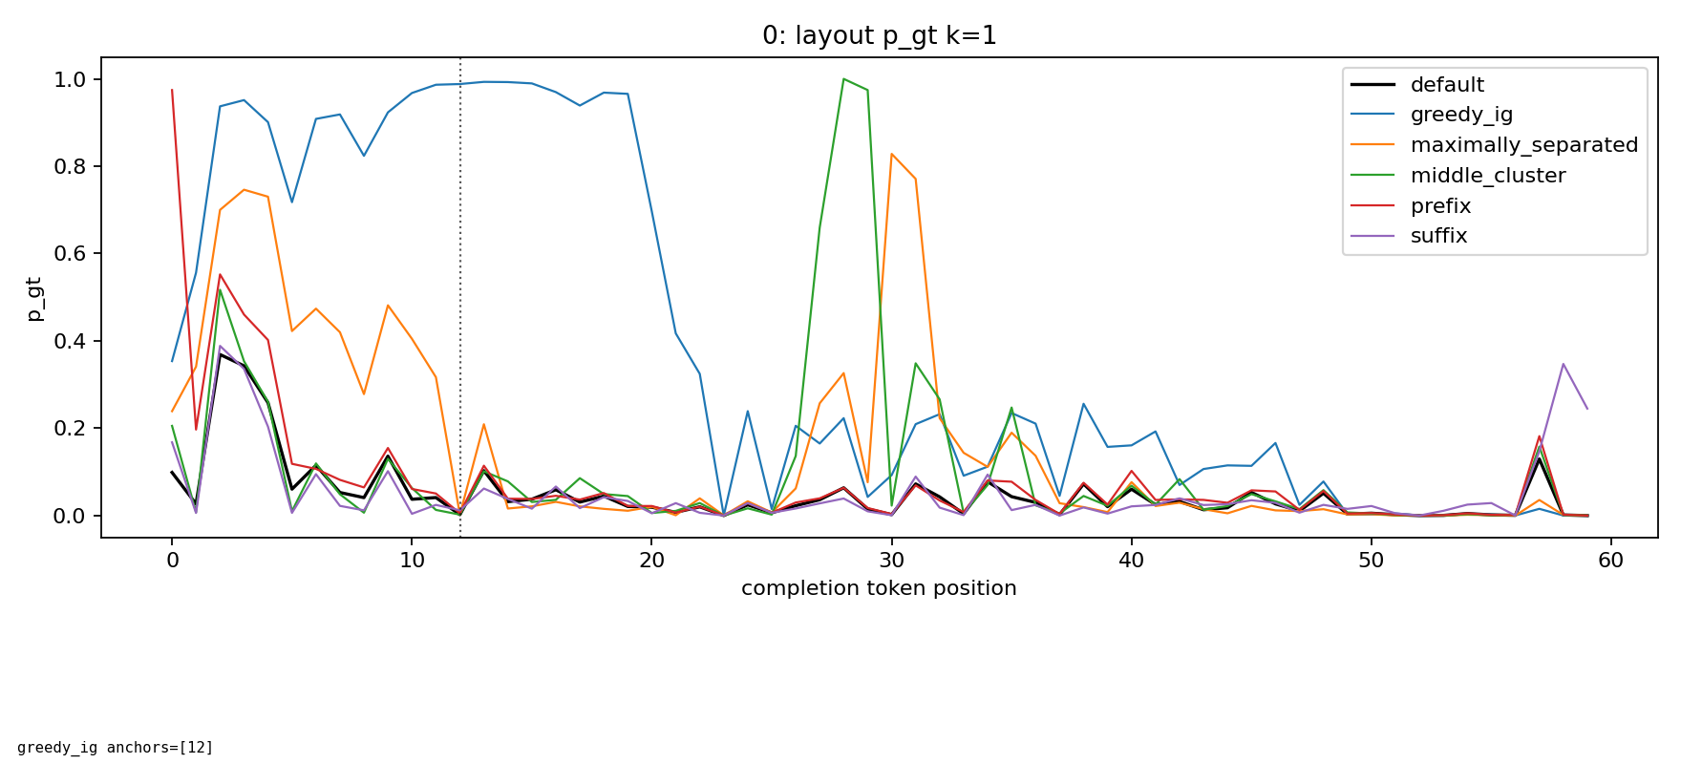
LLaDA-8B-Instruct / HumanEval, example HumanEval/0
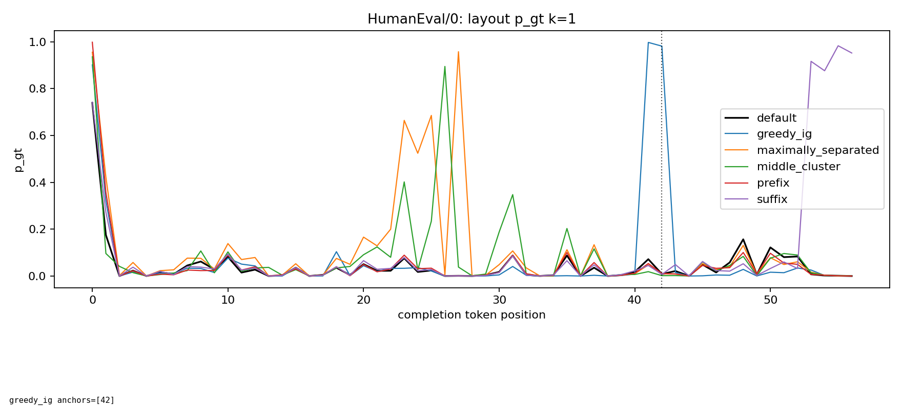
Dream-v0-Instruct-7B / GSM8K, example 0
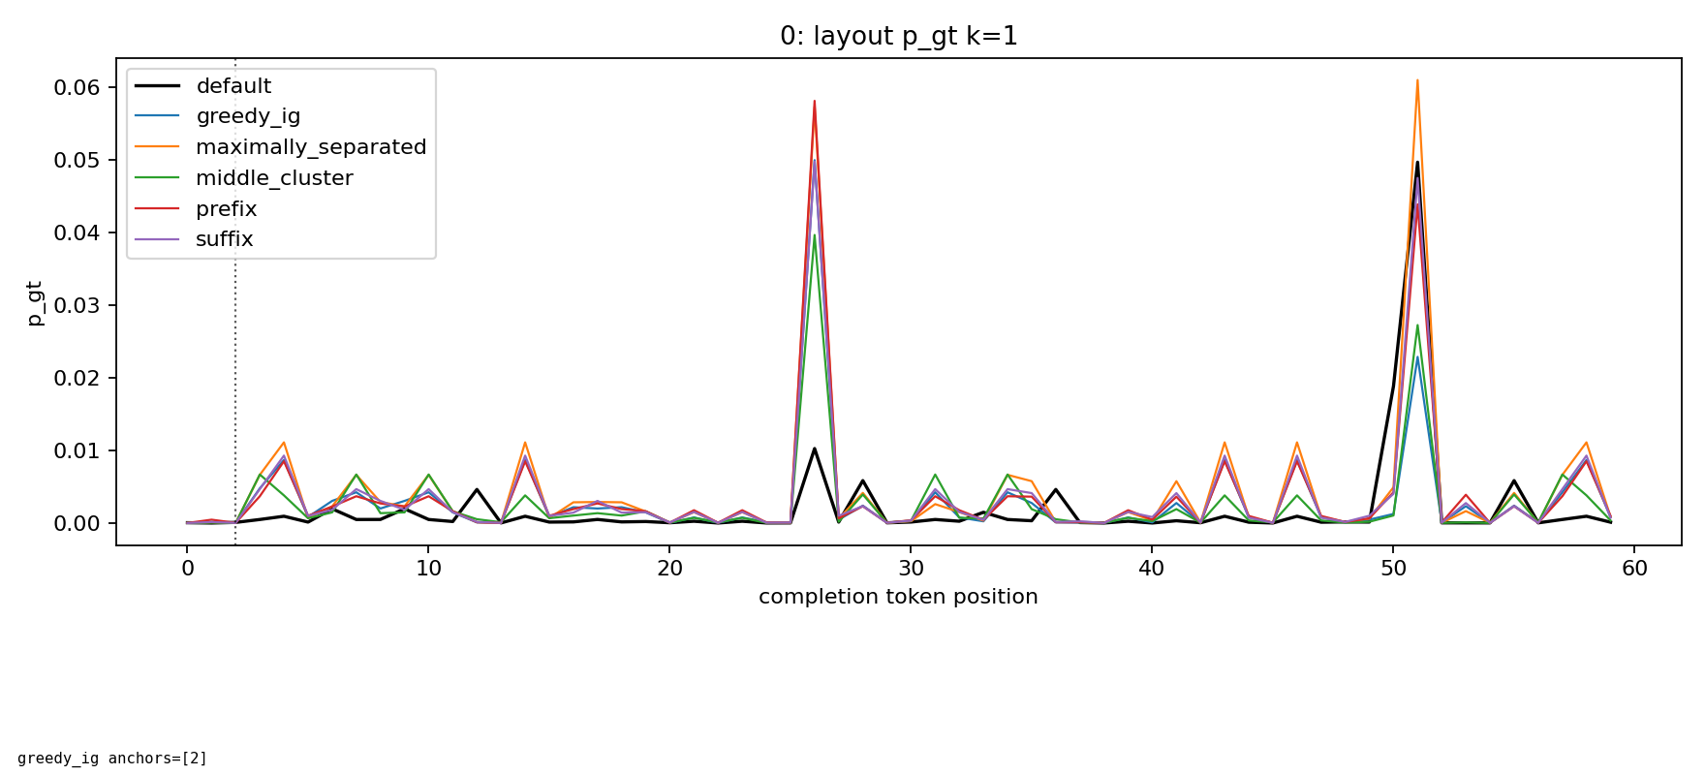
Dream-v0-Instruct-7B / HumanEval, example HumanEval/0
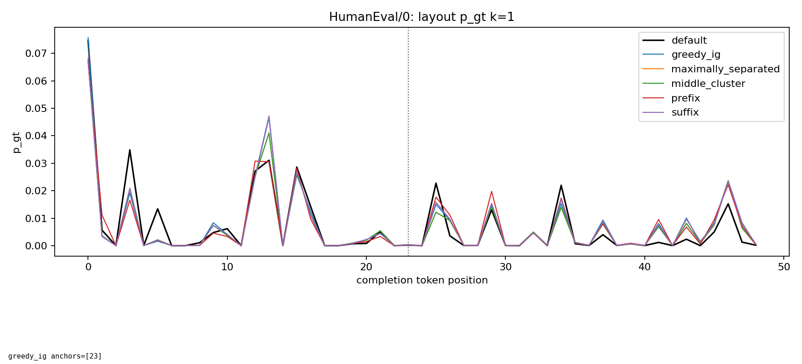
k = 2
LLaDA-8B-Instruct / GSM8K, example 0
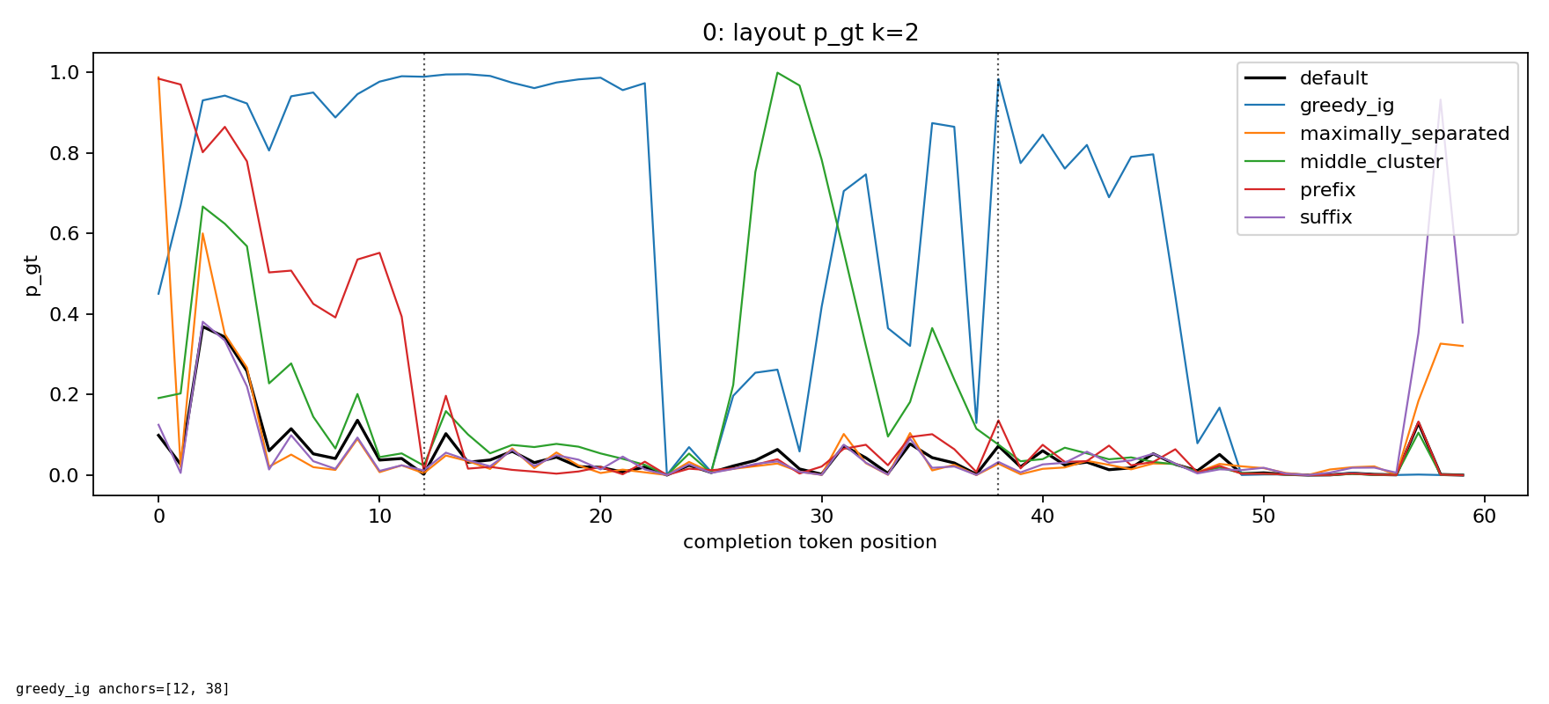
LLaDA-8B-Instruct / HumanEval, example HumanEval/0
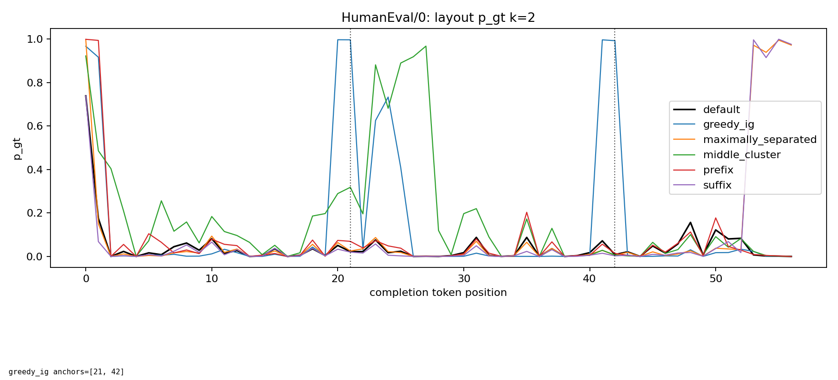
Dream-v0-Instruct-7B / GSM8K, example 0
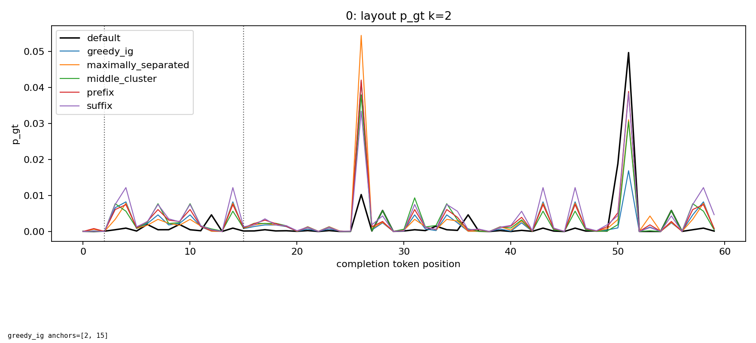
Dream-v0-Instruct-7B / HumanEval, example HumanEval/0
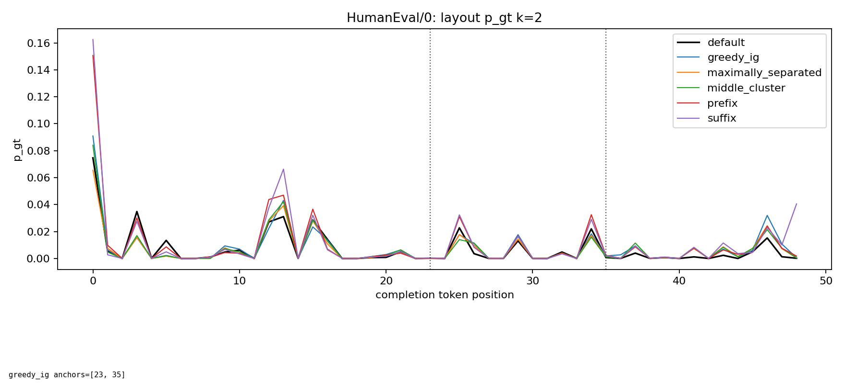
k = 4
LLaDA-8B-Instruct / GSM8K, example 0
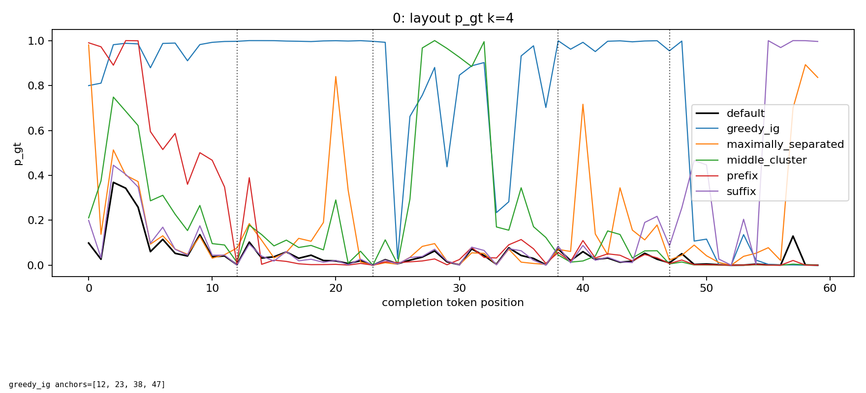
LLaDA-8B-Instruct / HumanEval, example HumanEval/0
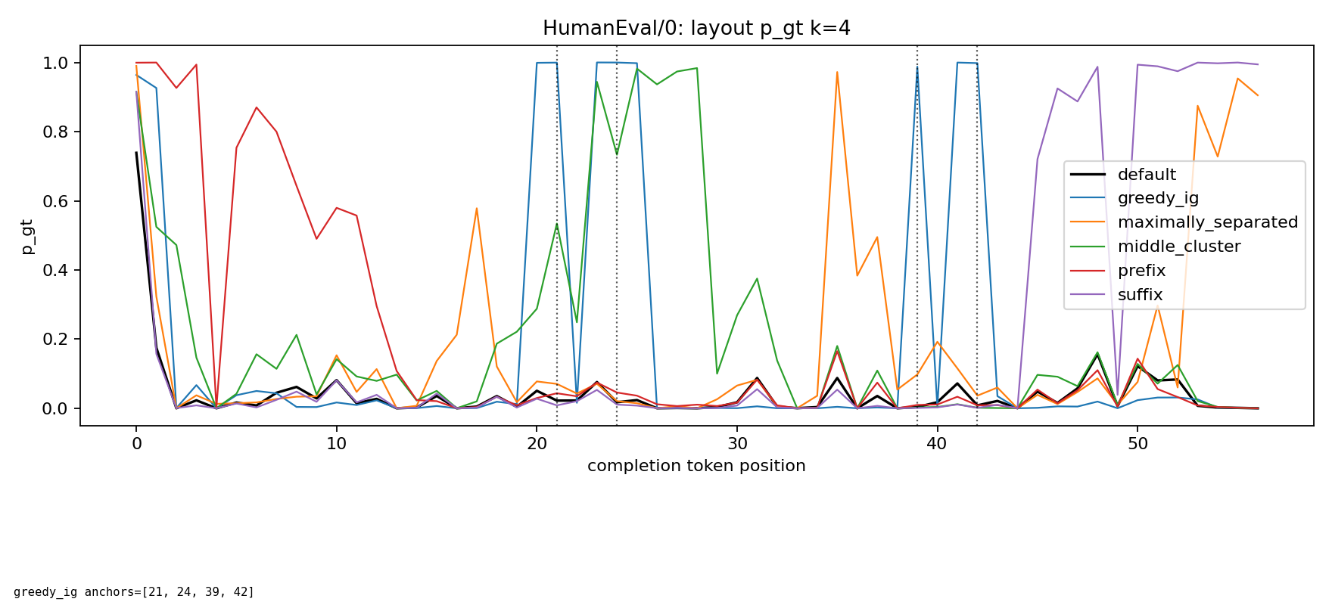
Dream-v0-Instruct-7B / GSM8K, example 0
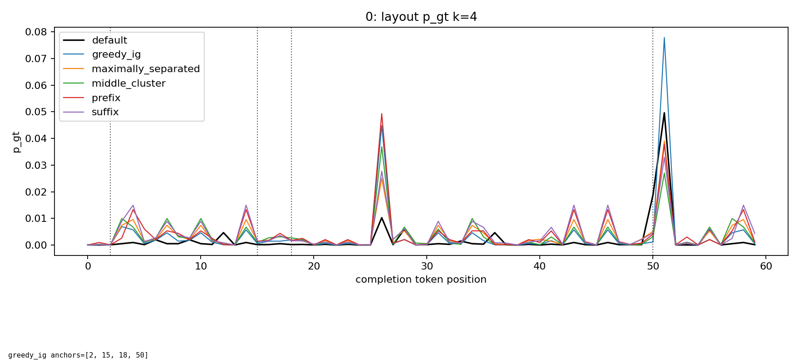
Dream-v0-Instruct-7B / HumanEval, example HumanEval/0
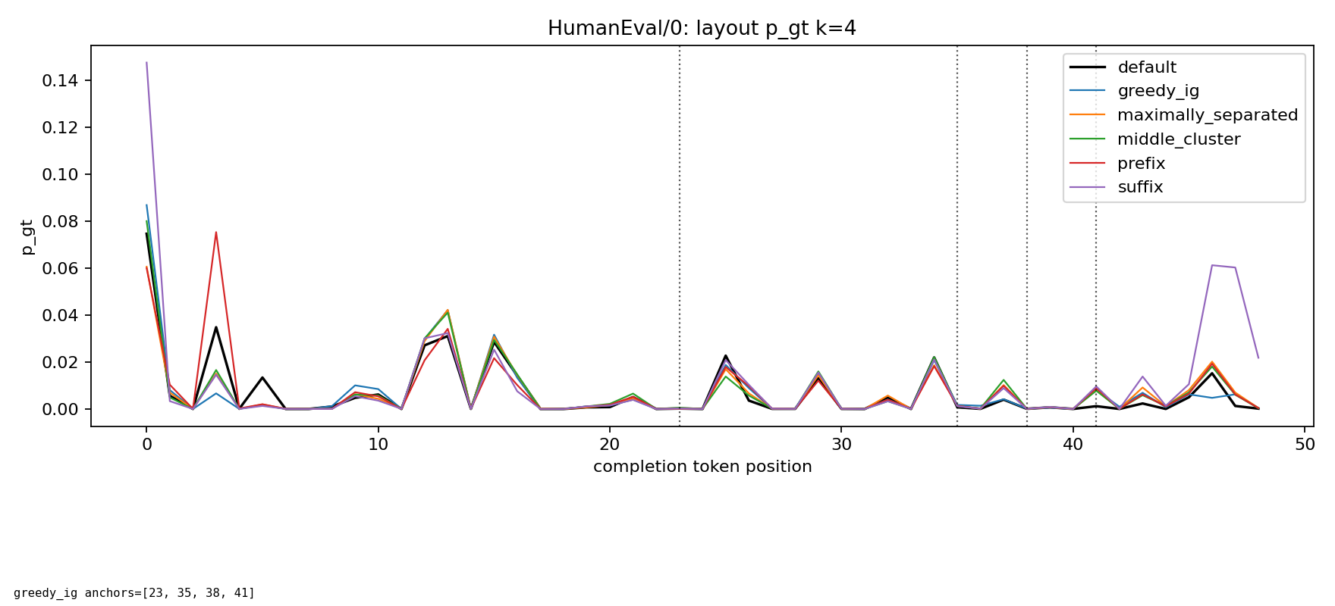
k = 8
LLaDA-8B-Instruct / GSM8K, example 0
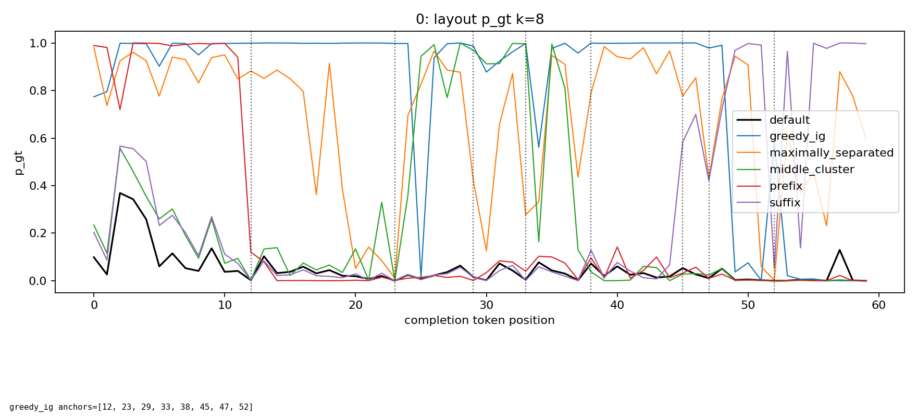
LLaDA-8B-Instruct / HumanEval, example HumanEval/0
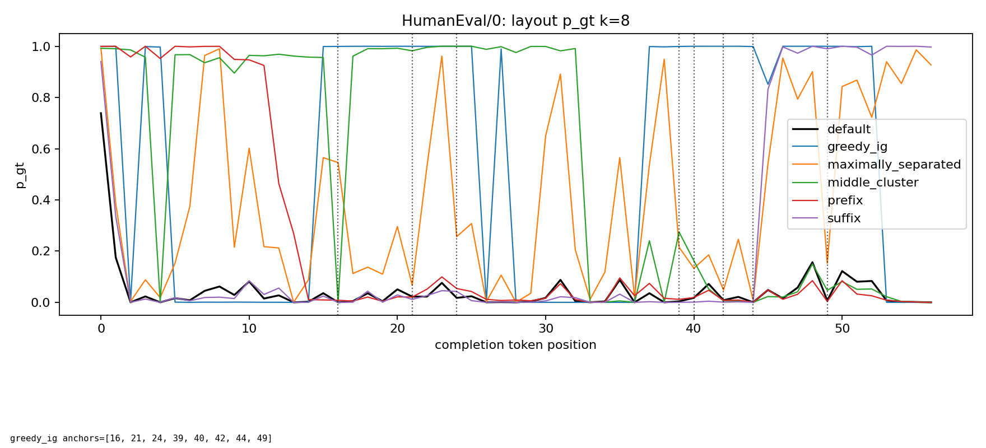
Dream-v0-Instruct-7B / GSM8K, example 0
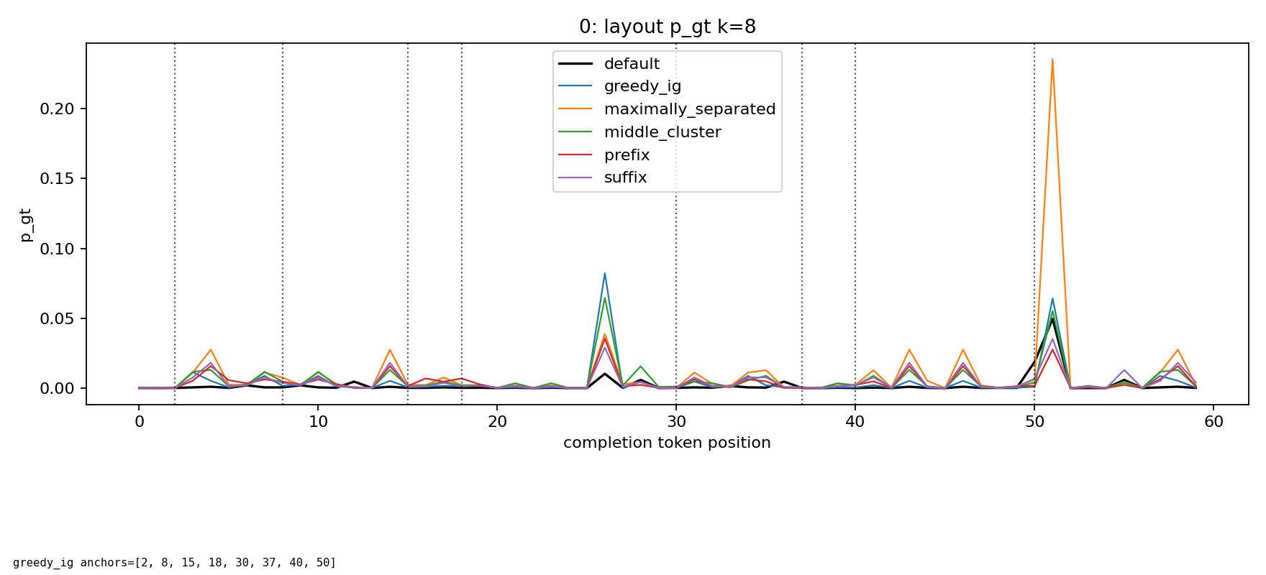
Dream-v0-Instruct-7B / HumanEval, example HumanEval/0
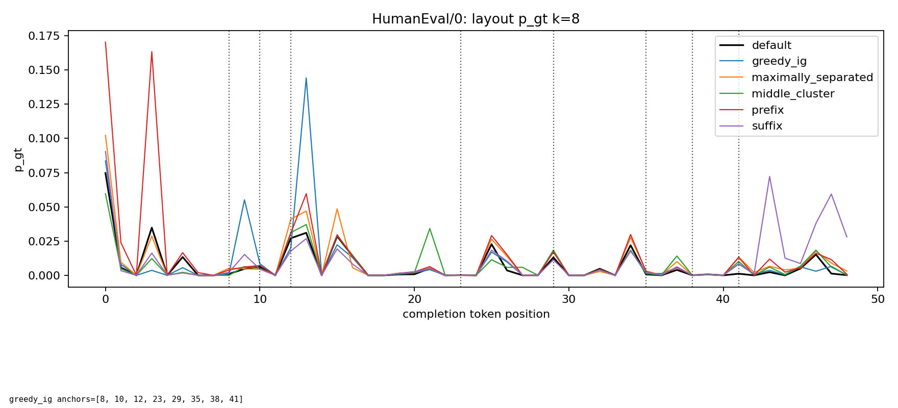
Conclusion And Next Steps
The layout-control tables show whether greedy AggregatedIG_gt anchors produce larger summed gold entropy reduction than simple prefix, suffix, middle-cluster, or maximally separated anchors. This supports the core anchor-position hypothesis: where the revealed true tokens are placed matters.
The GSM8K effect is especially strong, which may partly reflect that GSM8K solutions are more structured and easier for these models once a few informative tokens are revealed. Code generation is more mixed: Dream shows a much smaller HumanEval effect, while LLaDA still benefits but the layout controls narrow the gap at larger k. The weaker or mixed code signal is surprising and worth checking on more prompts and other code tasks.
Next steps: test additional domains such as MATH500, bio, legal, creative writing, and text-to-SQL; add alternative confidence scores such as max_w p(w | z_A, q), p_gt, and log p_gt/NLL; and only after the anchor mechanism is established, evaluate downstream decoding metrics such as GSM8K exact match and HumanEval pass@1.

