**TC_Login_001 - Verify the login of HRM with valid credentials.**

1. Enter valid username

2. Enter valid password

3. Click on "Login" button

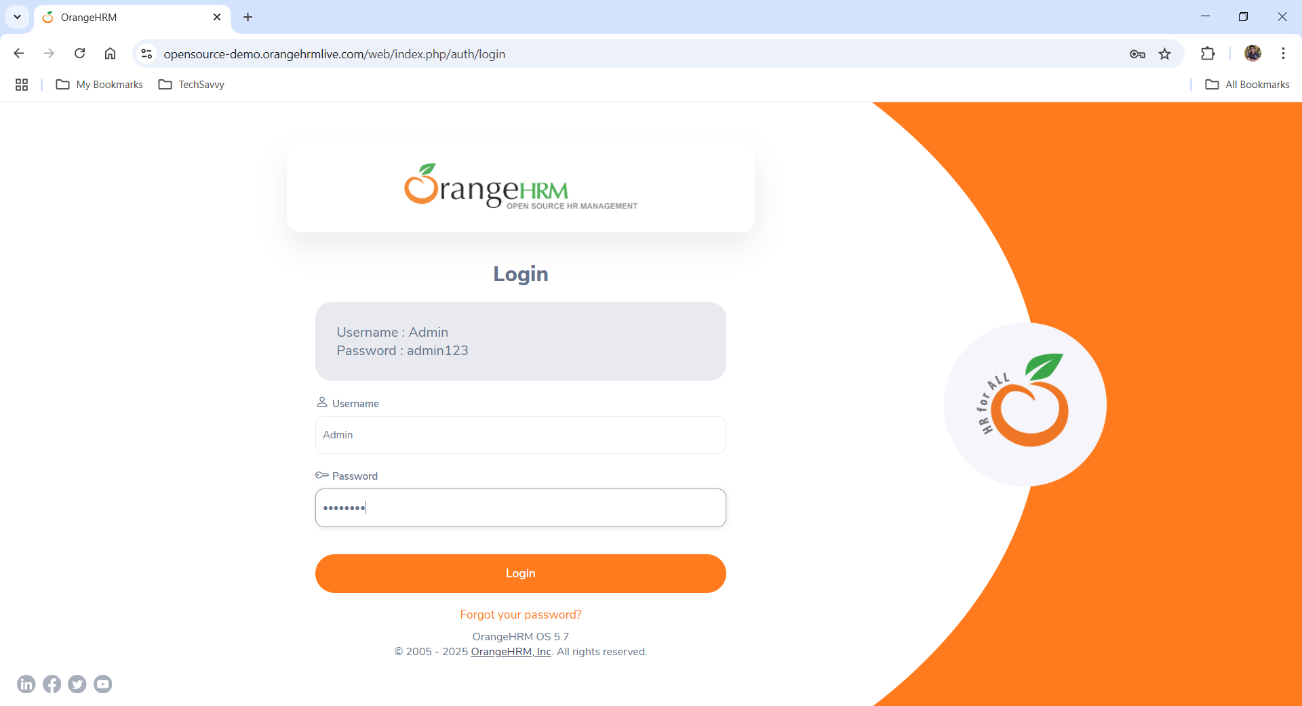

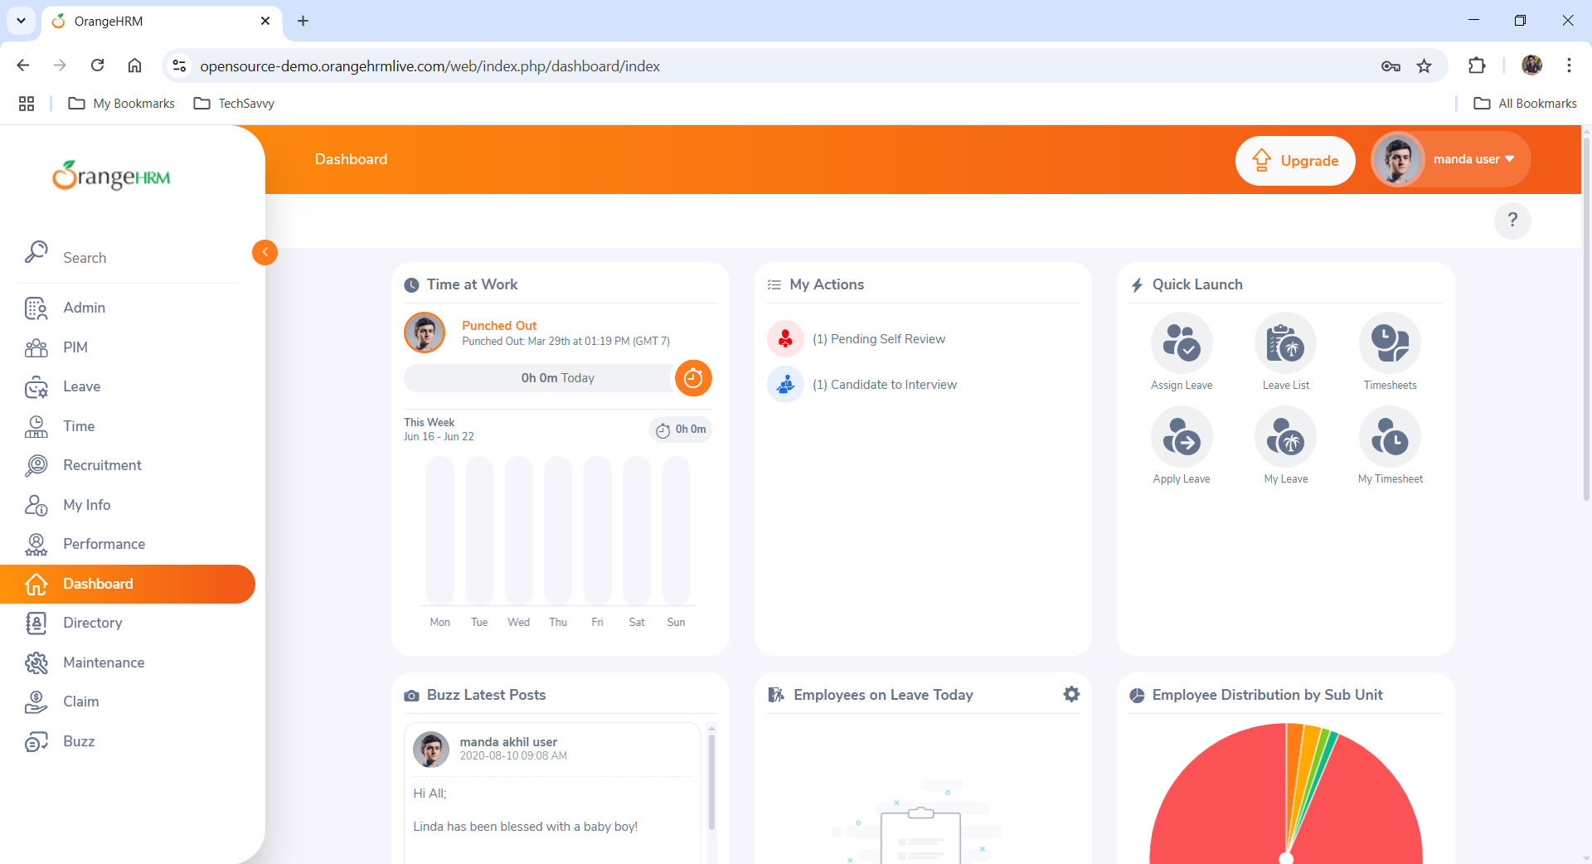

Expected: User should be logged in successfully.

Actual: User is able to logged in successfully.

**TC_Login_002 - Verify the login of HRM with invalid username and valid password.**

1. Enter invalid username

2. Enter valid password

3. Click on "Login" button

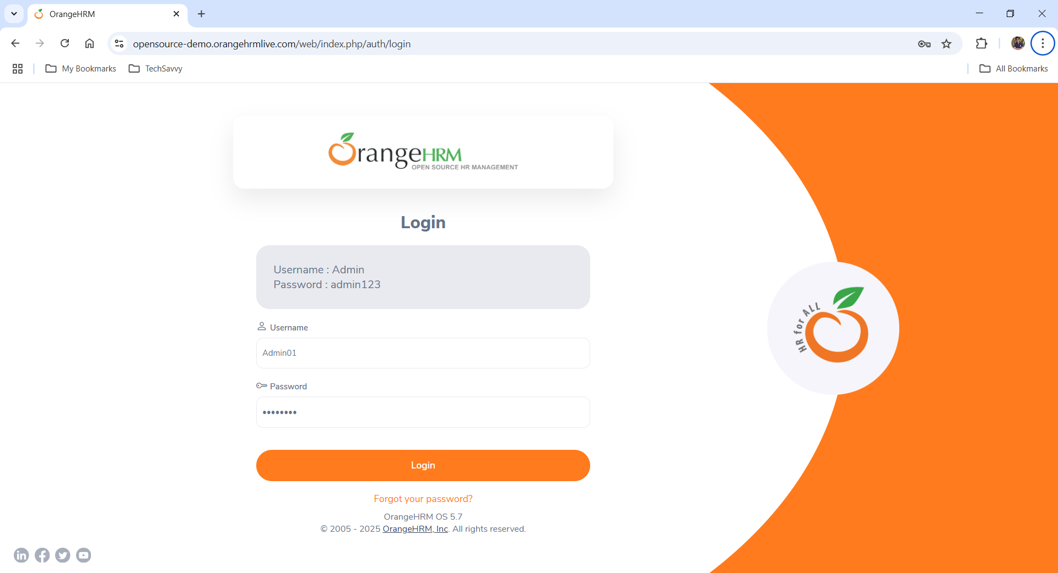

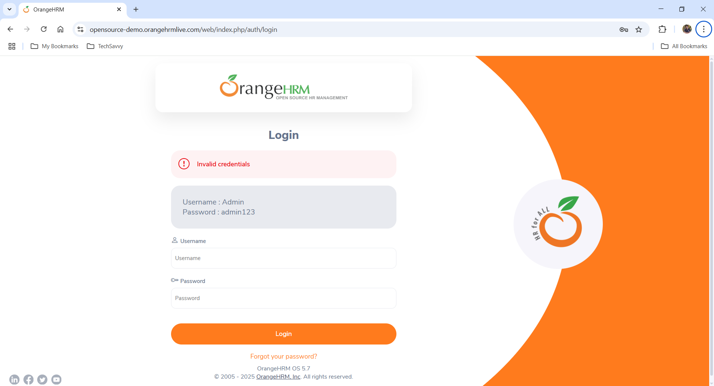

Expected: User should not be logged in successfully.

Actual: User should not be logged in successfully.