**Contents**

**INTRODUCTION .................................................................................................................................. 4**

**LIMITATIONS WITH LEGACY SYSTEMS ..................................................................................................4**

**OBJECTIVES ......................................................................................................................................... 4**

**IMPORTANCE OF WEB RD – CONDUCTOR ............................................................................................ 4**

**TOPIC OF THIS PAPER AND ITS SCOPE .................................................................................................. 5**

**SOLUTION OFFERING BY SYNECHRON ..................................................................................................5**

**Application FRAMEWORK ................................................................................................................... 6**

*a. User Interface Layer (UI) ................................................................................. 8*

*b. Conductor .................................................................................................... 12*

*c. One Click Deployments .................................................................................. 15*

**CASE STUDY ...................................................................................................................................... 20**

*a. Context ....................................................................................................... 20*

*b. Objectives .................................................................................................... 20*

*c. Solution ....................................................................................................... 20*

*d. Salient Features ............................................................................................ 21*

**INTRODUCTION**

The SyneMobile application framework is an all-in-one protection application and companion web portal featuring Security, Recovery, Content Backup, and Diagnostic functions such as Health Scan, Battery Management, and technical support.

AMF will be available across all Android devices, and the web portal will be accessible through all major browsers including optimization for mobile browsers.

The overall product objective is to create a compelling “shrink wrap” Protection Application (PA) product which is vertically integrated with Device Protection (DP) and Premier Support (PS) in order to compliment a Mobile Protection (MP) offer.

In order to achieve these objectives the product will be constructed as a platform solution consisting of two key components:

1.

Customer experience interfaces(s) built by the Synechron (AMA) team: The primary customer experience interfaces or UIs will consist of web portal and companion mobile application(s).

2.

AMF Eligibility Platform built by enterprise middle-tier team: The EP is a customer relationship management system consisting of databases and rules engines which manage and track customers’ eligibility for AMF. The system will have 4 primary functions.

1. Enrollment File Processing: The system will process enrollment files from channel partners and grant access to AMF based on specific criteria.
2. ActivationCodes: In order to properly link customer enrollment records to accounts created on the Web or through a Mobile App, customers will receive activations codes from channel partner. The creation, security, and confirmation of activations codes will be managed as part of the EP.

Whitelisting: While external customers’ records will be managed via enrollment files, internal or specially designated customers will be “whitelisted” and granted complimentary access to Premium features. The EP will be capable of processing “whitelist” enrollment requests from internal Asurion systems and processes.

1. In App Purchase: Specific to Android, the ability to purchase a “standalone” subscription to “Premium” will be facilitated through Google Wallet’s in-app purchase mechanism. The EP solution will manage the backend customer records as necessary to integrate with Google Wallet and facilitate eligibility.

Problems/Limitations

Through Synechron’s relationships with leading customers around the world, it was noticed that increasingly, wireless carriers and subscribers were demonstrating a growing demand for security of their mobile devices i.e. to protect not only their phones, but also the valuable data and content on the phones. (along with a strong technical support)

Today, business is increasingly likely to be a mobile enterprise, conducted using devices that might not have been existed a few years ago. Mobile devices also add significant value to people and organizations through increased efficiency and productivity. The world around us is also digitally transforming in a way that is having significant impact on how people and enterprises operate and this is affecting the technology and systems that are designed and built to support them.

Proper technical support

There is also a lack of prompt technical support for the end users and there is huge void which needs to be fill in to keep the customers/users engaged with the business.

Threats to Mobile Security

Security and privacy are the two highly dynamic and fast- paced challenges faced by end users and since mobile phones become user programmable i.e. they supports app downloads, the scope for device protection extends and is not limited to data-theft. There is also a possibility that a virus-infected or malware app be installed on the device and may not only harm the device OS but can also act in leakage of user data.

Threats can be categorized as-

Application-level

Major threat which falls in this category is malware

Data or Storage-Level:

These threats are related to files which we copy or transfer to the device, these can be word documents, excel sheets, pdf or may be apk(android package) files. Sometimes these are virus infected and can vitiate the whole storage system.

Web-Level:

These kind of threats do not directly impact devices but still the users's privacy is at risk from these kind of threats. One of the main web related threat is phishing, which uses emails and other un-trusted platforms to send across links to a phishing website which is developed to trick the end users into providing sensitive information like his credentials.

Objective

Protection applications objective is to provide data management features such as backup and restore contact and content data; recovery options such as locate, lock, wipe, and alarm; security options such as antivirus, app assist, and malware detection; and mobile technical support services. AMA applications enhance mobile experience and satisfaction for subscribers, and provide value-added services for carriers, OEMs, and partners.

So while providing all these functionalities it should not be the case that the app UI will get so complex that it loses it shine(synm). User's data is the most sensitive and needs to be secured at any cost.

Solution

The solution came into existence in the form of a protection application framework which will incorporate a host of features including -

These functions together in tendem will provide a complete mobile solution and at the same time will be user centric.

**Architecture**

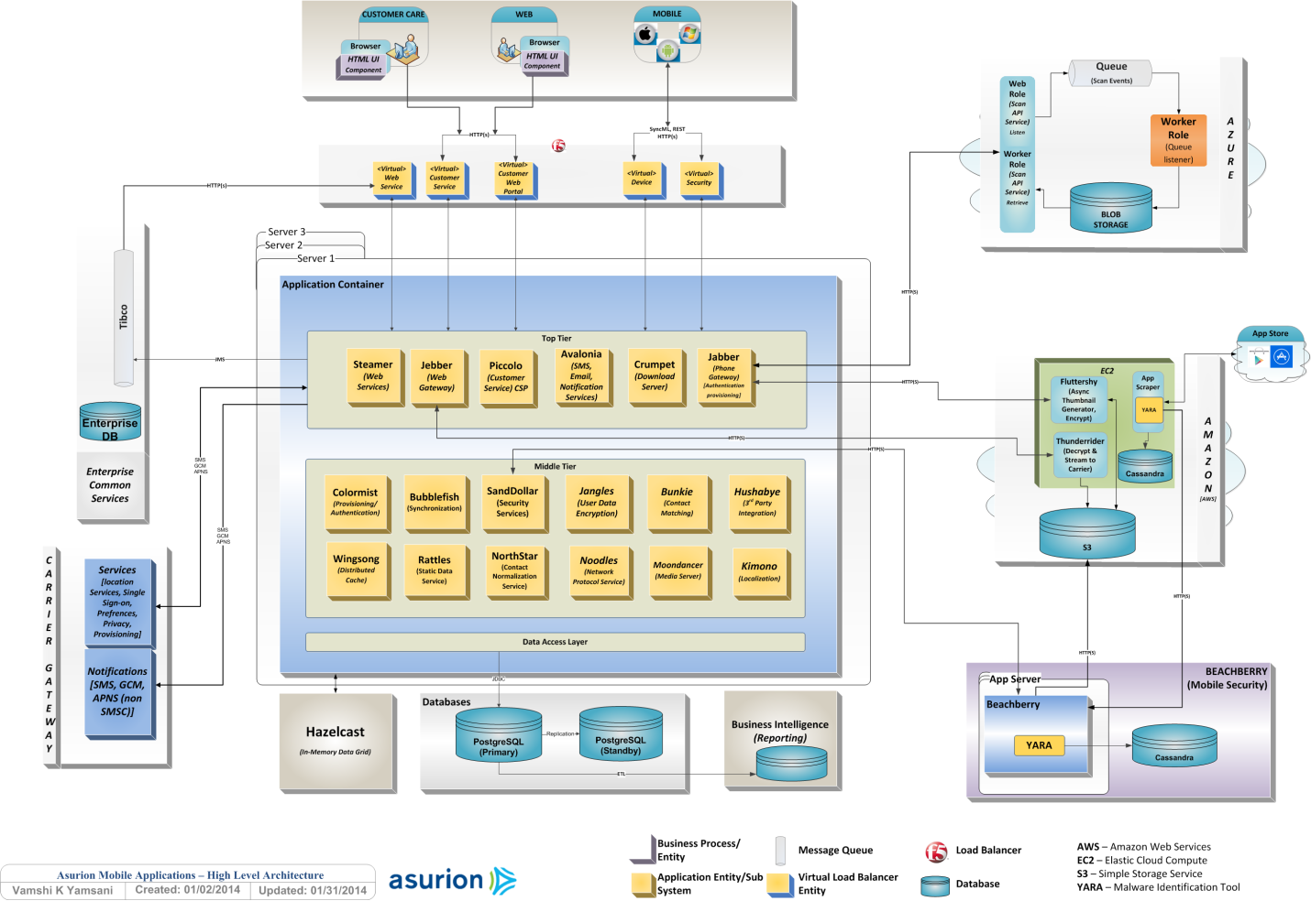

Telemetery-

Customer Support-

The AMA Operations Production Support team is central to resolving issues and outages that impact customers and carriers.

Functionalties -

Backup/Restore

Locate/Sound/Lock/Wipe

AntiVirus/Safebrowsing

Remote Customer Support

Telemetery & Bigdata anaylsis

Live Chat and KIA(Knowledge based module)