**PARKING ASSISTANCE SYSTEM**

**by**

**Yash Kumar (1900320100202)**

**Shourya Nagpal (1900320100154)**

**Vishal Singh Chaudhary (1900320100199)**

**Department of Computer Science & Engineering**



**ABES Engineering College**

**19th Km Stone, NH-09, Ghaziabad (U.P)**

**April, 2023**

**PARKING ASSISTANCE SYSTEM**

**by**

**Yash Kumar (1900320100202)**

**Shourya Nagpal (1900320100154)**

**Vishal Singh Chaudhary (1900320100199)**

**Submitted to the department of Computer Science & Engineering**

**in partial fulfilment of the requirements**

**for the degree of**

**Bachelor of Technology**

**in**

**Computer Science & Engineering**



**ABES Engineering College, Ghaziabad**

**Dr. A.P.J. Abdul Kalam Technical University, Uttar Pradesh Lucknow**

**April, 2023**

***DECLARATION***

*We hereby declare that this submission is our own work that, to the best of our knowledge and belief, it contains no material previously published or written by another person nor material which to a substantial extent has been accepted for the award of any other degree or diploma of the university .or other institute of higher learning, except where due acknowledgment has been made in the text*

*Signature:*

*Name: Yash Kumar*

*Roll number: 190032010020*

*Date:*

*Signature:*

*Name: Shourya Nagpal*

*Roll number: 1900320100154*

*Date:*

*Signature:*

*Name: Vishal Singh Chaudhary*

*Roll number: 1900320100199*

*Date:*

**CERTIFICATE**

This is to certify that Project Report entitled “Parking Assistance System” which is submitted by Yash Kumar, Shourya Nagpal & Vishal Singh Chaudhary in partial fulfillment of the requirement for the award of degree Bachelors of Technology in Department of Computer Science & Engineering of Dr. A.P.J. Abdul Kalam Technical University, formerly Uttar Pradesh Technical University is a record of the candidates’ own work carried out by them under my supervision.

The plagiarism percentage evaluated for the content presented is

The matter embodied in this thesis is original and has not been submitted for the award of any other degree.

**Supervisor Signature**

**Name: Abhishek Kumar Shukla**

**Designation: Assistant Professor (Computer Science & Engineering)**

**Date:**

**ACKNOWLEDGEMENT**

It gives us a great sense of pleasure to present the report of the B. Tech Project undertaken during B. Tech. Final Year. We owe special debt of gratitude to Professor Abhishek Kumar Shukla, Department of Computer Science & Engineering, ABESEC Ghaziabad for his constant support and guidance throughout the course of our work. His sincerity, thoroughness and perseverance have been a constant source of inspiration for us. It is only his cognizant efforts that our endeavors have seen light of the day.

We also take the opportunity to acknowledge the contribution of Professor (Dr.) Divya Mishra, Head, Department of Computer Science & Engineering, ABESEC Ghaziabad for her full support and assistance during the development of the project.

We also do not like to miss the opportunity to acknowledge the contribution of all faculty members of the department for their kind assistance and cooperation during the development of our project. Last but not the least, we acknowledge our friends for their contribution in the completion of the project.

**Signature: Signature: Signature:**

**(Yash Kumar) (Shourya Nagpal) (Vishal Singh Chaudhary)**

**ABSTRACT**

The shortage of space results in people parking their vehicles almost anywhere without organization. Usually what happens is that in unorganized spaces, people park their vehicles behind other already parked vehicles and this many times leads to chaos when the vehicle parked in the interior needs to get out of there as some vehicle is always blocking the exit. There needs to be a medium to contact the driver of the vehicle blocking the exit so that the stuck vehicle owner can ask them to move their vehicle a bit so that they can bring out theirs. Tackling this issue is the first phase of our journey towards fixing the vehicle management system of India.

How are we going to do that? Let's suppose A's car is stuck behind B's car in an unorganized parking lot. A and B will both have an app designed by us in their mobile phones. A will just need to open the app and scan the number plate of B from our app's scanner and our tech will read that number plate and give out the details B and the car. A will also have options to contact B via text, call, or just a simple notification alert to B so that he/she knows that they need to move their car.

**TABLE OF CONTENTS** Page

LIST OF TABLES............................................................................................................i

LIST OF FIGURES..........................................................................................................ii

LIST OF ABBREVIATIONS ............................................................................................iii

CHAPTER 1.....................................................................................................................1

1.1. ................................................................................................................1

1.1.1…………………………………………………………………..........1

1.1.2…………………………………………………………………...…...2

1.1.3………………………………………………………………………...2

1.2...................................................................................................................3

1.3.………………………………………………………………............................5

CHAPTER 2 ……………………………. ...........................................................................6

2.1..................................................................................................................6

2.2..................................................................................................................9

2.3................................................................................................................10

CHAPTER 3 .…………………………….........................................................................11

3.1.................................................................................................................11

3.2.................................................................................................................17

CHAPTER 4 ……………………....................................................................................20

4.1…………………………………………………………………………............20

4.2.................................................................................................................21

4.3…………………………………………………………………………............22

4.4…………………………………………………………………………............29

CHAPTER 5 …………………………………………………………………….……………..30

5.1…………………………………………………………………………............30

5.2…………………………………………………………………………............33

5.3…………………………………………………………………………............35

APPENDIX A .................................................................................................................37

REFERENCES................................................................................................................40

**LIST OF TABLES**

|  |  |  |
| --- | --- | --- |
| **S.No** | **Table Name** | **Page No** |
| 1 | Table 2.1 Tabular Summary for Literature Review Based Papers | 8 |
| 2 | Table 4.1 Test cases and their results | 29 |

**LIST OF FIGURES**

|  |  |  |
| --- | --- | --- |
| **S.No** | **Figure Name** | **Page No** |
| 1 | Use Case Diagram | 9 |
| 2 | Sequence Diagram | 10 |
| 3 | System Architecture | 11 |
| 4 | Flow Chart | 12 |
| 5 | Entity Relationship Diagram | 13 |
| 6 | DFD Level 0 | 14 |
| 7 | DFD Level 1 | 14 |
| 8 | Activity Diagram | 15 |
| 9 | Class Diagram | 16 |
| 10 | Deep Learning model algorithm | 17 |
| 11 | Plate detection using Contours algorithm | 18 |
| 12 | Characters segmentation algorithm | 19 |
| 13 | Home Screen | 22 |
| 14 | Sign up screen | 23 |
| 15 | Sign in screen | 24 |
| 16 | Scan Screen | 25 |
| 17 | User Details Screen | 26 |
| 18 | Database 1 | 27 |
| 19 | Database 2 | 28 |
| 20 | Brightness vs Accuracy comparison | 30 |
| 22 | Contrast vs Accuracy comparison | 31 |
| 22 | Accuracy of different models | 32 |
| 23 | Speed of different models | 32 |

**LIST OF ABBREVIATIONS**

ANPR Automatic Number Plate Recognition

SVM Support Vector Machine

KNN K nearest neighbors

ANN Artificial Neural Networks

DL Deep Learning

CNN Convolutional Neural Networks

OCR Optical Character Recognition

ML Machine Learning

**CHAPTER 1**

**INTRODUCTION**

* 1. **PROBLEM INTRODUCTION**

The shortage of space results in people parking their vehicles almost anywhere without organization. Usually what happens is that in unorganized spaces, people park their vehicles behind other already parked vehicles and this many times leads to chaos when the vehicle parked in the interior needs to get out of there as some vehicle is always blocking the exit. There needs to be a medium to contact the driver of the vehicle blocking the exit so that the stuck vehicle owner can ask them to move their vehicle a bit so that they can bring out theirs. Tackling this issue is the first phase of our journey towards fixing the vehicle management system of India.

How are we going to do that? Let's suppose A's car is stuck behind B's car in an unorganized parking lot. A and B will both have an app designed by us in their mobile phones. A will just need to open the app and scan the number plate of B from our app's scanner and our tech will read that number plate and give out the details B and the car. A will also have options to contact B via text, call, or just a simple notification alert to B so that he/she knows that they need to move their car.

* + 1. **Motivation**

India is a big and diverse country. This also implies that we are very unorganized in a lot of aspects. One such aspect is the management of vehicles on and off the roads of our nation. In a country with the third largest road network in the world, the total number of vehicles in fiscal year 2019 stood at 295.8 million. Road travel seemed to be the preferred choice in India with over 60 percent of the population who used personal or shared vehicles for commute. But we still face traffic jams on the roads and extreme shortage of space to park our vehicles. Both the problems need to be addressed separately to let our country run fast.

The shortage of space results in people parking their vehicles almost anywhere without organization. Usually what happens is that in unorganized spaces, people park their vehicles behind other already parked vehicles and this many times leads to chaos when the vehicle parked in the interior needs to get out of there as some vehicle is always blocking the exit. There needs to be a medium to contact the driver of the vehicle blocking the exit so that the stuck vehicle owner can ask them to move their vehicle a bit so that they can bring out theirs. Tackling this issue is the first phase of our journey towards fixing the vehicle management system of India.

* + 1. **Project Objective**

This project aims to avoid emergency situations caused by incorrect parking of vehicles that leave our vehicle stuck and unable to contact its owner. The main objective is to build an application that identifies a vehicle's owner from a scan of the number plate and enables the owner to be contacted quickly and easily.

* + 1. **Scope of the Project**

The scope of the project includes -

* **Contact the owner of the vehicle -** The application provides a safe and secure way to contact the owner of the vehicle quickly and easily
* **Law authorities**: This application can be used to find out the information of stolen and vehicles. The captured plates can be matched with the plates of reported vehicles.
* **Parking management:** It can be used to manage the parking spaces in societies and public places.
* **Roadways safety:** Speeding tickets can be provided and track of vehicles can be kept on highways.
* **E-challan** : This helps traffic police officers to do fast e-challans.
* **Ease of Transaction at Toll-Tax :** Fast scan of vehicles number plate with automatic transfer of money from vehicle owners account will lead to less traffic at toll-tax areas .

**1.2 RELATED PREVIOUS WORK**

As a team we have gone through various articles, models, algorithms, and api's for this project .

In recent years, there has been a lot of research in license plate recognition and much license plate recognition has been proposed and used. In the past, the license plate recognition system was a key element in many applications such as traffic control and parking lots access control. In this article the authors present current research in license plate recognition and elaborate the use of license plate recognition system in e-Government. License plate recognition involves three main components: plate deletion, character segmentation, character recognition. Here we considered all of the three components and also presented the method applicable for license plate recognition and enables the system to work efficiently in e-Government.

Automatic Number Plate Recognition (ANPR), also known as Automatic License Plate Recognition (ALPR), is software used to recognize the number plates automatically by performing sophisticated optical character recognition on images to read the license plates of vehicles.

Following on the research we have gathered the application would function as follows.

### **Product Functions**

### This software package is expected to offer the following services:

1. for User A:
   1. To scan the number plate of the car blocking their car’s way(B).
   2. To contact the owner of car B via calls, messages, notifications and ask them to make way.
2. for User B:
   1. To receive notifications about the Car A and its owner and respond accordingly.
   2. To gather information about the Car A and its own car too.
   3. Facility to go through their course progress and the grades and marks of various fields in the course.
   4. Facility to view their personal details and view some of them.

### **Assumptions and Dependencies**

* It is necessary for both party A and B to be connected to the internet.
* It is assumed that the owner of the vehicle is the one driving/parking it.
* The functioning of the application becomes contact when more than two parties are involved.
* It is assumed that the users have submitted their details in the app at the time of registration.
* The receiver should be ready with their app notifications turned on,
* As of now proper OCR camera availability is a challenge.

### 

### **Operating Environment**

* Web application
* Android / iOS application

**1.3 ORGANIZATION OF THE REPORT**

Chapter 1 describes the introduction of the project and problem statement.

Chapter 2 describes the Literature Review done while researching for the project.

Chapter 3 describes the System and methodology used in the project.

Chapter 4 shows the implementation and result of the project execution.

Chapter 5 finally draws the conclusion from the project work.

**CHAPTER 2**

**LITERATURE SURVEY**

As a team we have gone through various articles, models, algorithms , and APIs for this project .

Some of the research papers which we surveyed are mentioned below. Their conclusions and learning is also discussed briefly.

**[1]** This illustration shows how the Otsu method and K nearest neighbor (KNN) are applied and how accurate they are. RGB images are converted into binary images using the Otsu method. The KNN algorithm is robust against noise and is used for classification. As part of pattern recognition, pixels are converted into binary data through feature extraction. Through the use of the Otsu method, the KNN classifies neighborhood test data based on its comparison with training data. A learning algorithm and classification process are used to categorize testing data. In the Otsu method, threshold values are not affected by the binary vector used in pattern recognition. To obtain accurate results and better binary segmentation, it is necessary to adjust the distribution of the pixel values of an imagification. This study, it proved a significant in recognition of vehicle number plate. **[1].**

**[2]** A supervised K-means ML algorithm is applied to blurry license plate images to classify the characters into subgroups and then classify these subgroups further with a neural network. In character recognition, this method will distinguish obstacles based on the angle of the camera, the speed of the vehicle, as well as the surrounding light and shadow. Images of faint and unrecognizable characters are captured by the camera. Due to its high accuracy and superior performance, SVMs are used in regression and classification. Multiple classifications SVM classifiers must be capable of classifying samples from different classes. SVM algorithms are affected by the high number of samples, which increases their workload. With supervised K-means, it is easy to classify difficult-to-recognize characters. In addition, SVMs can be used to classify the character of subgroups and to reduce the number of classes of characters, which decreases the quantity of SVMs and their entanglement.**[2].**

**[3]** In this study, we focus on classifying characters from number plates using a KNN algorithm. In order to capture images of vehicles traveling on a highway, images are received from an image processing camera installed on the highway. Number plates' contours are computed as if they were valid characters, and then their contours are segmented. Each contour is classified using the KNN algorithm. In order to train the KNN algorithm, 36 characters containing 26 alphabets and 10 numerical digits are used. Character recognition techniques such as artificial neural networks are compared with the algorithm on previously segmented characters. **[3]**

**[4]** Demonstrates the use of a technique to recognize characters on a number plate whilst uploading information about a number plate to a server. This process is hindered by blurred or ambiguous images. This in turn is segmented to extract the image of the vehicle number plate. Characters from the number plate are compartmentalized and KNN is applied to extract the characters. Then uploading the same onto the server. **[4]**.

**[5]** Deep learning techniques are used for training. Advanced machine learning classifies license plates accurately. Two parts of this system are involved. The first part preprocesses and extracts features from HOG. The second part classifies each number and letter to analyze and segregate each number and letter on the number plate. Extreme learning machine (ELM) is a fast supervisor learning algorithm working on single hidden layer feed forward networks and its classification performance is comparable to SVM. ELM is used to classify while HOG is used to extract key features from the plate to recognize Thai characters on the number plate. The ELM system is used because of its fast speed and acceptable testing and training tenets. **[5].**

[6] Number plate detection in India is plagued by a variety of problems. Due to the many font sizes, different colors, and double-line number plates, etc., there is a lot of confusion. The results are also highly inaccurate. This site provides a real-life solution to all of these problems. Support Vector Machines are used to detect plate contours and Artificial Neural Networks are used for character recognition. Various algorithms are employed to reduce noise and improve plate recognition, as well as neural networks for optimal results with a reduction of camera constraints.**[6].**

**[7]** SVM, ANN, and KNN algorithms have been used in this paper for recognizing UK number plates. Machine learning algorithms are trained with a huge car image dataset created from scratch in order to develop efficient applications. The most powerful machine learning algorithms are combined with high-resolution digital images to create fast and reliable number plate applications. In today's world, computational sciences have made incredible advances. Several computer vision techniques are used to analyze the car image, including KNN, SVM, and several other approaches. In the final result, the number plate of the car is identified. **[7].**

**[8]** Among the challenges associated with the proposed system are unclear number plates in rough weather conditions, high speed vehicles, and different traffic conditions. These challenges further complicate the process of extracting relevant information from the vehicle number plate. Using real-time and intelligent algorithms to overcome the challenges of a hardware platform. This dataset includes images from various paths, including roads, streets and highways, daytime and nighttime, inclement weather, and other factors such as number plate clarity. There is no impact on various parts of the system due to variations in the light, size, and clarity of the number plates. In high-speed applications without language specificity, we recommend ANPR due to its industry-proven reliability. A dedicated set of solutions to number-plate recognition problems and challenges has been developed using these techniques and algorithms, along with their dataset. **[8].**

Table 2.1 Tabular Summary for Literature Review Based Papers

(In Appendix A)

**2.2. Use Case Diagram**

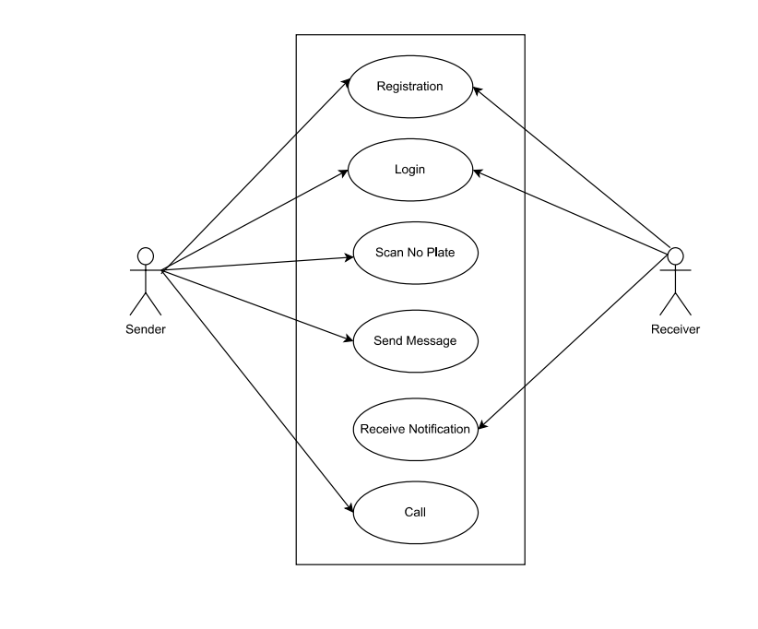

**Figure 2.1 Use Case Diagram**

**2.3. Sequence Diagram**

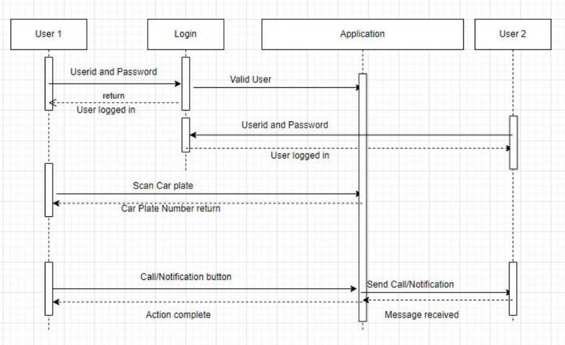

**Figure 2.2 Sequence Diagram**

**CHAPTER 3**

**SYSTEM DESIGN AND METHODOLOGY**

**3.1. System Design**

* + - **System Architecture / Diagrammatical View**

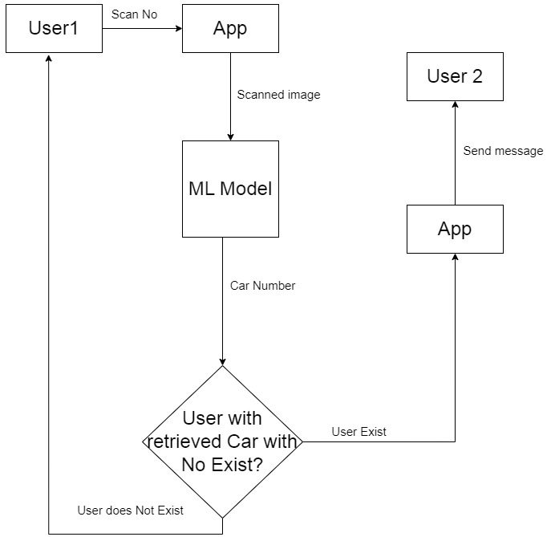

**Figure 3.1 System Architecture**

* + - **DFD, Class Diagram, flow charts, ER Diagrams.**

**Flow chart**

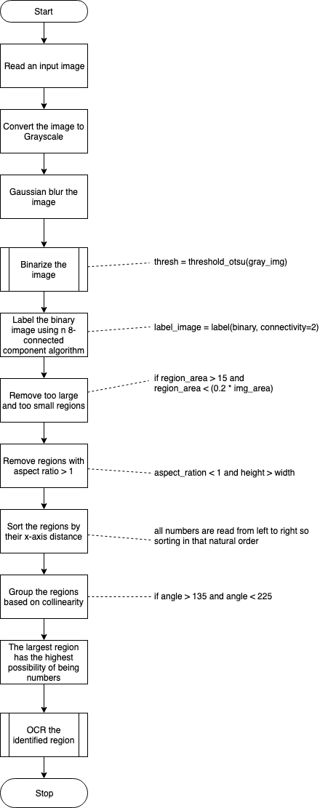

**Figure 3.2 Flow Chart**

**ER Diagram**

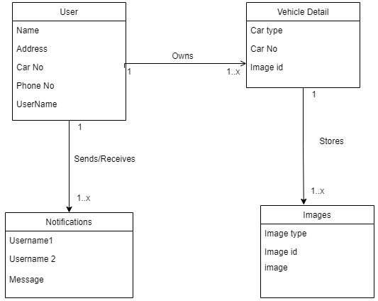

**Figure 3.3 Entity Relationship Diagram**

**Data Flow Diagram (Level 0, Level 1)**

**Figure 3.4 DFD Level 0**

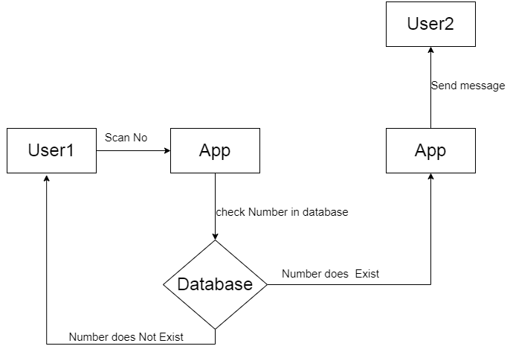**Figure 3.5 DFD Level 1**

**Activity Diagram**

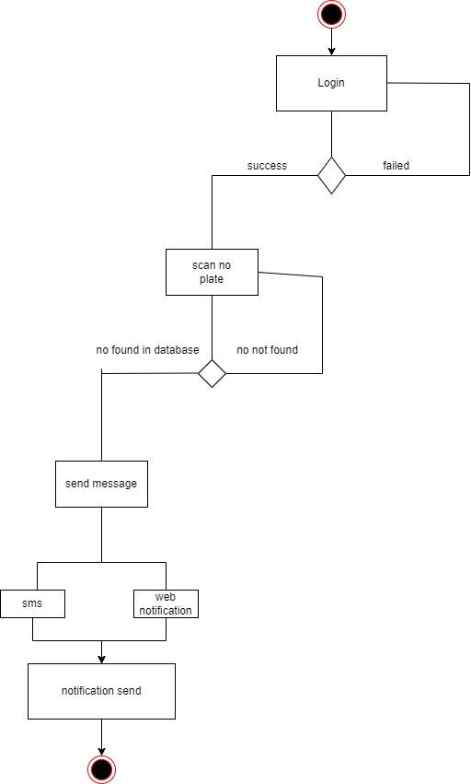

**Figure 3.6 Activity Diagram**

**Class Diagram**

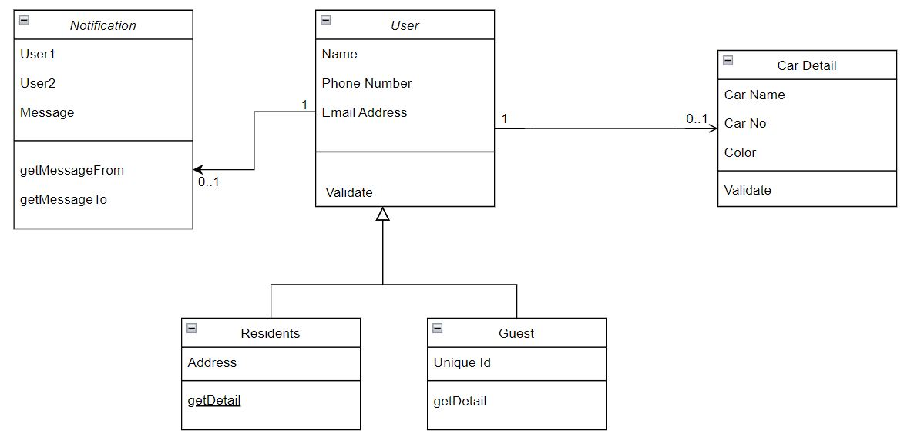

**Figure 3.7 Class Diagram**

**3.2. Algorithms**

* **Model algorithm**

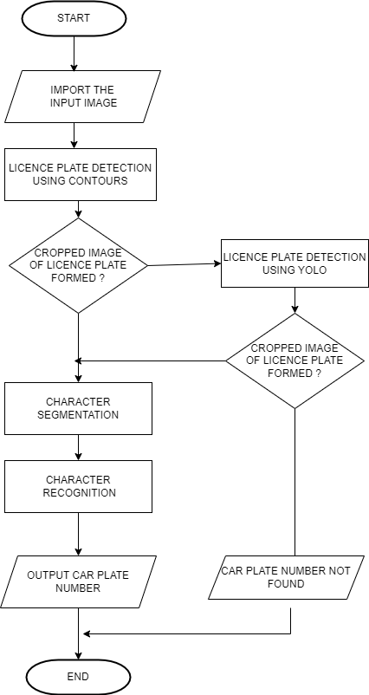

**Figure 3.8 Deep Learning model algorithm**

* **Plate detection using Contours algorithm**

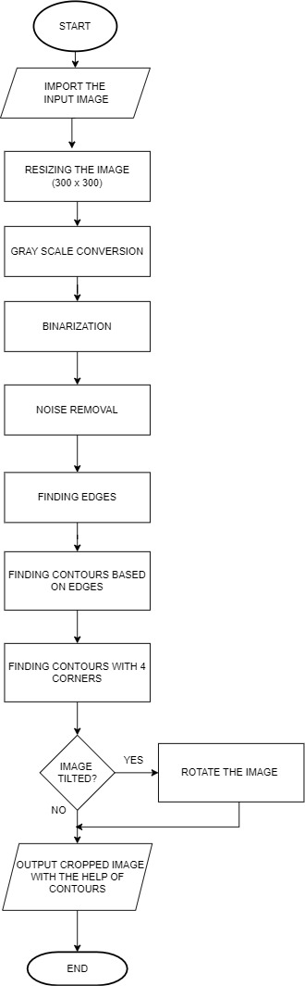

**Figure 3.9 Plate detection using Contours algorithm**

* **Character segmentation algorithm**

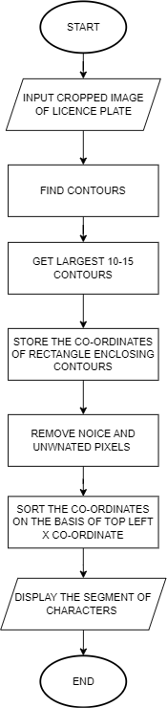

**Figure 3.10 Characters segmentation algorithm**

**CHAPTER 4**

**IMPLEMENTATION AND RESULTS**

**4.1. Software and Hardware Requirements**

**Hardware Requirements :**

* Processor: i3 (equivalent) or above
* Secondary Storage: 256 GB
* RAM: 2 GB

**Software Requirements :**

**Python Libraries :**

* Pandas
* Numpy
* Opencv
* EasyOcr
* Imutils
* Pickle
* Flask / Django

**OS Requirements :**

* Desktop OS: Windows 7 or above
* Smartphone OS: Android Oreo / iOS 12 or above

**Database Requirements :**

* MySQL
* MySQL Workbench

**Storage Requirements :**

* Secondary Storage: 256 GB
* RAM: 2 GB

**4.2. Assumptions and dependencies**

* It is necessary for both party A and B to be connected to the internet.
* It is assumed that the owner of the vehicle is the one driving/parking it.
* The functioning of the application becomes contact when more than two parties are involved.
* It is assumed that the users have submitted their details in the app at the time of registration.
* The receiver should be ready with their app notifications turned on,
* As of now proper OCR camera availability is a challenge.

**4.3. Implementation Details**

* **Snapshots Of Interfaces**

1. **Home screen**

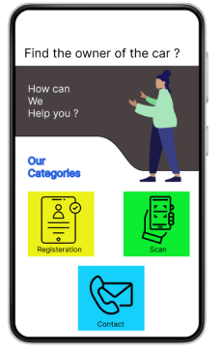

**Figure 4.1 Home Screen**

The moment a user launches the app on their mobile phones; this screen would be visible to them. This is called the Home Screen of the app. It has various options to choose from for the user. Let us understand each option one by one.

* **Registration** : This feature allows the users to get registered with the platform. This is for the first time users. For returning users this feature will show the Login button inside of it. The app uses token based login system which will remember the user and keep them logged in until they log out themselves.
* **Scan** : This feature is the crux of the app. On clicking this button, the app will open the camera and the user will be able to scan the number plate of any vehicle from it. If the scanned number plate owner is registered with the app the scanner will show some details of the owner to the user. Along with that the user will also have options to contact the owner.
* **Contact**: This feature remembers the previously contacted owners. It is just like the contact application on any mobile phone. It just remembers the saved contacts in case they are frequently contacted. The user can directly use this feature to contact them and has no need to scan the number plate again.

1. **Sign up**

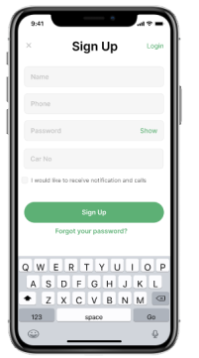

**Figure 4.2 Sign up screen**

This Sign Up screen appears when a new user clicks on the **Register** button on the **Home Screen.** As it can be seen in the snapshot, the user has to enter their details like Phone number, Password, Car Number etc., to get registered on the platform.

1. **Sign in**

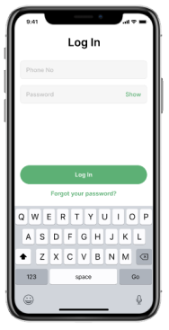

**Figure 4.3 Sign in screen**

For the already registered users, the **Register** option on the **Home Screen** lands then into the **Sign in** page. The old users can just enter their phone number which works as a unique user id and their password to log into the application.

Once Signed in, the users don’t have to sign in again and again unless they delete the application from their device. The system will use tokens to keep them logged in to the system.

1. **Scan**

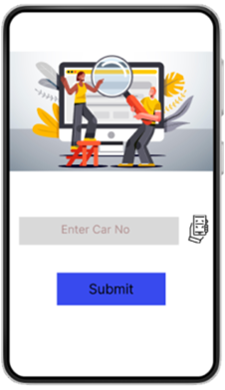

**Figure 4.4 Scan Screen**

On clicking the **Scan** option from the **Home Screen**, this window appears. Here it is visible that the user has options either to write the Car registration number manually or use the scan icon adjacent to it to use their camera to scan and identify the details of the owner of the scanned vehicle.

After scanning the number plate the user just has to click on the **Submit** button and the final screen will appear before them.

1. **User Details**

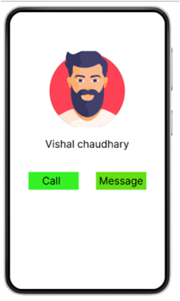

**Figure 4.5 User Details Screen**

After clicking the **Submit** button on the **Scan** screen, the **User Details** of the owner of the scanned car plate will be visible. The user will be able to see name and some other basic details about the owner. The details will not be too private for security concerns.

Thereon, the user will have options to either **Call** the owner of **Message** them about their concern. An API will be used for calling the owners and maintaining that session. After the completion of this process, the user can just go back to the **Home Screen** and **Scan** another Plate if they want.

* **Snapshots Of Database**

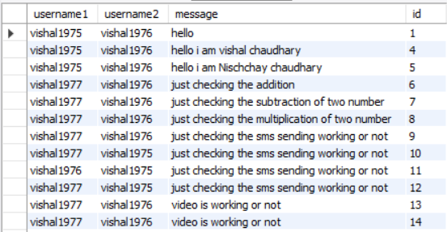

**Figure 4.6 Database 1**

This is a snapshot of the database where the messages sent by users to the owners of the scanned number plate are stored. As we can see that this database has attributes like username1, username2, message, and id.

* **username1** : This attribute stores the userid of the sender.
* **username2** : This attribute stores the userid of the receiver.
* **message** : This attribute stores the message sent by username1 to username2.
* **id** : This attribute stores the unique key of each record in the database**.**

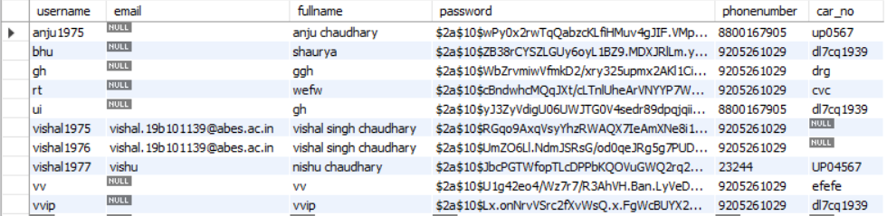

**Figure 4.7 Database 2**

This database stores the credentials of the registered users of the application. As it is visible, there are lots of attributes in this database. Lets discuss these one by one.

* **username** : This attribute stores the user id of the user.
* **email** : This attribute stores the email id of the user.
* **fullname** : This attribute stores the complete name of the user.
* **password** : The login password of the user is stored in this attribute.
* **phonenumber** : The mobile phone number of the user is stored in this attribute.
* **car_no** : The registration number of the user’s car is stored in this attribute.

**4.4 Test Cases and Results**

**Table 4.1 Test cases and their results**

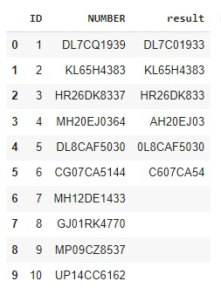

The column ‘NUMBER’ is the set of test cases which is fed as input in the Deep Learning model.

The column ‘result’ is the output of the test cases which are given as input to the model.

**CHAPTER 5**

**CONCLUSION**

**5.1. Performance Evaluation**

* Brightness vs Accuracy comparison

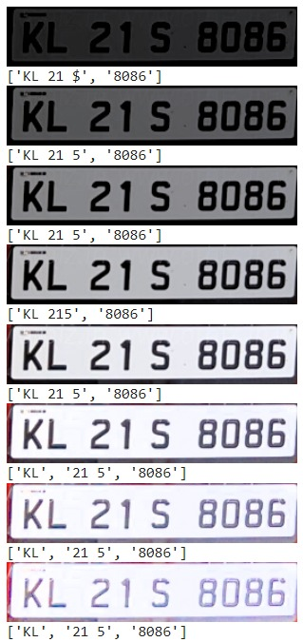

**Figure 5.1 Brightness vs Accuracy comparison**

* Contrast vs Accuracy comparison

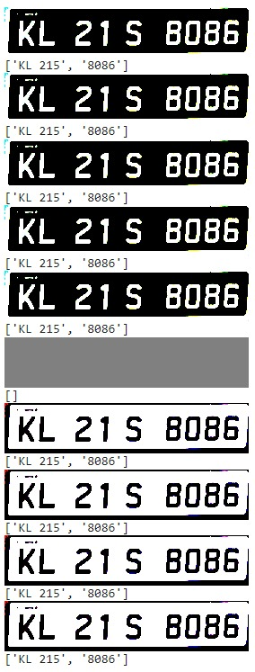

**Figure 5.2 Contrast vs Accuracy comparison**

* Comparison between accuracies of different models/algorithms

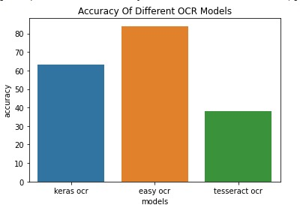

**Figure 5.3 Accuracy of different models**

* Comparison between speed of different models/algorithms

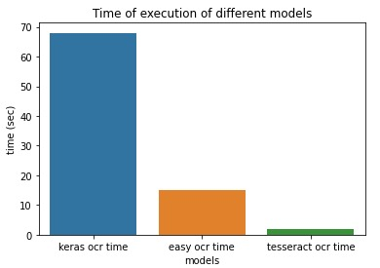

**Figure 5.4 Speed of different models**

**5.2. Existing State-of-the-Art Technologies**

**Free flow tolling:**

**In a free-flow tolling system, toll is collected without the need for toll booths, and travellers travel without encountering toll barriers.**

**A smart ALPR camera installed on these structures detects the license plates of vehicles in transit. A central system then processes the recorded data in order to identify the vehicle owner and assign the toll fee.**

**Stop & Go tolling:**

**Toll collection that uses individual lanes for toll collection. As soon as the vehicle passes through the toll plaza, it stops to pay the toll fee. Traffic monitoring cameras ensure safety and control at tollbooths.**

**Low emission zone:**

**The use of ANPR cameras can ensure drivers respect the restriction zone laws in order to reduce emissions in these areas.**

**VEHICLE TRACKING**

**Homeland security**

**An intelligent system for analyzing urban transit. In order to document transits, a BW image of the number plate and related textual information are sent directly to an File Transfer Protocol server. This enables the user to have a clear and complete overview of the territory.**

**Parking and access control**

**With ANPR cameras, access control and parking management are fully integrated. No external sensors are required to detect a vehicle, and the device can open and close barriers automatically.**

**Further, the cameras are able to load watch lists that, based on the plate recognition, can allow or deny access to specific vehicles.**

**ANPR Mobile**

**Authorities' cars are equipped with modern license plate reading systems that serve as a constant eye on the road. With the ANPR mobile camera, up to a hundred license plates can be scanned per second, no matter what the lighting condition is. It is majorly implemented for crime prevention.**

**Speed Enforcement**

**The speed enforcement system assists in detection of vehicles violating speed limits on expressways.**

**Red Light Enforcement**

**Infractions of red lights can be identified without a physical connection to the traffic light with the red light enforcement system. Traffic light status can be analyzed using image analysis.**

**Bus Lanes Enforcement**

**Vehicles that travel irregularly on the lanes reserved for buses can be monitored using ANPR cameras. To make public transport more convenient, the license plate reading system can be used in bus lanes.**

**Why and how do police use ANPR?**

**ANPR is used by police for the primary objective of improving security and reducing crime. By tracing offendors and their use of roadways with ANPR cameras, police forces can prevent crime, detect traffic, speed and other crimes. They can also detect offenders and uninsured, stolen vehicles.**

**How does the ANPR police car system work?**

**ANPR police car system consists of ANPR cameras attached on the roof of police vehicles. ANPR mobile cameras can scan up to 100 license plate / second, front and back, in any lighting. ANPR mobile camera is part of the All on Board camera family, and it can read license plates in motion.**

**This vehicle tracking system is used for enforcement purposes, and for crime prevention and reduction.**

**5.3 Future Directions**

The increasing adoption of ANPR in electronic toll system will offer strong opportunities for the market. With improved road connectivity, toll booths have shot up in numbers around the globe. There is an increasing requirement for automated solutions to decrease crowding and improve vehicle monitoring systems at toll booths, which is encouraging the application of ANPR for tolling. Scams and frauds can be avoided with ANPR technology, and road charging systems can be more accurate.

The lack of consistency in the plate design, especially in the Indian subcontinent will act as a speed breaker for the market. Number plates are very varying. They have differences in terms of sizes, pattern, and colors etc. Besides, the designs across the world are not the same. These factors make it difficult for recognition of plates and reading the numbers.

But as now the Indian government has issued guidelines for a uniform system of vehicle number plates, it is expected that the situation will improve. The vehicle owners now will have to abide by the rules of the given format. This will most definitely make the accuracy of ANPR models increase as model training will be easier.

The ANPR market is segmented based on factors like end user, application, component, and type.

By the factor type, fixed type will dominate the ANPR market in the coming future.

By the factor component, software type will lead the Automatic Number Plate Recognition scene in the coming future.

By the factor application, traffic management type will be the force to reckon within the ANPR market in the near future.

By the factor end user, government will be biggest stakeholder in the market very soon.

**Biggest firms in the ANPR Market will be:**

* Kasich TrafficCom AG
* Vigilant Solutions
* Siemens AG
* Leonardo Company
* Tattile SRL
* Neology Inc.
* Jenoptik Group
* Genetec Inc.
* Conduent Inc.
* Financial Overview
* Bosch Group

The aim of this research and project application is to ensure that the cost of ANPR systems falls down in the future. Right now we see that very expensive cameras are used by big organizations to access the ANPR technology. Also the common public are deprived of the benefits of this method.

In future, we aim at making this technology accessible to everyone on their mobile phones itself. There should be no need of high end state of the art cameras which are very expensive. The mobile phone camera should be able to work as fine as any other high end device

**Appendix A**

**Table 1. Tabular Summary for Literature Review Based Papers**

|  |  |  |  |  |
| --- | --- | --- | --- | --- |
| **S. No.** | **Paper Name** | **Summary** | **Methodology, dataset, Algorithms** | **Concluding Remarks** |
| 1 | Maulidia R. Hidayap. et al.,(2017) [1] | Shows implementation and accuracy of Otsu method and K nearest neighbor (KNN). The Otsu method is used to convert RGB images into binary images and to extract characteristics from images. | Otsu, KNN, Binary vectors | To get good results and better binary segmentation, it is necessary to adjust the distribution of the pixel values of an imagification in this study proved a great boon in recognition of vehicle number plate. |
| 2 | Liu et al.,(2017) and his team [2] | Supervised K-means machine learning algorithm utilized to segregate the characters into subgroups and these subgroups are in turn classified further by Support Vector Machine (SVM) which recognizes blurred license plate images and improves accuracy. | K-means machine learning, SVM, Multi-classification | Hard-to-recognize characters can be classified easily with supervised K-means. |
| 3 | Quiros, et al.,(2017) [3]. | This study focuses on the KNN algorithm which is used to classify characters from number plates. | KNN, Contouring | Using a set of 36 characters consisting of 26 alphabets and 10 numerical digits, the KNN algorithm is trained. |
| 4 | Thangallapally, et al.,(2018) [4]. | Deep learning techniques are used for training. The advanced ML classifiess the plates accurately. Two parts of this system are involved. | KNN | Characters from the number plate are compartmentalized and KNN is applied to extract the characters. |
| 5 | Subhadhira,S., et al.,(2018) [5] | Deep learning techniques are used for training. The advanced ML classifiess the plates accurately | KNN, HOG, ELM, SVM | The ELM system is used because of its fast speed and acceptable testing and training tenets. |
| 6 | Singh, A. K., et al.,(2018) [6] | When it comes to number plate detection in India, a variety of issues arise. | SVM, ANN | Different algorithms to remove noise and enhance plate recognition and the usage of neural networks for improved results with easing lots of camera constraints |
| 7 | Leticia Fernandez sanchez ., et al.,(2018) [7] | Machine learning algorithms are trained with a huge car image dataset created from scratch in order to develop efficient applications. | SVM, KNN, ANN | Several computer vision techniques are used to analyze the car image, including KNN, SVM, and several other approaches. |
| 8 | Rahim Panahi and Iman Gholampour [8] | Among the challenges associated with the proposed system are unclear number plates in rough weather conditions, high speed vehicles, and different traffic conditions. | Real-time and intelligent algorithms, Contouring, ANPR | We use these techniques and algorithms along with our dataset to compile a dedicated set of solutions to problems and challenges involved in the formation of number plate recognition systems. |

**References**

**Research Journals**

1. Maulidia R. Hidayap, Isa Akhlis2, Endang Sugiharti3 Recognition Number of The Vehicle Plate Using Otsu Method and K-Nearest Neighbour Classification, Scientific Journal of Informatics Vol. 4, No. 1, May2017.

<https://pdfs.semanticscholar.org/d1b2/ec4705bffd3d236239ff17634d36eca0dcec.pdf>

1. Liu, W.-C., &Lin, C.-H. (2017). A hierarchical license plate recognition system using supervised K-means and Support Vector Machine, 2017 International Conference on Applied System Innovation(ICASI).

<https://scholar.lib.ntnu.edu.tw/en/publications/a-hierarchical-license-plate-recognition-system-using-supervised--2>

1. Quiros,A.R.F.,Bedruz,R.A.,Uy,A.C.,Abad,A.,Bandala,A.,Dadios,E.P.,Sa lle,D.L.(2017),A kNN-based approach for the machine vision of character recognition of license plate numbers, TENCON 2017 – 2017 IEEE Region 10 Conference.

<https://www.researchgate.net/publication/340893074_Philippine_License_Plate_Character_Recognition_using_Faster_R-CNN_with_InceptionV2>

1. Thangallapally,S.K.,Maripeddi,R.,Banoth,V.K.,Naveen,C.,&Satpute,V. R.(2018).E- Security System for Vehicle Number Tracking at Parking Lot,(Application for VNIT Gate Security). 2018 IEEE International Students Conference on Electrical, Electronics and Computer Science (SCEECS).

<https://www.semanticscholar.org/paper/E-Security-System-for-Vehicle-Number-Tracking-at-Thangallapally-Maripeddi/2bb4dddfb10e1472528e96edc49f6095c6e9cd37>

1. Subhadhira,S., Juithonglang, U., Sakulkoo, P., &Horata, P. (2014). License plate recognition application using extreme learning machines,2014Third ICT International Student Project Conference (ICT-ISPC).doi:10.1109/ict-ispc.2014.6923228.

<https://ieeexplore.ieee.org/document/6923228>

1. Singh, A. K., & Roy, S. (2015). ANPR Indian system using surveillance cameras,2015 Eighth International Conference on Contemporary Computing(IC3).

<https://ieeexplore.ieee.org/document/7346695>

1. Leticia Fernandez sanchez, cranfield university, Automatic number plate recognition System using machine learning techniques, PHD Thesis, cranfielduniversity,2017-18.

<https://issuu.com/irjet/docs/irjet-v7i7114>

1. Rahim Panahi and Iman Gholampour Accurate Detection and Recognition of Dirty Vehicle Plate Numbers for High-Speed Applications,IEEE Transactions on intelligent transportation systems, vol. 18, no. 4, april2017.

<https://dl.acm.org/doi/10.1109/TITS.2016.2586520>

**Websites**

1. <https://www.tattile.com/anpr-cameras/?doing_wp_cron=1671628769.4106490612030029296875>
2. <https://www.globenewswire.com/news-release/2022/05/25/2450096/0/en/Automatic-Number-Plate-Recognition-ANPR-Market-Estimated-to-Garner-USD-5-6-Billion-at-a-9-5-CAGR-by-2030-Report-by-Market-Research-Future-MRFR.html>