Maharashtra ETR Estimation System
Project Report

Report status | Versions 1-2 finalized; Version 3 in progress
Guide | Dr. S. D. Gorantiwar
Prepared by | Vishal Pandey
Last updated | 19 August 2026
This report is maintained cumulatively as the project develops. Content for a version is frozen once that version is finalized (a copy is saved into Versions/Version_N/); new work is appended below as its own "(In Progress)" section until it, too, is finalized.

1. Introduction
Evapotranspiration (ET) is a central quantity in irrigation scheduling and water-balance studies - it represents the combined loss of water from soil and crop surfaces to the atmosphere, and is the basis for estimating crop water requirement. This project develops a software system to estimate the reference evapotranspiration (ETR / ET0) across Maharashtra state, as an input toward a larger irrigation/crop-water-modelling effort.
The work is being carried out under the guidance of Dr. S. D. Gorantiwar, as part of a staged assignment: begin with the Hargreaves method at a single location, extend it to a network of locations across the state, and progress toward the fuller FAO-56 Penman-Monteith method once the base system is in place.

2. Objective
- Estimate daily reference evapotranspiration (ETR) for any location in Maharashtra using the Hargreaves (1985) method.
- Extend single-point estimates to a spatial (state-wide) representation using interpolation between sampled locations.
- Provide the result at multiple administrative scales - state, district, and taluka - not just at arbitrary points.
- Support both a forecast/near-term view (using live weather data) and a long-term historical archive (1951-2025, using India Meteorological Department gridded data).
- Lay the groundwork for the next stage of the assignment: the FAO-56 Penman-Monteith method and, eventually, integration with soil and farm-boundary data for irrigation modelling.

3. Methodology

3.1 Hargreaves Method
ET0 = 0.0023 x (Tmean + 17.8) x sqrt(Tmax - Tmin) x Ra
Tmax and Tmin are the daily maximum and minimum air temperature (deg C). Ra is the extraterrestrial radiation (expressed in mm/day equivalent), computed purely from a location's latitude and the day of year using the standard FAO-56 astronomical formulas - no external radiation data is required for this term. The Hargreaves method was chosen as the starting point because it needs only temperature data, unlike the fuller Penman-Monteith method which also requires humidity, wind, and solar radiation records.

3.2 Validation
The Hargreaves implementation was validated against a confidential reference dataset (a worked FAO-56 Penman-Monteith / Hargreaves / Modified Penman calculation for Dapoli station, 1985, provided by the Guide). For 1 January 1985 at Dapoli (latitude 19 deg 24' N):
Quantity | This system | Reference
Ra (MJ/m2/day) | 26.185 | 26.191
ET0 (mm/day) | 4.1236 | 4.1245

Agreement is within approximately 0.02%, confirming the formula implementation is correct.

3.3 Data Sources
- Live and forecast weather - Open-Meteo API (free, no key required): daily Tmax/Tmin for any coordinate, historical archive and up to a 16-day forecast.
- Historical weather archive (1951-2025) - India Meteorological Department (IMD) gridded daily temperature dataset, supplied by the user: 39 fixed grid points (1 deg x 1 deg resolution) covering Maharashtra, provided as NetCDF files.
- Administrative boundaries - official state, district (36), and taluka (358) boundary shapefiles, supplied by the user, reprojected and simplified for use in the application.

3.4 Spatial Interpolation (IDW)
To go from a set of sampled locations to a continuous picture of ETR across the state, Inverse Distance Weighting (IDW) is used: the estimated value at any location is a distance-weighted average of nearby sampled points, with closer points weighted more heavily (weight proportional to 1/distance^2). For the live map, a network of points is sampled across Maharashtra and interpolated onto a fine grid; for the historical archive, the same principle is applied via a precomputed weight matrix, so that 75 years of daily data can be aggregated to district and taluka level in a single matrix operation rather than processed one day at a time.

4. Application Features
The system is a Streamlit web application with three tabs, described below.

4.1 Point Lookup
- Click any location inside Maharashtra to get its daily ETR.
- Choose either an upcoming forecast period (up to 16 days) or a historical date range.
- The location's district and taluka are identified automatically from the boundary data.
- Results are shown as a table and chart, with a CSV download option.

4.2 Statewide Map
- An interactive, zoom-adaptive map: zoomed out shows the state-wide average ETR; zooming in switches to a district-level choropleth, then to taluka-level as you zoom in further.
- Clicking any point at any zoom level shows that exact location's ETR, independent of the district/taluka shading beneath it.
- Works for a chosen date - today, an upcoming forecast date, or a past date.
- District boundaries are drawn as bold outlines over the taluka layer so it remains clear where one district ends and the next begins.
- CSV downloads are available for the district/taluka averages table, and for a clicked point's forecast/history series.

4.3 Historical Data (1951-2025)
- Built from the IMD gridded temperature archive described in section 3.3.
- Select State, District, or Taluka level, and (for District/Taluka) the specific unit.
- The actually-available date range is shown for the exact selection made (computed from the real data rather than assumed, so it will correctly reflect any gaps a future data update might introduce).
- Download a CSV of the daily ETR series for the selected unit and date range.

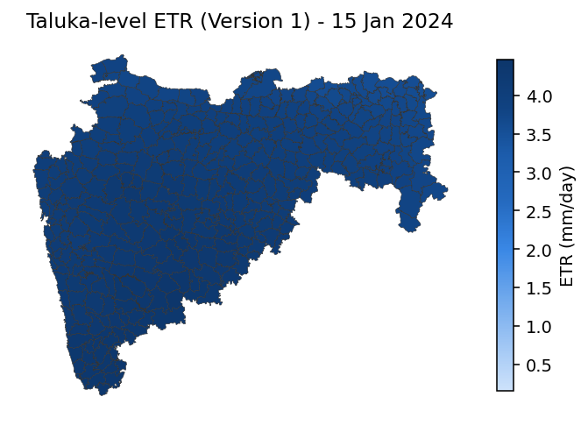
Figure 1: Illustrative taluka-level ETR output (15 January 2024) as it appeared in Version 1, with district boundaries overlaid in bold. (Version 2 changed the colour scale and boundary styling further - see the Version 2 section below.)

5. Technical Architecture
- app.py - the Streamlit application: page layout, the three tabs, and all user interaction.
- etr_core.py - shared, framework-independent logic: the Hargreaves formula, boundary loading, and single-point weather-fetch helpers.
- etr_grid.py - the statewide grid: station sampling, batched weather fetching, IDW interpolation, and map-colour rendering.
- etr_historical.py - builds and serves the 1951-2025 historical archive from the IMD NetCDF data, aggregated to state/district/taluka level.
Technology stack: Python, Streamlit (web app framework), Folium + streamlit-folium (interactive maps), GeoPandas/Shapely (geospatial processing), Pandas/NumPy (data handling), Requests (API calls), Parquet (efficient storage for the historical archive).

6. Version History
Version | Date | Summary
1 | 19 Aug 2026 | Base system: Hargreaves method, Point Lookup / Statewide Map / Historical Data (1951-2025) tabs, validated against reference data. Shown to the Guide as base work.
2 | 19 Aug 2026 | Statewide map reliability fix; Digital Elevation Model acquired for Maharashtra (prep for elevation downscaling); boundary visual hierarchy (state/district/taluka by boldness); green-yellow-red colour scale; taluka name corruption and typo fixes; official district renames (Ahilyanagar, Chhatrapati Sambhajinagar, Dharashiv); Point Lookup tab redesigned to match the Statewide Map's transparent boundary styling. See "Version 2" section below for full details.

7. Planned Next Steps (as of Version 1)
- FAO-56 Penman-Monteith method, using additional inputs (humidity, wind speed, solar radiation) already available from the Open-Meteo API.
- Elevation-based downscaling of the interpolated ETR field, using a 1km-resolution Digital Elevation Model to account for terrain effects such as the Western Ghats, which flat distance-based interpolation cannot represent.
- Eventually, integration with soil-map and farm-boundary data toward the broader irrigation model, per the Guide's original assignment.

Version 2 - Changes Since Version 1
Finalized 19 Aug 2026. The following changes were made after Version 1 was finalized and are adopted in Version 2. Version 1's content above is unchanged and reflects the system exactly as it stood at that point.

Changes adopted in Version 2
- Statewide map reliability: the live weather fetch for the statewide/district/taluka map now retries with exponential backoff on rate-limit (HTTP 429) responses from the weather API, and uses larger request batches to reduce the number of API calls needed - fixing a failure that occurred at the finest station-spacing setting (0.2 deg).
- Digital Elevation Model acquired: a whole-India SRTM DEM (supplied by the user) was clipped to Maharashtra's boundary, reprojected to latitude/longitude, and resampled to approximately 1km resolution. Verified against known terrain (Western Ghats ridge, Konkan coast, Deccan plateau). This is preparatory work for elevation-based downscaling of the ETR map (see Version 1's Planned Next Steps) - not yet integrated into the ETR calculation itself.
- Boundary visual hierarchy: at every zoom level in the Statewide Map tab, administrative boundaries are now layered by boldness so it is clear which line is which - the state outline is boldest, district outlines medium, and taluka outlines thinnest. Previously all boundary lines looked the same, making it hard to tell where a district or the state itself ended.
- Colour scale changed: the statewide/district/taluka map now uses a green (low ETR) to yellow (medium) to red (high) colour gradient, replacing the original single-hue blue scale. This follows the standard convention used for agricultural water-stress/demand maps, at the user's request.
- Taluka name data-quality fix: the source taluka boundary shapefile contained a systematic character-encoding corruption affecting 21 taluka names - specifically the talukas that share their district's name (e.g. "J<lna" instead of "Jalna", "N<gpur" instead of "Nagpur"). The corruption followed a consistent, verifiable substitution pattern (a mis-encoded as '<', u as '#', i as '\') and was corrected at the source; two further unrelated spelling typos ("Kajrat" -> "Karjat", "Shrimapur" -> "Shrirampur") were also corrected after cross-checking against the official Ahilyanagar district government website. This was a source-data fix, not a full audit of all 358 taluka names against authoritative records, which would be a separate, larger task.
- District renaming to current official names: three Maharashtra districts were officially renamed by the state government (gazette notifications, 2023-2024) - Ahmednagar to Ahilyanagar, Aurangabad to Chhatrapati Sambhajinagar, and Osmanabad to Dharashiv. Verified against news coverage of the official government notifications before applying. The two HQ talukas that were renamed alongside their districts (Aurangabad and Osmanabad talukas) were updated to match; the Ahmednagar-area taluka is genuinely named "Nagar" in the source data and government records, so it required no change. All administrative boundary data and the historical archive (1951-2025) were rebuilt with the corrected/renamed values.
- Point Lookup tab redesigned to match the Statewide Map's boundary appearance: the same zoom-adaptive hierarchy (state outline boldest, district medium, taluka thinnest, shown progressively as the user zooms in) replaces the previous single on/off taluka mesh - but with no fill colour at any level, so the underlying map (roads, place names) stays fully visible, making it easier to visually pick a location to click.

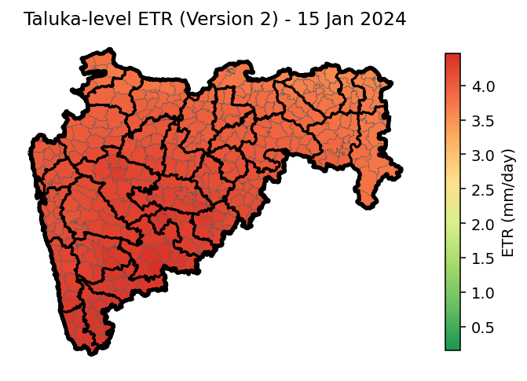
Figure 2: The same output as Figure 1, re-rendered with Version 2's green-yellow-red colour scale and bold state/district boundary overlay (15 Jan 2024).

Version 3 (In Progress) - Changes Since Version 2
The following changes have been made after Version 2 was finalized (19 Aug 2026) and are adopted in Version 3, once finalized. Version 1 and Version 2's content above is unchanged and reflects the system exactly as it stood at each of those points.

Changes so far
- (none yet)

