LAB 10 — SETUP & RUN GUIDE
Container Apps Deploy · CI/CD · LLMOps (Capstone)
Docker · Azure Container Registry · Azure Container Apps · GitHub Actions · Application Insights
Scenario — a bank's agent goes live
A bank's transaction-triage agent must go to production with a rehearsed 02:00 rollback runbook and an eval gate that blocks bad deploys. You will containerise it, push to ACR, deploy to Azure Container Apps with auto-scaling and health probes, wire a GitHub Actions blue/green pipeline with an automated eval gate, and rehearse a SEV-1 rollback.
Estimated time: 4 hours · Level: Advanced · Language: India English

Contents

Part 0 — Before you start
This guide creates the Azure services for Lab 10 and runs every activity. A companion Outcomes guide explains how to read the results; a Rollback Runbook (Excel) is the 02:00 SEV-1 procedure. Written in simple India English.

0.1 The artefacts you will produce
# | Artefact | From
1 | Containerised agent image in ACR | Lab 10-A (Dockerfile + az acr build)
2 | Live agent on Container Apps (autoscale + probes) | Lab 10-B
3 | Blue/green CI/CD pipeline with eval gate | Lab 10-C (GitHub Actions)
4 | Rehearsed SEV-1 rollback runbook | Lab10_Rollback_Runbook.xlsx

0.2 Offline first
The whole app and the eval gate run locally with no Docker and no Azure, so you can learn the flow first. The deploy scripts and pipeline are the Azure path.
pip install -r app/requirements.txt
uvicorn main:app --app-dir app --port 8000 # open http://localhost:8000/health
python eval/eval_gate.py # GOOD policy -> PASS (exit 0)
AGENT_POLICY=app/policies/policy_v2_bad.json python eval/eval_gate.py # BAD -> FAIL (exit 1)

0.3 Prerequisites
- Azure subscription (Contributor) and the Azure CLI (az). Docker is optional — az acr build builds in the cloud.
- A GitHub repo for the CI/CD part, with permission to add secrets.

Part 1 — When Container Apps wins vs AKS
Both run containers on Azure. For this agent — a stateless HTTP API that must autoscale, do blue/green, and stay cheap — Azure Container Apps (ACA) is the right default. AKS (Kubernetes) is the read-ahead for when you outgrow ACA; we do not build AKS live.
Dimension | Azure Container Apps (use this) | AKS (read-ahead)
Ops burden | Serverless; no nodes/cluster to manage | You run and patch a Kubernetes cluster
Autoscale | Built-in KEDA; scale to zero; HTTP/event rules | Configure HPA/KEDA yourself
Blue/green | Revisions + traffic split out of the box | Do it with Deployments/Services/Ingress
Best for | Microservices, APIs, event-driven agents | Complex orchestration, GPUs, service mesh, node control
When to move up | You need custom networking, DaemonSets, node pools, or heavy stateful workloads | That is exactly AKS territory
One-line rule
Start on Container Apps. Reach for AKS only when you need Kubernetes-level control (custom CNI, node pools, GPUs, sidecars/mesh) that ACA does not expose. Most agent APIs never need to.

Part 2 — The app you are shipping
The service is a small FastAPI app: a bank transaction-triage agent that returns approve / review / block. Its decisions come from a VERSIONED policy file — this plays the role of the 'prompt' that LLMOps versions, and a bad change to it is what the eval gate must catch.
Endpoint | Purpose | Used by
GET /health | Liveness — is the process up? | Container Apps liveness probe
GET /ready | Readiness — is a valid policy loaded? | Container Apps readiness probe
POST /decide | The triage decision for one transaction | Callers + the eval gate
GET /version | app version + git sha + policy version | Traceability / rollback verification
GET /modelcard | The auto-generated model card | LLMOps / audit
Two policies ship: policy_v1.json (good) and policy_v2_bad.json (a regression where the high-value block rule is removed — the '02:00 bad prompt change'). Point the app at either with the AGENT_POLICY environment variable.

Part 3 — Create the Azure services

3.1 Names to reuse (edit deploy/00_env.sh)
Placeholder | Example
Resource group | rg-lab10-agent
Region | eastus
ACR name (globally unique, lowercase) | acrlab10vrl -> acrlab10vrl.azurecr.io
Container Apps environment | cae-lab10
Container App | bank-triage-agent
Reuse what you already have
If you created a resource group or an Application Insights resource in an earlier lab, reuse them — no need to make new ones. Only ACR and the Container Apps environment are new for Lab 10.

3.2 Sign in and register providers
az login
az account set --subscription "<your-subscription>"
az extension add --name containerapp --upgrade
az provider register --namespace Microsoft.App
az provider register --namespace Microsoft.OperationalInsights

Part 4 — Lab 10-A: containerise and push to ACR

What the Dockerfile does
It uses a slim Python base, installs only the small runtime deps, copies the app, runs as a non-root user (bank security baseline), adds a container HEALTHCHECK, and starts uvicorn on the port Container Apps expects.

Build and push (cloud build — no local Docker needed)
source deploy/00_env.sh
export TAG=$(git rev-parse --short HEAD) # or any tag
./deploy/01_acr_build_push.sh
Under the hood this runs az acr build, which builds the image in Azure and pushes it to your registry as bank-triage-agent:<tag>.
Check
az acr repository show-tags --name <ACR> --repository bank-triage-agent lists your new tag.

Part 5 — Lab 10-B: deploy to Container Apps
Goal: a live, auto-scaling app with health probes.
./deploy/02_deploy_containerapp.sh
This creates the Container Apps environment (once), creates the app in MULTIPLE revision mode (needed for blue/green), sets an HTTP auto-scale rule, then applies deploy/containerapp.yaml which adds the liveness / readiness / startup probes.

5.1 Auto-scaling rule
Setting | Value | Meaning
min replicas | 1 | Keep one warm for latency (use 0 to scale to zero)
max replicas | 10 | Upper bound on scale-out
rule | http concurrency = 50 | Add a replica for roughly every 50 concurrent requests

5.2 Health probes
Probe | Path | Why it matters
Startup | /health | Give the app time to boot before liveness starts
Liveness | /health | Restart the container if the process wedges
Readiness | /ready | Only send traffic once a valid policy is loaded
Check
az containerapp show ... --query properties.configuration.ingress.fqdn gives the URL. Open /health, /ready and /version.

Part 6 — Lab 10-C: CI/CD with blue/green + eval gate
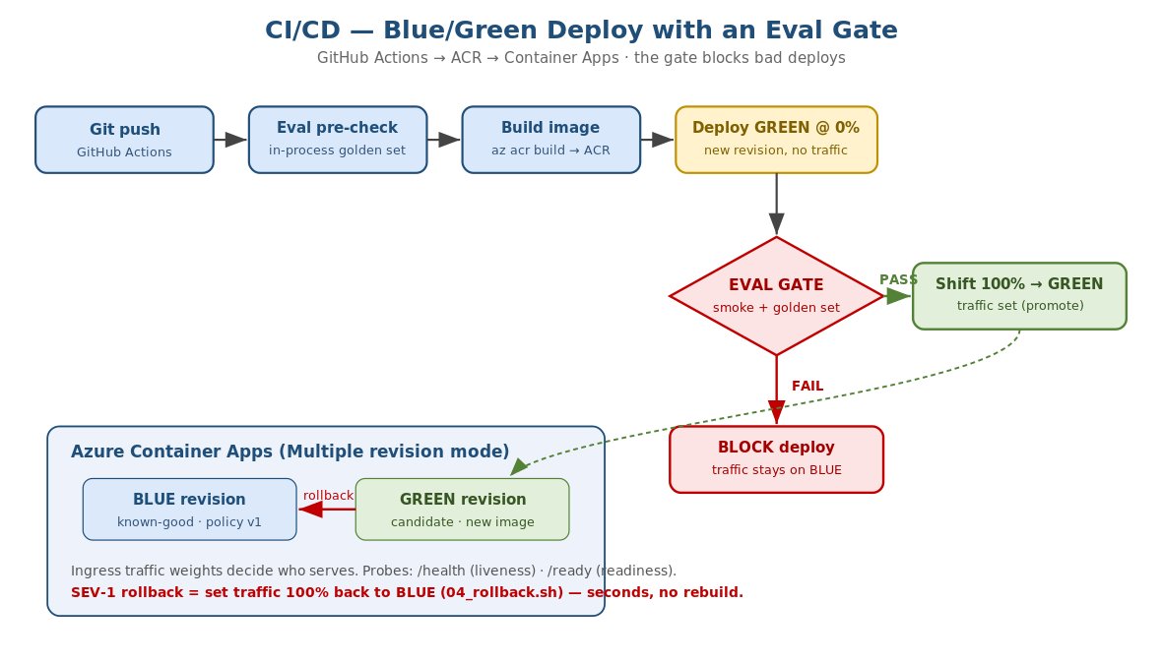
Figure 1 — the pipeline: build -> ACR -> deploy GREEN at 0% -> eval gate -> promote or block.

6.1 The flow
- On push, GitHub Actions runs an in-process eval pre-check (fast fail on a bad policy).
- It builds the image with az acr build and generates the model card.
- It deploys the new image as a GREEN revision at 0% traffic (users stay on BLUE).
- It smoke-tests and runs the eval gate against GREEN's own URL.
- Only if the gate PASSES does it shift 100% traffic to GREEN. If it fails, the job fails and traffic never moves.

6.2 Wire the GitHub secrets (OIDC login)
Create a federated credential (app registration) and add three repo secrets so azure/login works without a stored password:
Secret | What
AZURE_CLIENT_ID | App registration (federated) client id
AZURE_TENANT_ID | Your tenant id
AZURE_SUBSCRIPTION_ID | Your subscription id
# high level (run once): create the app registration + federated credential
az ad app create --display-name lab10-gha
# then add a federated credential for your repo/branch and assign it
# Contributor + AcrPush on the resource group. See Azure OIDC docs.
The eval gate is the point
The gate runs the golden set against the candidate. A good change scores 12/12 and promotes; the bad policy scores 7/12 and the pipeline BLOCKS the deploy. This is what stops a bad prompt reaching production.

Part 7 — LLMOps: versioning, model cards, rollback

7.1 Prompt / policy versioning
The active policy is chosen by the AGENT_POLICY env var and its version shows on /version. Every deploy records which policy version is live, so you always know what is serving and can roll back to a known-good one.

7.2 Model card automation
python scripts/model_card.py --app-version $TAG --git-sha $TAG \
--policy app/policies/policy_v1.json --eval-passed 12 --eval-total 12
CI runs this on every release, so each image ships with an accurate model card (version, policy, eval score, limitations, rollback note) at /modelcard — no hand-written docs that drift.

7.3 Rollback pattern
Because Container Apps keeps previous revisions, rollback is a traffic shift, not a rebuild: send 100% back to the last known-good revision. This is instant and reversible — the heart of the SEV-1 runbook.
./deploy/04_rollback.sh # 100% traffic back to the previous good revision

Part 8 — The 02:00 SEV-1 rollback drill
Rehearse the incident using Lab10_Rollback_Runbook.xlsx. The trigger: a bad policy change is failing in production at 02:00. The goal: restore service in under 10 minutes.
- Simulate the bad deploy: deploy the app with AGENT_POLICY=policies/policy_v2_bad.json (or let the pipeline try — the gate should catch it; for the drill, deploy it directly to force the incident).
- Detect: the /decide endpoint now approves high-value transactions it should block; App Insights shows the bad behaviour.
- Roll back: run ./deploy/04_rollback.sh — traffic shifts to the good revision in seconds.
- Verify: curl /version shows policy_version back to v1; errors clear.
- Learn: add a golden-set case so the gate blocks this change next time.
Why the gate + runbook are both needed
The eval gate is prevention (it should stop the bad deploy). The runbook is the safety net for when something still slips through. A production bank agent needs both, and the team must have rehearsed the runbook before 02:00, not during it.

Part 9 — Troubleshooting and cleanup
Symptom | Likely cause and fix
az acr build fails | Check you are logged in and the ACR name is correct/unique
App shows 'not ready' | The policy file failed to load — check AGENT_POLICY path in the revision
Image pull fails | Registry creds/identity missing — enable admin or assign AcrPull
Traffic did not shift | App must be in multiple revision mode; check revision names in the traffic command
Pipeline blocked | The eval gate failed — that is correct if the policy regressed; read the failing cases

9.1 Clean up
az group delete --name rg-lab10-agent --yes --no-wait

9.2 Outcomes checklist
- ✓ Image built and pushed to ACR (10-A).
- ✓ Live on Container Apps with autoscale + probes (10-B).
- ✓ Blue/green pipeline with an eval gate that blocks bad deploys (10-C).
- ✓ SEV-1 rollback rehearsed against the runbook.

Next
Read the Outcomes Interpretation guide to understand revisions, traffic weights, probe states, the eval-gate verdict, and the rollback outcome.

