LAB 10 — OUTCOMES GUIDE
Interpreting the deploy, the eval gate, and the rollback
What each output means · what 'good' looks like · how to judge the pipeline
How to use this guide
Run the labs with the Setup guide, then come here to read the results: the app's health/version endpoints, the eval-gate verdict, Container Apps revisions and traffic weights, probe states, autoscale, and the rollback outcome.

Contents

Part 1 — The mental model
Everything in this lab is about moving traffic safely to a new version and moving it back fast if needed. Keep this pipeline picture beside you.
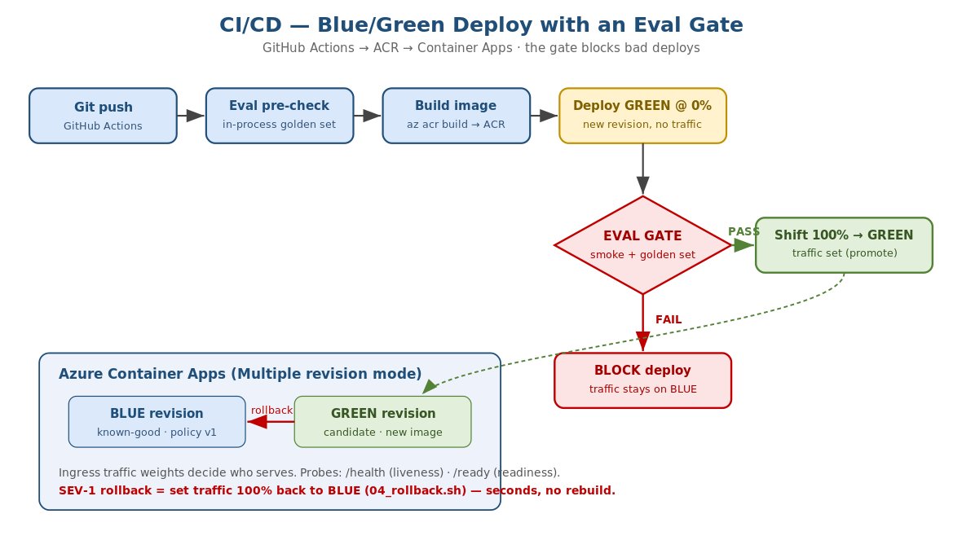
Figure 1 — build -> ACR -> GREEN@0% -> eval gate -> promote or block; rollback = traffic back to BLUE.
The lens
A deploy is not 'the new code is running' — it is 'traffic has moved to the new revision'. In Container Apps those are two separate things: a new revision can exist at 0% traffic. That gap is exactly where the eval gate lives, and why rollback is instant.

Part 2 — Reading the app endpoints
Endpoint | Healthy output | How to read it
GET /health | {"status":"alive"} | Process is up. If this fails, liveness restarts the container.
GET /ready | {"status":"ready","policy_version":"v1"} | A valid policy loaded. 503 => readiness holds traffic away.
POST /decide | {"decision":"block",...} | The triage decision + reason + policy_version.
GET /version | app_version, git_sha, policy_version | Exactly what is serving — your rollback truth check.
The most important field during an incident is policy_version on /version. It tells you, in one call, which version of the 'prompt' is live — so after a rollback you confirm it flipped back to the good one.
Example
POST /decide with amount_gbp=25000 and no HITL should return decision='block' on the good policy. If it returns 'approve', a bad policy is live — that is the 02:00 symptom.

Part 3 — Interpreting the eval gate
The eval gate runs the golden set (12 transactions with known-correct decisions) and prints a pass rate. It is the single thing that decides whether a deploy is allowed to take traffic.

3.1 A PASS
EVAL GATE: 12/12 passed (rate=100.00%, threshold=95%)
RESULT: PASS — safe to promote to production.
All golden cases matched, rate >= threshold, exit code 0. The pipeline proceeds to shift traffic to GREEN.

3.2 A BLOCK (the bad policy)
EVAL GATE: 7/12 passed (rate=58.33%, threshold=95%)
FAIL high_value_no_hitl_MUST_BLOCK: expected 'block' but got 'approve'
FAIL just_over_threshold_block: expected 'block' but got 'approve'
... (5 failures)
RESULT: FAIL — blocking the deploy. Do NOT shift traffic.
Read the failing case names — they tell you exactly what regressed. Here the high-value BLOCK rule was removed, so transactions that must be blocked are being approved. Exit code is non-zero, so the pipeline stops and production stays on the old revision. This is the gate doing its job.
What good looks like
Good changes pass 12/12 and promote automatically. Bad changes fail with named cases and never reach users. The threshold (default 95%) is your risk dial — raise it for a bank.

Part 4 — Reading Container Apps: revisions, traffic, probes, scale

4.1 Revisions and traffic weights
Every template change creates a new REVISION. In multiple revision mode, an INGRESS TRAFFIC WEIGHT decides who serves. Blue/green is just two revisions with weights 100/0, then 0/100.
az containerapp revision list --name $APP -g $RG -o table
# NAME ACTIVE TRAFFICWEIGHT CREATED
# bank-triage-agent--v-abc True 100 ...(BLUE, serving)
# bank-triage-agent--v-def True 0 ...(GREEN, candidate)
Read the TRAFFICWEIGHT column: 100 = serving users, 0 = deployed but idle. During blue/green you will see GREEN at 0 while it is tested, then 100 after promotion.

4.2 Probe states
Probe | What a failure means | What Container Apps does
Liveness (/health) | The process is wedged | Restarts the container
Readiness (/ready) | No valid policy loaded | Stops sending traffic to that replica (no restart)
Startup (/health) | Still booting | Delays liveness so a slow start is not killed
If /ready returns 503 (bad policy path), the replica stays up but receives no traffic — you will see requests not reaching it. That is readiness protecting users from a half-initialised instance.

4.3 Autoscale
With the http-concurrency rule at 50 and min/max 1/10, replica count rises under load and falls when quiet. Read the replica count over time: a spike in concurrent requests should add replicas within a few scaling intervals; an idle app returns to the minimum.
az containerapp replica list --name $APP -g $RG --revision <rev> -o table

Part 5 — Reading a blue/green promotion
03_bluegreen_promote.sh prints its progress. Interpret it as three moves:
- Deploy GREEN at 0%: the new revision exists but users still hit BLUE. Zero user impact so far.
- Validate GREEN: smoke test + eval gate run against GREEN's own URL. This is the safety check on real, running code before any user sees it.
- Flip: traffic set to GREEN=100 BLUE=0. Only now do users get the new version. BLUE stays deployed at 0% as the instant rollback target.
What good looks like
GREEN is validated at 0% before any traffic moves. After the flip, /version shows the new app_version and the good policy_version. BLUE remains available at 0% so rollback is one command away.
If the eval gate fails at step 2, the script exits and the flip never happens — you will see the app still 100% on BLUE. That is a blocked (not broken) deploy.

Part 6 — Reading the rollback (SEV-1)
04_rollback.sh shifts 100% traffic back to the previous known-good revision. Interpret the outcome by three signals:
Signal | Before rollback | After rollback
Traffic weight | BAD revision = 100 | GOOD revision = 100, BAD = 0
/version | policy_version = v2-bad | policy_version = v1 (good)
Behaviour / errors | High-value txns approved; error rate up | Correct blocks resume; error rate falls
The key property is SPEED: rollback is a traffic shift, not a rebuild, so it completes in seconds. That is why the runbook target is under 10 minutes end-to-end including detection and comms. After rollback, the bad revision is deactivated so it cannot silently take traffic again.
What good looks like
Within seconds of running the script, /version flips to the good policy and the bad behaviour stops. The team then records the timeline and opens a postmortem — see the runbook's Post-incident sheet.

Part 7 — LLMOps artefacts

7.1 Model card
GET /modelcard (or app/model_card.json) shows the deployed version, git sha, the active policy, the eval score, limitations, and the rollback note. Read it as the single source of truth for 'what is this model, and how good was it at release'. Because CI regenerates it every release, it never drifts from reality.

7.2 Prompt/policy version traceability
Every artefact carries the same identifiers: the image tag (git sha), /version, and the model card all agree. During an incident this lets you answer 'what changed?' instantly — compare the policy_version on the bad revision with the last good one.

Part 8 — Mapping outcomes to the artefacts
Required capability | The outcome that proves it
Container Apps deploy | az containerapp show returns a live FQDN; /health is 200
Auto-scaling + probes | replica count moves under load; /ready gates traffic
Blue/green CI/CD | GREEN validated at 0%, then traffic flips to 100%
Eval gate blocks bad deploys | bad policy scores below threshold; pipeline stops
Rollback runbook | 04_rollback.sh flips /version back to good in seconds

8.1 Quick self-assessment
Question | Yes = healthy
Does a new revision start at 0% traffic until validated? | Yes
Does the eval gate block the bad policy (not just warn)? | Yes
Can you roll back with one command in seconds? | Yes
Does /version tell you exactly what is serving? | Yes
Has the team rehearsed the 02:00 runbook? | Yes

The big idea
Safe production for an agent is not 'it works on my machine' — it is a pipeline that validates each change at 0% traffic, a gate that blocks bad prompts, and a rollback you can run half-asleep at 02:00. Every outcome in this lab is evidence of one of those.

