Dev Environment CI/CD
What is implemented, what was tested, what is pending — and why
Repo: https://github.com/vishal20034/branch-rule-test Branch: dev
This document does not cover Production. Prod (feat → rc → main) starts tomorrow.
1. Scope
Only the Dev path. Developers open a Pull Request from feat/* into branch dev. Merge starts GitHub Actions. There is no Azure account on this work yet, so deploy is simulated. There is no SonarQube and no FHS release note on Dev.
In scope (Dev) | Out of scope (tomorrow / later)
feat/* → PR → merge into dev | feat/* → rc-* → main (Production)
GitHub Actions workflow Dev CI/CD | SonarQube quality gate
Build Function + App Service packages once | Manual tag on rc-*
Simulated Dev deploy (both Azure resource types) | Manual verification / approval on production
Email 1 Started / Email 2 Failed / Email 3 Succeeded | FHS Pasrr Service release notes Word file
GitHub Environment named dev (no reviewers) | Real Azure Function App + App Service deploy

2. Dev flow diagram
Green = tested and working. Amber = code is in the repo but blocked on credentials or Azure access.
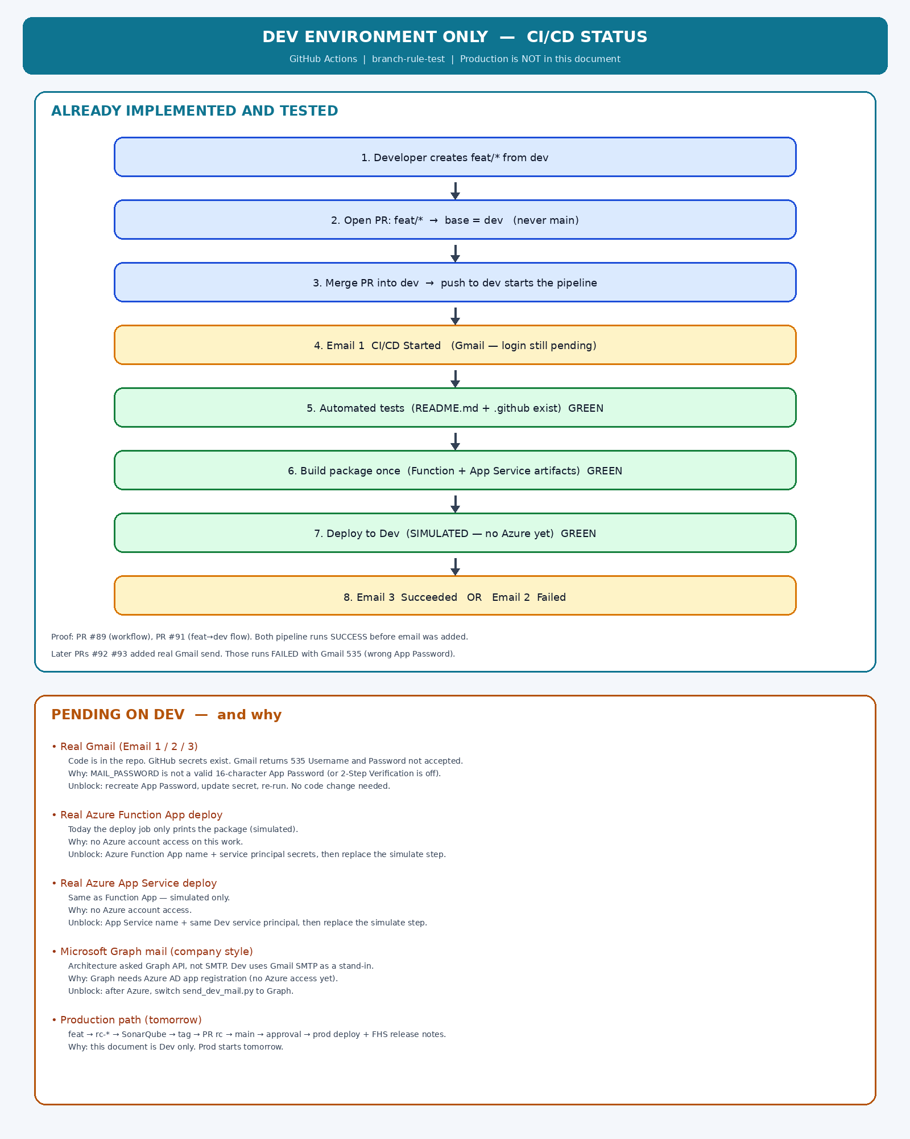
3. Already implemented
3.1 Files on branch dev
Path | What it does
.github/workflows/dev-cicd.yml | The pipeline: 6 jobs, trigger on push to dev + manual Run workflow
.github/scripts/send_dev_mail.py | Sends one Gmail via SMTP (used by Email 1, 2 and 3)
GitHub Environment: dev | Referenced by the deploy job. No required reviewers.
GitHub secrets MAIL_TO / FROM / USERNAME / PASSWORD | Mailbox for the 3 emails (Gmail). Password still rejected by Google (see pending).

3.2 Pipeline jobs (as written)
Job on Actions screen | What it does | Status
Email 1 - CI/CD Started | Send (or try to send) Started mail, then continue | Code yes. Gmail login 535 — pending App Password
Run automated tests | Check README.md file and .github folder exist | Tested GREEN
Build package once | Create Function + App Service folders, upload 2 artifacts, keep 14 days | Tested GREEN
Deploy to Dev Environment | Download same artifacts. Print them. No Azure API call. | Tested GREEN (simulated)
Email 3 - CI/CD Succeeded | Mail only if deploy succeeded | Code yes. Blocked by Email 1 if Gmail fails
Email 2 - CI/CD Failed | Mail only if any watched job failed. Skipped on green runs. | Code yes. Same Gmail block

3.3 Branch rule that Dev must follow
This repo already auto-closes Pull Requests into main unless the source branch starts with rc/. That is correct. Dev does not use main.
From | To | Allowed?
feat/* | dev | YES — this is the Dev path
rc/* | main | YES — Production (tomorrow)
dev | main | NO — bot closes the PR
feat/* | main | NO — bot closes the PR

4. Already tested (proof)
PR | What we tested | Result
#89 feat/dev-cicd → dev | First add of Dev CI/CD workflow (print-in-log version) | Merged. Actions SUCCESS
#91 feat/dev-flow-test → dev | Real daily path: feat PR, merge to dev, pipeline starts by itself | Merged. Actions SUCCESS (40s). Email 2 skipped (correct). 2 artifacts uploaded.
#92 SMTP emails → dev | Replace print with real Gmail send | Merged. Actions FAILURE — Gmail 535 BadCredentials
#93 Gmail SMTP retry → dev | Strip spaces in App Password, try ports 587 then 465 | Merged. Actions FAILURE — same 535. Code is fine; password is not.
#94 feat/dev-mail-retry → dev | Re-run after password update (if merged) | Use this after MAIL_PASSWORD is a real App Password

Green pipeline proof (before real Gmail): https://github.com/vishal20034/branch-rule-test/actions/runs/32843911120
On that green run the jobs were: Email 1 print Started → tests → build (2 artifacts) → simulated Function + App Service deploy → Email 3 Succeeded. Email 2 was skipped.
5. Pending on Dev — and why
Pending item | Why it is pending | How to unblock (still Dev only)
Real Gmail Email 1 / 2 / 3 | Google returns 535 Username and Password not accepted. MAIL_PASSWORD is not a valid 16-character App Password (or 2-Step Verification is off). Code and secrets names are already there. | Logged in as bnag7309@gmail.com: myaccount.google.com/apppasswords → new App Password → update GitHub secret MAIL_PASSWORD (16 letters, no spaces) → Re-run all jobs. No YAML change.
Real Azure Function App deploy | No Azure account access. Deploy job only lists the package. | When Azure is available: Function App name + Dev service principal (AZURE_CREDENTIALS_DEV, AZURE_FUNCTIONAPP_NAME_DEV). Replace the simulate step with Azure/functions-action.
Real Azure App Service deploy | Same reason — no Azure access. Second simulate step only. | When Azure is available: App Service name (AZURE_APPSERVICE_NAME_DEV). Replace simulate step with azure/webapps-deploy. Same service principal as Function App.
Company Graph API mail (not Gmail SMTP) | Architecture wants Microsoft Graph sendMail. That needs an Azure AD app registration. No Azure access now. Gmail SMTP is a stand-in so Dev can still prove the 3-email pattern. | After Azure: GRAPH_MAIL_CLIENT_ID / SECRET / TENANT_ID / FROM. Point send_dev_mail.py at Graph. SMTP can then be removed.
Real app tests (npm / pytest / etc.) | This repo is a branch-rule test repo (text files only). Checks are README + .github. | On the real product repo (fhs-pasrr-service) replace the two test lines with the real test command.
Production path | Out of scope for this document. Agreed: tomorrow. | Tomorrow: feat → rc-* → SonarQube → manual tag → PR rc → main → approval → prod Function App + App Service + FHS release notes.

6. How to run Dev tomorrow morning (checklist)
- Create feat/* from branch dev (not from main).
- Change code. Push. Open PR with base = dev.
- Merge the PR. Do not open that PR into main.
- Open Actions → Dev CI/CD → latest run.
- Expect: Email 1 → tests → build → deploy → Email 3. Email 2 skipped if green.
- If Email 1 is red with 535: fix MAIL_PASSWORD App Password, then Re-run all jobs.
- No tag. No release note. No Sonar on Dev.
7. Secrets already on the repo (Dev mail)
Secret name | Expected value | Notes
MAIL_TO | bnag7309@gmail.com | Who receives the 3 mails
MAIL_FROM | bnag7309@gmail.com | Must be the same Gmail account
MAIL_USERNAME | bnag7309@gmail.com | Full address
MAIL_PASSWORD | 16-character Gmail App Password | NOT the normal Google password. This is the blocked item.
MAIL_HOST | smtp.gmail.com (optional) | Empty is OK — script defaults to Gmail

8. What we will not do on Dev
- Do not PR dev → main (auto-close bot).
- Do not run SonarQube on Dev.
- Do not create GitHub Release / FHS Word file on Dev.
- Do not add production approvers on Environment dev.
End of Dev status document. Production document starts tomorrow.

