**1. ReactJS-HOL**

**Objectives**

* **Define SPA and its benefits:**

A Single-Page Application (SPA) is a web application that loads a single HTML page and dynamically updates that page as the user interacts with the app. This provides a more fluid and desktop-like user experience by avoiding full page reloads.

* **Define React and identify its working:**

React is a JavaScript library for building user interfaces. It works by creating a component-based structure where each component is a small, reusable piece of code that controls a part of the UI.

* **Identify the differences between SPA and MPA:**
  + SPA (Single-Page Application): Loads a single HTML page and updates content dynamically. Faster and more responsive user experience after the initial load.
  + MPA (Multi-Page Application): Each user action (e.g., clicking a link) triggers a full page reload from the server. This can be slower and less fluid.
* **Explain Pros & Cons of Single-Page Application:**
  + Pros: Improved user experience, faster performance (after initial load), and easier debugging with modern browsers.
  + Cons: Slower initial load time, SEO challenges (can be mitigated), and requires JavaScript to be enabled.
* **Explain about React:**

React is a declarative, efficient, and flexible JavaScript library for building user interfaces. It lets you compose complex UIs from small and isolated pieces of code called "components."

* **Explain Features of React:** Component-based architecture, declarative views, JSX syntax, Virtual DOM, and a one-way data flow.
* **Define Virtual DOM:**

The Virtual DOM is a lightweight copy of the real DOM. When the state of a React component changes, React first updates the Virtual DOM, then efficiently calculates the minimum number of changes needed to update the real DOM. This process, known as "reconciliation," significantly improves performance.

Code:

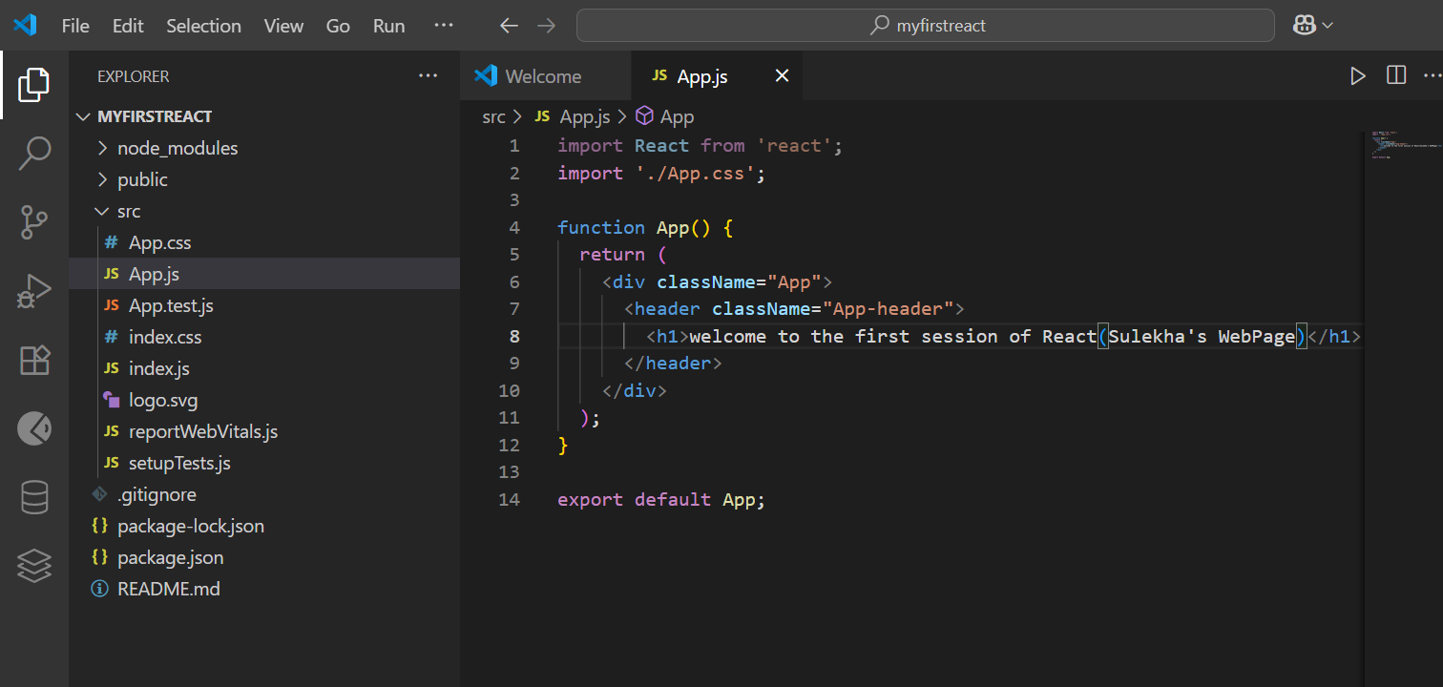

Output