**3. ReactJS-HOL**

**Objectives**

* **Explain React components**: Independent, reusable pieces of UI code.
* **Identify the differences between components and JavaScript functions**: React components are specialized functions or classes that take props and return React elements (UI), while JavaScript functions perform tasks and return outputs.
* **Identify the types of components**: The two main types are Class Components and Function Components.
* **Explain class component**: Defined using ES6 class syntax, extending React.Component, and including a render() method. Can manage state and lifecycle methods.
* **Explain function component**: Defined using a JavaScript function. Simpler to write and, with Hooks, can manage state and lifecycle events.
* **Define component constructor**: (Relevant to Class Components) A special method called upon component creation, used for state initialization and binding methods.
* **Define render() function**: The mandatory method in a class component, responsible for returning the JSX that describes the UI. Should be a pure function.

**Student Management Portal to Calculate Score**

**Code:**

CalculateScore.js

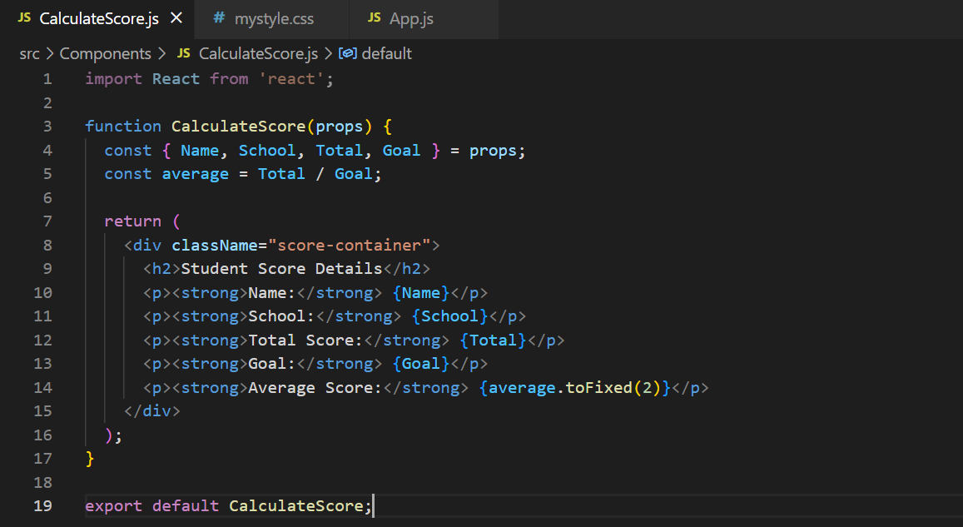

MyStyle.css

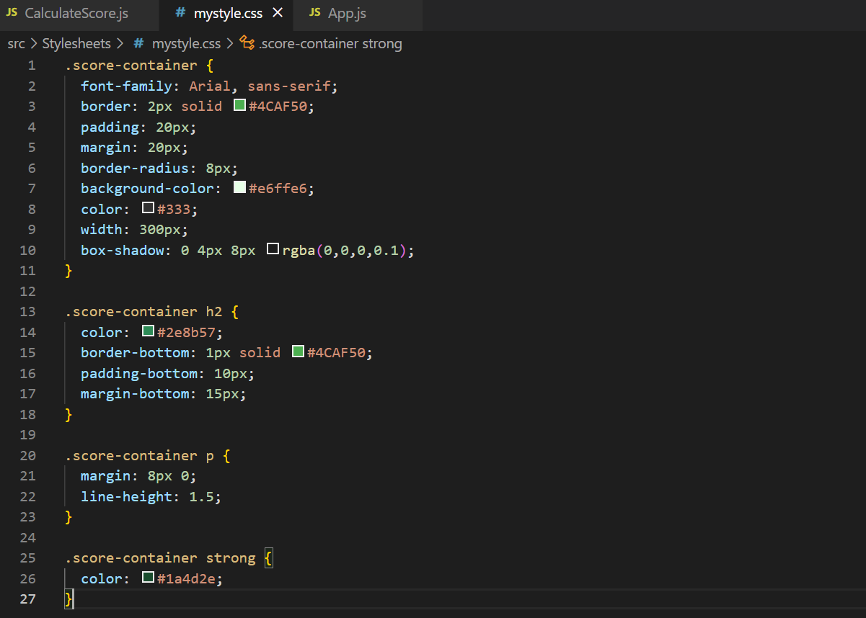

App.js

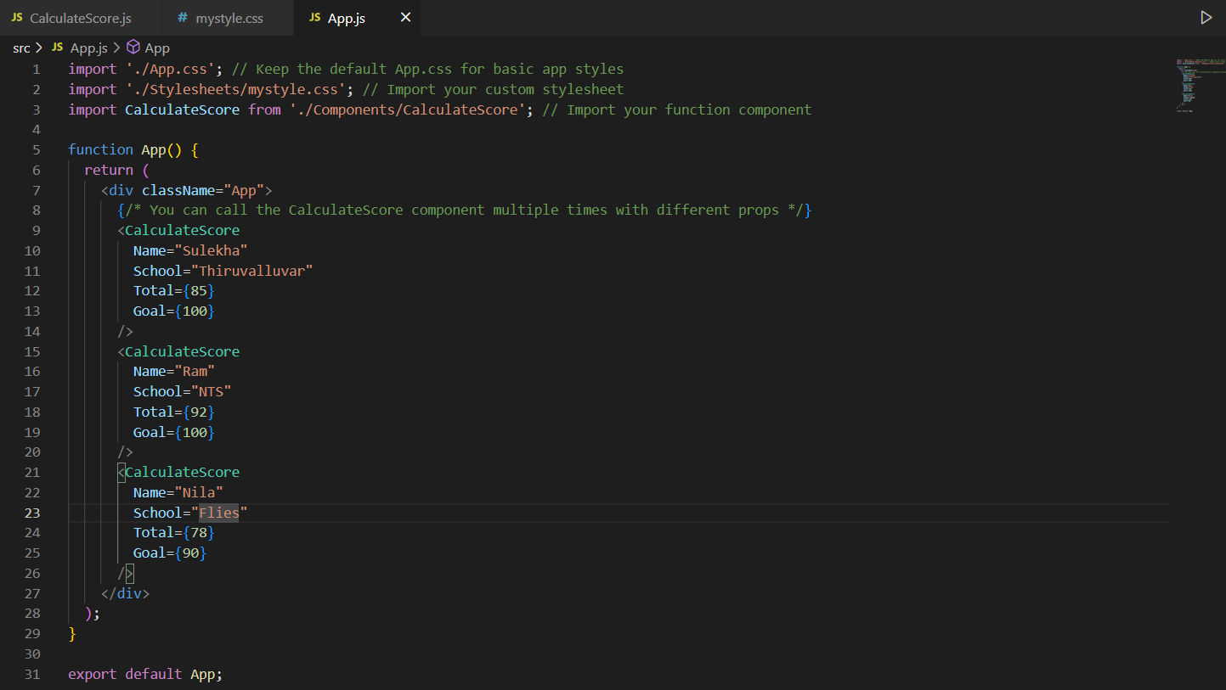

**Output:**

