LOCALMART:
LOCAL COMMERCE MANAGEMENT SYSTEM
A Java-Based Console Application

PROJECT REPORT

Submitted By:
Vishal Andhale
[25BAI10992]
B.Tech – Computer Science and Engineering
(Artificial Intelligence and Machine Learning)

VIT Bhopal University

Academic Year 2026–27

1. INTRODUCTION:
LocalMart is a Java-based Local Commerce Management System designed to connect customers with local businesses through a unified platform. The system supports both product-based businesses and service-based businesses.
Customers can browse shops, view products and services, place orders for standard products, request customized services, schedule appointments, and provide ratings and reviews.
Shop owners can manage their shops, products, services, orders, service requests, appointments, and reviews. An administrator can monitor major system entities and activities.
The project is implemented using Java and demonstrates object-oriented programming concepts such as classes, objects, inheritance, encapsulation, method overriding, object relationships, and ArrayList collections. The current system uses in-memory storage and does not require a database.

2. PROBLEM STATEMENT:
Many local businesses do not follow the same workflow as traditional e-commerce platforms. Some businesses sell ready-to-buy products, while others provide customized products or physical services that require customer interaction, consultation, appointments, site visits, quotations, and completion of work.
Customers may therefore face difficulty discovering local businesses, viewing their products and services, comparing ratings and reviews, placing orders, and requesting customized services through one system.
LocalMart addresses this problem by providing a unified platform for product ordering and customized service-request management while allowing shop owners to manage their business activities.

3. OBJECTIVES:
1.To develop a Java-based system for connecting customers with local businesses.
2.To allow customers to browse shops, products, and services.
3.To implement product ordering with stock validation.
4.To implement customized service-request management.
5.To provide appointment management for services.
6.To implement ratings and reviews for shops.
7.To provide shop owners with product, service, order, and request management.
8.To provide administrative monitoring of system activities.
9.To demonstrate Java Object-Oriented Programming concepts.
10.To implement input validation and controlled workflow transitions.

4. FUNCTIONAL REQUIREMENTS:
4.1 Customer Management:
1.Customer registration and login
2.View customer profile
3.Browse shops
4. Browse products and services
5. Place product orders
6.Submit service requests
7. View orders and appointments
8. Add and view reviews
4.2 Shop Owner Management:
1.Shop owner registration and login
2.Automatic shop creation
3.Add and view products
4.Add and view services
5.View and update orders
6.View and update service requests
7.View and update appointments
8.View customer reviews
4.3 Product and Order Management:
Customers can purchase available products from registered shops.
Order workflow:
PLACED → CONFIRMED → PROCESSING → COMPLETED
The system checks product availability before placing an order and reduces stock after a successful order.
4.4 Service Request Management:
Customers can request customized or physical services.
Service workflow:
REQUESTED → CONTACTED → APPOINTMENT_SCHEDULED → SITE_VISIT → QUOTATION → ACCEPTED → IN_PROGRESS → COMPLETED

4.5 Appointment Management:
Appointments are created when a service request reaches the appointment stage.
Appointment workflow:
SCHEDULED → COMPLETED / CANCELLED
4.6 Rating and Review Management:
Customers can provide ratings and comments for eligible completed interactions. The system calculates the shop's average rating and prevents duplicate reviews from the same customer for the same shop.
4.7 Administration:
The administrator can view:
Customers
Shop owners
Shops
Orders
Service requests
Appointments
Overall system summary

5. NON-FUNCTIONAL REQUIREMENTS:
5.1 Usability:
The console menus are designed to provide simple and understandable options for customers, shop owners, and administrators.
5.2 Reliability:
The system validates important operations and prevents invalid workflow transitions.
5.3 Maintainability:
The system is divided into separate Java classes based on their responsibilities, making the code easier to understand and modify.
5.4 Error Handling:
The system validates user inputs, product quantities, ratings, and workflow status transitions. Insufficient-stock orders are rejected.
5.5 Resource Efficiency:
The current system uses Java ArrayList collections for in-memory storage and does not require a database.

6. SYSTEM ARCHITECTURE:
The project follows a simple layered logical structure:
User
↓
Java Console Interface
↓
Main / LocalMartSystem
↓
Domain and Business Classes
↓
ArrayList In-Memory Storage
Architecture Description:
Main starts the application. LocalMartSystem manages menus, user interactions, validation, and major business workflows. Domain classes represent users, shops, products, services, orders, service requests, appointments, and reviews. ArrayList collections are used for storing objects during program execution.
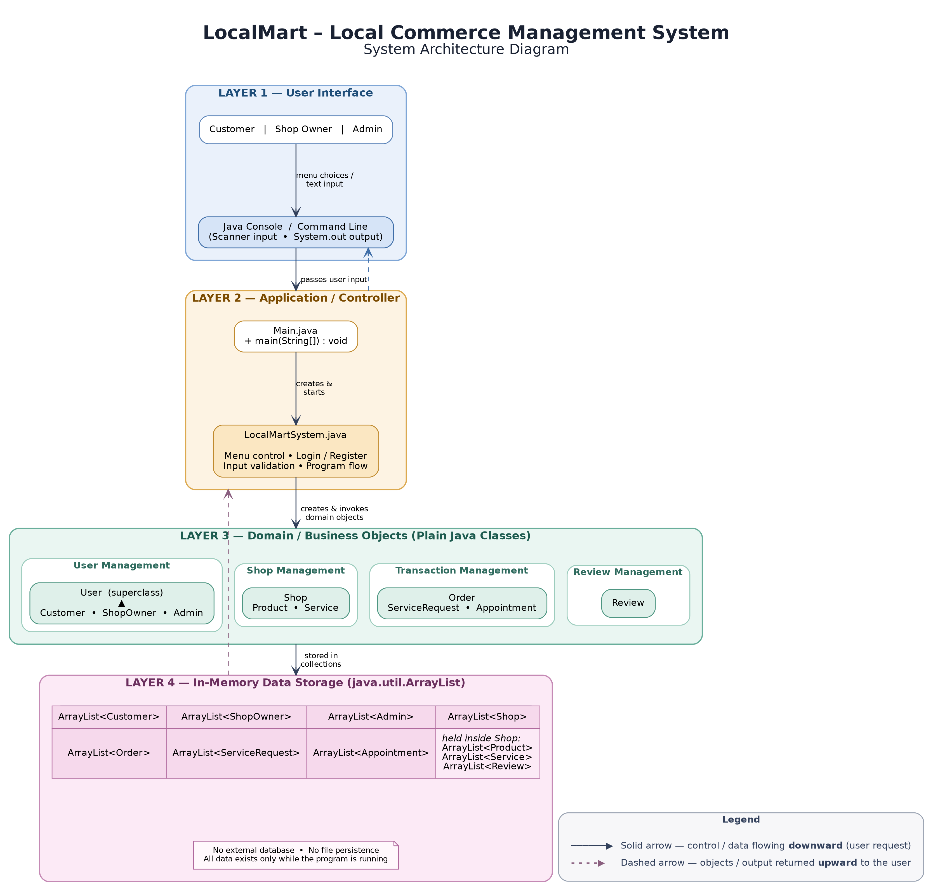
7. SYSTEM DESIGN AND UML DIAGRAMS:
7.1 UML Class Diagram:
The class diagram represents the major classes and relationships in LocalMart.
Important relationships include:
User → Customer
User → ShopOwner
User → Admin
Shop → Product
Shop → Service
Shop → Review
Order → Customer, Shop, Product
ServiceRequest → Customer, Shop, Service
Appointment → Customer, Shop, Service, ServiceRequest
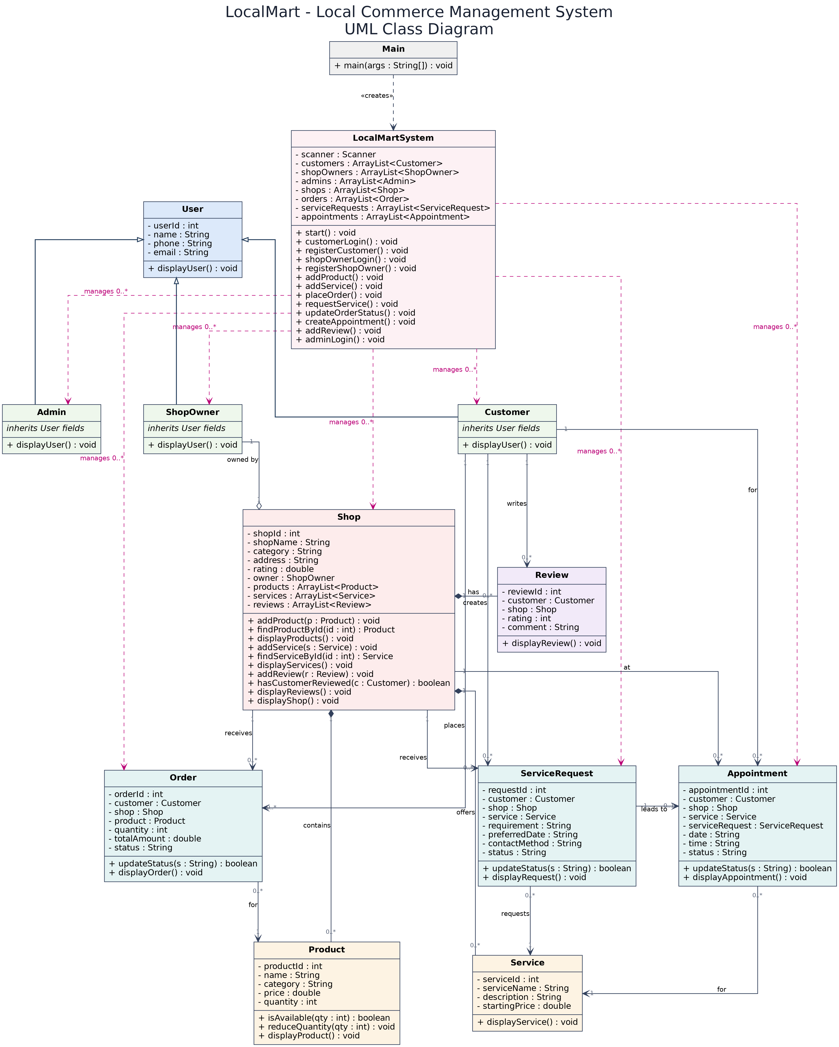

7.2 UML Use Case Diagram:
The Use Case Diagram represents interactions between:
- Customer
- Shop Owner
- Admin
and the major system functions.
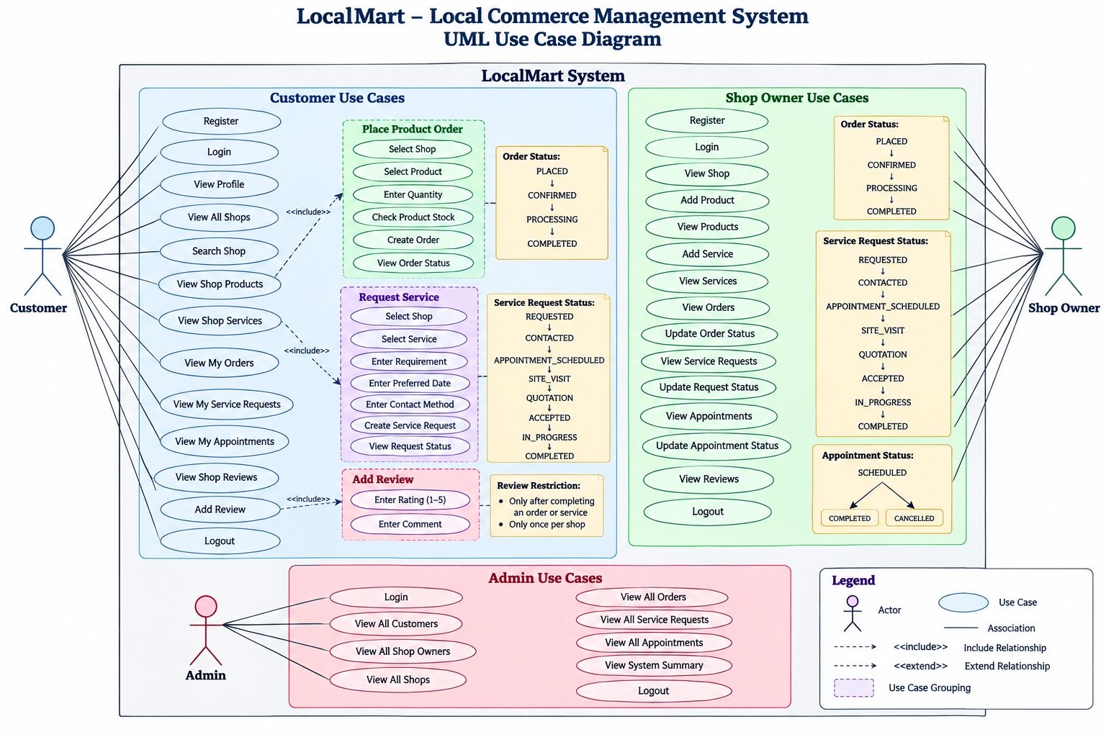
7.3 Overall Workflow Diagram:
The workflow represents the overall operation of LocalMart from user interaction to completion of product or service activities.
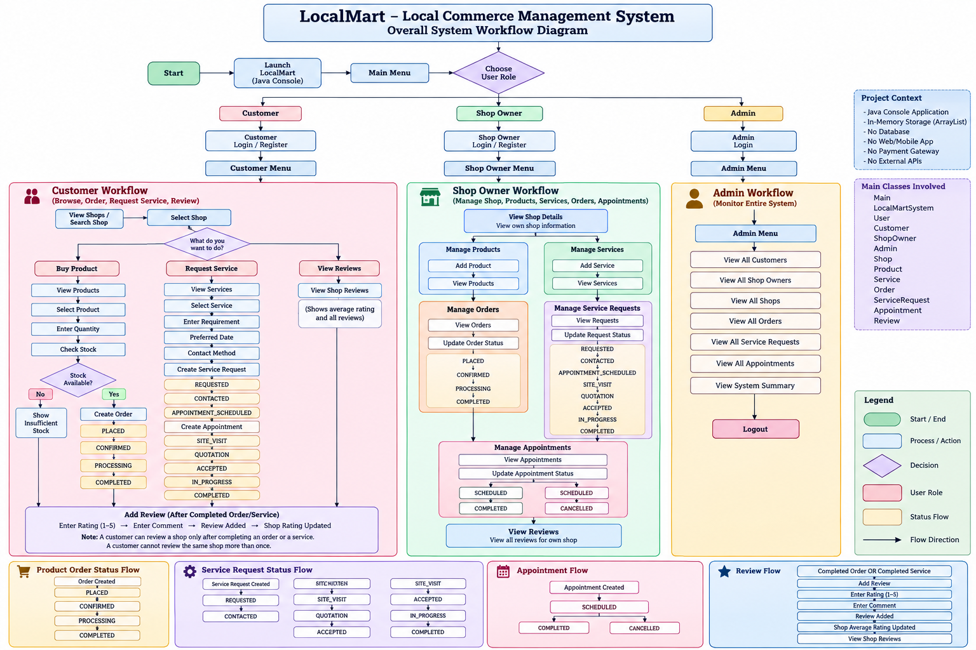

7.4 Sequence Diagram — Product Order:
The sequence diagram represents communication between the customer, system, shop, and product/order objects during a product purchase.
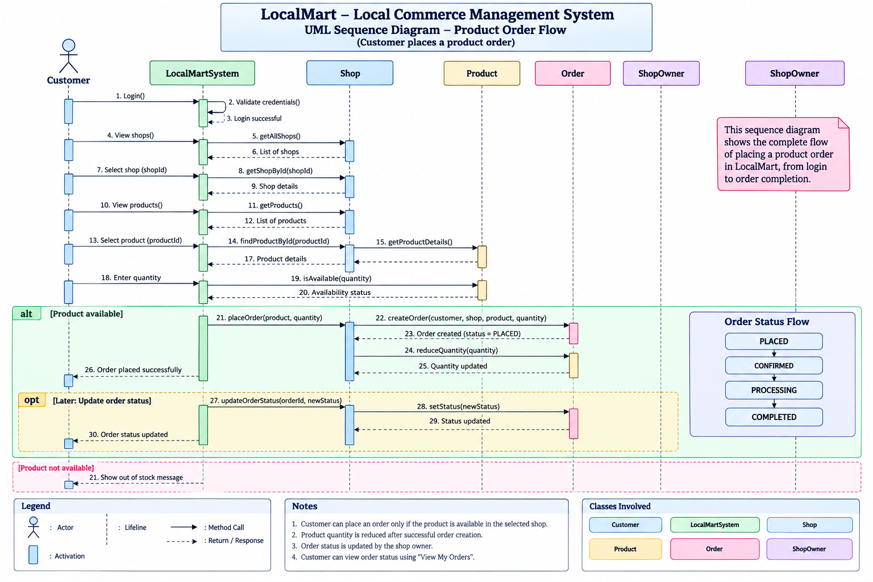
7.5 Sequence Diagram — Service Request:
This diagram represents the service-request and appointment process from customer request through appointment creation.
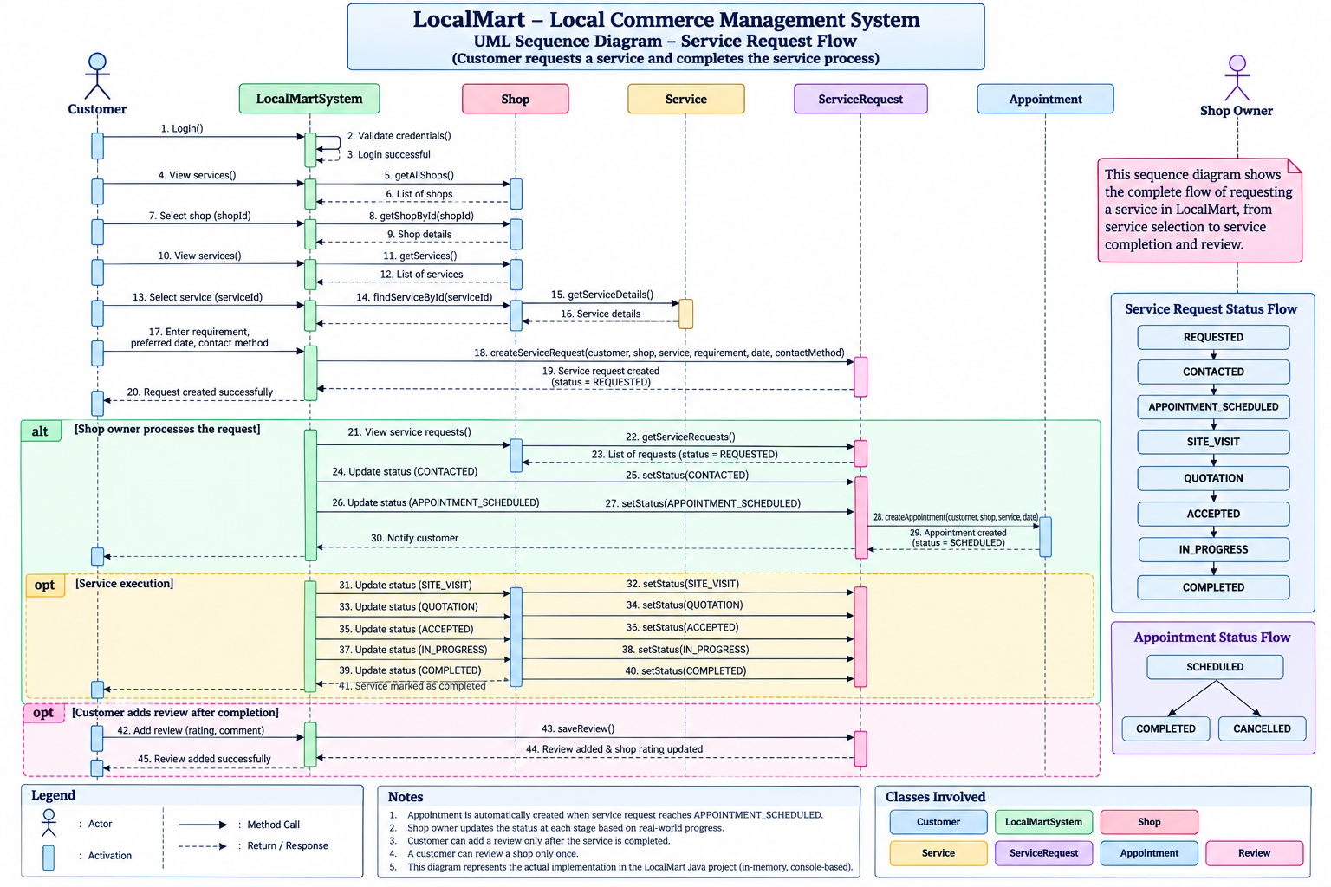
8. DESIGN DECISIONS AND RATIONALE:
Java and OOP
Java was selected because the project focuses on Java and Object-Oriented Programming concepts.
Class-Based Design
Separate classes were created for major entities such as Customer, Shop, Product, Service, Order, ServiceRequest, Appointment, and Review.
Inheritance
Inheritance is used through the User base class and its subclasses:
User → Customer, ShopOwner, Admin
ArrayList Storage
ArrayList was selected for the current implementation because the project does not use a database and requires simple in-memory storage.
Separate Product and Service Workflows
Product ordering and customized services follow different business processes, so separate classes and workflows were designed for them.
Controlled Status Transitions
Order and service statuses can only move through valid predefined stages, preventing invalid workflow progression.
9. IMPLEMENTATION DETAILS:
The project contains 13 Java classes:
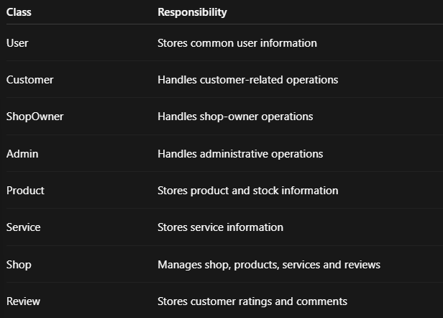

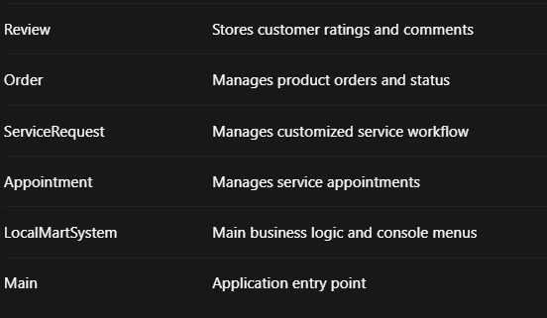
OOP Concepts Used:
1.Classes and Objects
2.Encapsulation
3.Inheritance
4.Method Overriding
5.Constructors
6.Object Relationships
7.ArrayList Collections
8.Modular Design
10. SCREENSHOTS AND RESULTS:
Customer Registration/Login:
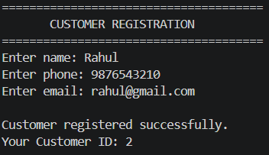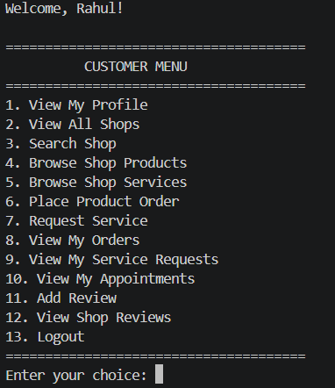

Shop Owner and Shop:
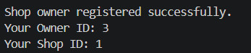
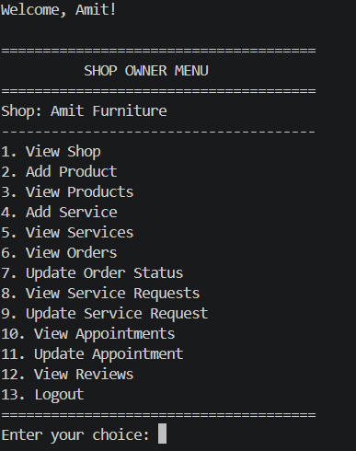
Product Ordering:
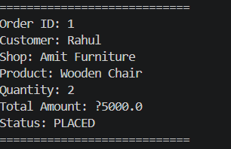
Service Request and Appointment:
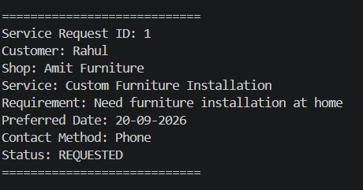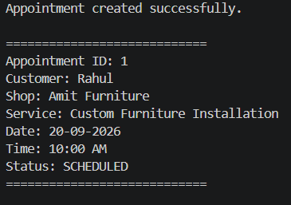
Rating and Review:
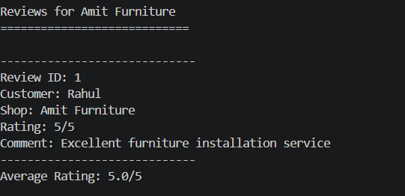
Admin System Summary:
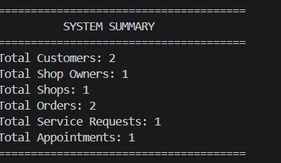
The screenshots demonstrate the successful execution of the major LocalMart workflows, including customer management, shop management, product ordering, service requests, appointments, reviews, and administrative monitoring.
11. TESTING APPROACH AND RESULTS:
The project was manually tested using the Java console application.
Testing Summary:
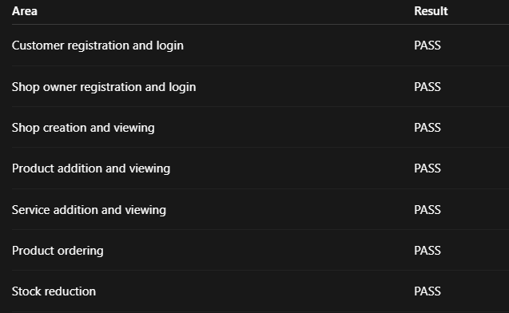

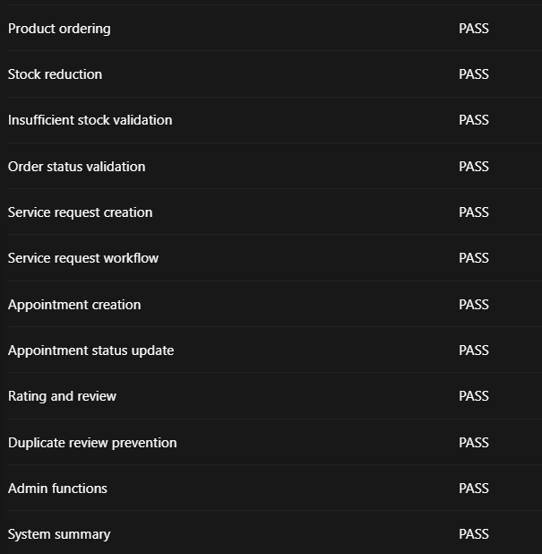
Testing Result:
The recorded functional test scenarios produced the expected behavior. The system successfully handled normal operations as well as validation cases such as insufficient stock, duplicate reviews, and invalid status transitions.
12. CHALLENGES FACED:
During development, the following challenges were encountered:
1.Managing relationships between multiple Java objects.
2.Designing separate workflows for products and services.
3.Implementing controlled status transitions.
4.Maintaining application data using ArrayList collections.
5.Handling invalid user inputs and insufficient stock.
6.Managing multiple user roles and console menus.

13. LEARNINGS AND KEY TAKEAWAYS:
Through this project, the following concepts were practically applied:
- Java Object-Oriented Programming
- Inheritance and method overriding
- Encapsulation and class design
- Object relationships
- ArrayList collections
- Input validation
- Error handling
- Workflow and status management
- Modular software design
- Testing and documentation
- GitHub-based project organization

14. FUTURE ENHANCEMENTS:
The current project can be extended in the future by adding:
1.Database integration using MySQL.
2.Web-based frontend.
3.REST APIs.
4.User authentication and improved security.
5.Online payment integration for applicable products.
6.Notifications for orders and appointments.
7.Location-based shop discovery.
8.Product and service image uploads.
9.Advanced search and filtering.
10.Online deployment.
These are future enhancements only and are not part of the current implementation.

15. REFERENCES:
1. VITyarthi – Build Your Own Project: General Project Instructions & Submission Guidelines.
2. Java Documentation — Java language and standard library reference.
3.Java College Notes and Assignment provided by Faculty.

