**Newer :**​ Vishal Sharma

**Newer ID :**​ 4171

**Email :**​ ​ [vishal.sharma@tothenew.com](mailto:vishal.sharma@tothenew.com)

**Exercise :**​ Introduction to HTML/CSS

1. How are inline and block elements different from each other?

**Answer:**

**INLINE elements**

Basically, an inline element does not cause a line break (start on a new line) and does not take up the full width of a page, only the space bounded by its opening and closing tag. It is usually used within other HTML elements.

For-example: <a>,<em>,<span>,<img> tags etc.

**BLOCK elements**

A block-level element always starts on a new line and takes up the full width of a page, from left to right. A block-level element can take up one line or multiple lines and has a line break before and after the element.

For-example: <h1> to <h6>, <div> tags etc.

1. Explain the difference between visibility:hidden and display:none

**Answer:**

**display:none** means that the tag will not appear on the page at all (although we can still interact with it through the DOM). There will be no space allocated for it between the other tags.

**visibility:hidden** means that unlike display:none, the tag is not visible, but space is allocated for it on the page. The tag is rendered, it just isn't seen on the page.

1. Explain the clear and float properties.

**Answer:**

**The float property** specifies how an element should float.

The float property is used for positioning and formatting content.

e.g. let an image float left to the text in a container.

**The clear property** specifies what elements can float beside the cleared element and on which side.

The most common way to use the clear property is after using a float property on an element.

1. explain difference between absolute, relative,fixed and static.

**Answer:**

**Fixed:**

An element with position: fixed; is position relative to the viewport, which means it stays at the same place even if the page is scrolled.

The properties used to position element are top, right, bottom and left.

**For Eg:**

div.fixed{

position: fixed;

bottom: 0;

right: 0;

width: 200px;

border: 2px solid #73AD21;

}

**Static:**

An element with position: static; is not positioned in a special away but it is positioned according to the flow of the page:

They are not affected by properties like top, bottom, left, and right.

HTML elements are positioned static by default.

**For Eg:**

div.static{

position: static;

border: 2px solid #73AD21;

}

**Absolute:**

An element with position: absolute; is positioned relative to the nearest positioned ancestor(instead of position relative to the viewport, like fixed)

However, if an absolute positioned element has no positioned ancestor, it uses the document body and moves along with page scrolling.

**For Eg:**

div.absolute {

position: absolute;

top: 80px;

right: 0;

width: 200px;

height: 100px;

border: 3px solid #73AD21;

}

**Relative:**

An element with position: relative; is positioned relative to its normal position.

Setting the top, right, bottom, and left properties of the relative-positioned element will cause it to be adjusted away from its normal position.

**For Eg:**

div.relative {

position: relative;

left: 30px;

border: 3px solid #73AD21;

}

1. Write the HTML code to create a table in which there are 4 columns( ID , Employee Name, Designation, Department) and at least 6 rows. Also do some styling to it.

**Answer:**

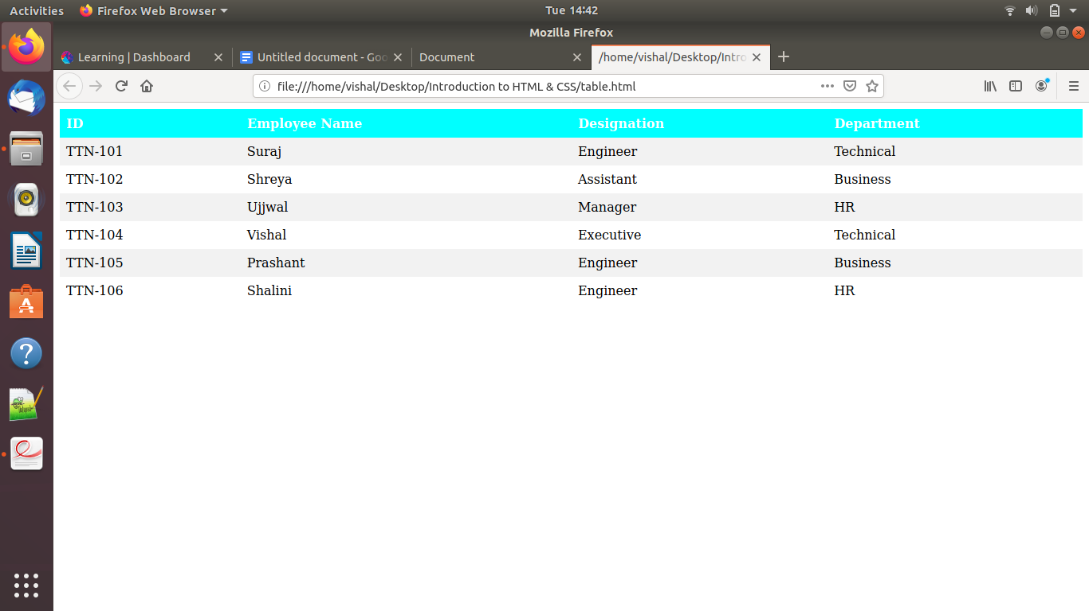

<!DOCTYPE html>

<html>

<head>

<style>

table {

border-collapse: collapse;

width: 100%;

}

th, td {

text-align: left;

padding: 8px;

}

th {

background-color: cyan;

color: white;

}

tr:nth-child(even) {background-color: #f2f2f2;}

</style>

</head>

<body>

<div style="overflow-x:auto;">

<table>

<tr>

<th>ID</th>

<th>Employee Name</th>

<th>Designation</th>

<th>Department</th>

</tr>

<tr>

<td>TTN-101</td>

<td>Suraj</td>

<td>Engineer</td>

<td>Technical</td>

</tr>

<tr>

<td>TTN-102</td>

<td>Shreya</td>

<td>Assistant</td>

<td>Business</td>

</tr>

<tr>

<td>TTN-103</td>

<td>Ujjwal</td>

<td>Manager</td>

<td>HR</td>

</tr>

<tr>

<td>TTN-104</td>

<td>Vishal</td>

<td>Executive</td>

<td>Technical</td>

</tr>

<tr>

<td>TTN-105</td>

<td>Prashant</td>

<td>Engineer</td>

<td>Business</td>

</tr>

<tr>

<td>TTN-106</td>

<td>Shalini</td>

<td>Engineer</td>

<td>HR</td>

</tr>

</table>

</div>

</body>

</html>

1. Why do we use meta tags?

**Answer:**

Metadata is “data about data”. It can be any useful information associated with HTML document.

The <meta> tag provides metadata about the HTML document. Metadata will not be displayed on the page, but will be machine parsable.

Meta elements are typically used to specify page description, keywords, author of the document, last modified, and other metadata.

The metadata can be used by browsers (how to display content or reload page), search engines (keywords), or other web services.

1. Explain box model.

**Answer:**

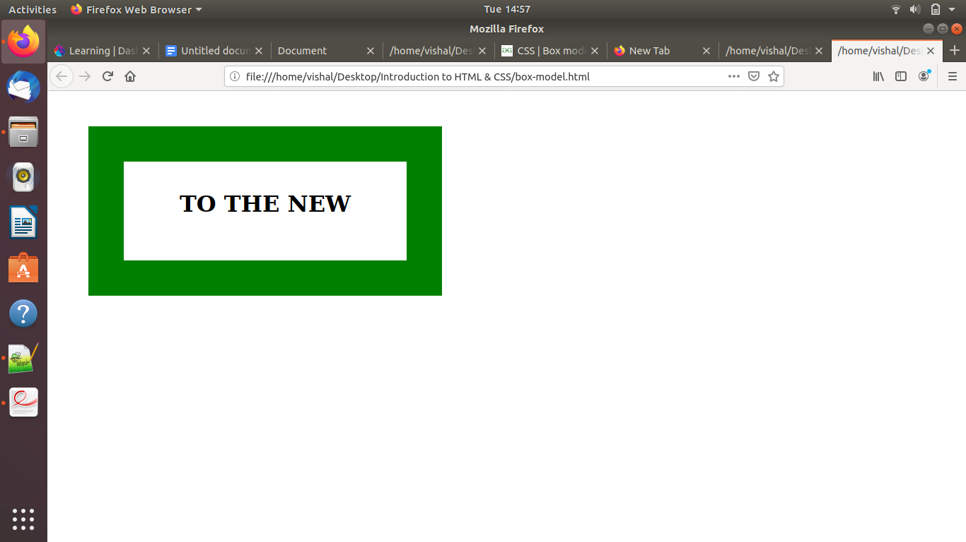

CSS box model is a container which contains multiple properties including borders, margin, padding and the content itself. It is used to create the design and layout of web pages. It can be used as a toolkit for customizing the layout of different elements. The web browser renders every element as a rectangular box according to the CSS box model.

Box-Model has multiple properties in CSS like borders, margins, padding, content.

1. What are the different types of CSS Selectors?

**Answer:**

There are mainly 5 types of CSS Selectors.

#### **Universal Selector**

The CSS universal selector selects all the elements on a webpage.

For-example:

* {

color: blue;

font-size: 21px;

}

#### **Element Selector**

CSS Element Selector is also known as a Type selector. Element Selector in CSS tries tomatch the HTML element having the same name.

For-example:

ul {

border: solid 1px #ccc;}

#### **ID Selector**

CSS ID selector helps the developer to match the ID created by the developer to its styling content. ID Selector is used with the help of the hash (#) sign before the ID name. ID selector matches every HTML element having an ID attribute with the value the same as that of the selector, without the hash sign

For-example:

#box {

width: 90px;

margin: 10px;

}

#### **Class Selector**

The CSS Class selector is one of the most helpful selectors of all the selectors. It is declared by using a dot followed by the name of the class. The different elements with similar style property are grouped in to same class and then CSS property is applied.

For-example:

.square {

margin: 20px;

width: 20px;

}

#### **Attribute Selector**

The CSS Attribute selector styles content according to the attribute and the attribute value mentioned in the square brackets.

For-example:

input[type="text"] {

background-color: #fff;

width: 100px;

}

1. Define Doctype.

**Answer:**

A doctype or document type declaration is an instruction which tells the web browser about the markup language in which the current page is written. The Doctype is not an element or tag, it lets the browser know about the version of or standard of HTML or any other markup language that is being used in the document.

**Declaration of a Doctype**: A DOCTYPE declaration appears at the top of a web page before all other elements. According to the HTML specification or standards, every HTML document requires a document type declaration to ensure that the pages are displayed in the way they are intended to be displayed.

Syntax : < !DOCTYPE html > (for *html 5*)

1. Explain 5 HTML5 semantic tags.

**Answer:**

A semantic element clearly describes its meaning to both the browser and the developer.

Semantic tags in HTML5 are:

## **<section> tag**

The <section> element defines a section in a document.

A home page could normally be split into sections for introduction, content, and contact information.

<section>

<h1>ToTheNew</h1>

<p>The Section tag</p>

</section>

## **<article> tag**

The <article> element specifies independent, self-contained content.

Examples of where an <article> element can be used are Forum post, Blog post, Newspaper article etc.

<article>

<h1>ToTheNew</h1>

<p>ToTheNew is a digital transformation IT Company in Noida..</p>

</article>

**<header> tag**

The <header> element specifies a header for a document or section.

The <header> element should be used as a container for introductory content.

<header>

<h1>ToTheNew</h1>

<p>The Section tag</p>

</header>

## **<footer>**

The <footer> element specifies a footer for a document or section.

A footer typically contains the author of the document, copyright information, links to terms of use, contact information, etc.

<html>

<body>

<footer>

<p>Created by: Vishal Sharma</p>

<p>Contact information: <a href="mailto:vishal.sharma@tothenew.com">

vishal.sharma@tothenew.com</a>.</p>

</footer>

</body>

</html>

## **<nav> tag**

The <nav> element defines a set of navigation links.

<html>

<body>

<nav>

<a href="/html/">HTML</a> |

<a href="/css/">CSS</a> |

<a href="/js/">JavaScript</a> |

<a href="/jquery/">jQuery</a>

</nav>

</body>

</html>

1. Create HTML for web-page.jpg (check resources, highest weightage for answers)

**Answer:**