**Newer :**​ Vishal Sharma

**Newer ID :**​ 4171

**Email :**​ ​ [vishal.sharma@tothenew.com](mailto:vishal.sharma@tothenew.com)

**Exercise :**​ Introduction to Java 1

1. Write a program to replace a substring inside a string with other string ?

Answer : File name - **StringReplace.java**

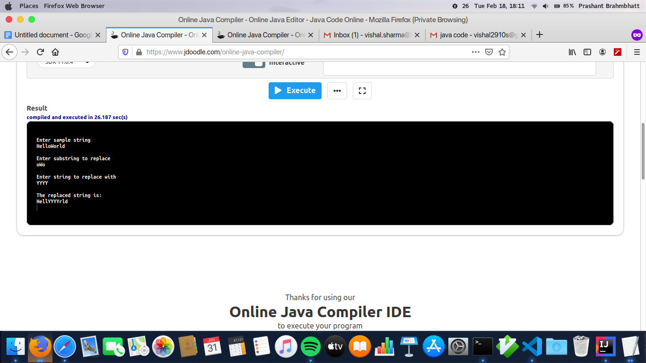

1. Write a program to find the number of occurrences of the duplicate words in a string and print them ?

Answer: FileName - **DuplicateWords.java**

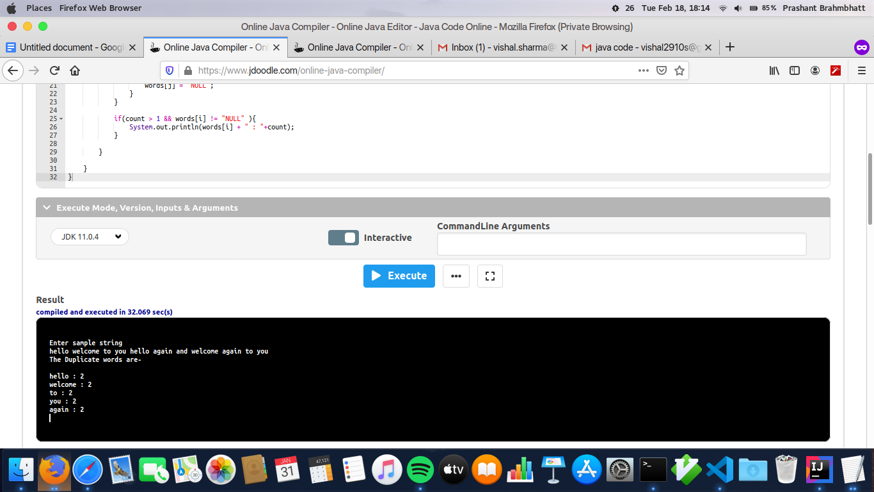

1. Write a program to find the number of occurrences of a character in a string without using loop?

Answer: Filename - **DuplicateCharWoLoop.java**

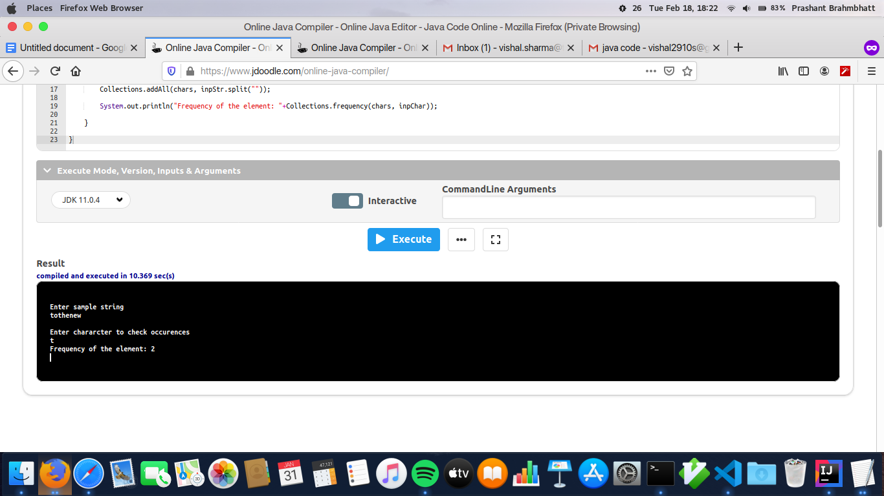

1. Calculate the number & Percentage Of Lowercase Letters,Uppercase Letters, Digits And Other Special Characters In A String

Answer: Filename - **GroupCharCount.java**

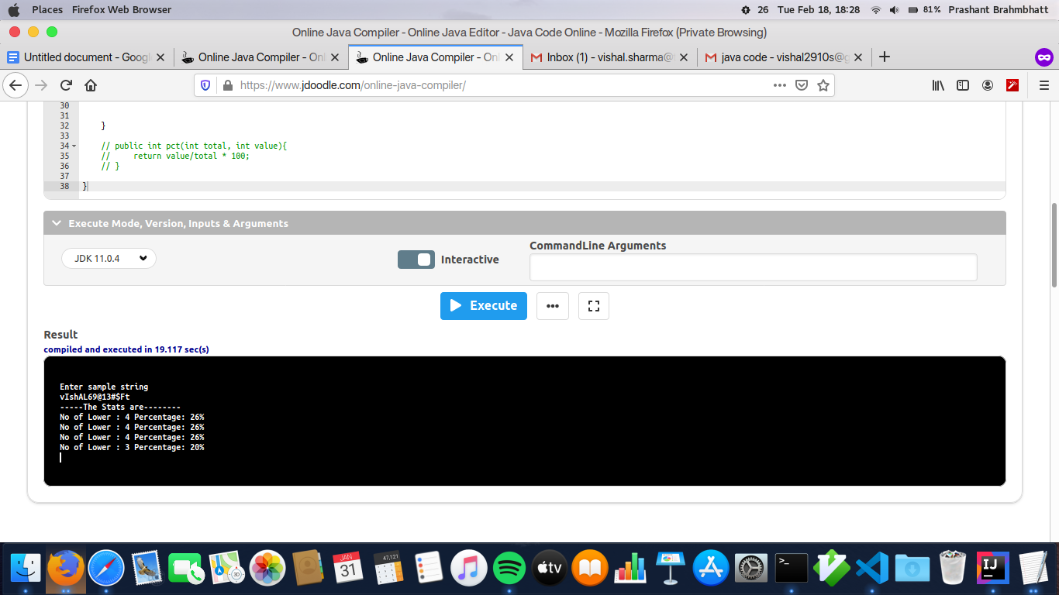

1. Find common elements between two arrays.

Answer : FileName- **ArrayCommon.java**

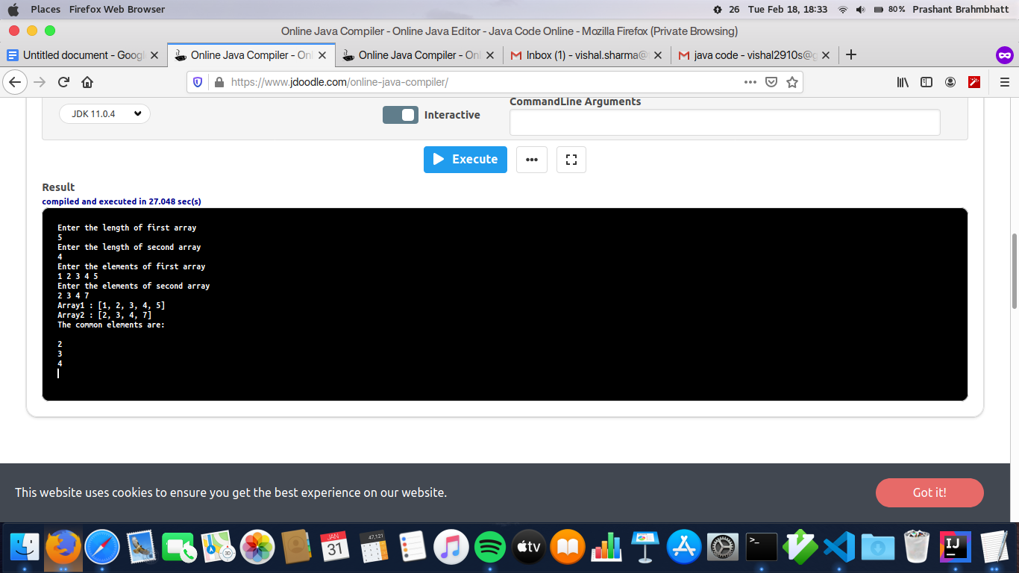

1. There is an array with every element repeated twice except one. Find that element

Answer: Filename- **FileSingle.java**

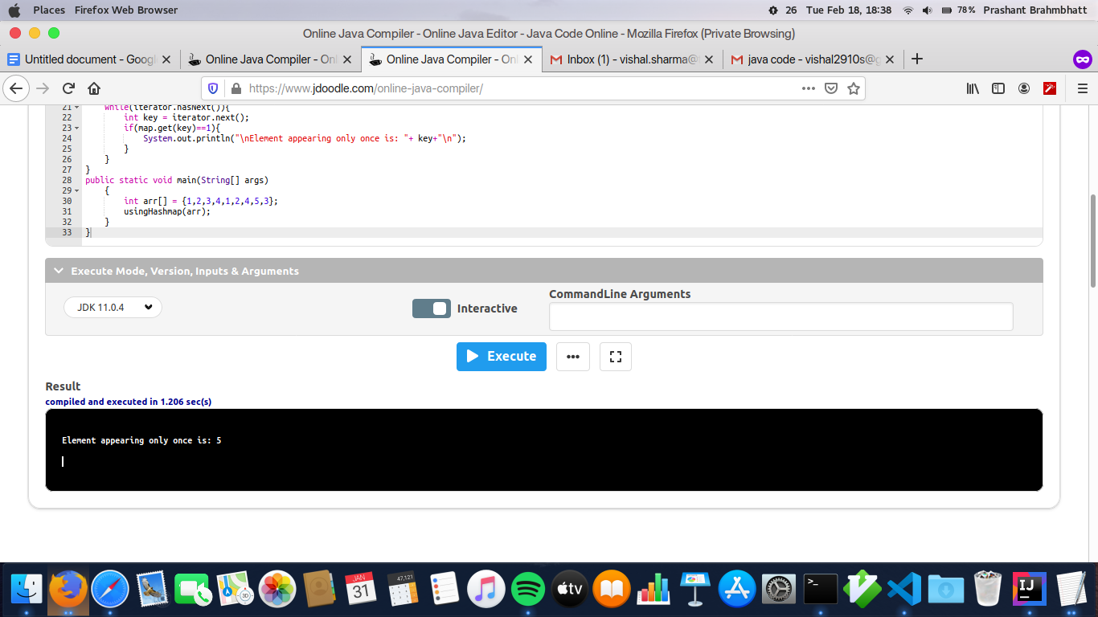

1. Write a program to print your Firstname,LastName & age using static block,static method & static variable respectively.

Answer: Filename- **AllStatic.java**

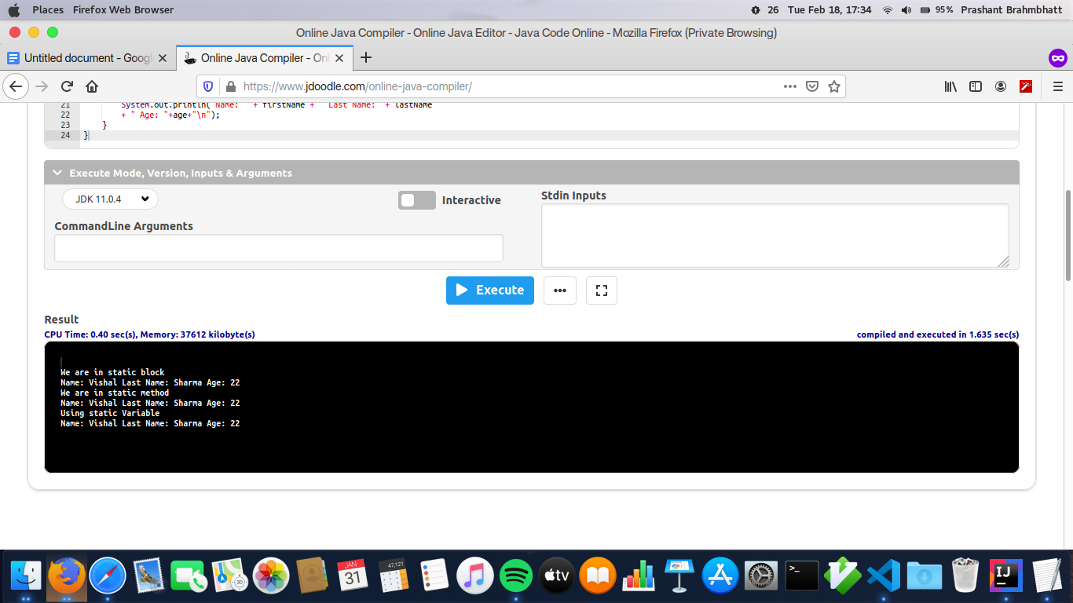

1. Write a program to reverse a string and remove character from index 4 to index 9 from the reversed string using String Buffer.

Answer: Filename- **ReverseRemove.java**

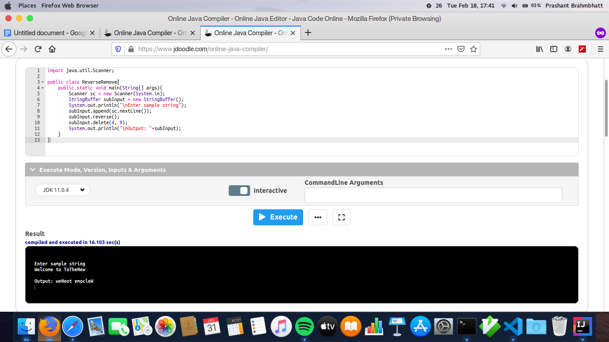

1. Write a program to display values of enums using a constructor & getPrice() method (Example display house & their prices)

Answer: Filename- **EnumHouses.java**

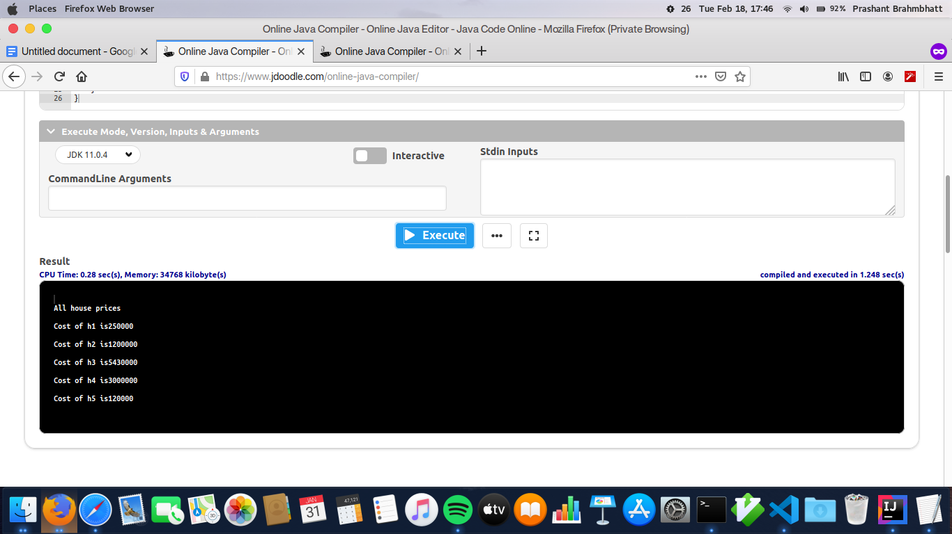

1. Write a single program for following operation using overloading

A) Adding 2 integer number

B) Adding 2 double

C) multiplying 2 float

D) multiplying 2 int

E) concate 2 string

F) concate 3 String

Answer: Filename- **MethodOverloading.java**

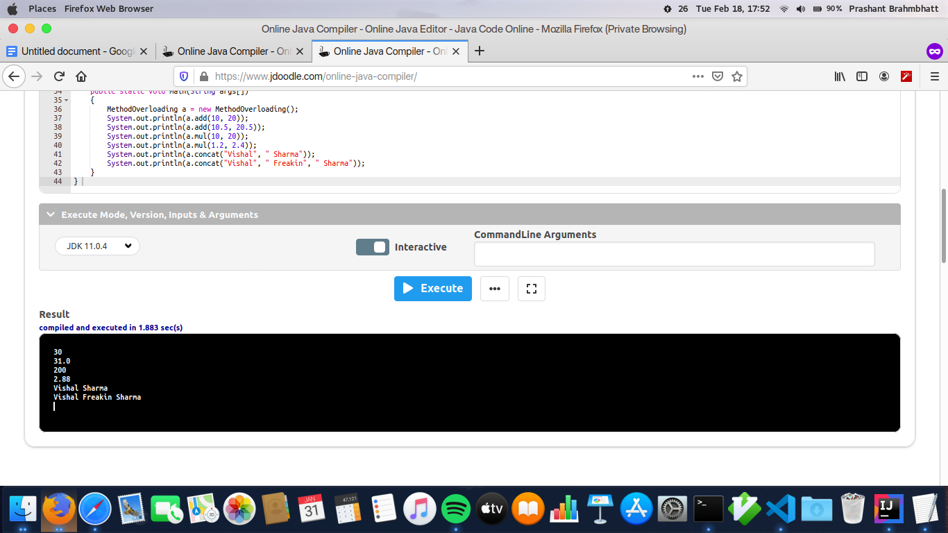

1. Create 3 sub class of bank SBI,BOI,ICICI all 4 should have method called getDetails which provide there specific details like rateofinterest etc,print details of every banks.

Answer: Filename- **BankClass.java**

