Selector Practice

All style.css files and screenshots are inside selectorpractice.tar.gz

- Select the <h1> element

CSS code:

h1 {
color: red;
}

ScreenShot:

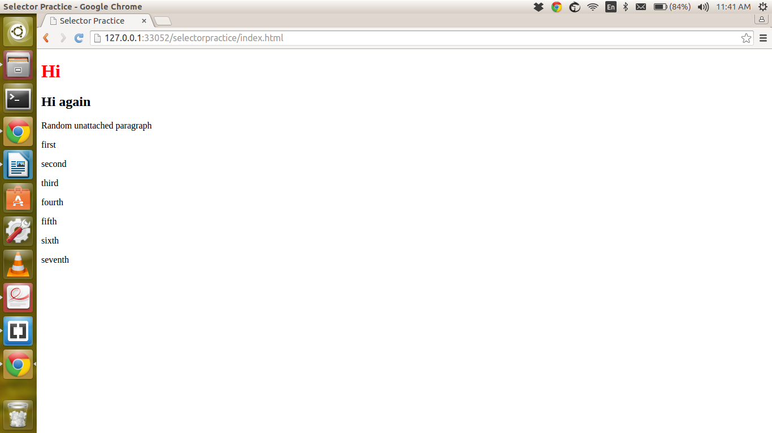

- Select the <h2> element by its class

CSS code:

h2.important {
color: red;
}

ScreenShot:

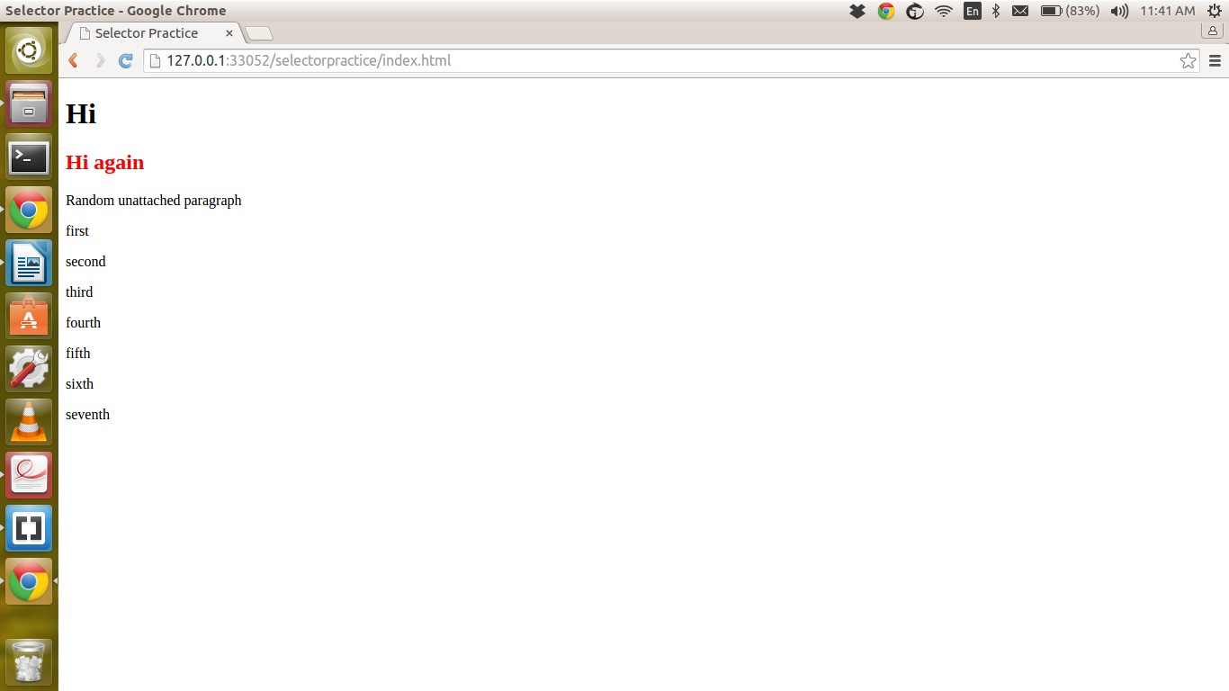

- Select all of the relevant paragraph.

CSS code:

div.relevant p {
color: red;
}

ScreenShot:

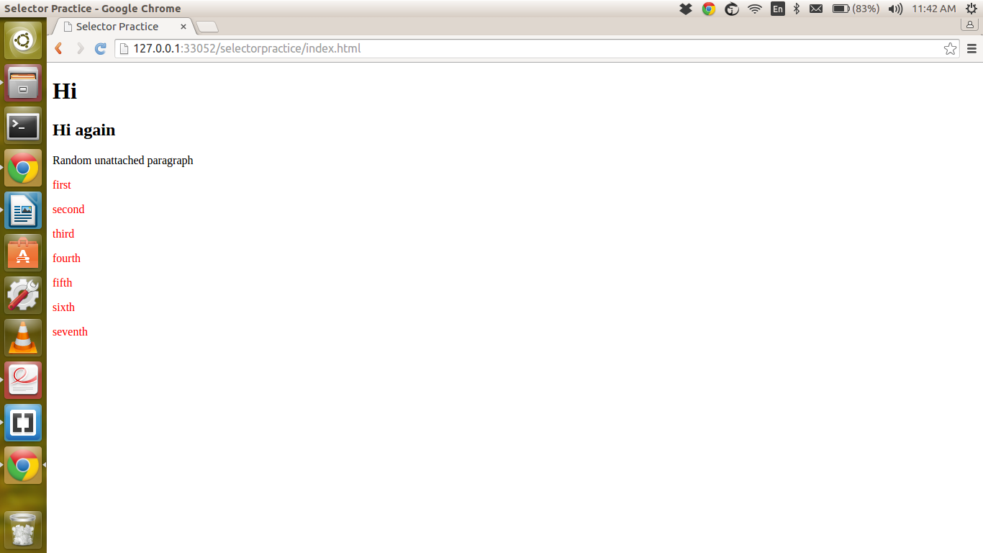

- Select the first paragraph of relevant paragraph.

CSS Code:

div.relevant p:first-child {
color: red;
}

ScreenShot:

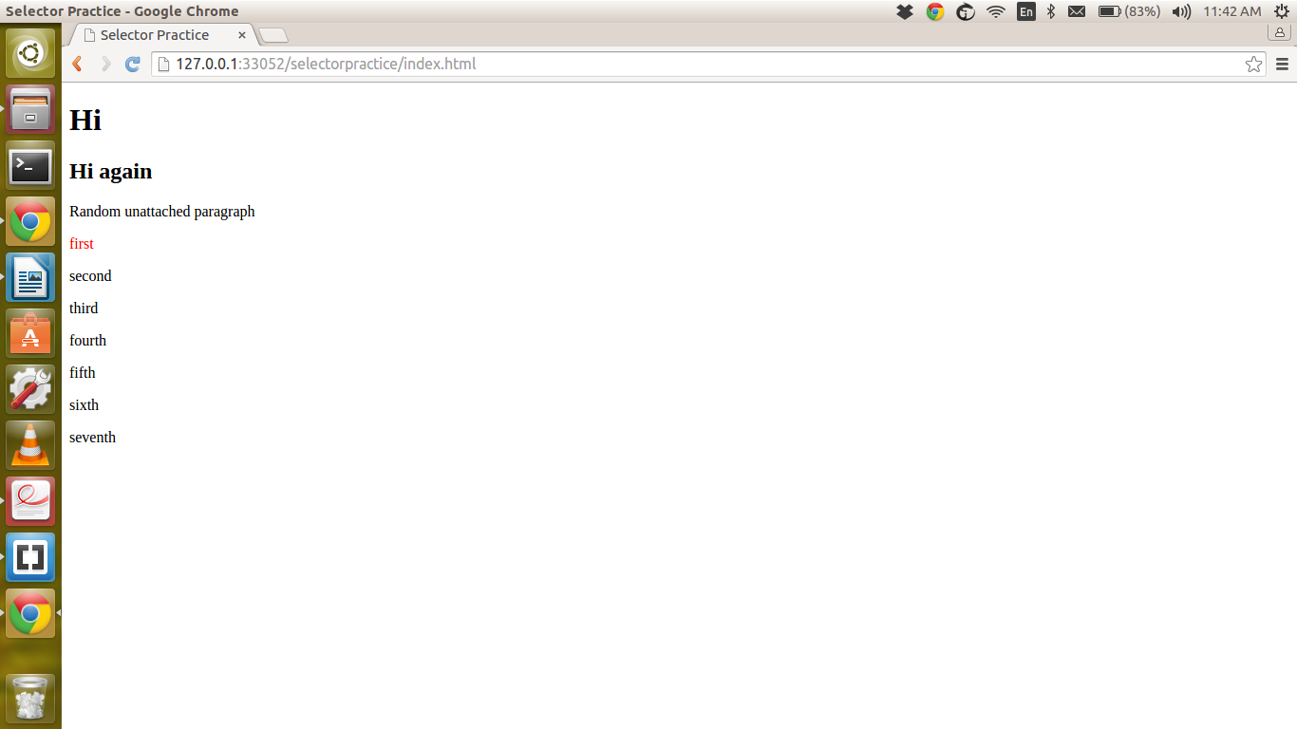

- Select the third paragraph of relevant paragraphs.

CSS Code:

div.relevant p:nth-child(3) {
color: red;
}

ScreenShot:

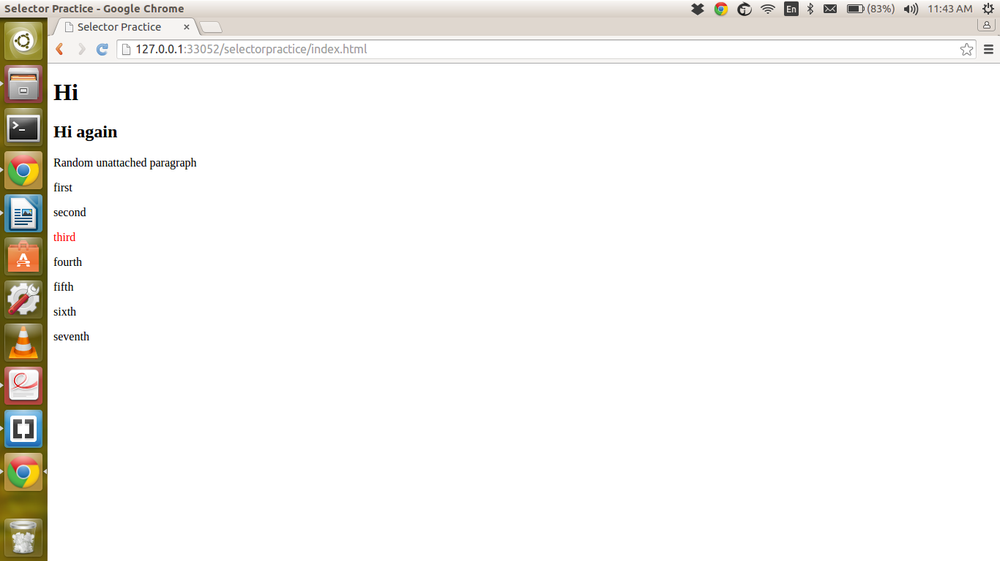

- Select the seventh relevant paragraph

CSS Code:

div.relevant p:nth-child(7) {
color: red;
}

ScreenShot:

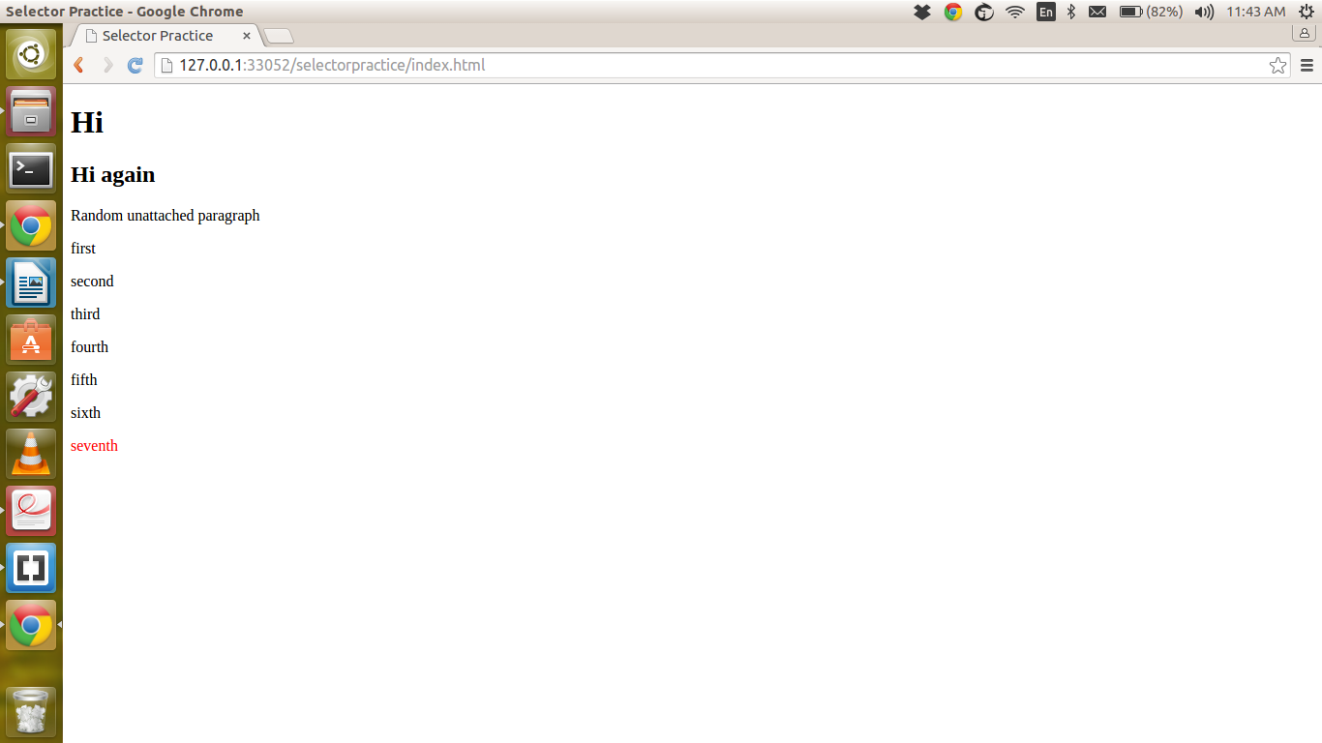

- Select all of the paragraph on the page

CSS Code:

p {
color: red;
}

ScreenShot:

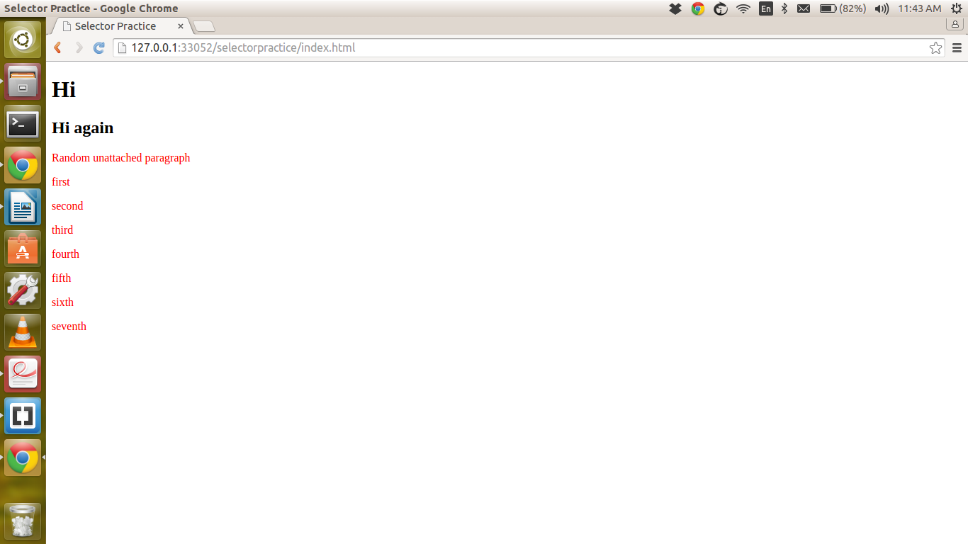

- Select only the random, unattached paragraph

CSS Code:

p:first-of-type:last-of-type {
color: red;
} /* https://developer.mozilla.org/en-US/docs/Web/Guide/CSS/Getting_Started/Selectors */

ScreenShots:

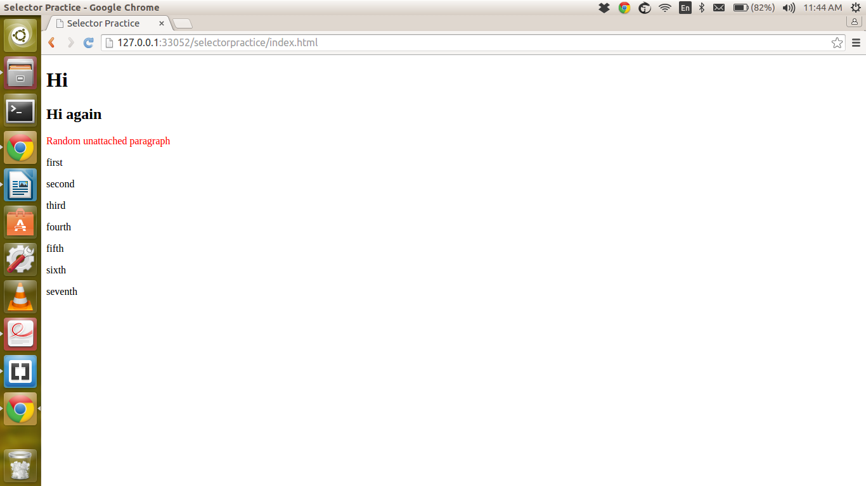

- Select all of the paragraphs with the a class

CSS Code:

p.a {
color: red;
}

ScreenShot:

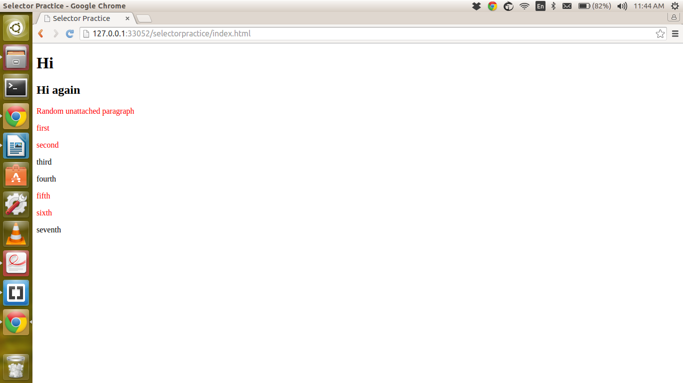

- Select only the relevant paragraphs with the a class

CSS Code:

div.relevant p.a {
color: red;
}

ScreenShot:

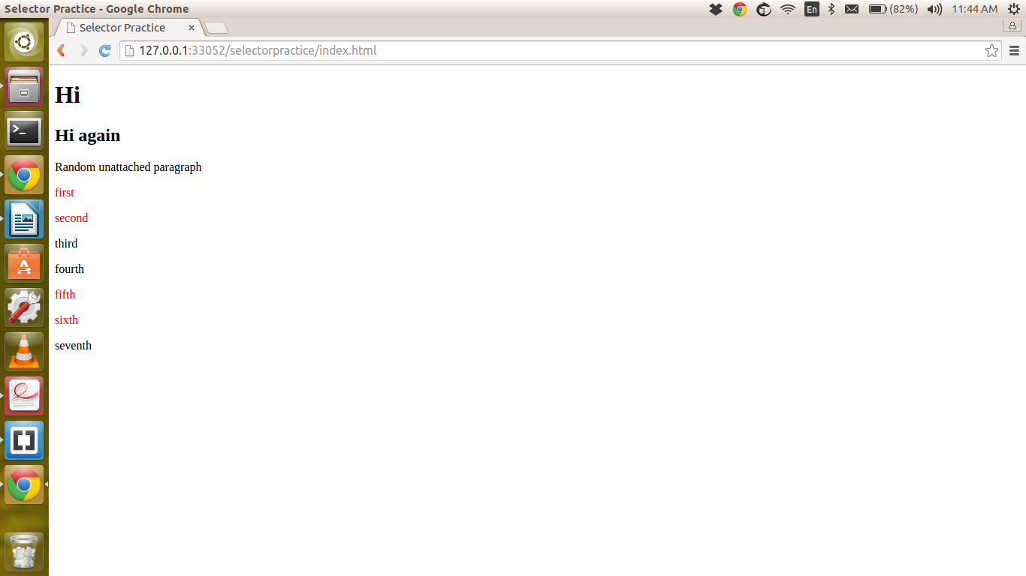

- Select the second and fourth paragraphs

CSS Code:

div.relevant p:nth-child(2),p:nth-child(4) {
color: red;
}

ScreenShot:

