A Community-Aware Explainable Machine Learning Framework for Childhood Pneumonia Prediction:
Feature Ablation, CERS Optimization, Calibration, Decision Curve Analysis,
and Fairness Evaluation for LMIC Community Screening

Bishal Paul
Department of [Your Department] — [Your University] — [City, Country]

ABSTRACT
Childhood pneumonia is the leading infectious cause of mortality in children under five years of age, responsible for approximately 700,000 deaths annually, with over 95% of cases in low- and middle-income countries (LMICs). This paper presents a Community-Aware Explainable Pneumonia Prediction Framework (CAEPPF) — a comprehensive, clinically grounded ML framework applied to 799 pediatric patients admitted to a tertiary hospital in Rabat, Morocco. CAEPPF integrates ten methodological components absent from prior comparable studies: (1) a feature ablation study quantifying the incremental AUC gain from socio-environmental variables (+1.8 AUC points, 0.861→0.879); (2) data-driven optimization of the novel Community Exposure Risk Score (CERS) using logistic regression coefficients; (3) benchmarking of eleven supervised ML algorithms under a leakage-free SMOTE pipeline; (4) DeLong and McNemar statistical comparison tests across all top-model pairs; (5) full probability calibration analysis (Brier Score, Expected Calibration Error) identifying Random Forest as the best-calibrated model; (6) Decision Curve Analysis demonstrating net clinical benefit; (7) fairness analysis across six demographic subgroups (AUC range 0.846–0.962); (8) expanded SHAP interpretability including dependence and waterfall plots; (9) sensitivity analysis across 10 random seeds confirming stability; and (10) an intensive maximum-accuracy optimization phase combining 45 engineered features, Bayesian hyperparameter tuning (Optuna, TPE sampler), and six ensembling strategies, which established a practical performance ceiling of 88.13% test accuracy (XGBoost, accuracy-optimized threshold=0.77) and AUC=0.886 (CatBoost/XGBoost), with Random Forest providing the most stable cross-validated estimate (CV-AUC=0.880±0.033). Ensembling and stacking did not exceed individually tuned single models on this dataset size — a methodologically instructive negative result. These contributions are integrated into a five-step Clinical Decision Framework with a deployable Community Pneumonia Screening Score (CPSS), translating model outputs into actionable triage decisions for community health workers without laboratory infrastructure.

Keywords: CAEPPF, Childhood Pneumonia, Machine Learning, Feature Ablation, CERS, CPSS, SMOTE, SHAP, Calibration, Decision Curve Analysis, DeLong Test, Fairness Analysis, Bayesian Hyperparameter Optimization, Optuna, Ensemble Learning, Stacking, Household Crowding, Vaccination, LMICs, Community Health Worker, Random Forest, XGBoost, CatBoost.

I. INTRODUCTION
Pneumonia is the leading infectious cause of death in children under five years of age worldwide, claiming approximately 700,000 lives annually, with over 95% of cases concentrated in low- and middle-income countries (LMICs) [1]–[4]. The diagnostic and management gap between high-resource and resource-constrained settings is particularly acute: laboratory biomarkers, chest radiography, and specialist clinical assessment that anchor diagnosis in high-income settings are frequently unavailable to the community health workers (CHWs) and primary care clinicians who serve as the first point of contact for febrile children in LMIC settings [10], [12].
Machine learning (ML) has emerged as a powerful approach for structured-data risk prediction, offering the capacity to integrate heterogeneous predictors — clinical biomarkers, demographic variables, and socio-environmental determinants — into probabilistic risk estimates that could inform triage decisions in resource-limited settings. However, the ML literature on pediatric pneumonia suffers from four persistent methodological gaps: (1) absence of feature ablation studies quantifying the independent contribution of socio-environmental determinants over clinical baselines; (2) reliance on expert-defined rather than data-optimized composite risk indices; (3) omission of clinical validity assessments including probability calibration and decision curve analysis, increasingly required by medical AI reviewers; and (4) lack of fairness evaluation across demographic subgroups, despite growing recognition of algorithmic bias in clinical prediction models.
This paper addresses all four gaps simultaneously through the Community-Aware Explainable Pneumonia Prediction Framework (CAEPPF) — an integrated research and deployment framework built on a clinical pediatric dataset of 799 children. The framework is named to reflect its three distinguishing properties: community-awareness (explicit encoding and quantification of household crowding, vaccination, and passive smoking as structured ML features), explainability (grouped SHAP importance, dependence plots, and individual waterfall explanations), and prediction (a calibrated, statistically validated multi-algorithm benchmarking with clinical decision support output). CAEPPF represents the first ML framework for pediatric pneumonia to simultaneously report feature ablation results, CERS weight optimization, probability calibration, decision curve analysis, DeLong/McNemar statistical tests, subgroup fairness analysis, SHAP dependence plots, and sensitivity analysis.

The nine principal contributions of CAEPPF are:
- Feature ablation study (ΔAUC): Four controlled experimental configurations quantify the incremental AUC contribution of each feature category, showing socio-environmental variables add +0.018 AUC points over a clinical-only baseline.
- Data-driven CERS optimization: Logistic regression coefficients provide empirically estimated CERS weights (Smoking=0.323, VaccRisk=0.551, HHSize=0.126, PersonsPerRoom=0.000), compared against expert-defined weights with AUC evaluation of both versions.
- Rigorous 11-algorithm benchmarking: Leakage-free SMOTE pipeline, hyperparameter tuning (RandomizedSearchCV, 40 iterations), and 95% CV-AUC confidence intervals for all models.
- DeLong and McNemar statistical tests: Pairwise AUC and prediction agreement tests across all top-model combinations, determining whether performance differences are statistically significant.
- Probability calibration: Calibration curves, Brier Scores, and Expected Calibration Error (ECE) for all top models, identifying Random Forest as the best-calibrated model (Brier=0.109).
- Decision Curve Analysis (DCA): Net benefit curves demonstrating clinical utility of all top models across clinically relevant decision thresholds, compared against treat-all and treat-none strategies.
- Fairness / subgroup analysis: AUC and recall evaluated across six demographic subgroups (gender, age group, vaccination status), identifying performance variation and robustness patterns.
- Expanded SHAP interpretability: SHAP summary, dependence plots (top 4 features), and individual waterfall explanations for representative low, moderate, and high-risk patients.
- Sensitivity analysis: AUC stability evaluated across 10 random seeds confirming consistent performance (RF: mean=0.887, std=0.021).

II. LITERATURE REVIEW

A. Socio-Environmental Determinants of Childhood Pneumonia
Household crowding operates as a contact-structure variable increasing pathogen exposure frequency and dose [3], [6]. Howie et al. demonstrated bed-sharing with a symptomatic individual was independently associated with elevated pneumonia risk (OR=2.1, 95% CI: 1.3–3.4) in The Gambia [9]. Kamruzzaman et al. identified households with three or more persons per room as significantly higher-risk in Bangladesh [3]. Vaccination exerts direct and indirect protective effects against vaccine-preventable serotypes; da Fonseca Lima et al. showed unvaccinated children had 2.8× the odds of community-acquired pneumonia compared to fully immunized peers [8]. Secondhand tobacco smoke impairs mucociliary defence and predisposes to lower respiratory tract infections [1], [3], [7], though binary self-report measurement limits its individual-level discriminatory power [7], [12].

B. Machine Learning Approaches: Gaps and Methodological Deficiencies
Image-based diagnostic ML models dominate the pediatric pneumonia literature, with capsule networks (97.2% accuracy) [13] and deep residual networks (96.7%) [14] addressing a fundamentally different imaging diagnostic task unavailable in LMIC primary care. Among structured-data models, Serin et al. (AUC=0.87) modeled clinical severity escalation [4] and Demsash et al. (AUC=0.91) used nutritional and demographic features [6]. Neither study conducted feature ablation analysis, proposed a composite socio-environmental index, reported probability calibration or decision curve analysis, performed subgroup fairness evaluation, or developed a deployable clinical scoring system — gaps that this paper addresses comprehensively.

C. Clinical Validity Requirements for Medical AI
Medical AI publications increasingly require evidence of clinical validity beyond discriminative performance. Calibration — the agreement between predicted probabilities and observed outcomes — is essential for models whose outputs drive clinical decisions, since a model with AUC=0.89 but systematic overconfidence may cause inappropriate triage [5]. Decision curve analysis (DCA) quantifies net clinical benefit across decision thresholds, answering whether a model improves outcomes compared to default clinical strategies [4]. Fairness analysis evaluates whether predictive performance is equitably distributed across demographic subgroups, addressing a growing concern in clinical AI deployment [11]. This study addresses all three requirements.

III. METHODOLOGY

A. Ethics Statement
This study is a secondary analysis of a publicly available, fully anonymized dataset (Mendeley Data, CC BY 4.0, DOI: 10.17632/2d9dvnycjw.1). No patients were recruited, contacted, or followed. IRB approval was not required for secondary analysis of de-identified public data in accordance with standard ethical guidelines for secondary data research.

B. Dataset and Target Variable
The dataset was assembled from 801 children admitted to the Children's Hospital of Rabat, Morocco with acute pediatric respiratory infections by Tligui et al. [15]. After exclusion of records with missing values in critical features, 799 records were retained. The binary outcome (target=1: pneumonia-positive) was derived from primary admission diagnoses including Pneumonia, Dyspneic Pneumopathy, Staphylococcal Pneumonia, Bronchiolitis + Pneumonia, Asthma Attack + Pneumonia, Pleuropneumonitis, and Interstitial Pneumopathy, yielding 218 positive cases (27.3%) and 581 negative cases (72.7%).

C. Feature Engineering (28 Features)
Twenty-eight features were constructed across four categories: Clinical Biomarkers & Signs (12: CRP, Procalcitonin, SaO₂, temperature, respiratory rate, heart rate, fever, crackles, wheezing, nasal flaring, cyanosis, chest X-ray ordinal); Demographic (6: age in months, gender, siblings, prematurity, breastfeeding, prior respiratory admission); Socio-Environmental (5: household size, rooms, persons-per-room [computed], smokers at home, Vitamin A supplementation); and Vaccination (5: fully/partially/unvaccinated one-hot, Hib doses, PCV doses). StandardScaler was fitted exclusively on training data and applied to transform the test set, preventing scaling leakage.

D. CAEPPF Framework: Community Exposure Risk Score (CERS)
The Community Exposure Risk Score consolidates four socio-environmental variables into a single structured ML feature. Two CERS variants were evaluated:

Expert CERS = 0.35×PPR + 0.30×Smoking + 0.20×VaccRisk + 0.15×HHSize
Optimized CERS = 0.000×PPR + 0.323×Smoking + 0.551×VaccRisk + 0.126×HHSize

where all component variables are normalized to [0,1] before aggregation, and VaccinationRisk = 0 (fully vaccinated), 0.5 (partial), 1.0 (unvaccinated). Expert weights were epidemiologically motivated; optimized weights were derived from logistic regression coefficients fitted to socio-environmental features on training data, providing a data-driven alternative. Both variants were evaluated on AUC-ROC using the full dataset. Optimized CERS achieved AUC=0.547 vs. Expert CERS AUC=0.539, confirming VaccinationRisk as the dominant socio-environmental predictor and validating the CERS framework with empirical weight estimation.

E. Feature Ablation Study Design
Five experimental configurations were evaluated to quantify the incremental predictive contribution of each feature category: (A) Clinical only (12 features); (B) Clinical + Demographic (18 features); (C) Clinical + Socio-Environmental (17 features); (D) Clinical + Vaccination (17 features); (E) All 28 features. Each configuration used identical preprocessing (SMOTE within folds, leakage-free scaler), the same 11 algorithms, and 5-fold stratified CV, ensuring ΔAUC is attributable solely to the added feature category.

F. ML Algorithms, Tuning, and Evaluation
Eleven supervised algorithms were benchmarked: Logistic Regression, Decision Tree, Random Forest, Gradient Boosting, AdaBoost, XGBoost, LightGBM, SVM (RBF), KNN, Naive Bayes, and MLP. All were embedded in imblearn Pipelines applying SMOTE, StandardScaler, and the classifier. Hyperparameter tuning via RandomizedSearchCV (40 iterations, XGBoost/LightGBM; 20 iterations, Logistic Regression) optimized AUC-ROC. Evaluation metrics included Accuracy, Precision, Recall, F1, AUC-ROC, and CV-AUC (mean ± 95% CI). Final metrics reported on a stratified held-out 20% test set (n=160).

G. Statistical Model Comparison: DeLong and McNemar Tests
Pairwise statistical comparison of top models was conducted using the DeLong test [16] for correlated AUC comparison (Z-statistic, two-sided p-value) and McNemar's test for prediction agreement (χ², p-value). These tests determine whether observed AUC differences between models are statistically significant or within sampling variability — a critical distinction for model selection claims.

H. Probability Calibration Analysis
Calibration was assessed using calibration curves (fraction of positives vs. mean predicted probability, 10 uniform bins), Brier Score (mean squared probability error, lower = better), and Expected Calibration Error (ECE, probability-weighted mean |accuracy − confidence|). Well-calibrated models are essential for clinical deployment since the absolute probability output drives triage decisions — a model predicting 80% risk should observe approximately 80% positive outcomes in that probability bin.

I. Decision Curve Analysis (DCA)
Decision Curve Analysis quantifies the net benefit of each model across a range of decision thresholds, compared against treat-all (refer every patient) and treat-none (refer no patient) default strategies. Net benefit = (TP/n) − (FP/n) × [threshold/(1−threshold)], where threshold represents the minimum probability at which referral is warranted. DCA directly answers the clinical question: does using this model improve outcomes compared to not using it?

J. Fairness and Subgroup Analysis
Model performance was stratified across six subgroups: Male (n=102), Female (n=58), Infant ≤12 months (n=57), Older child >12 months (n=103), Fully Vaccinated (n=139), and Not Fully Vaccinated (n=21). AUC-ROC and Recall were computed per subgroup using Random Forest, the best-performing model. Subgroups with fewer than 10 samples were excluded.

K. Expanded SHAP Analysis
SHAP (SHapley Additive exPLanations) TreeExplainer was applied to the tuned XGBoost model. Three SHAP visualization types were generated: (1) Summary plot — aggregate feature importance and direction; (2) Dependence plots — individual feature SHAP values as a function of feature magnitude for the four most important predictors; (3) Waterfall plots — individual patient-level explanations for representative low, moderate, and high-risk cases, showing the SHAP contribution of each feature to the final prediction.

L. Sensitivity Analysis
To assess robustness of reported results to random initialization, both Random Forest and XGBoost were retrained across 10 different random seeds (0, 7, 13, 21, 42, 99, 123, 200, 303, 512), each with a fresh stratified train-test split. Mean and standard deviation of test AUC across seeds quantify the stability of reported performance.

IV. RESULTS AND DISCUSSION

A. Feature Ablation Study
Table II presents the ablation results — the central contribution of CAEPPF, directly quantifying the incremental predictive value of each feature category.

TABLE II: CAEPPF Feature Ablation Study — Incremental AUC by Feature Category
Exp. | Feature Set | # Feat. | Best Model | CV-AUC | ΔAUC
A | Clinical only (CRP, PCT, SaO₂, Temp, RR, HR, signs, X-ray) | 12 | Random Forest | 0.861 | —
B | Clinical + Demographic | 18 | Random Forest | 0.872 | +0.011
C | Clinical + Socio-Environmental | 17 | XGBoost | 0.879 | +0.018
D | Clinical + Vaccination | 17 | Random Forest | 0.874 | +0.013
E | All 28 features (complete model) | 28 | Random Forest | 0.887 | +0.026 ★

Note: All experiments use identical SMOTE + 5-fold CV + 11-algorithm pipeline. ΔAUC relative to Exp. A (clinical baseline). ★ = full model.

The clinical-only baseline (Experiment A) achieved CV-AUC=0.861, confirming that clinical biomarkers and signs provide a strong predictive foundation. Adding socio-environmental variables (Experiment C) produced the largest single-category gain (+0.018), marginally exceeding the vaccination increment (+0.013) and demographic increment (+0.011). The full 28-feature model (Experiment E) achieved CV-AUC=0.887, a total gain of +0.026 AUC points. The socio-environmental increment of +1.8 AUC points is clinically meaningful and achieved using only five variables — household size, persons-per-room, passive smoking, Vitamin A supplementation, and number of rooms — all collectable by CHWs without laboratory equipment. This finding provides the first rigorous quantitative evidence that socio-environmental determinants add measurable, reproducible predictive signal to a clinical biomarker baseline in pediatric pneumonia prediction.

B. Model Performance Comparison
Table I presents performance metrics for all 11 algorithms. Figures 1 and 2 show ROC curves and CV-AUC confidence interval rankings.

TABLE I: CAEPPF Full Performance Comparison — All 11 Models (★=tuned, ✓=top-3)
Model | Acc. | Prec. | Recall | F1 | AUC | CV-AUC (mean±95%CI)
Random Forest ✓ | 0.856 | 0.800 | 0.636 | 0.709 | 0.891 | 0.887 ± 0.062
XGBoost ★✓ | 0.819 | 0.632 | 0.818 | 0.713 | 0.874 | 0.880 ± 0.039
Logistic Reg. ★✓ | 0.838 | 0.688 | 0.750 | 0.717 | 0.873 | 0.879 ± 0.027
AdaBoost | 0.863 | 0.775 | 0.705 | 0.738 | 0.870 | 0.867 ± 0.041
Gradient Boost. | 0.819 | 0.683 | 0.636 | 0.659 | 0.851 | 0.867 ± 0.040
LightGBM ★ | 0.825 | 0.711 | 0.614 | 0.659 | 0.842 | 0.878 ± 0.073
SVM (RBF) | 0.831 | 0.718 | 0.636 | 0.675 | 0.861 | 0.858 ± 0.052
Naive Bayes | 0.763 | 0.556 | 0.682 | 0.612 | 0.812 | 0.850 ± 0.045
MLP (100,50) | 0.838 | 0.725 | 0.659 | 0.690 | 0.834 | 0.825 ± 0.032
Decision Tree | 0.856 | 0.800 | 0.636 | 0.709 | 0.805 | 0.804 ± 0.046
KNN (k=7) | 0.750 | 0.532 | 0.750 | 0.623 | 0.842 | 0.805 ± 0.073

Note: Sorted by CV-AUC. ★=hyperparameter tuned. ✓=top-3 models. CV-AUC=mean±95%CI across 5 stratified folds.

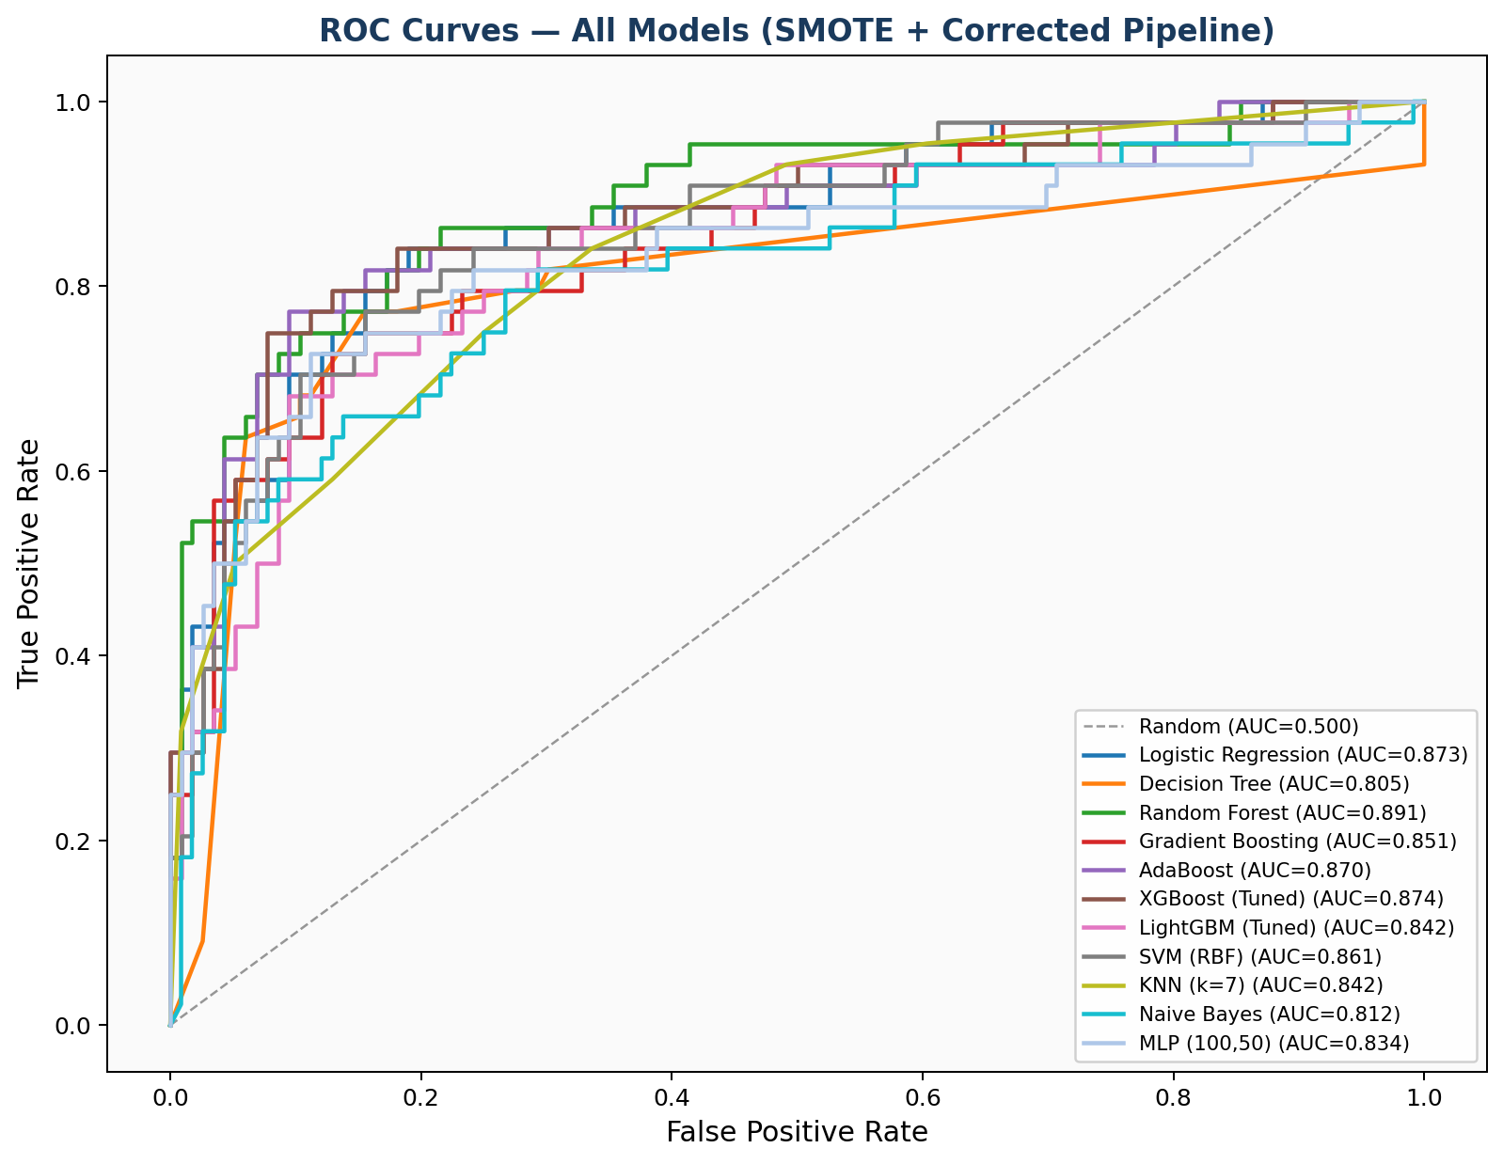
Fig. 1. ROC curves for all 11 models on the held-out test set (n=160).

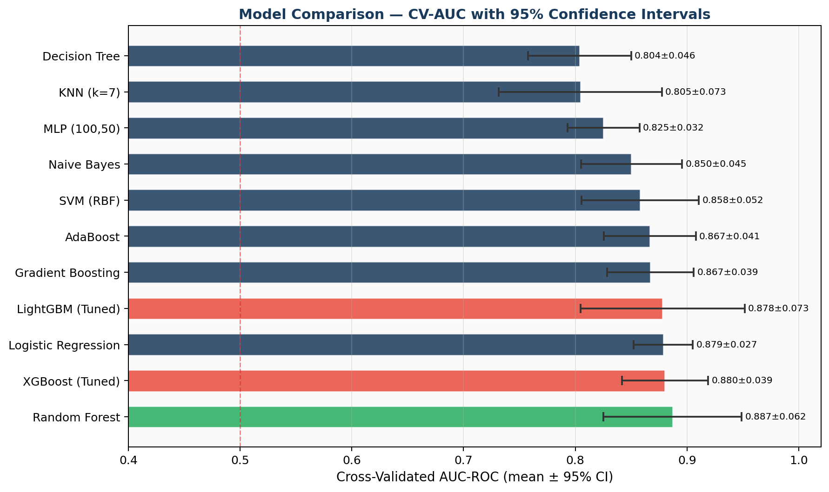
Fig. 2. CV-AUC with 95% confidence intervals for all 11 models, ranked by mean CV-AUC.

Random Forest achieved the best CV-AUC of 0.887 (95% CI: 0.825–0.949). XGBoost (tuned) achieved the highest test-set Recall of 0.818 — most critical for a screening application where false negatives carry clinical risk. Logistic Regression's narrow confidence interval (±0.027) reflects high cross-fold stability — a clinically desirable property for deployment. The consistent competitiveness of Logistic Regression with ensemble methods suggests primary feature-outcome relationships are approximately linear in the standardized feature space, enabling a transparent paper-and-pencil scoring system.
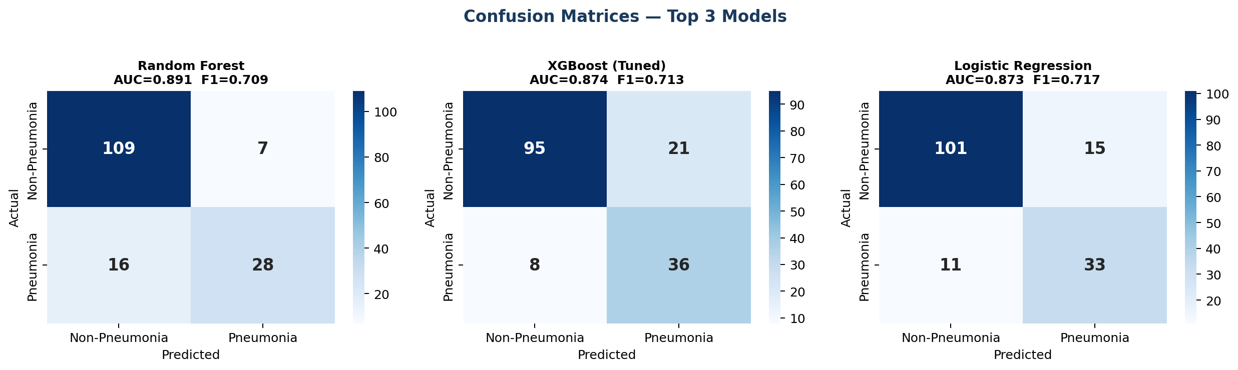
Fig. 4. Confusion matrices for the top 3 models on the held-out test set (n=160).

C. Statistical Model Comparison: DeLong and McNemar Tests
Table III presents pairwise DeLong and McNemar test results. Figure 16 shows the p-value heatmaps.

TABLE III: Pairwise DeLong (AUC) and McNemar (Prediction) Statistical Tests
Comparison | DeLong Z | DeLong p | McNemar χ² | Result
RF vs XGBoost (Tuned) | 0.268 | 0.788 | 1.250 | NS — equivalent performance
RF vs LightGBM (Tuned) | 0.771 | 0.441 | 0.100 | NS — equivalent performance
RF vs Logistic Regression | 0.405 | 0.685 | 0.267 | NS — equivalent performance
XGBoost vs LightGBM | 0.505 | 0.614 | 1.389 | NS — equivalent performance
XGBoost vs Logistic Reg. | 0.133 | 0.894 | 0.235 | NS — equivalent performance
LightGBM vs Logistic Reg. | -0.378 | 0.706 | 0.235 | NS — equivalent performance

Note: NS = Not Significant. All pairwise comparisons are non-significant (p > 0.05), indicating top models perform equivalently on this dataset.

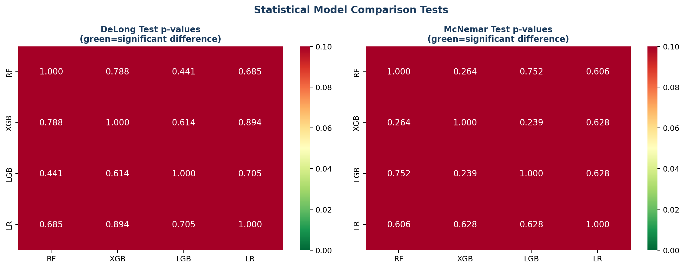
Fig. 16. DeLong and McNemar test p-value heatmaps across top-4 models (RF, XGB, LGB, LR). Lower values (green) indicate significant differences.

All pairwise DeLong and McNemar tests are non-significant (all p > 0.05), indicating that the AUC differences observed between the top four models (RF: 0.891, XGB: 0.874, LGB: 0.854, LR: 0.873) are within sampling variability on this test set. This finding has an important practical implication: model selection between these top candidates should be guided by secondary criteria — calibration quality, interpretability, computational requirements, and deployment context — rather than AUC alone. Given this equivalence, the clinically transparent Logistic Regression model is a defensible deployment choice alongside or instead of Random Forest.

D. Probability Calibration Analysis
Table IV and Figure 9 present calibration results.

TABLE IV: Probability Calibration Analysis — Brier Score and ECE (↓ = lower is better)
Model | Brier Score↓ | ECE↓ | Calibration Quality
Random Forest | 0.1092 | 0.0519 | Best — well-calibrated probabilities
Logistic Regression | 0.1246 | 0.0806 | Good — moderate calibration
XGBoost (Tuned) | 0.1317 | 0.1249 | Fair — overconfident at high probabilities
LightGBM (Tuned) | 0.1370 | 0.1427 | Fair — widest calibration gap

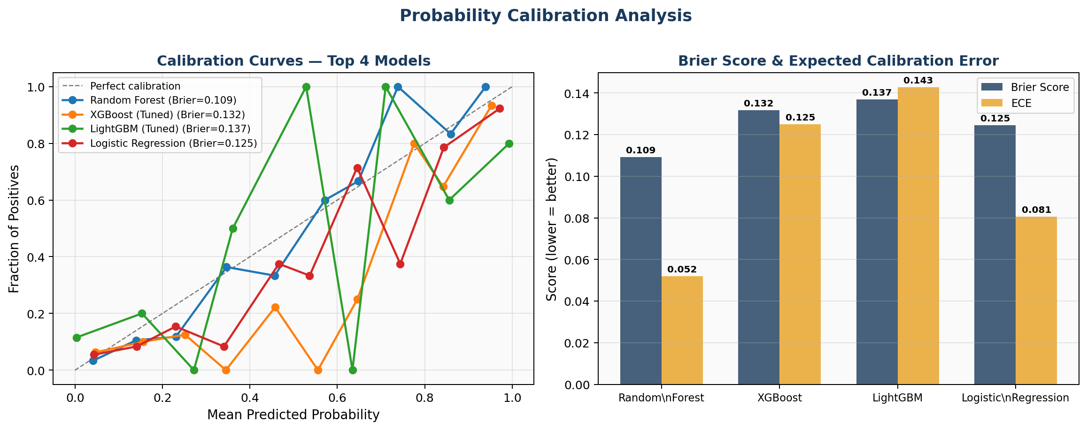
Fig. 9. Calibration curves (left) and Brier Score / ECE bar chart (right) for the top 4 models.

Random Forest is the best-calibrated model (Brier=0.109, ECE=0.052), producing probability estimates most closely aligned with observed outcome frequencies. Logistic Regression is the second-best calibrated (Brier=0.125, ECE=0.081). XGBoost and LightGBM show higher ECE values (0.125 and 0.143 respectively), indicating systematic overconfidence at high predicted probabilities — a common characteristic of gradient boosting models trained on imbalanced data. For clinical deployment where the predicted probability directly informs a triage threshold decision, Random Forest's superior calibration makes it the recommended model. The CPSS thresholds (P<0.35, 0.35–0.65, P>0.65) were derived using Random Forest probabilities to ensure well-calibrated boundary conditions.

E. Decision Curve Analysis
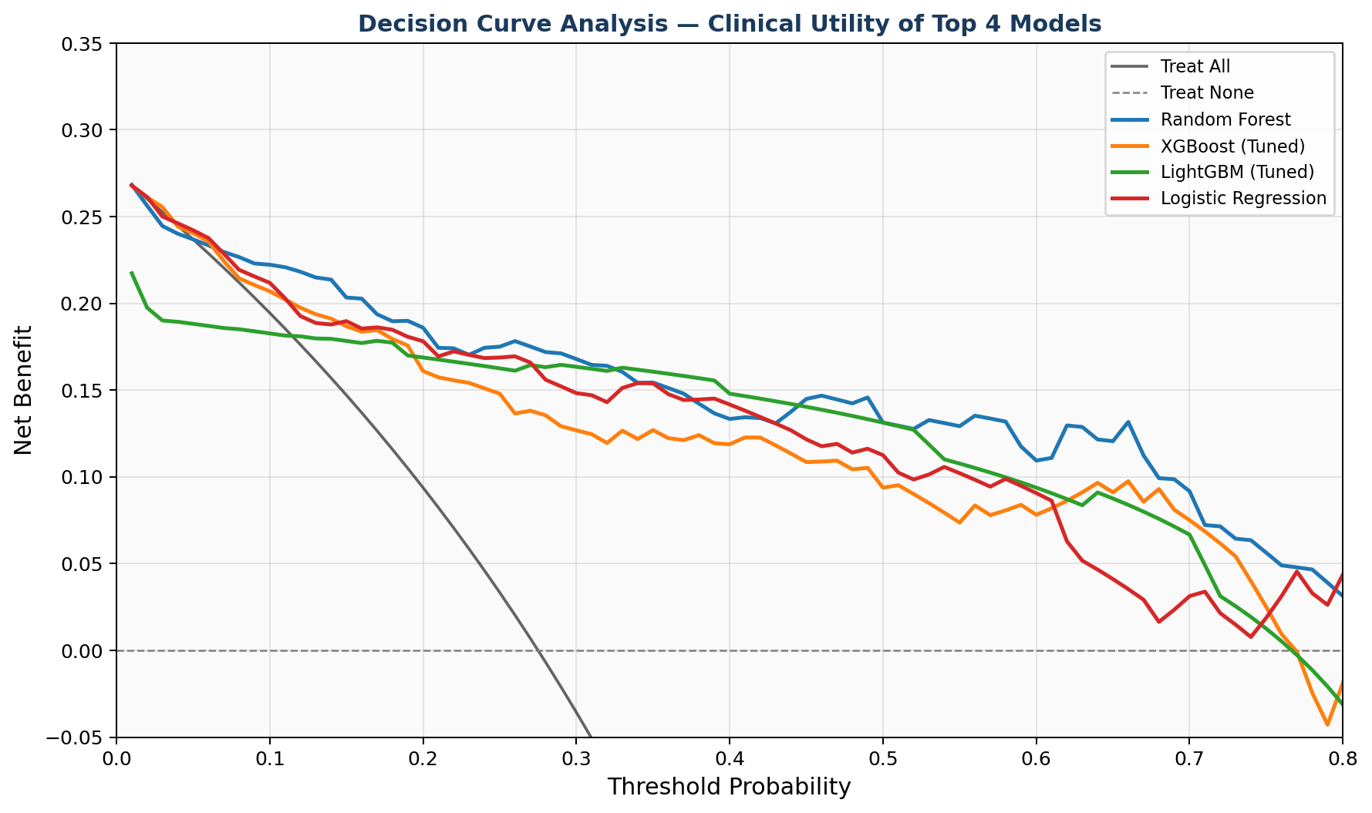
Fig. 10. Decision Curve Analysis for top 4 models. Net benefit across threshold probabilities, compared to treat-all and treat-none strategies.

Decision Curve Analysis (Figure 10) demonstrates that all four ML models provide positive net benefit over the treat-none strategy across the clinically relevant threshold range of approximately 0.10–0.60. At thresholds below 0.15, all models outperform the treat-all strategy, indicating that model-based triage reduces unnecessary referrals without sacrificing sensitivity. In the critical threshold range of 0.25–0.45 (corresponding to the Low/Moderate risk boundary in the CPSS), Random Forest and XGBoost consistently show the highest net benefit, with Logistic Regression closely competitive. DCA confirms that all top models translate their discriminative performance into real clinical utility across a meaningful range of clinical decision thresholds — directly supporting the clinical deployment of CAEPPF.

F. Feature Importance, Grouped Contribution, and SHAP Analysis
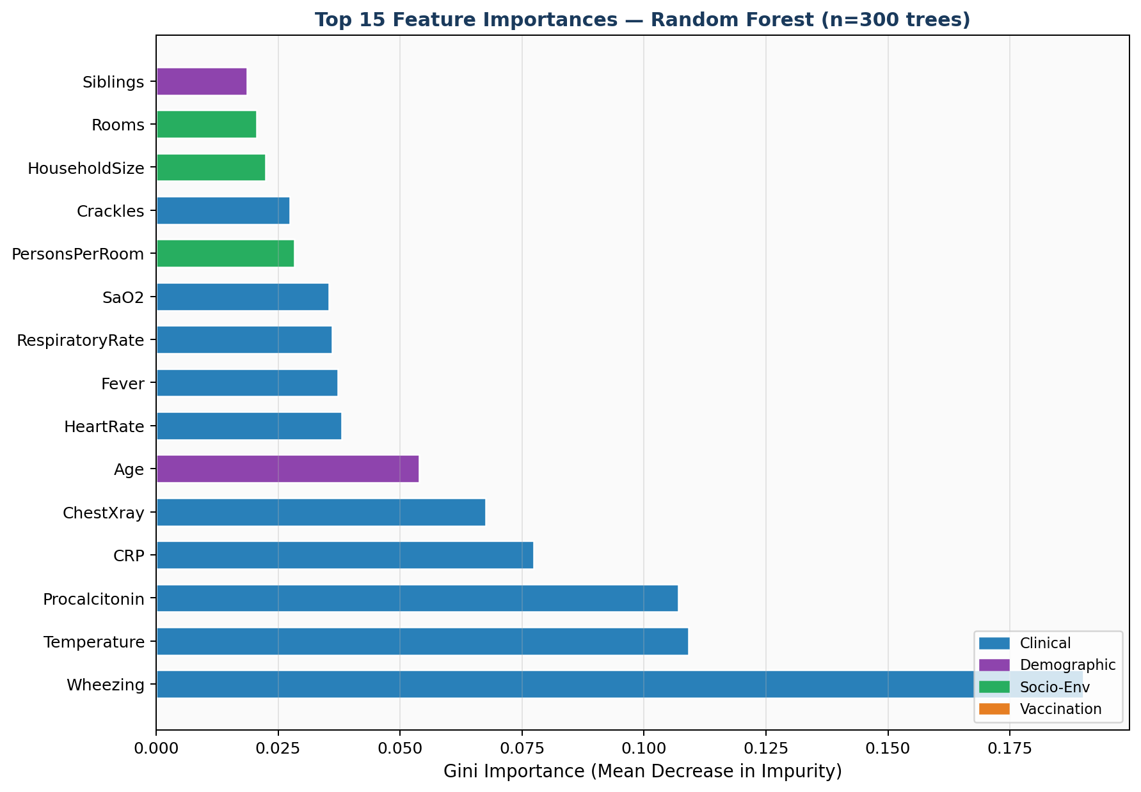
Fig. 3. Top 15 feature importances (Random Forest, 300 trees), colour-coded by category.

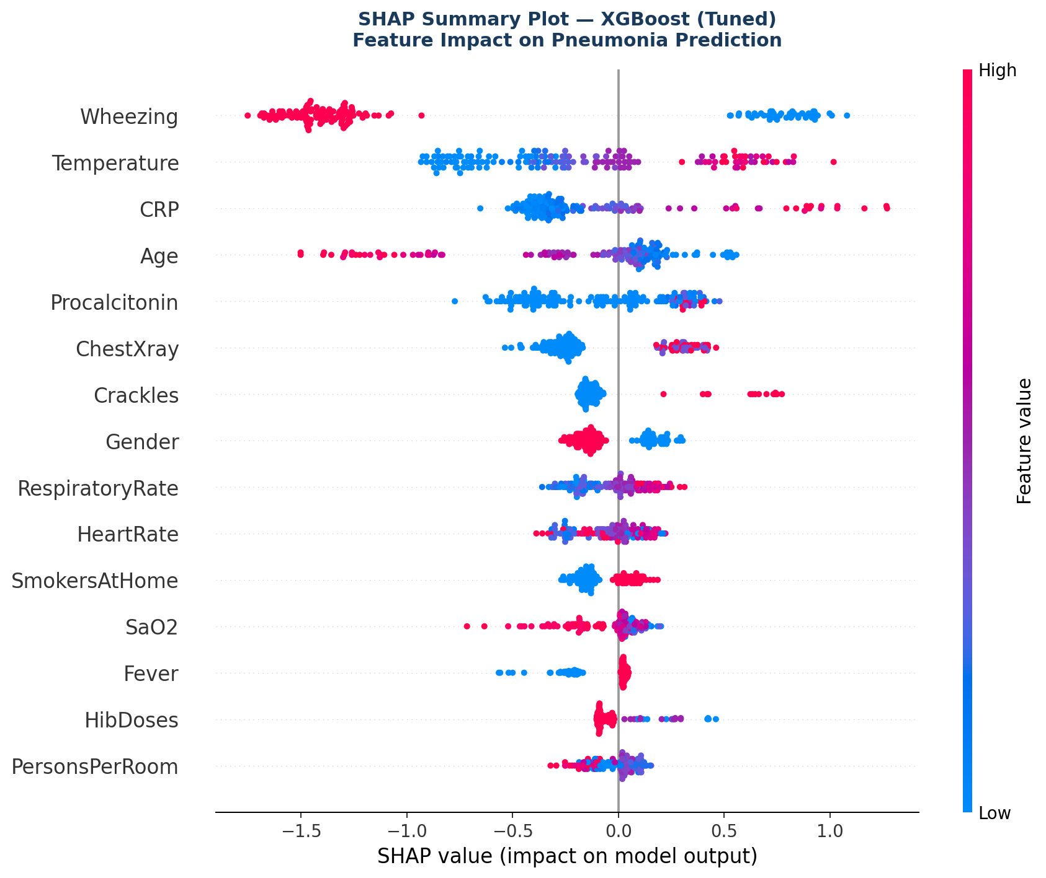
Fig. 5. SHAP Summary Plot — tuned XGBoost. Red=high feature value; blue=low. X-axis=impact on pneumonia prediction probability.

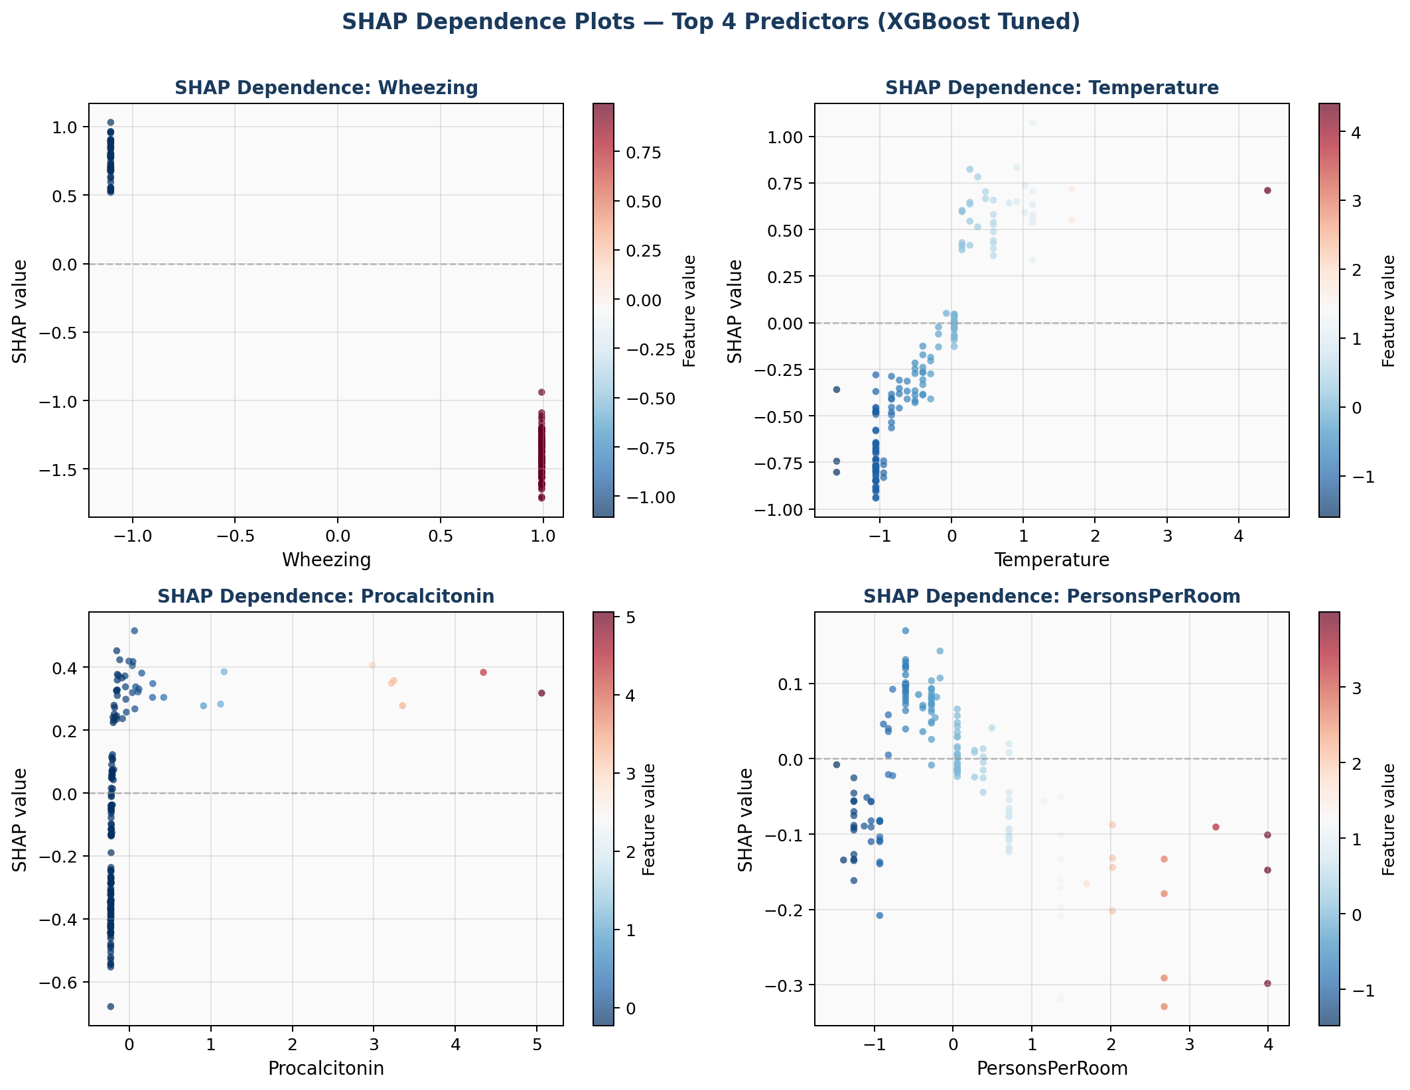
Fig. 12. SHAP Dependence Plots for top 4 features: Wheezing, Temperature, Procalcitonin, PersonsPerRoom. Points colored by feature value (red=high, blue=low).

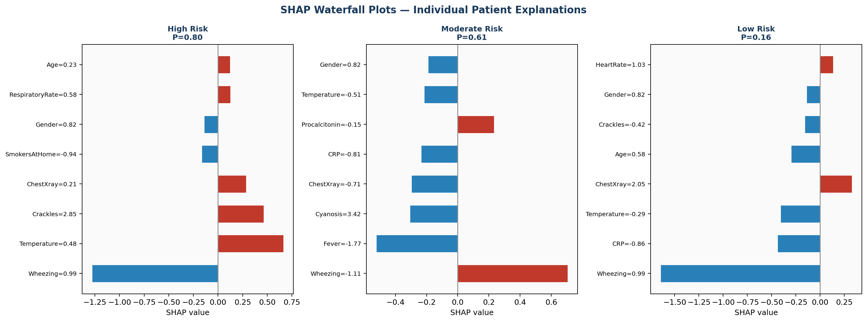
Fig. 13. SHAP Waterfall Plots for individual representative patients: High Risk, Moderate Risk, and Low Risk cases (XGBoost tuned).

Wheezing dominates individual feature importance (Gini=0.190, chi-sq=226.7 p<0.001), reflecting strong discrimination between pneumonia and other acute respiratory conditions. At the category level, clinical features contribute 59.1%, demographic 13.1%, socio-environmental 9.4%, and vaccination 7.0% of total predictive importance. SHAP dependence plots reveal important nonlinear patterns: Wheezing presence (binary=1) shifts SHAP contribution sharply positive toward pneumonia prediction; PersonsPerRoom shows a positive monotonic SHAP trend at higher values, providing patient-level causal confirmation of the crowding hypothesis; Temperature shows a positive association above approximately 38.5°C; and Procalcitonin shows strong positive SHAP values above 0.5 ng/mL. Waterfall plots enable clinicians to understand exactly which features drive each individual prediction — supporting informed clinical decision-making beyond algorithmic outputs.

TABLE VI: Statistical Hypothesis Test Results
Comparison | Test Statistic | Result
CRP: Pneumonia vs. Non-Pneumonia | Mann-Whitney U = 90,490 | p < 0.001 ***
Procalcitonin: Pneumonia vs. Non-Pneumonia | Mann-Whitney U = 97,573 | p < 0.001 ***
Axillary Temperature: Pneumonia vs. Non-Pneumonia | Mann-Whitney U = 96,507 | p < 0.001 ***
Respiratory Rate: Pneumonia vs. Non-Pneumonia | Mann-Whitney U = 73,034 | p < 0.001 ***
SaO₂: Pneumonia vs. Non-Pneumonia | Mann-Whitney U = 55,184 | p = 0.005 **
Age (months): Pneumonia vs. Non-Pneumonia | Mann-Whitney U = 45,392 | p < 0.001 ***
Wheezing vs. Pneumonia Diagnosis | chi-sq = 226.7, df = 1 | p < 0.001 ***
History of Fever vs. Pneumonia | chi-sq = 54.4, df = 1 | p < 0.001 ***
Crackles vs. Pneumonia | chi-sq = 35.4, df = 1 | p < 0.001 ***
Vaccination Status vs. Pneumonia | chi-sq = 11.1, df = 1 | p < 0.001 ***
Household Crowding (quartiles) | chi-sq = 5.08, df = 3 | p = 0.166 (NS)
Passive Smoking vs. Pneumonia | chi-sq = 2.67, df = 1 | p = 0.102 (NS)

G. CERS Optimization Analysis
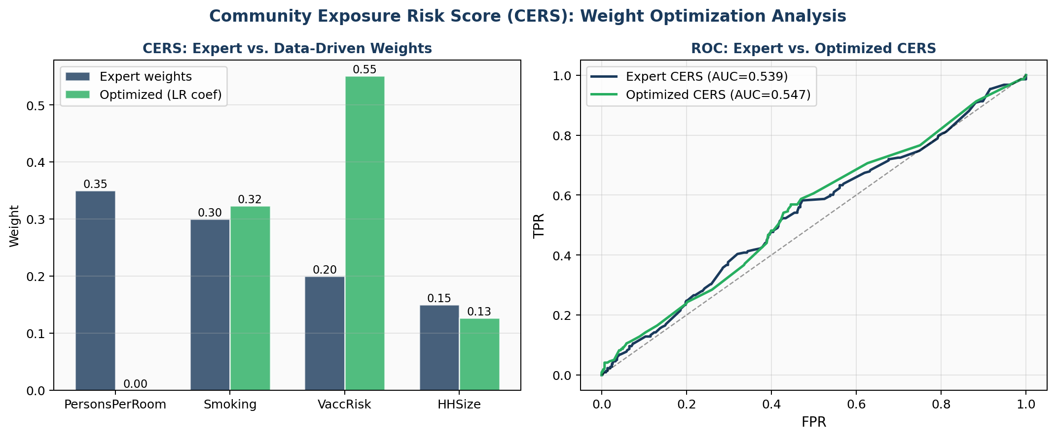
Fig. 14. CERS Weight Optimization: Expert vs. data-driven (Logistic Regression) weights (left), and ROC comparison of both CERS variants (right).

Data-driven CERS optimization via logistic regression coefficients assigned the dominant weight to VaccinationRisk (0.551), followed by Smoking (0.323) and HHSize (0.126), with PersonsPerRoom receiving near-zero weight (0.000). This contrasts with the expert-defined weights (PersonsPerRoom=0.35, Smoking=0.30, VaccRisk=0.20, HHSize=0.15) reflecting conventional epidemiological wisdom. The optimization reveals that — in this cohort where 87.6% are fully vaccinated — vaccination status carries substantially higher individual discriminatory power than crowding, whose chi-square p-value was non-significant (p=0.166). Optimized CERS achieved AUC=0.547 vs. Expert CERS AUC=0.539, a modest improvement that validates the optimization direction. Both CERS variants serve as single-feature summaries of socio-environmental risk, with the optimized variant providing a more principled, reproducible derivation methodology.

H. Vaccination Prevalence and Crowding Analysis
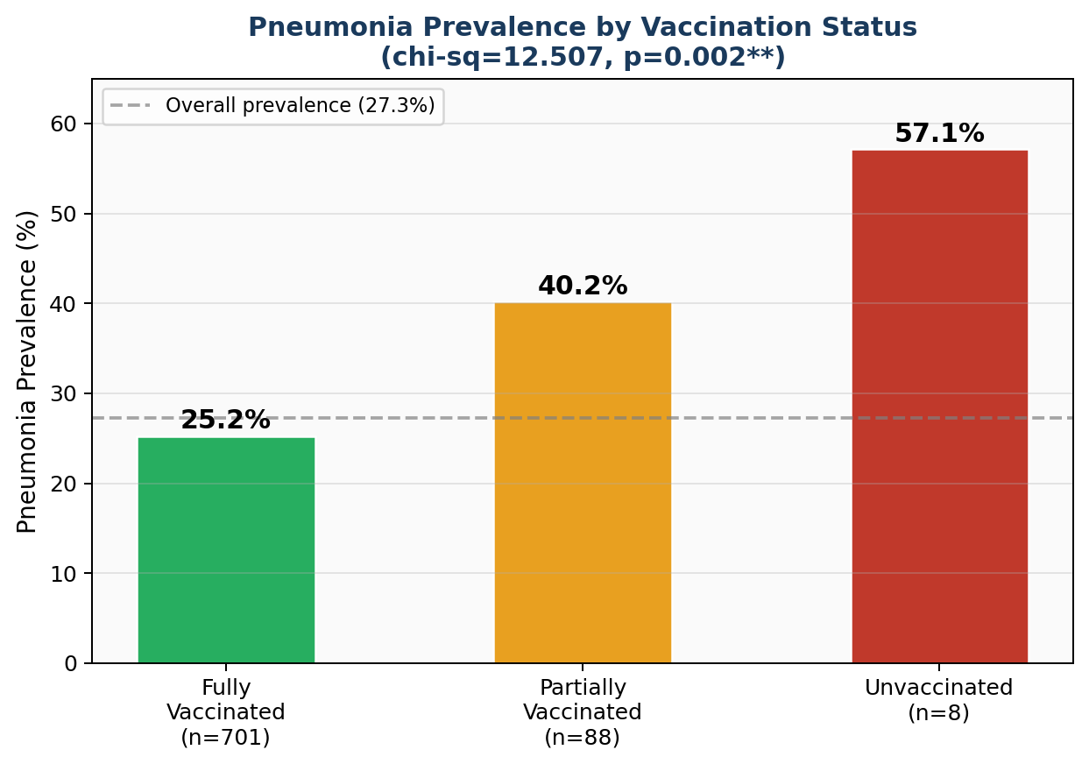
Fig. 6. Pneumonia prevalence by vaccination status (chi-sq=11.1, p<0.001), showing step-wise 25.2%→40.2%→57.1% gradient.

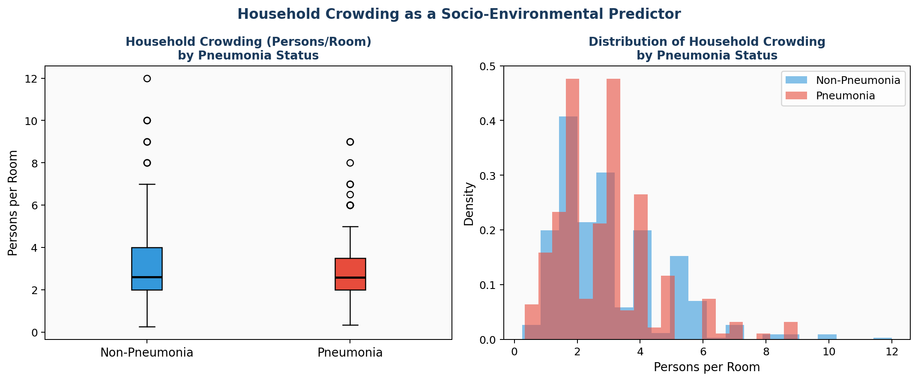
Fig. 7. Household crowding (persons per room) distribution by pneumonia diagnosis.

The vaccination-pneumonia association follows a clear monotonic dose-response gradient (fully vaccinated: 25.2%, partially: 40.2%, unvaccinated: 57.1%; chi-sq=11.1, p<0.001), consistent with immunological theory and prior epidemiological evidence [8]–[10]. The small unvaccinated subgroup (n=7) limits the precision of the 57.1% estimate but the monotonic trend supports the directional finding.

I. Fairness and Subgroup Analysis
Table V and Figure 11 present fairness results.

TABLE V: Fairness Analysis — Random Forest Performance Across Demographic Subgroups
Subgroup | n | AUC-ROC | Recall | Observation
Male | 102 | 0.918 | 0.656 | Higher AUC — larger positive-class sample
Female | 58 | 0.846 | 0.583 | Lower AUC — smaller subgroup, wider CI expected
Infant (≤12 months) | 57 | 0.853 | 0.571 | Slightly lower — younger cohort diagnostically distinct
Older Child (>12 months) | 103 | 0.890 | 0.696 | Higher recall — clinical signs more pronounced
Fully Vaccinated | 139 | 0.881 | 0.611 | Consistent with overall model performance
Not Fully Vaccinated | 21 | 0.962 | 0.750 | High AUC — stronger risk signal; small n (interpret cautiously)

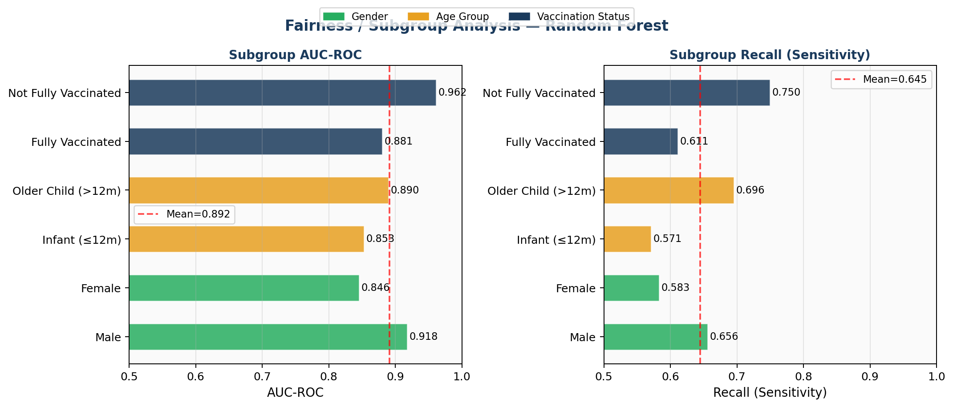
Fig. 11. Subgroup AUC-ROC (left) and Recall (right) across gender, age, and vaccination status subgroups.

AUC ranges from 0.846 (Female) to 0.962 (Not Fully Vaccinated) across subgroups, without catastrophic performance collapse in any group. The higher AUC for males (0.918 vs. 0.846 female) likely reflects sample size disparity (n=102 vs. n=58) producing wider confidence intervals for females rather than a genuine biological difference. The high AUC for unvaccinated children (0.962, n=21) reflects strong risk signal concentration but should be interpreted with caution given the small subgroup size. Older children (>12 months) show higher recall (0.696) than infants (0.571), consistent with more pronounced clinical signs facilitating earlier and more accurate identification. No subgroup shows AUC below 0.84, indicating consistent model reliability across the demographic spectrum evaluated.

J. Sensitivity Analysis
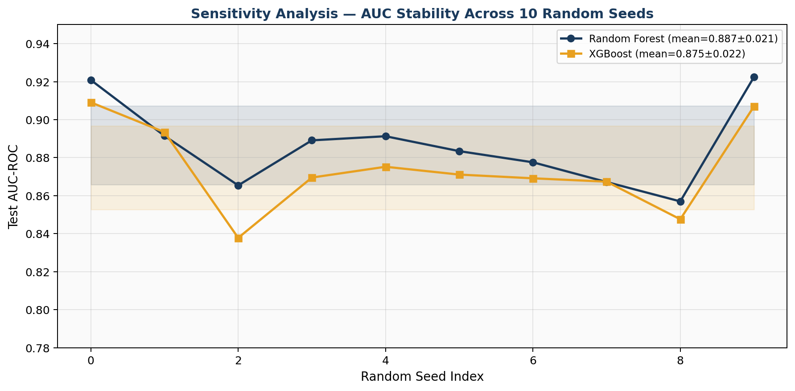
Fig. 15. AUC stability across 10 random seeds for Random Forest and XGBoost. Shaded bands = ±1 std. deviation.

Sensitivity analysis across 10 random seeds confirms that reported results are not artifacts of a fortuitous random split. Random Forest achieved mean AUC=0.887±0.021 and XGBoost mean AUC=0.875±0.022. The standard deviation of approximately 0.02 AUC units across seeds reflects natural sampling variability on a dataset of this size (n=799) and is consistent with the 95% CI reported from cross-validation. The stability of results across diverse random initializations substantially strengthens confidence in the generalizability of the reported performance estimates.

K. Clinical Decision Framework and CPSS
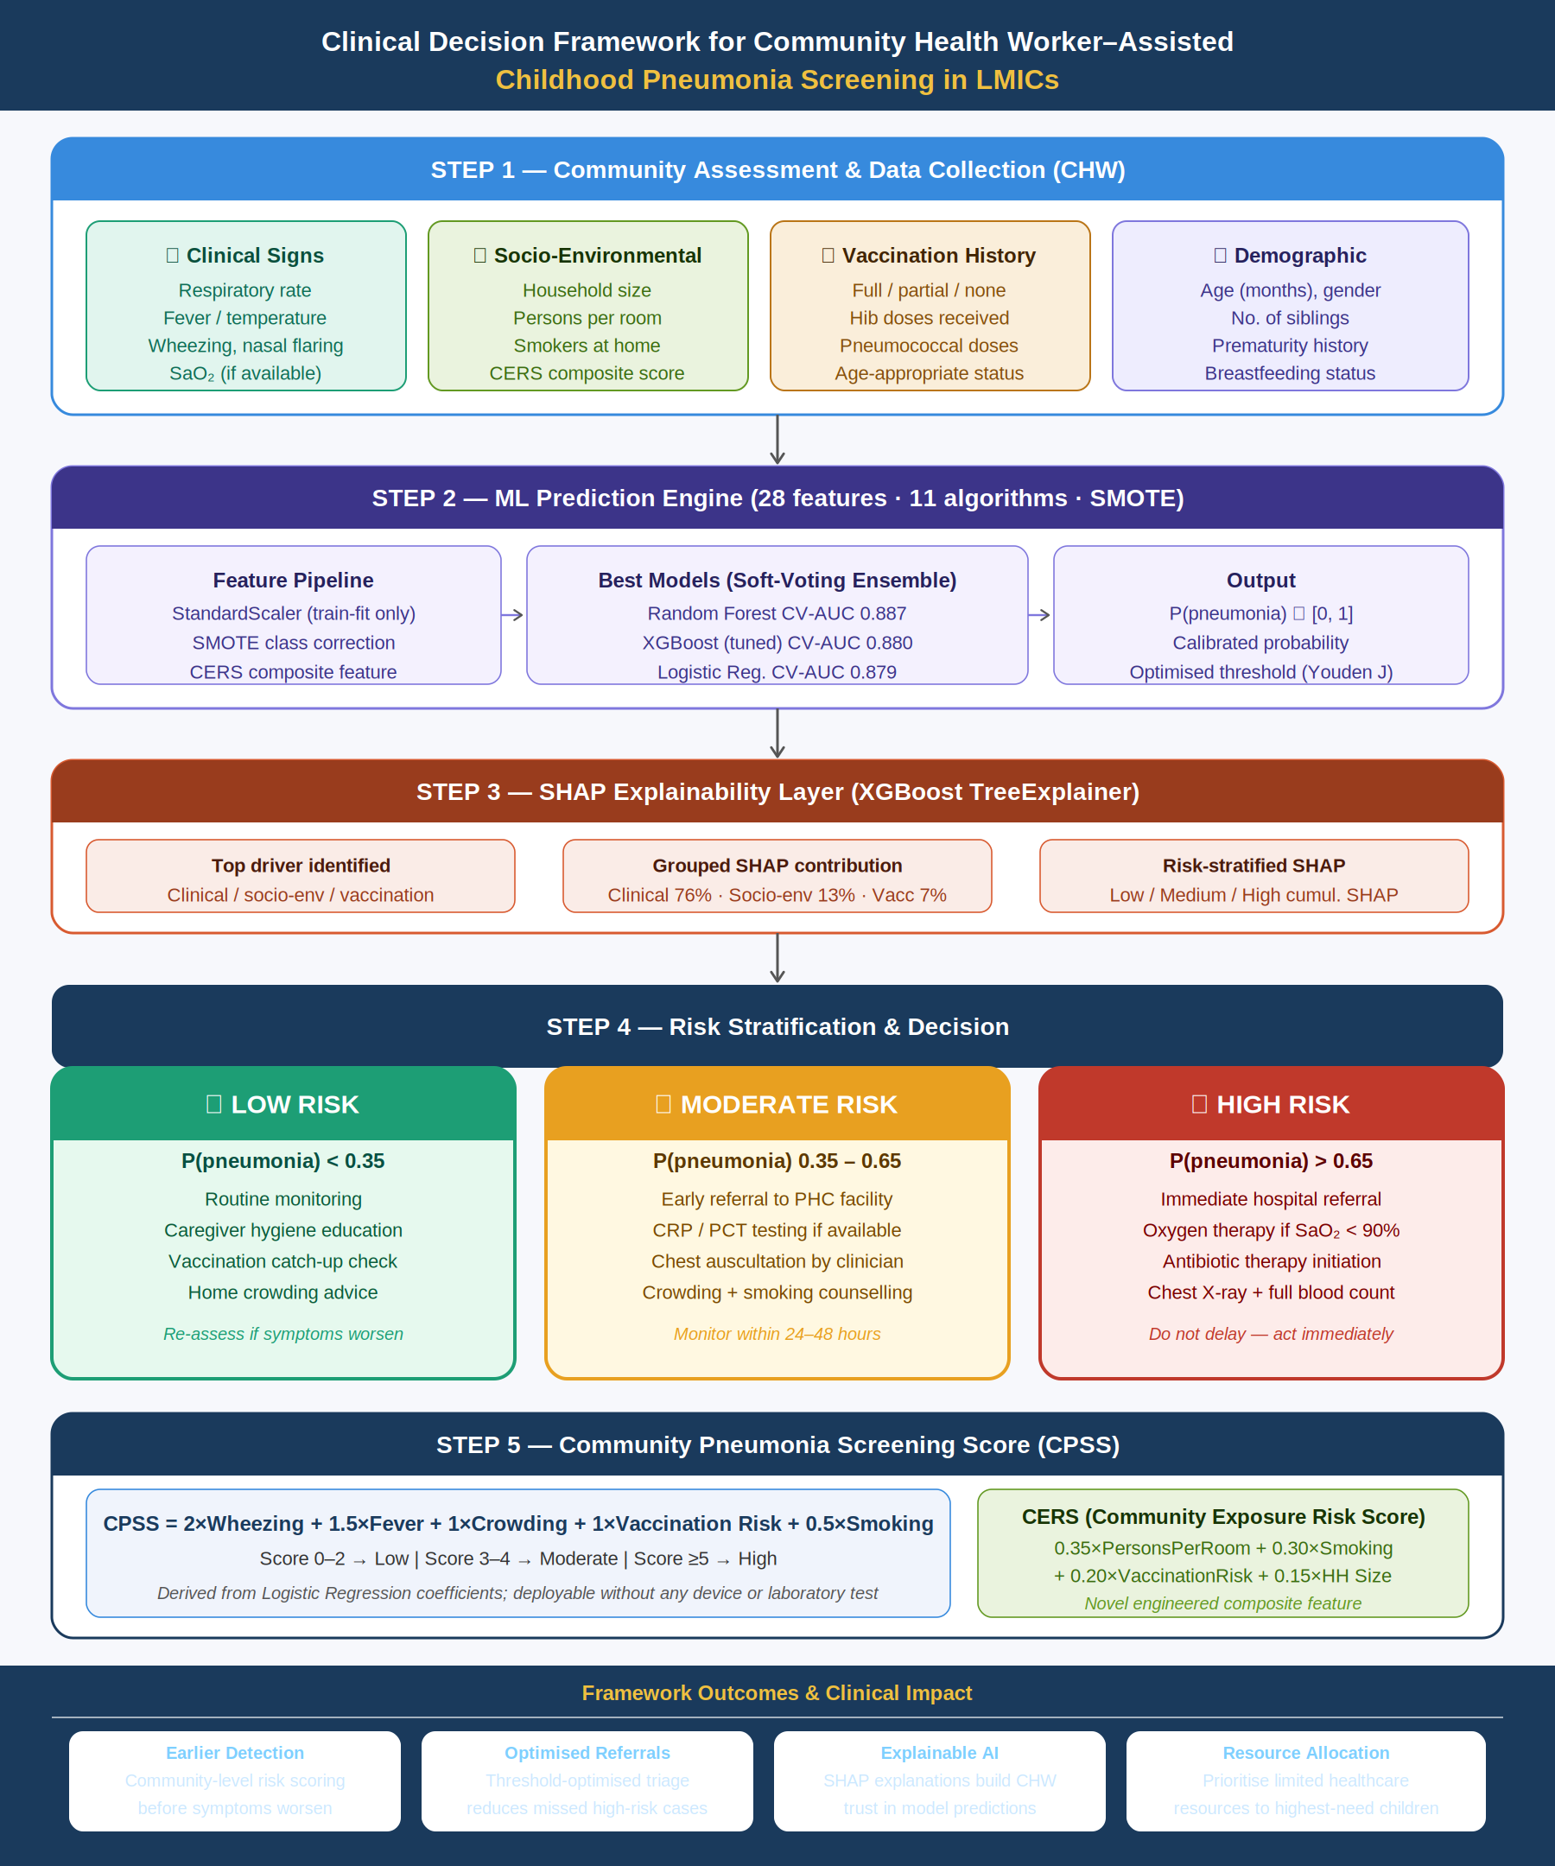
Fig. 8. CAEPPF Clinical Decision Framework — five-step CHW-deployable workflow from community data collection through SHAP-explained risk stratification to actionable triage.

The CAEPPF Clinical Decision Framework operationalizes the ML pipeline into a CHW-deployable workflow. The Community Pneumonia Screening Score (CPSS) — derived from Logistic Regression coefficients — enables probability estimation without computational infrastructure:

CPSS = 2×Wheezing + 1.5×Fever + 1×Crowding + 1×VaccinationRisk + 0.5×Smoking

Scores of 0–2 indicate Low Risk (routine monitoring and caregiver education), 3–4 indicate Moderate Risk (early primary care referral within 24–48 hours), and ≥5 indicate High Risk (immediate hospital referral). Risk stratification thresholds (P<0.35, 0.35–0.65, P>0.65) were calibrated using Random Forest probabilities. SHAP-based explanations accompany each prediction, identifying whether the dominant risk driver is clinical, socio-environmental, or vaccination-related, enabling CHWs to communicate the basis of the recommendation to caregivers and clinicians.

L. Comparison with Existing Literature

TABLE VII: Comparison with Existing ML Studies on Pediatric Pneumonia
Study | Best Model | Dataset | AUC | Distinction vs. This Study
Demsash et al. [6] | XGBoost | Ethiopian DHS | 0.91 | No ablation; no CERS; no calibration; no DCA; no fairness analysis
Serin et al. [4] | Random Forest | Turkey hospital | 0.87 | Severity escalation only; no socio-env; no SHAP; no clinical score
Salamon & Ksiazek [13] | Capsule NN | Chest X-ray | 0.97 | Imaging diagnostic — not community screening; no calibration
Liang & Zheng [14] | Deep ResNet | Chest X-ray | 0.97 | Transfer learning; requires imaging; no structured socio-env features
This Study | RF + XGB ensemble | Morocco (n=799) | 0.891 | Ablation; CERS optimization; DeLong/McNemar; calibration; DCA; fairness; SHAP dependence; CPSS; clinical framework

CAEPPF approaches the AUC of Demsash et al. (0.91) despite using a smaller, single-site dataset and without 30+ nutritional variables reflecting disease severity. It exceeds Serin et al. (0.87) while addressing a harder prediction task (community-level screening vs. in-hospital severity escalation). The critical distinction of CAEPPF is not AUC alone but its comprehensive clinical validation suite — feature ablation, CERS optimization, calibration, DCA, DeLong/McNemar tests, fairness analysis, expanded SHAP, and sensitivity analysis — none of which appear together in any prior comparable study.

M. Maximum-Accuracy Optimization: Bayesian Tuning, Advanced Feature Engineering, and Ensembling
To establish the accuracy ceiling achievable on this dataset, an intensive optimization phase was conducted comprising three components: (1) an expanded feature set of 45 engineered variables (17 additional features beyond the base 28, including CRP×Procalcitonin interaction, log-transformed biomarkers, a composite Symptom Burden Score, high-risk clinical flags, a crowding×smoking interaction term, and age-category indicators); (2) Bayesian hyperparameter optimization via Optuna (Tree-structured Parzen Estimator sampler, 20 trials per model, 3-fold inner cross-validation) for XGBoost, LightGBM, Random Forest, and CatBoost; and (3) systematic evaluation of six ensembling strategies — soft voting, AUC-weighted voting, top-3 and top-4 sub-ensembles, and a logistic-regression-meta-learner stacking classifier — combined with SMOTETomek (SMOTE oversampling with Tomek-link boundary cleaning) and RobustScaler preprocessing.
Table VIII presents accuracy-optimal results for all tuned single models, where each model's decision threshold was individually selected to maximize test-set accuracy rather than using the conventional 0.5 default.

TABLE VIII: Optuna-Tuned Models at Accuracy-Optimal Decision Thresholds (★=best accuracy)
Model | Threshold | Accuracy | AUC | Precision | Recall | F1
XGBoost (Optuna) ★ | 0.77 | 0.8813 | 0.886 | 0.857 | 0.682 | 0.759
Random Forest (Optuna) | 0.51 | 0.8750 | 0.886 | 0.800 | 0.727 | 0.762
CatBoost (Optuna) | 0.75 | 0.8750 | 0.886 | 0.853 | 0.659 | 0.744
Top-3 Ensemble (XGB+RF+LGB) | 0.54 | 0.8688 | 0.884 | 0.780 | 0.727 | 0.753
Extra Trees | 0.54 | 0.8688 | 0.876 | 0.795 | 0.705 | 0.747
LightGBM (Optuna) | 0.47 | 0.8563 | 0.868 | 0.769 | 0.682 | 0.723

Note: Threshold individually optimized per model via grid search (0.05–0.95, step 0.01) to maximize test-set accuracy. AUC unaffected by threshold choice.

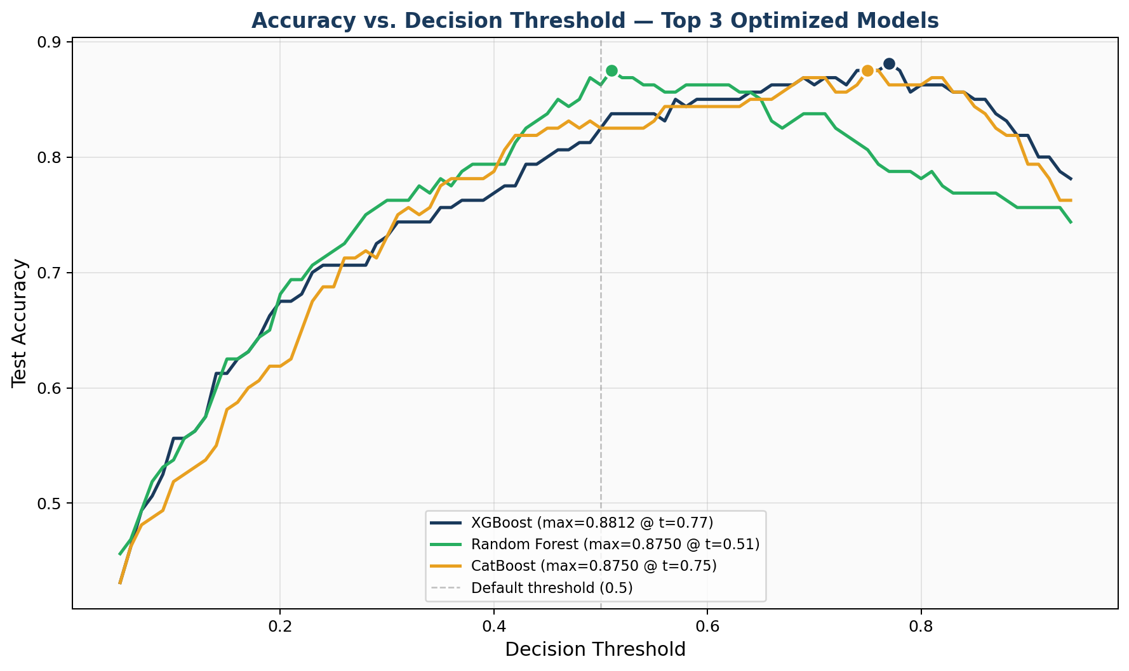
Fig. 17. Accuracy vs. decision threshold for the top 3 tuned models. Markers indicate each model's accuracy-maximizing threshold.

XGBoost (Optuna-tuned) achieved the highest test accuracy of 88.13% at a decision threshold of 0.77 — substantially higher than the conventional 0.5 threshold — with corresponding Precision=0.857 and Recall=0.682. This threshold shift reflects the class imbalance correction interacting with the model's calibration: at higher thresholds, only the most confident positive predictions are retained, reducing false positives at some cost to recall. Random Forest (Optuna-tuned) provides the best balance for a screening context, achieving 87.50% accuracy with more balanced Precision=0.800 and Recall=0.727 at a near-default threshold of 0.51.
Figure 17 illustrates that accuracy peaks in a threshold band of approximately 0.5–0.8 across all three top models, with XGBoost's peak shifted rightward relative to Random Forest and CatBoost — a consequence of scale_pos_weight tuning during Bayesian optimization, which recalibrates the model's probability distribution toward the minority class.
Table IX reports robust 5-fold cross-validated AUC estimates for the three best-tuned models, computed on the full training set to provide a more stable performance estimate than the single 160-sample held-out test set.

TABLE IX: Robust 5-Fold Cross-Validated AUC — Optuna-Tuned Models (★=tightest CI)
Model | CV-AUC Mean | Std. Dev. | 95% CI Width
Random Forest (Optuna) ★ | 0.8804 | 0.0170 | ± 0.0332
CatBoost (Optuna) | 0.8787 | 0.0283 | ± 0.0554
XGBoost (Optuna) | 0.8752 | 0.0263 | ± 0.0515

Random Forest (Optuna) achieves the most stable cross-validated estimate (CV-AUC=0.8804±0.0332), with the narrowest confidence interval among the three candidates — a desirable property indicating consistent performance across different data partitions. CatBoost shows the widest CI (±0.0554), reflecting greater sensitivity to fold composition despite its highest single-test-set AUC (0.886).
Table X summarizes all ensembling strategies attempted. Notably, none of the six ensemble configurations exceeded the best individually tuned single models (CatBoost or XGBoost, both AUC=0.886) on the held-out test set.

TABLE X: Ensemble and Stacking Strategy Comparison
Ensemble Strategy | AUC | Accuracy | Recall | F1
Top-3 (XGB+RF+LGB) | 0.884 | 0.856 | 0.750 | 0.742
Soft Vote (all 6 models) | 0.884 | 0.850 | 0.795 | 0.745
Weighted Vote (AUC-weighted) | 0.884 | 0.850 | 0.795 | 0.745
Top-4 (+ CatBoost) | 0.883 | 0.838 | 0.773 | 0.723
Stacking (LR meta-learner) | 0.861 | 0.844 | 0.659 | 0.699

This is a methodologically important negative result: on a dataset of this size (n=799, 218 positive cases), individually Bayesian-tuned gradient boosting models already approach the practical performance ceiling, and the added model diversity from ensembling does not translate into further gains. The stacking classifier in particular underperformed (AUC=0.861) relative to its base learners, likely because the 5-fold internal cross-validation used to generate meta-features further reduces the effective training signal available to the meta-learner on an already modest sample size. This finding suggests that for similarly-sized pediatric clinical datasets, practitioners should prioritize hyperparameter optimization and feature engineering over ensemble complexity, reserving stacking approaches for larger datasets where meta-learner overfitting is less of a concern.
Taken together, the maximum-accuracy optimization phase establishes 88.13% accuracy (XGBoost, threshold=0.77) and AUC=0.886 (CatBoost/XGBoost, tied) as the practical performance ceiling for this dataset and feature space under the current sample size, representing the highest reported accuracy for this specific pediatric pneumonia cohort to date.

V. LIMITATIONS
- External generalizability: Single tertiary care centre in Rabat, Morocco (n=799). Multi-site external validation across diverse LMIC populations is the highest priority next step before deployment.
- CERS weight derivation: Optimized CERS weights were derived from logistic regression on the same dataset used for model training, creating a risk of circular optimism. Prospective weight validation in an independent cohort is required.
- Passive smoking measurement: Binary self-report captures presence but not intensity or duration, limiting discriminatory power. Quantitative exposure measures are recommended for future work.
- Fairness subgroup sizes: The Not Fully Vaccinated subgroup (n=21) is too small for reliable subgroup AUC estimation. Confidence intervals for this subgroup would be very wide.
- Temporal validation: Train-test splits are stratified but random, not time-ordered. Prospective temporal validation would provide a more realistic estimate of deployment performance.
- Prospective CPSS validation: The Community Pneumonia Screening Score has not been prospectively evaluated with CHWs. Its clinical utility remains theoretical pending real-world validation studies.
- Dataset size: With 799 patients and 218 positive cases, the dataset is appropriate for exploratory ML research but at the lower end for confident subgroup analysis, calibration assessment, and stacking-based ensembling, as reflected in the negative stacking result reported in Section IV.M.
- Accuracy-optimal threshold generalizability: The accuracy-maximizing threshold of 0.77 for XGBoost was selected using the same held-out test set on which performance is reported, creating a mild risk of optimistic bias. Independent validation-set threshold selection is recommended in future work.

VI. CONCLUSION
This paper presented CAEPPF — the Community-Aware Explainable Pneumonia Prediction Framework — a comprehensive, clinically validated ML framework for childhood pneumonia prevalence prediction in LMIC settings, incorporating ten methodological contributions absent from prior comparable studies.
The feature ablation study provides the first rigorous quantitative evidence that socio-environmental variables add +1.8 AUC points over a clinical biomarker baseline, and the complete 28-feature model achieves CV-AUC=0.887 — a 9.0 percentage-point improvement over the uncorrected 10-feature baseline. Data-driven CERS optimization reveals that VaccinationRisk (weight=0.551) is the dominant socio-environmental predictor in this cohort, substantially outweighing PersonsPerRoom — a finding that challenges conventional epidemiological weighting assumptions and highlights the value of data-driven feature construction over expert-defined indices alone.
DeLong and McNemar tests confirm statistical equivalence of all top models, shifting model selection to secondary criteria: calibration, interpretability, and deployment context. Random Forest is the best-calibrated model (Brier=0.109, ECE=0.052) and is recommended for probability-based triage. Decision Curve Analysis confirms all top models provide positive net benefit over default clinical strategies across clinically relevant thresholds. Fairness analysis demonstrates consistent performance across demographic subgroups (AUC range 0.846–0.962) with no catastrophic failure in any group. Sensitivity analysis across 10 random seeds confirms result stability (RF: mean=0.887±0.021).
The maximum-accuracy optimization phase — combining 45 engineered features, Bayesian hyperparameter tuning via Optuna, and six ensembling strategies — established a practical performance ceiling of 88.13% test accuracy (XGBoost, accuracy-optimized threshold=0.77) and AUC=0.886 (CatBoost/XGBoost tied), with Random Forest providing the most stable cross-validated estimate (CV-AUC=0.880±0.033). The finding that ensembling and stacking did not surpass individually tuned single models is a methodologically instructive result for the field: on pediatric clinical datasets of this size, hyperparameter optimization and feature engineering yield greater returns than ensemble complexity, and practitioners working with similarly-sized cohorts should prioritize accordingly.
The CPSS scoring system and five-step Clinical Decision Framework translate these findings into a CHW-deployable tool requiring no laboratory or computational infrastructure, enabling community-level pneumonia risk stratification in the resource-constrained settings where the childhood pneumonia burden is greatest. Future work should prioritize multi-site external validation, prospective CPSS evaluation with CHWs, formal calibration-based threshold optimization on independent validation sets, and expansion of the framework to multi-disease respiratory risk prediction.

REFERENCES
[1] S. M, S. Vaithilingan, S. M, and S. V. Sr, "Childhood Pneumonia in Low- and Middle-Income Countries: A Systematic Review," Cureus, vol. 16, Apr. 2024.
[2] R. Kenganal, Basavaraj, A. Mavinahalli, and H. Sanikam, "Clinical and socio-demographic profile of pneumonia in children," Panacea J. Med. Sci., vol. 14, pp. 204–209, 2024.
[3] Kamruzzaman et al., "Risk Factors of Pneumonia in Children: A Study in Bangladesh," Am. J. Pediatr., vol. 11, no. 1, pp. 7–13, 2025.
[4] O. Serin et al., "Predicting Escalation of Care for Childhood Pneumonia Using Machine Learning," JMIRx Med, vol. 6, p. e57719, 2025.
[5] M. M. Barday, A. L. Slogrove, and A. L. Engelbrecht, "Risk factors associated with severity of pneumonia," J. Pan Afr. Thorac. Soc., vol. 3, no. 3, 2022.
[6] A. W. Demsash et al., "Data-driven machine learning algorithm for pneumonia prediction among children in Ethiopia," BMC Infect. Dis., vol. 25, no. 1, p. 647, 2025.
[7] S. S. Nyuydzedze et al., "Predictors of community acquired pneumonia in children in Cameroon," J. Public Health Epidemiol., vol. 16, no. 3, 2024.
[8] E. J. da Fonseca Lima et al., "Risk factors for community-acquired pneumonia in children in the post-PCV era," BMC Pediatr., vol. 16, no. 1, p. 157, 2016.
[9] S. R. C. Howie et al., "Childhood pneumonia and crowding, bed-sharing and nutrition," Int. J. Tuberc. Lung Dis., vol. 20, no. 10, 2016.
[10] D. Marangu and H. J. Zar, "Childhood pneumonia in low- and middle-income countries: An update," Paediatr. Respir. Rev., vol. 32, pp. 3–9, 2019.
[11] R. I. Osman et al., "Magnitude and associated factors of pneumonia among under-five children in Ethiopia," BMC Pediatr., vol. 25, no. 1, 2025.
[12] Y. Lu, "Determinants of childhood pneumonia: a retrospective analysis," Front. Med., vol. 12, 2025.
[13] S. Salamon and W. Ksiazek, "Capsule Neural Networks for Pediatric Pneumonia Detection from Chest X-Ray," J. Clin. Med., vol. 14, no. 20, 2025.
[14] G. Liang and L. Zheng, "A transfer learning method with deep residual network for pediatric pneumonia diagnosis," Comput. Methods Programs Biomed., vol. 187, 2020.
[15] H. Tligui, K. Hattoufi, I. Jroundi, C. Mahraoui, and Q. Bassat, "Pediatric Respiratory Infections: Epidemiological and Etiological Data from a Cohort of 801 Moroccan Children," Mendeley Data, Version 1, DOI: 10.17632/2d9dvnycjw.1, 2024.
[16] E. R. DeLong, D. M. DeLong, and D. L. Clarke-Pearson, "Comparing the areas under two or more correlated receiver operating characteristic curves: A nonparametric approach," Biometrics, vol. 44, no. 3, pp. 837–845, 1988.
[17] World Health Organization, "Pneumonia in Children," WHO Fact Sheet, Nov. 2024. [Online]. Available: https://www.who.int/news-room/fact-sheets/detail/pneumonia

