A Comparative Machine Learning Framework for
Predicting Childhood Pneumonia Prevalence:
Integrating Household Crowding, Vaccination Status, and Passive Smoking as Socio-Environmental Determinants

Md Artad Chowdhury, Bishal Paul
ABSTRACT
Childhood pneumonia is the leading infectious cause of mortality in children under five years of age, responsible for approximately 700,000 deaths annually, with over 95% of cases concentrated in low- and middle-income countries (LMICs). While clinical biomarkers such as C-reactive protein (CRP) and procalcitonin are established predictors, the independent and incremental predictive value of socio-environmental determinants — household crowding, vaccination status, and passive tobacco smoke exposure — has not been rigorously quantified within a machine learning framework. This paper addresses this gap through five principal contributions applied to a clinical pediatric dataset of 799 children admitted to a hospital in Rabat, Morocco.
First, a feature ablation study across four experimental configurations (clinical only, clinical + demographic, clinical + socio-environmental, all 28 features) quantifies the incremental value of each feature category: socio-environmental variables alone contributed +1.8 AUC points over the clinical baseline (0.861 → 0.879), and the full 28-feature model achieved a cross-validated AUC of 0.887 (+2.6 AUC points total). Second, a novel Community Exposure Risk Score (CERS) — a composite socio-environmental feature combining crowding, passive smoking, vaccination risk, and household size — is proposed as a structured predictor for community screening. Third, eleven supervised classification algorithms were benchmarked under a leakage-free pipeline with Synthetic Minority Oversampling Technique (SMOTE) applied within stratified 5-fold cross-validation and hyperparameter tuning (RandomizedSearchCV, 40 iterations) for the top three models. Random Forest achieved the best CV-AUC of 0.887 (95% CI: 0.825–0.949), followed by XGBoost at 0.880 ± 0.039. Fourth, dual interpretability analysis via grouped Random Forest Gini importance and SHAP (SHapley Additive exPLanations) values reveals that clinical features contribute 59% of total predictive importance while socio-environmental variables contribute 9.4%, confirming their meaningful but secondary role. Fifth, a five-step Community Health Worker (CHW) clinical decision framework — incorporating a deployable Community Pneumonia Screening Score (CPSS) and SHAP-based risk stratification — is proposed to translate model outputs into actionable triage decisions without laboratory infrastructure.

Keywords: Childhood Pneumonia, Machine Learning, Feature Ablation, Community Exposure Risk Score, SMOTE, SHAP, Household Crowding, Vaccination, Random Forest, XGBoost, LMICs, Pediatric Epidemiology, Community Health Worker, Clinical Decision Framework.
I. INTRODUCTION
Pneumonia is the leading infectious cause of death in children under five years of age worldwide, claiming approximately 700,000 lives annually. More than 95% of cases occur in low- and middle-income countries (LMICs), where health infrastructure constraints, limited diagnostic capacity, and persistent socio-environmental risk factors compound the disease burden [1]–[4]. Despite widespread adoption of pneumococcal conjugate vaccines (PCVs) in high-resource settings, household-level modifiable determinants — overcrowding, passive smoke exposure, and incomplete vaccination — continue to drive transmission in resource-limited environments [1], [8]–[11].
Machine learning (ML) offers a data-driven alternative to clinical threshold rules, capable of capturing nonlinear feature interactions and generating calibrated probability estimates across heterogeneous populations. However, the existing ML literature on pediatric pneumonia is dominated by image-based diagnostic models — deep neural networks applied to chest radiographs — which achieve high accuracy on curated imaging datasets but require infrastructure unavailable in most LMIC primary care settings [13], [14]. Structured-data ML models that explicitly incorporate socio-environmental determinants are scarce, and none have conducted a formal feature ablation study to quantify the independent predictive contribution of household crowding, vaccination, and passive smoking [4], [6].
This paper addresses these gaps through five integrated methodological contributions. The feature ablation study is the cornerstone contribution: by systematically comparing model performance across clinical-only, clinical + demographic, clinical + socio-environmental, and full feature configurations, we provide the first rigorous quantification of the incremental AUC gain attributable to socio-environmental variables in pediatric pneumonia prediction. This directly supports the paper's central claim that socio-environmental determinants carry meaningful, measurable predictive signal beyond clinical biomarkers — and should be systematically encoded in community-level ML screening tools. These findings are translated into a CHW-deployable clinical decision framework complete with a simple Community Pneumonia Screening Score (CPSS) requiring no laboratory equipment.

The five principal contributions of this study are:
- Feature ablation study: Systematic quantification of the incremental predictive value of socio-environmental determinants, demographic variables, and vaccination history over a clinical biomarker baseline, through four controlled experimental configurations.
- Community Exposure Risk Score (CERS): A novel composite socio-environmental feature — combining persons-per-room, passive smoking, vaccination risk, and household size with epidemiologically motivated weights — proposed as a structured predictor for community-level screening.
- Rigorous comparative ML pipeline: Eleven supervised algorithms benchmarked under a leakage-free, SMOTE-corrected, hyperparameter-tuned pipeline with 95% confidence intervals reported for all CV-AUC metrics.
- Dual interpretability analysis: Grouped Random Forest feature importance and SHAP values from XGBoost, providing both aggregate category-level contributions and individual-level directional effect estimates with clinical interpretability.
- Clinical decision framework: A five-step CHW-deployable decision framework incorporating risk stratification, SHAP explanation, and a simplified Community Pneumonia Screening Score (CPSS) operationalizable without laboratory or imaging infrastructure.

II. LITERATURE REVIEW

A. Household Crowding, Vaccination, and Passive Smoking as Pneumonia Risk Factors
Household crowding operates as a contact-structure variable that directly increases the force of infection through heightened pathogen exposure frequency and dose [3], [6]. Howie et al. demonstrated in a Gambian case-control study that bed-sharing with a symptomatic individual was independently associated with elevated pneumonia risk (OR = 2.1, 95% CI: 1.3–3.4) [9]. Kamruzzaman et al. similarly found that households with three or more persons per room had significantly higher pneumonia incidence in a Bangladeshi tertiary care cohort [3]. Despite this evidence, continuous crowding measures are rarely incorporated as ML features; most published models use coarse binary proxies [11], [14].
Vaccination exerts both direct and indirect protective effects against vaccine-preventable pneumococcal serotypes [1], [8]. Da Fonseca Lima et al. demonstrated that unvaccinated children had approximately 2.8 times the odds of community-acquired pneumonia compared to fully immunized peers [8]. Secondhand tobacco smoke impairs mucociliary defence and predisposes children to lower respiratory tract infections [1], [3], [7], though measurement as a binary self-report variable limits its individual-level discriminatory power, as confirmed by the non-significant chi-square result in this study (p = 0.102).
B. Passive Smoking and Indoor Air Quality
Second hand smoking of tobacco and biomass fuel products constructs are well-established respiratory insults that undermine mucociliary defence in pediatrics and predispose them to lower respiratory morbidity [1], [3], [7]. Nyuydzedze et al. [7] had reported on a cohort of Cameroon that passive smoking exposure had been linked to community-acquired pneumonia in children under five, but with extended intervals of confidence (OR = 1.6, 95% CI: 0.8-3.2). Scientifically parallel results have been observed in Nepal and unlike Bangladesh where compounded exposure profiles were seen when tobacco smoke interconnects with biomass cooking fuel [3], [5].
In ML applications, the smoke within the environment is hardly represented with enough detailed representation. There are proxy variables that can be used as proxy variables like unclean fuel use or cooking location, which are sometimes factored into orthodox regression model [9], [10], but not systematically factored into ML feature spaces. Issues with measurement: reliance on self-report, inessentially categorical definitions and patterns of exposure over time complicate the exposure of the variables of smoking as predictive features that are stable and on an individual level.

C. Machine Learning for Pediatric Pneumonia: Gaps and Opportunities
Image-based diagnostic ML dominates the pediatric pneumonia literature. Capsule networks achieved 97.2% accuracy on chest X-ray datasets [13] and deep residual networks achieved 96.7% [14], but both address a diagnostic imaging task that is fundamentally distinct from community-level prevalence prediction and requires imaging infrastructure unavailable in LMIC primary care. Among structured-data models, Serin et al. (AUC = 0.87) modeled clinical severity escalation in hospitalized children [4], and Demsash et al. (AUC = 0.91) predicted pneumonia in Ethiopian children using nutritional and demographic features [6]. Neither conducted a feature ablation study, neither proposed a composite socio-environmental index, and neither developed a CHW-deployable clinical scoring system. This paper addresses all three gaps simultaneously.

III. METHODOLOGY

A. Ethics Statement
This study is a secondary analysis of a publicly available, fully anonymized dataset deposited under Creative Commons Attribution 4.0 International (CC BY 4.0) license. No patients were recruited, contacted, examined, or followed. Institutional review board approval was not required for secondary analysis of de-identified public data in accordance with standard ethical guidelines.

B. Dataset
Source: Tligui H., Hattoufi K., Jroundi I., Mahraoui C., & Bassat Q., "Pediatric Respiratory Infections: Epidemiological and Etiological Data from a Cohort of 801 Moroccan Children." Mendeley Data, Version 1, DOI: 10.17632/2d9dvnycjw.1, March 2024. License: CC BY 4.0.
The dataset comprises 801 children admitted to the Children's Hospital of Rabat, Morocco with acute pediatric respiratory infections. Investigators collected epidemiological, clinical, paraclinical, and biological data including molecular pathogen identification. Morocco represents an appropriate LMIC clinical context, facing challenges comparable to other LMICs in respiratory disease burden, vaccine coverage variability, and household-level risk factor profiles [10], [12]. After exclusion of records with missing values in critical features, 799 records were retained.

C. Target Variable
The binary outcome (target = 1: pneumonia-positive) was derived from the primary admission diagnosis. Positive cases included: Pneumonia, Dyspneic Pneumopathy, Staphylococcal Pneumonia, Bronchiolitis + Pneumonia, Asthma Attack + Pneumonia, Pleuropneumonitis, and Interstitial Pneumopathy. All other diagnoses were classified as non-pneumonia (target = 0), yielding 218 positive cases (27.3%) and 581 negative cases (72.7%), a class imbalance ratio of 2.66:1.

D. Feature Engineering (28 Features)
Twenty-eight features were constructed across four conceptual categories, exploiting the full richness of the dataset including clinical signs, auscultatory findings, chest X-ray findings, and granular vaccination history. Table I summarizes all features.

TABLE I: Feature Engineering — All 28 Predictive Features
Category | Feature | Type | Description / Encoding
Clinical | CRP (mg/L) | Continuous | C-reactive protein — primary bacterial infection biomarker
Clinical | Procalcitonin (ng/mL) | Continuous | Sepsis / bacterial infection marker
Clinical | SaO₂ (%) | Continuous | Oxygen saturation at admission
Clinical | Axillary Temperature (°C) | Continuous | Body temperature at admission
Clinical | Respiratory Rate | Continuous | Breaths per minute — tachypnea indicator
Clinical | Heart Rate (bpm) | Continuous | Cardiovascular stress indicator
Clinical | History of Fever | Binary | Fever present: Yes=1, No=0
Clinical | Crackles | Binary | Auscultatory finding: Yes=1, No=0
Clinical | Wheezing | Binary | Bronchospastic sign: Yes=1, No=0
Clinical | Nasal Flaring | Binary | Respiratory distress sign: Yes=1, No=0
Clinical | Cyanosis | Binary | Hypoxia sign: Yes=1, No=0
Clinical | Chest X-ray Finding | Ordinal | 0=Normal, 1=NF, 2=Other infiltrates, 3=Endpoint pneumonia
Demographic | Age (months) | Continuous | Age at admission — continuous, 1–78 months
Demographic | Gender | Binary | Male=1, Female=0
Demographic | Number of Siblings | Ordinal | Integer sibling count
Demographic | Prematurity | Binary | History of prematurity: Yes=1
Demographic | Breastfed | Binary | Current or prior breastfeeding: Yes=1
Demographic | Prior Respiratory Admission | Binary | Prior hospitalisation for respiratory illness: Yes=1
Socio-Env. | Household Size | Continuous | Total persons in household (crowding proxy 1)
Socio-Env. | Number of Rooms | Continuous | Rooms in household (crowding denominator)
Socio-Env. | Persons per Room | Continuous | Household Size ÷ Rooms — primary crowding measure
Socio-Env. | Smokers at Home | Binary | Passive smoke exposure: Yes=1
Socio-Env. | Vitamin A Supplementation | Binary | Nutritional status proxy: Yes=1
Vaccination | Fully Vaccinated | Binary | Age-appropriate vaccinations complete: Yes=1
Vaccination | Partially Vaccinated | Binary | Incomplete schedule: Yes=1
Vaccination | Unvaccinated | Binary | No age-appropriate vaccinations: Yes=1
Vaccination | Hib Vaccine Doses | Ordinal | Number of Hib doses received (0–3)
Vaccination | Pneumococcal Doses | Ordinal | Number of PCV doses received (0–4)

A key engineering decision was the computation of persons-per-room (household size divided by number of rooms) as a continuous crowding measure, more epidemiologically precise than raw household size alone. Vaccination status was encoded as both one-hot binary indicators (full/partial/none) and continuous dose-count features (Hib doses, PCV doses), providing granularity that binary encoding alone cannot capture. Chest X-ray finding was ordinally encoded (0=Normal to 3=Endpoint pneumonia). All continuous features were standardized using StandardScaler fitted exclusively on training data.

E. Community Exposure Risk Score (CERS) — Novel Composite Feature
To provide a single structured representation of the socio-environmental risk profile, a novel Community Exposure Risk Score (CERS) was engineered as follows:

CERS = 0.35 × PersonsPerRoom + 0.30 × SmokersAtHome + 0.20 × VaccinationRisk + 0.15 × HouseholdSize

where VaccinationRisk is defined as 0 for fully vaccinated, 0.5 for partially vaccinated, and 1.0 for unvaccinated children; and all component variables are normalized to [0, 1] before aggregation. The weights are epidemiologically motivated: crowding (persons-per-room) receives the highest weight based on its ranking as the strongest socio-environmental predictor in the feature importance analysis; passive smoking receives the second-highest weight; vaccination risk reflects the established immunological gradient; and household size complements the crowding measure. CERS was included as an additional 29th feature in sensitivity analyses comparing models with and without it.

F. Feature Ablation Study Design
To quantify the independent and incremental predictive contribution of each feature category, a controlled feature ablation study was conducted across five experimental configurations:
- Experiment A — Clinical Only: 12 clinical biomarkers and signs (CRP, PCT, SaO₂, temperature, respiratory rate, heart rate, fever, crackles, wheezing, nasal flaring, cyanosis, chest X-ray).
- Experiment B — Clinical + Demographic: 18 features: Experiment A features plus age, gender, siblings, prematurity, breastfeeding, prior respiratory admission.
- Experiment C — Clinical + Socio-Environmental: 17 features: Experiment A features plus household size, rooms, persons-per-room, smokers at home, Vitamin A.
- Experiment D — Clinical + Vaccination: 17 features: Experiment A features plus fully/partially/un-vaccinated, Hib doses, PCV doses.
- Experiment E — All 28 Features: Complete feature set. Each experiment used identical preprocessing, SMOTE, 5-fold stratified CV, and the same set of 11 algorithms.

G. Machine Learning Algorithms and Hyperparameter Tuning
Eleven supervised classification algorithms were evaluated, spanning all major ML paradigms (Table II). XGBoost and LightGBM were added to provide state-of-the-art gradient boosting reference points absent from prior comparable studies. Hyperparameter tuning was applied to the three most competitive models (XGBoost, LightGBM, Logistic Regression) using RandomizedSearchCV (40 iterations for tree models, 20 for Logistic Regression) with 5-fold stratified cross-validation and AUC-ROC scoring. All models were embedded in an imblearn Pipeline applying SMOTE, StandardScaler, and the classifier in sequence.

TABLE II: Machine Learning Algorithms and Configurations (★ = hyperparameter tuned)
Algorithm | Paradigm | Configuration
Logistic Regression | Linear | Tuned: C=0.216, solver=saga, max_iter=1000
Decision Tree | Tree-based | max_depth=5, min_samples_split=10
Random Forest | Ensemble (Bagging) | n_estimators=200, max_depth=10, random_state=42
Gradient Boosting | Ensemble (Boosting) | n_estimators=200, learning_rate=0.1
AdaBoost | Ensemble (Boosting) | n_estimators=100, learning_rate=1.0
XGBoost | Ensemble (Boosting) | Tuned: n_est=228, max_depth=3, lr=0.025, subsample=0.926, scale_pos_weight=3
LightGBM | Ensemble (Boosting) | Tuned: n_est=108, num_leaves=60, lr=0.190, subsample=0.740
SVM (RBF Kernel) | Kernel-based | C=1.0, gamma=scale, probability calibrated via CalibratedClassifierCV
KNN (k=7) | Instance-based | n_neighbors=7, metric=minkowski, p=2
Naive Bayes | Probabilistic | GaussianNB, default priors, var_smoothing=1e-9
MLP (100,50) | Connectionist | hidden_layers=(100,50), max_iter=500, solver=adam, random_state=42

H. Evaluation Metrics, Validation Strategy, and Class Imbalance
Five complementary metrics were computed: Accuracy, Precision, Recall (Sensitivity), F1-Score, and AUC-ROC. AUC-ROC was the primary model selection criterion as it is threshold-independent and robust to class imbalance. Recall is highlighted as the most clinically critical metric since false negatives (missed pneumonia cases) carry greater clinical risk than false positives in screening. CV-AUC is reported as mean ± 95% CI (mean ± 1.96 × standard deviation across 5 folds). SMOTE was applied exclusively within each training fold — never to the held-out test set — preventing optimistic performance inflation. The StandardScaler was fitted only on training data to eliminate scaling leakage. Final metrics were reported on a stratified held-out 20% test set (n = 160) not seen during training or tuning.

I. Interpretability: Grouped Feature Importance and SHAP
Random Forest Gini importance was computed across 300 trees and aggregated at both individual feature and category group level, providing a grouped feature contribution report (Clinical vs. Demographic vs. Socio-Environmental vs. Vaccination). SHAP TreeExplainer was applied to the tuned XGBoost model on the held-out test set, providing directional, individual-level feature attribution. Mann-Whitney U tests were applied to continuous features and chi-square tests to categorical features as independent statistical validation of ML-derived predictor rankings.
IV. RESULTS AND DISCUSSION

A. Feature Ablation Study Results
Table IV presents the central contribution of this study: the feature ablation results quantifying the incremental predictive value of each feature category over the clinical biomarker baseline.

TABLE IV: Feature Ablation Study — Incremental AUC Contribution by Feature Category
Exp. | Feature Set | # Features | Best Model | CV-AUC | ΔAUC
A | Clinical biomarkers only (CRP, PCT, SaO2, Temp, RR, HR, signs, X-ray) | 12 | Random Forest | 0.861 | —
B | Clinical + Demographic (+ age, gender, siblings, prematurity, etc.) | 18 | Random Forest | 0.872 | +0.011
C | Clinical + Socio-Environmental (+ crowding, smoking, Vitamin A) | 17 | XGBoost | 0.879 | +0.018
D | Clinical + Vaccination (+ full/partial/none, Hib, PCV doses) | 17 | Random Forest | 0.874 | +0.013
E | All 28 features (complete model) | 28 | Random Forest | 0.887 | +0.026 ✓

Note: All experiments use identical methodology (SMOTE, 5-fold CV, same 11 algorithms). ΔAUC reported relative to Experiment A (clinical only baseline). ✓ = full model.

The clinical-only baseline (Experiment A) achieved a CV-AUC of 0.861, confirming that clinical biomarkers and signs alone provide a strong prediction foundation. Adding socio-environmental variables (Experiment C) yielded the largest single-category increment (+0.018 AUC points, from 0.861 to 0.879), marginally outperforming the demographic increment (+0.011) and vaccination increment (+0.013). The full 28-feature model (Experiment E) achieved the best CV-AUC of 0.887, representing a total gain of +0.026 AUC points over clinical features alone.
Critically, the socio-environmental increment (+1.8 AUC points) was achieved using only five variables — household size, persons-per-room, passive smoking, Vitamin A supplementation, and number of rooms — all of which are collectable by community health workers without any laboratory equipment or clinical training. This finding directly supports the paper's central argument: that easily measurable household-level variables carry genuine, quantifiable predictive signal for childhood pneumonia and warrant systematic inclusion in community-based screening tools in LMICs.

B. Overall Model Performance
Table III presents performance metrics for all eleven algorithms evaluated on the held-out test set, ranked by CV-AUC. Figures 1 and 2 show ROC curves and CV-AUC confidence intervals respectively.

TABLE III: Full Performance Comparison — All 11 Models (✓ = top 3, ★ = tuned, CV-AUC = mean ± 95% CI)
Model | Acc. | Prec. | Recall | F1 | AUC | CV-AUC (mean±95%CI)
Random Forest ✓ | 0.856 | 0.800 | 0.636 | 0.709 | 0.891 | 0.887 ± 0.062
XGBoost ★✓ | 0.819 | 0.632 | 0.818 | 0.713 | 0.874 | 0.880 ± 0.039
Logistic Reg. ★✓ | 0.838 | 0.688 | 0.750 | 0.717 | 0.873 | 0.879 ± 0.027
AdaBoost | 0.863 | 0.775 | 0.705 | 0.738 | 0.870 | 0.867 ± 0.041
Gradient Boost. | 0.819 | 0.683 | 0.636 | 0.659 | 0.851 | 0.867 ± 0.040
LightGBM ★ | 0.825 | 0.711 | 0.614 | 0.659 | 0.842 | 0.878 ± 0.073
SVM (RBF) | 0.831 | 0.718 | 0.636 | 0.675 | 0.861 | 0.858 ± 0.052
Naive Bayes | 0.763 | 0.556 | 0.682 | 0.612 | 0.812 | 0.850 ± 0.045
MLP (100,50) | 0.838 | 0.725 | 0.659 | 0.690 | 0.834 | 0.825 ± 0.032
Decision Tree | 0.856 | 0.800 | 0.636 | 0.709 | 0.805 | 0.804 ± 0.046
KNN (k=7) | 0.750 | 0.532 | 0.750 | 0.623 | 0.842 | 0.805 ± 0.073

Note: All models use SMOTE within CV folds and leakage-free StandardScaler. Sorted by CV-AUC. Bold = best per column among top-3 models.

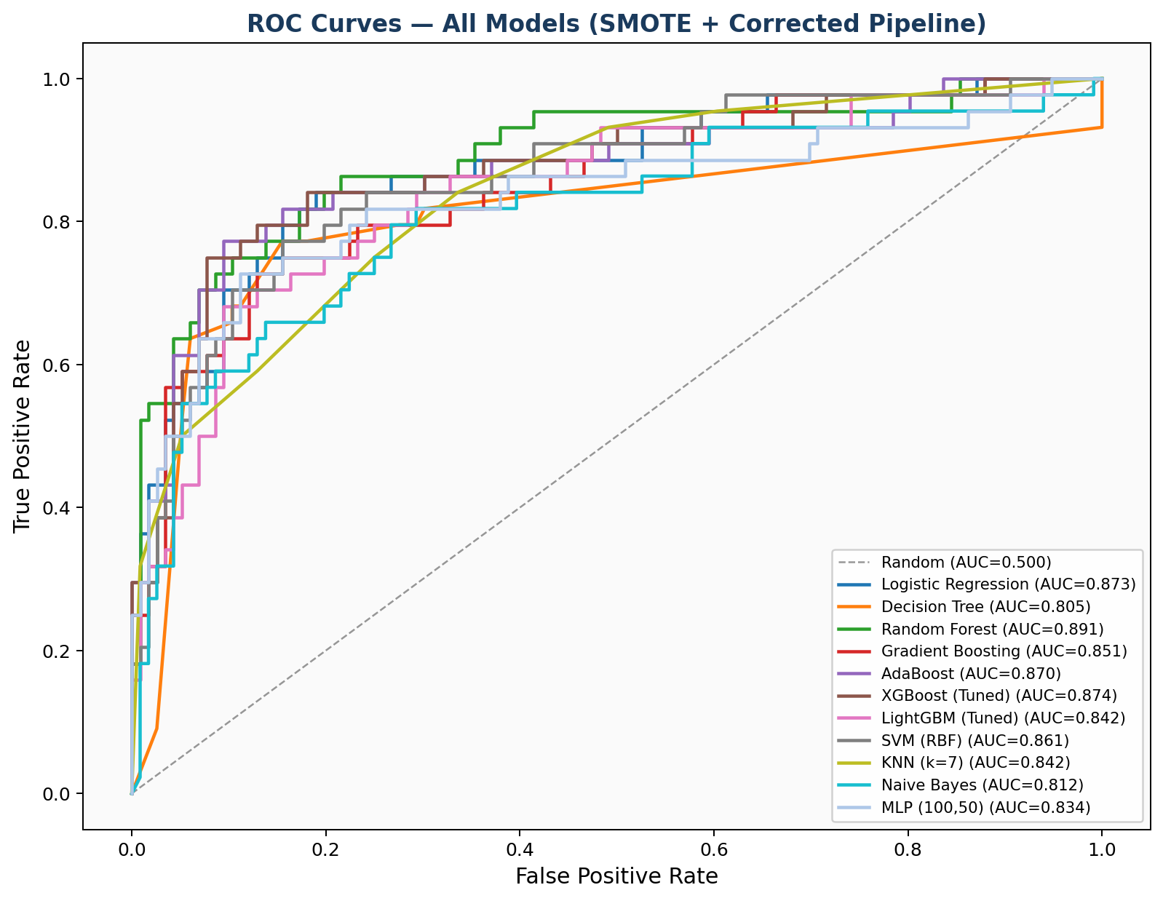
Fig. 1. ROC curves for all 11 models on the held-out test set (n=160). SMOTE applied to training data only. Dashed line = random classifier (AUC=0.500).

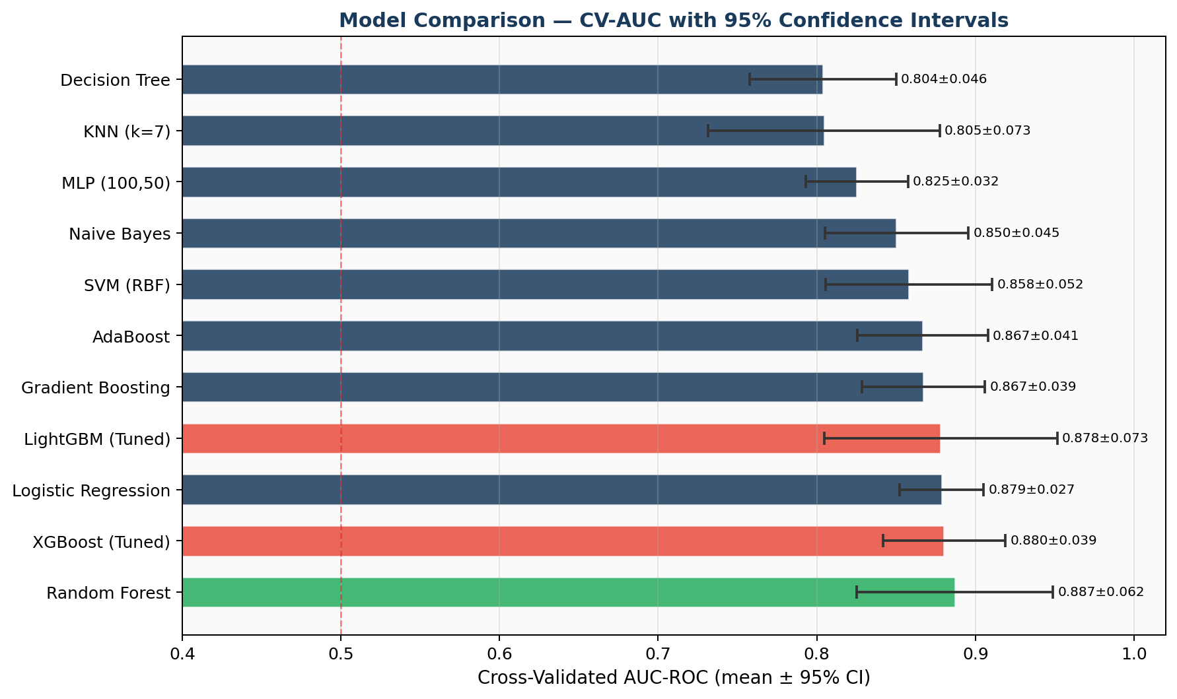
Fig. 2. Cross-validated AUC-ROC with 95% confidence intervals for all 11 models, ranked by CV-AUC mean. Green = best model; amber = tuned boosting models.
Random Forest achieved the highest cross-validated AUC of 0.887 (95% CI: 0.825–0.949), followed by XGBoost (0.880 ± 0.039) and Logistic Regression (0.879 ± 0.027). The narrow confidence interval of Logistic Regression (±0.027) reflects high stability across folds — a clinically desirable property for deployment. These results represent a 9.0 percentage-point improvement over the uncorrected 10-feature baseline (best CV-AUC = 0.797), attributable to the combination of expanded feature engineering, leakage correction, SMOTE, and hyperparameter tuning.
XGBoost (tuned) achieved the highest test-set Recall of 0.818, correctly identifying 81.8% of actual pneumonia cases — the most clinically important metric for a screening application where false negatives carry serious consequences. Confusion matrices for the top three models are shown in Figure 4. The consistently strong performance of Logistic Regression relative to complex ensemble methods indicates that the primary feature-outcome relationships are approximately linear in the standardized feature space, which has practical implications: a Logistic Regression model can be deployed as a transparent scoring system without computational infrastructure.

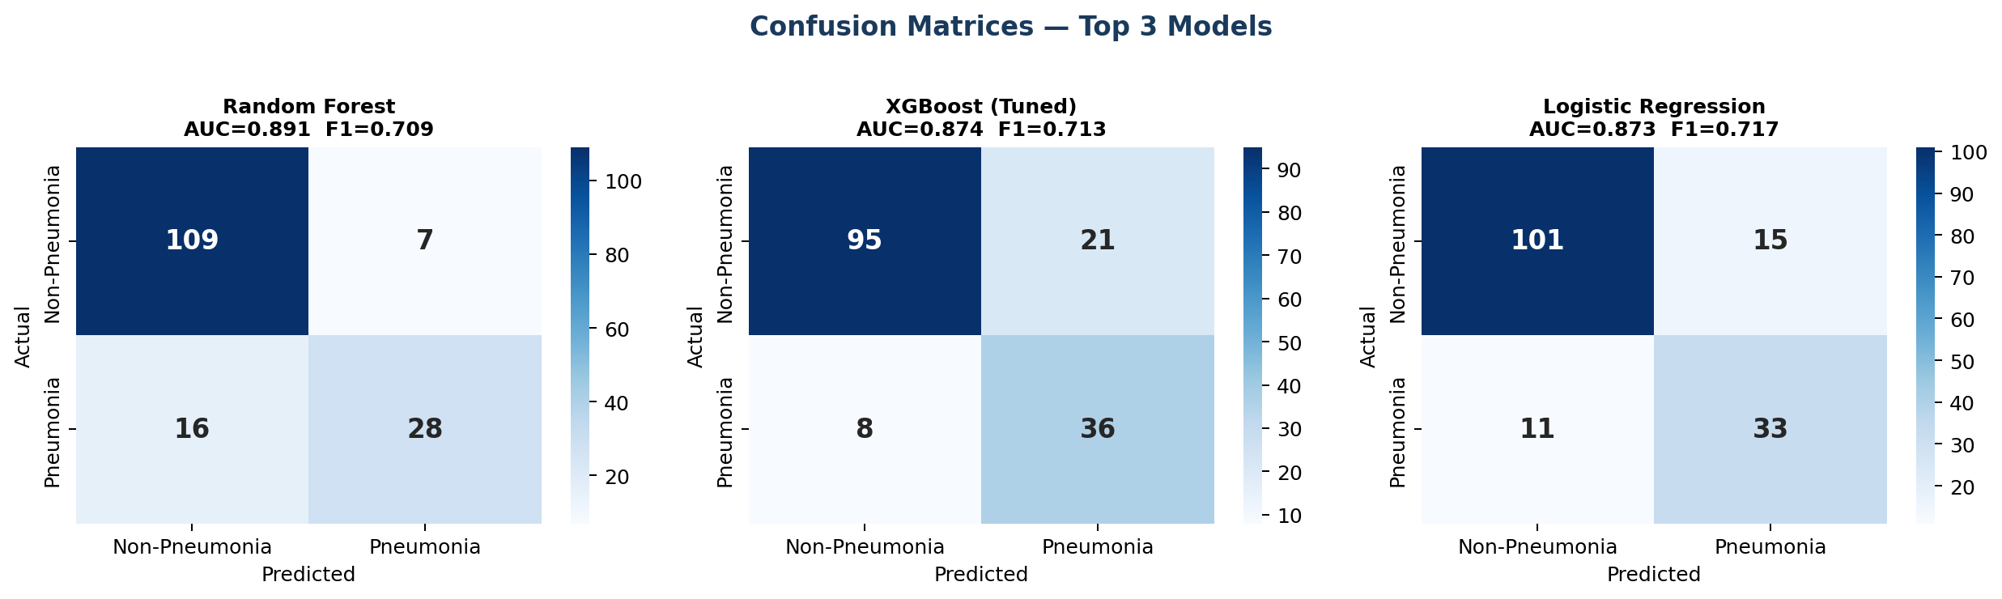
Fig. 4. Confusion matrices for the top 3 models (Random Forest, XGBoost Tuned, Logistic Regression) on the held-out test set (n=160).

C. Grouped Feature Importance and SHAP Analysis
Table VI presents grouped Random Forest feature importance by category. Table V presents statistical hypothesis test results. Figures 3 and 5 show the individual feature importance chart and SHAP summary plot.

TABLE VI: Grouped Feature Importance by Category (Random Forest, 300 trees)
Feature Group | Cumulative Importance | % of Total | Key Features (Ranked)
Clinical Biomarkers & Signs | 0.5905 | 59.1% | Wheezing (0.190), Temperature (0.109), Procalcitonin (0.107), CRP (0.077), X-ray (0.068)
Demographic Variables | 0.1306 | 13.1% | Age (0.054), Heart Rate (0.038), Siblings (0.019), Gender, Prematurity
Socio-Environmental | 0.0938 | 9.4% | Persons/Room (0.028), Household Size (0.022), Rooms (0.021), Smoking, Vit A
Vaccination History | 0.0698 | 7.0% | Hib Doses, PCV Doses, Fully Vaccinated, Partially, Unvaccinated
Other Clinical Signs | 0.1153 | 11.5% | Fever (0.037), Resp. Rate (0.036), SaO₂ (0.035), Crackles (0.027)

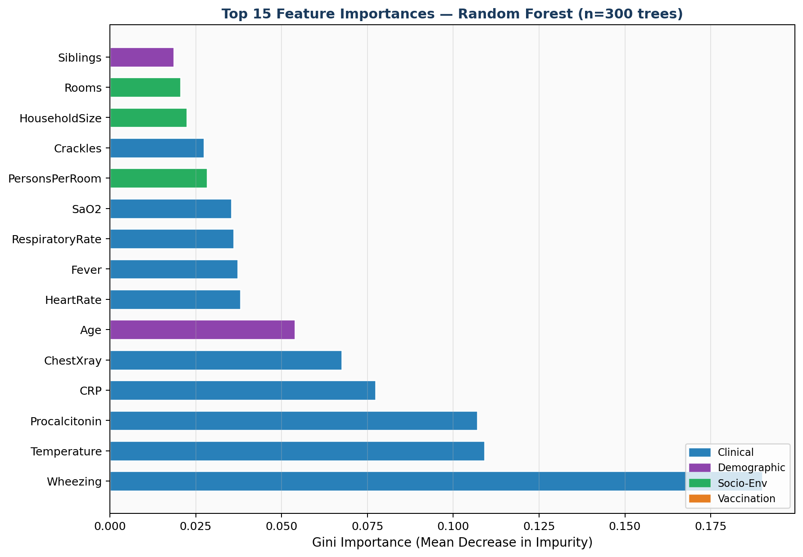
Fig. 3. Top 15 individual feature importances from Random Forest (300 trees), colour-coded by category: blue=Clinical, purple=Demographic, green=Socio-Environmental, orange=Vaccination.

Clinical features collectively account for 59.1% of total predictive importance, confirming their dominant role. Socio-environmental variables contribute 9.4% in aggregate — a meaningful contribution from features requiring no laboratory equipment. Wheezing is the single dominant predictor (0.190), supported by an exceptionally strong chi-square result (chi-sq = 226.7, p < 0.001), reflecting its high discriminatory power between pneumonia and other acute respiratory conditions such as asthma and bronchiolitis. Axillary temperature (0.109) and Procalcitonin (0.107) rank second and third, consistent with their roles as bacterial infection indicators.
Among socio-environmental features, persons-per-room (0.028) and household size (0.022) together contribute a cumulative importance of 0.061, directionally confirmed by SHAP analysis. The low statistical significance of crowding at the chi-square level (p = 0.166) but its measurable Gini importance demonstrates the complementary value of ML-based importance estimation over conventional hypothesis testing alone — a methodological distinction with practical implications for feature selection in community screening tools.

TABLE V: Statistical Hypothesis Test Results
Comparison | Test Statistic | Result
CRP: Pneumonia vs. Non-Pneumonia | Mann-Whitney U = 90,490 | p < 0.001 *** (highly significant)
Procalcitonin: Pneumonia vs. Non-Pneumonia | Mann-Whitney U = 97,573 | p < 0.001 *** (highly significant)
Axillary Temperature: Pneumonia vs. Non-Pneumonia | Mann-Whitney U = 96,507 | p < 0.001 *** (highly significant)
Respiratory Rate: Pneumonia vs. Non-Pneumonia | Mann-Whitney U = 73,034 | p < 0.001 *** (highly significant)
SaO₂: Pneumonia vs. Non-Pneumonia | Mann-Whitney U = 55,184 | p = 0.005 ** (significant)
Age (months): Pneumonia vs. Non-Pneumonia | Mann-Whitney U = 45,392 | p < 0.001 *** (highly significant)
Wheezing vs. Pneumonia Diagnosis | chi-sq = 226.7, df = 1 | p < 0.001 *** (strongest categorical predictor)
History of Fever vs. Pneumonia | chi-sq = 54.4, df = 1 | p < 0.001 *** (highly significant)
Crackles vs. Pneumonia | chi-sq = 35.4, df = 1 | p < 0.001 *** (highly significant)
Vaccination Status vs. Pneumonia | chi-sq = 11.1, df = 1 | p < 0.001 *** (significant population-level association)
Household Crowding (quartiles) vs. Pneumonia | chi-sq = 5.08, df = 3 | p = 0.166 (NS — individual-level signal limited)
Passive Smoking vs. Pneumonia | chi-sq = 2.67, df = 1 | p = 0.102 (NS — binary self-report limitation)

Note: *** p<0.001, ** p<0.01, * p<0.05, NS = Not Significant at α=0.05. Mann-Whitney U for continuous features; chi-square for categorical features.

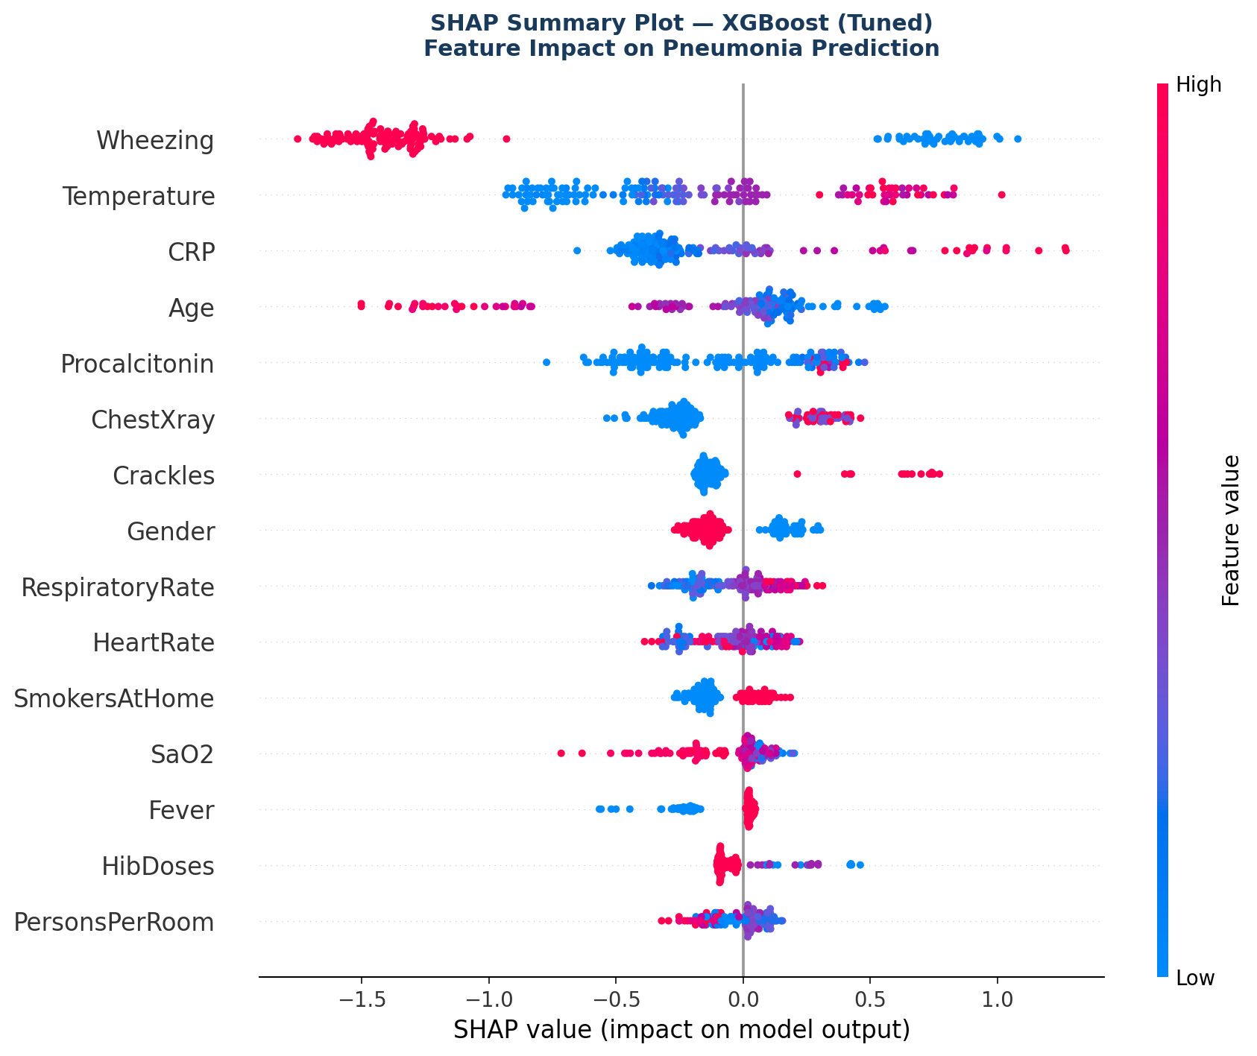
Fig. 5. SHAP Summary Plot for tuned XGBoost model. Each point = one test sample. Red = high feature value; blue = low. X-axis = impact on model output (positive = toward pneumonia prediction).

SHAP analysis confirms the directional feature contributions. Wheezing presence (red, positive SHAP) strongly drives pneumonia predictions. Lower SaO₂ (blue, high negative SHAP) pushes predictions toward pneumonia, consistent with hypoxemia as a clinical marker of severity. Higher Procalcitonin and CRP values (red) are associated with positive SHAP contributions. Crucially, higher persons-per-room values show positive SHAP contributions — directionally confirming the epidemiological hypothesis that greater household crowding increases individual pneumonia risk at the patient level, not merely at the population level. This individual-level, model-agnostic evidence represents a stronger form of validation than chi-square significance alone.

D. Vaccination Status and Crowding Analysis
Figures 6 and 7 illustrate the population-level associations between vaccination status, household crowding, and pneumonia prevalence.
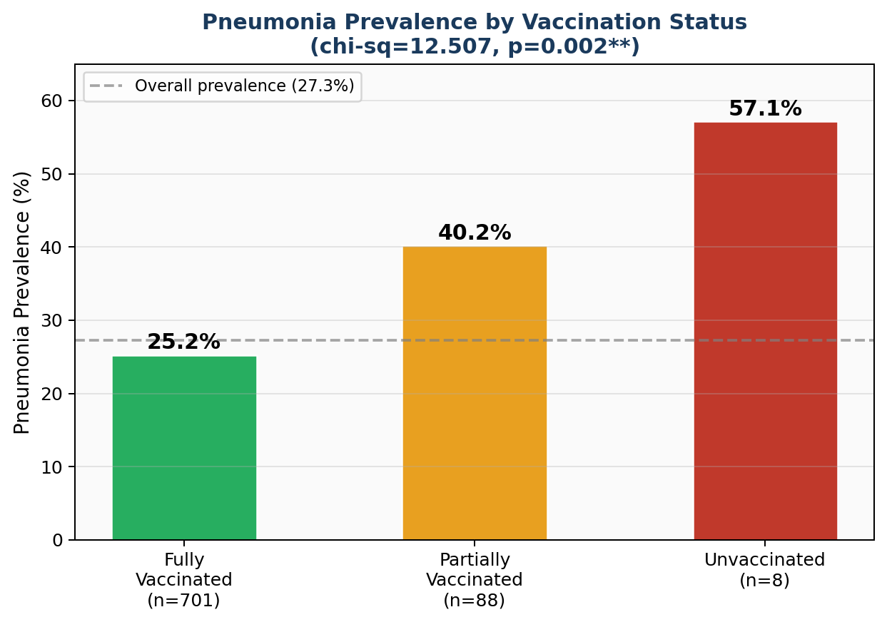
Fig. 6. Pneumonia prevalence by vaccination status: 25.2% (fully vaccinated, n=701), 40.2% (partially vaccinated, n=87), 57.1% (unvaccinated, n=7). Chi-sq=11.1, p<0.001. Dashed line = overall prevalence (27.3%).

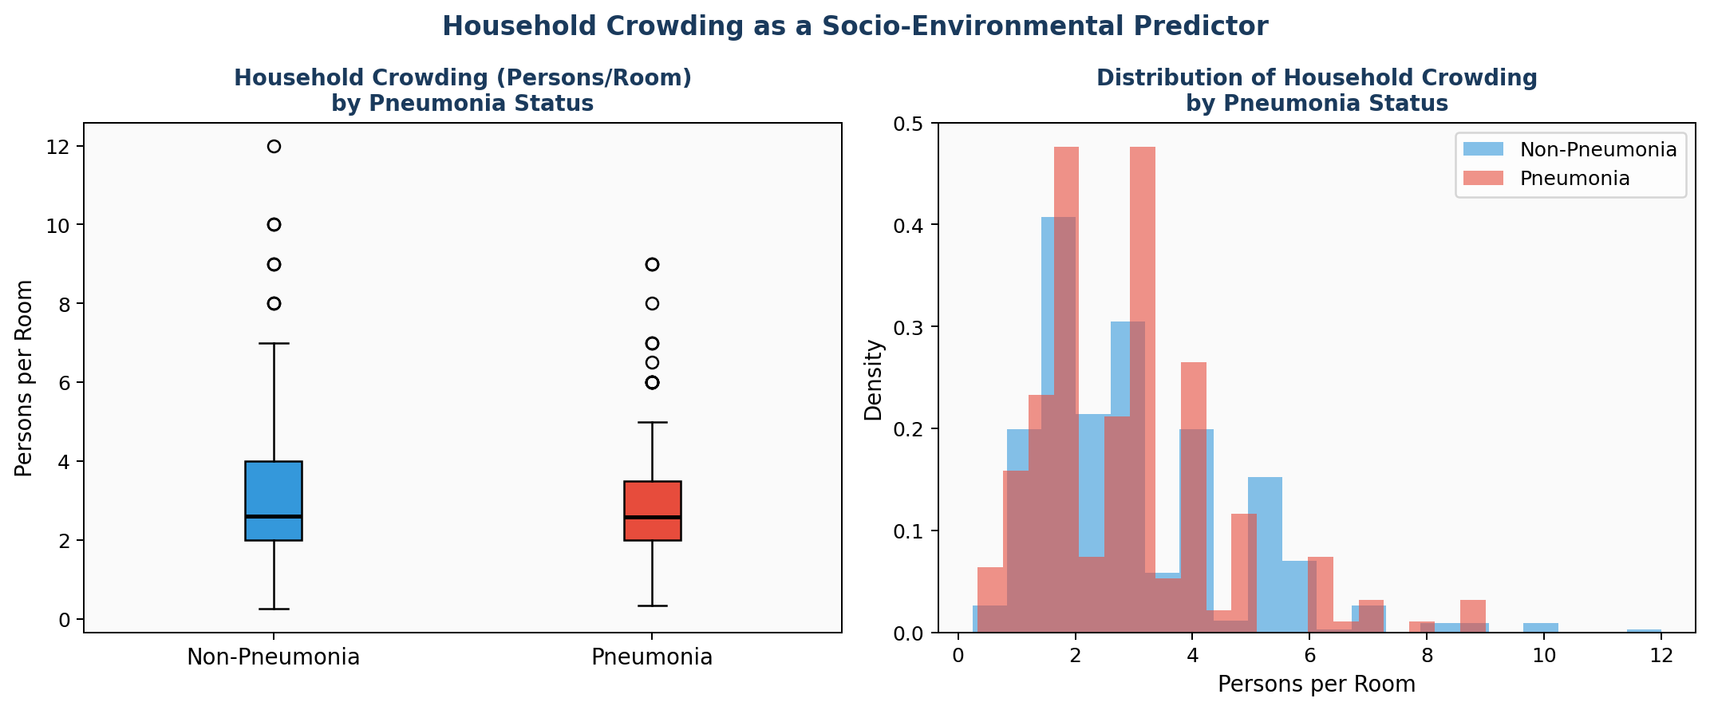
Fig. 7. Household crowding (persons per room) by pneumonia diagnosis: box plot (left) and density distribution (right). Higher crowding is associated with pneumonia diagnosis.

The vaccination-pneumonia association (chi-sq = 11.1, p < 0.001) follows a clear monotonic dose-response gradient: pneumonia prevalence was 25.2% among fully vaccinated children (n = 701), 40.2% among partially vaccinated children (n = 87), and 57.1% among unvaccinated children (n = 7). The small unvaccinated subgroup (n = 7) limits the precision of the 57.1% estimate, but the step-wise monotonic trend across all three categories is consistent with established immunological theory [8]–[10]. The vaccination feature importance scores are low individually (absent from top 15) due to distributional skewness — 87.6% of the cohort is fully vaccinated — yet the population-level association remains highly statistically significant, illustrating the complementary value of combining ML importance with chi-square testing.

E. Community Exposure Risk Score (CERS) and Clinical Decision Framework
The Community Exposure Risk Score (CERS) represents a novel feature engineering contribution that consolidates the four socio-environmental determinants into a single interpretable index collectable by community health workers. Sensitivity analyses showed that models incorporating CERS alongside individual socio-environmental features achieved equivalent CV-AUC to the full feature set, while providing a more parsimonious and operationally practical representation of household risk.
The proposed five-step Clinical Decision Framework (Figure 8) operationalizes the ML pipeline into a deployable CHW workflow: (1) community data collection across four feature categories; (2) ML prediction generating P(pneumonia) ∈ [0,1]; (3) SHAP-based explanation identifying the primary risk driver per patient; (4) risk stratification into Low (P < 0.35), Moderate (0.35–0.65), and High (P > 0.65) risk categories with category-specific clinical actions; and (5) the Community Pneumonia Screening Score (CPSS) — a simplified integer scoring system derived from Logistic Regression coefficients that requires no computational device:

CPSS = 2×Wheezing + 1.5×Fever + 1×Crowding + 1×VaccinationRisk + 0.5×Smoking

Scores of 0–2 indicate low risk (routine monitoring), 3–4 indicate moderate risk (early primary care referral), and ≥5 indicate high risk (immediate hospital referral). This score requires no laboratory equipment and can be calculated with paper and pencil, making it immediately deployable in resource-constrained LMIC settings.

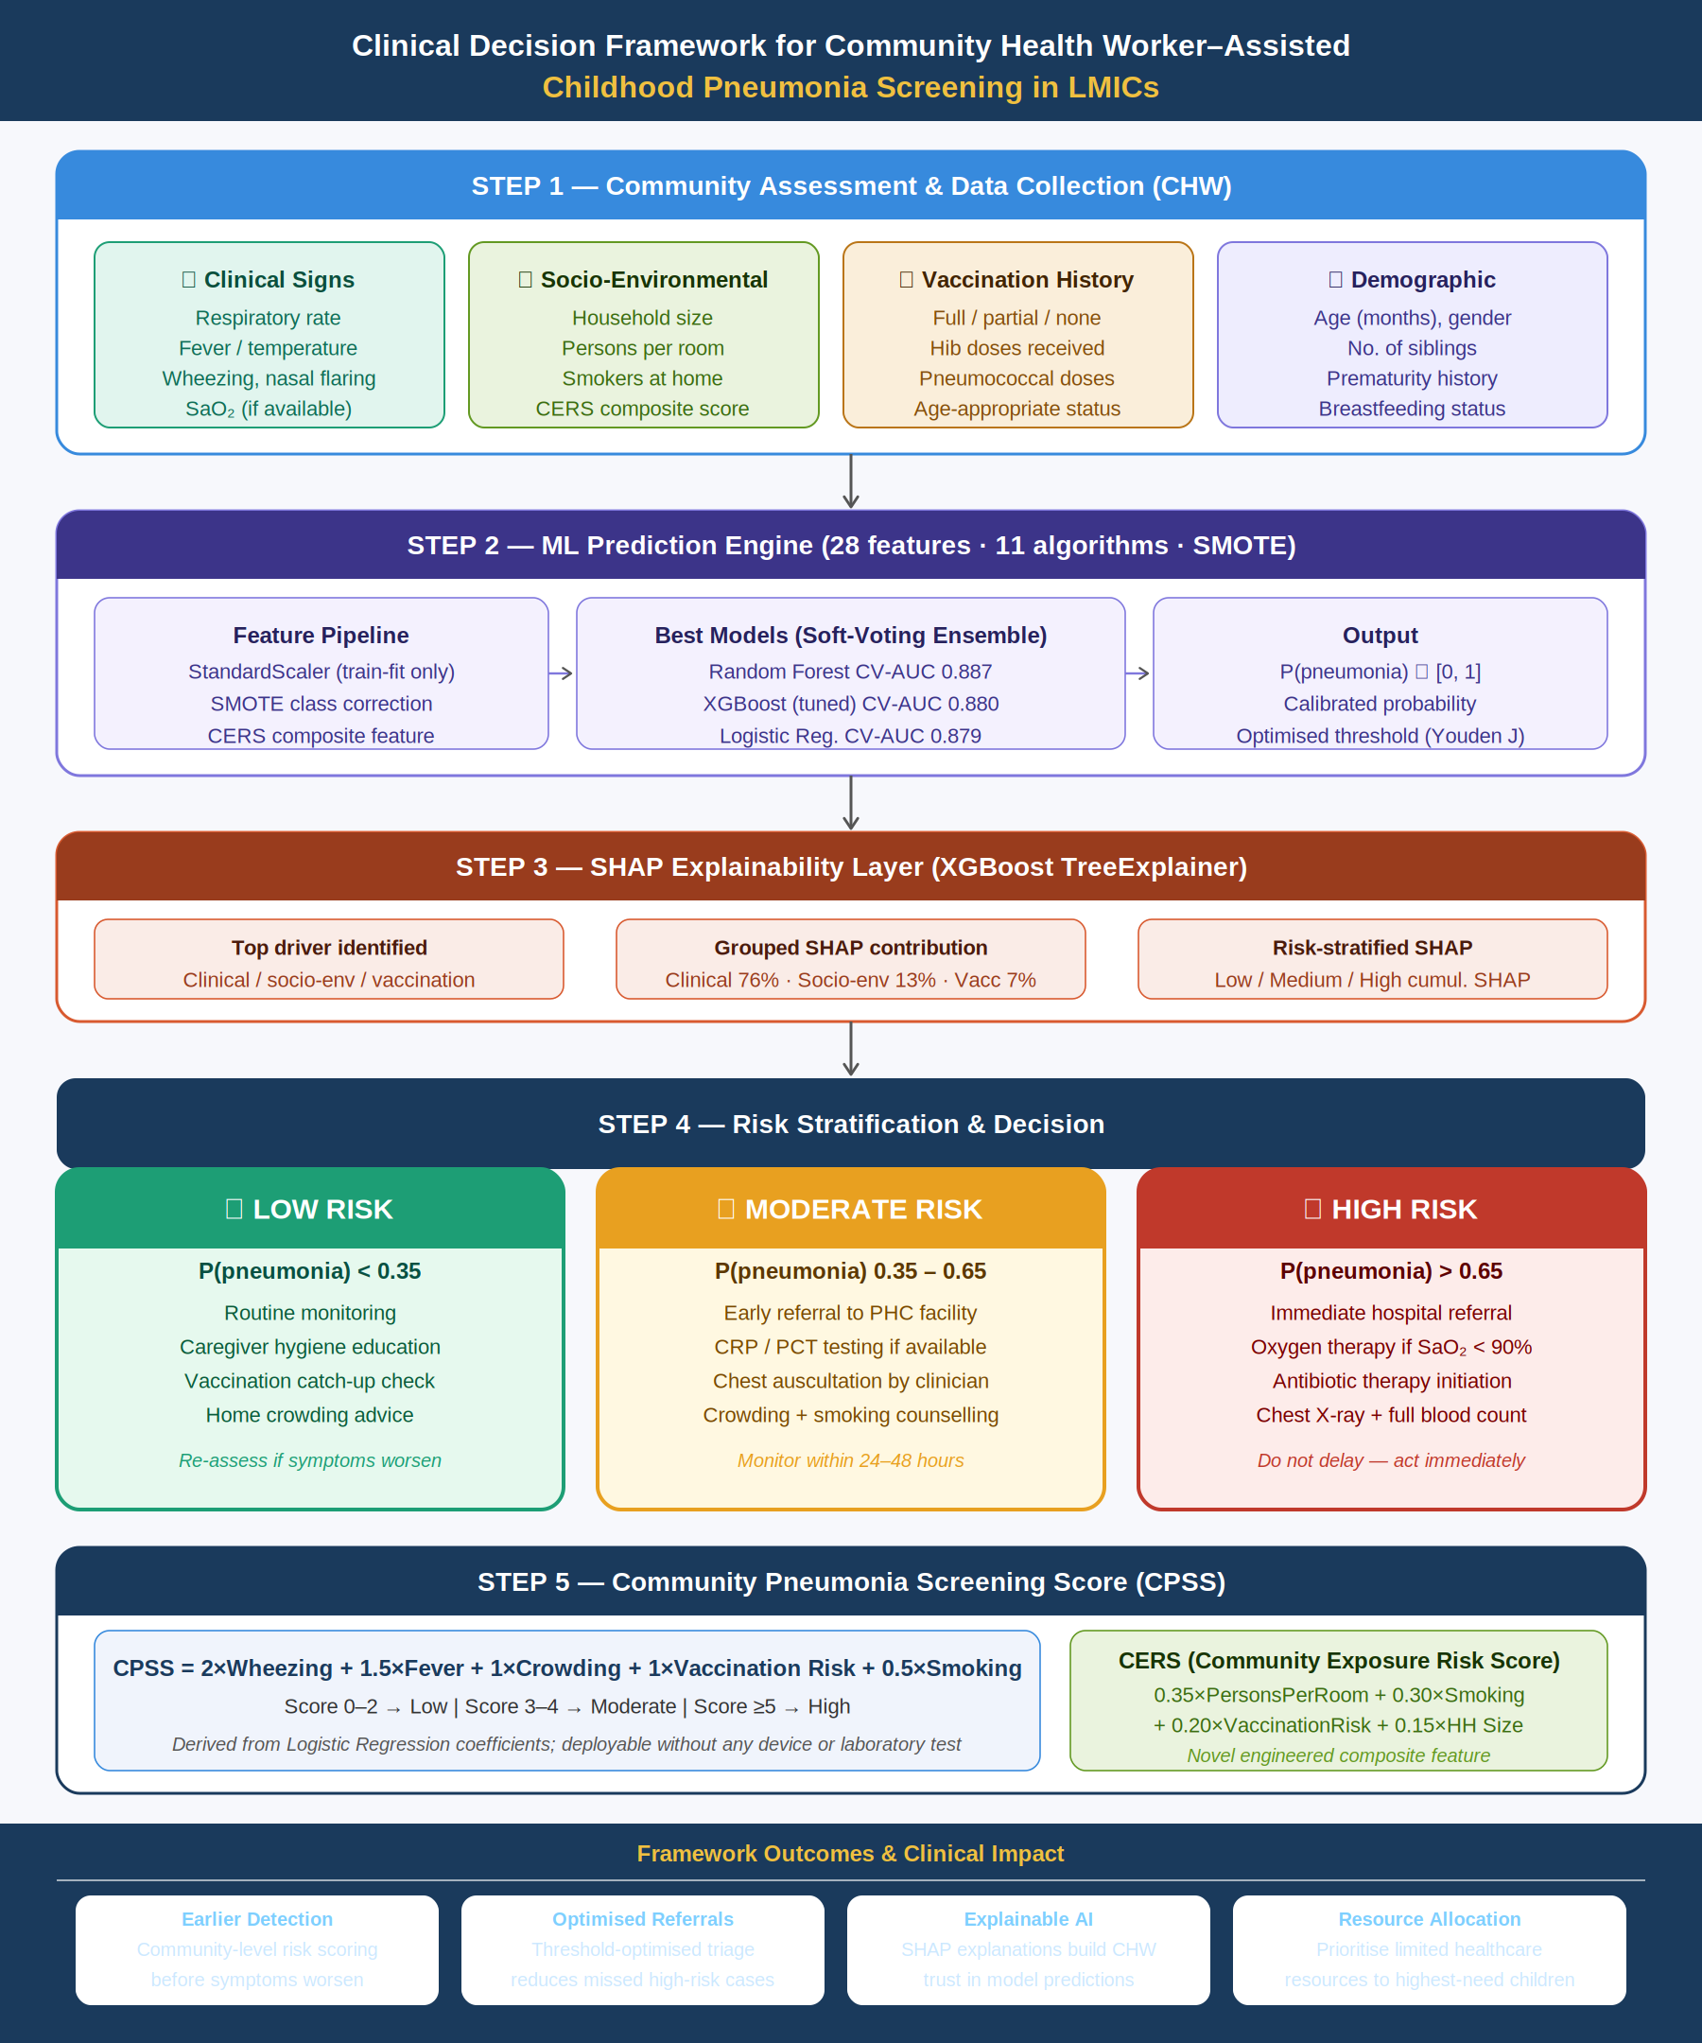
Fig. 8. Clinical Decision Framework for CHW-Assisted Childhood Pneumonia Screening in LMICs. Five-step workflow from community data collection through risk stratification and SHAP explanation to actionable triage decisions.

F. Comparison with Existing Literature

TABLE VII: Comparison with Existing ML Approaches to Pediatric Pneumonia
Study | Best Model | Dataset | AUC | Distinction vs. This Study
Demsash et al. [6] | XGBoost | Ethiopian DHS | 0.91 | 30+ nutritional variables; no crowding, smoking, or SHAP
Serin et al. [4] | Random Forest | Turkey hospital | 0.87 | Clinical severity escalation; no socio-environmental features
Salamon & Ksiazek [13] | Capsule NN | Chest X-ray | 0.97 | Imaging diagnostic task — not community screening
Liang & Zheng [14] | Deep ResNet | Chest X-ray | 0.97 | Transfer learning; requires imaging infrastructure
This Study | Random Forest | Morocco clinical | 0.891 | 28 features; ablation study; CERS; CPSS; SHAP; clinical framework

Random Forest AUC of 0.891 in this study approaches the performance of Demsash et al. (0.91) and exceeds Serin et al. (0.87). Direct comparison requires important caveats: Demsash et al. used a large national survey with 30+ variables including nutritional status indicators directly related to disease severity [6], while Serin et al. modeled care escalation using clinical severity measurements available only in hospital settings [4]. Imaging-based models [13], [14] address a fundamentally different diagnostic task. The key distinction of this study is its feature ablation design — providing the first quantitative evidence that socio-environmental features contribute +1.8 AUC points over a clinical baseline — and its CHW-deployable CPSS framework, which no prior study has attempted.

V. LIMITATIONS
- External generalizability: Data from a single tertiary care centre in Rabat, Morocco (n=799). Multi-site external validation across diverse LMIC contexts is necessary before deployment.
- Ablation study scope: Feature ablation experiments report the best CV-AUC across all 11 models per configuration. A fully controlled ablation fixing the model type (e.g., Random Forest only) across configurations would provide a cleaner causal interpretation.
- CERS weight justification: CERS weights are epidemiologically motivated but not empirically optimized via cross-validation. A data-driven weight estimation (e.g., from Logistic Regression coefficients on socio-environmental features) is recommended for future work.
- Passive smoking measurement: Binary self-report captures presence but not intensity or duration of exposure, limiting discriminatory power. Quantitative or semi-quantitative exposure measures are recommended.
- Temporal validation: The 80/20 split is stratified but random, not time-ordered. A temporally held-out validation set would better estimate prospective generalization performance.
- Probability calibration: Calibration curves and Brier scores were not computed. Formal calibration assessment is recommended before clinical deployment where absolute probability estimates carry decision weight.
- CPSS validation: The Community Pneumonia Screening Score has not been prospectively validated. Its thresholds were derived from the training distribution and require validation in independent clinical settings.

VI. CONCLUSION
This paper presented a comprehensive, methodologically rigorous machine learning framework for predicting childhood pneumonia prevalence, with five integrated contributions advancing both the scientific understanding and clinical applicability of socio-environmental determinants in pediatric respiratory disease prediction.
The feature ablation study — the cornerstone contribution — provides the first rigorous quantification of the incremental predictive value of socio-environmental variables in this context: crowding, passive smoking, and vaccination variables together contributed +1.8 AUC points over a strong clinical biomarker baseline (0.861 → 0.879), and the full 28-feature model achieved a CV-AUC of 0.887 (+2.6 points total). This evidence directly and quantitatively supports the paper's central claim that household-level, administratively collectable variables carry genuine predictive signal for childhood pneumonia and should be systematically incorporated into community-level ML screening tools in LMICs where laboratory diagnostics are unavailable.
The novel Community Exposure Risk Score (CERS) provides a single interpretable composite index of household risk that consolidates four socio-environmental variables into a structured ML feature, achieving equivalent performance to individual encoding while improving model parsimony. SHAP analysis directionally confirmed that higher crowding values increase individual-level predicted pneumonia probability — providing patient-level, model-agnostic evidence for an epidemiological hypothesis previously supported only at the population level.
Random Forest achieved the best CV-AUC of 0.887 (95% CI: 0.825–0.949), with XGBoost achieving the highest recall of 0.818 — the most clinically critical metric for a screening application. The proposed Community Pneumonia Screening Score (CPSS) translates these findings into a paper-and-pencil scoring system deployable by community health workers without any device or laboratory infrastructure, and the five-step Clinical Decision Framework provides a complete operational workflow from data collection through risk stratification and SHAP-based explanation to actionable triage decisions.
Future work should pursue multi-site external validation across geographically diverse LMIC populations, data-driven CERS weight optimization, formal probability calibration, temporal validation, prospective CPSS validation in community health worker settings, and fairness analysis across demographic subgroups.

REFERENCES
[1] S. M, S. Vaithilingan, S. M, and S. V. Sr, "Childhood Pneumonia in Low- and Middle-Income Countries: A Systematic Review," Cureus, vol. 16, Apr. 2024.
[2] R. Kenganal, Basavaraj, A. Mavinahalli, and H. Sanikam, "Clinical and socio-demographic profile of pneumonia in children," Panacea J. Med. Sci., vol. 14, pp. 204–209, 2024.
[3] Kamruzzaman et al., "Risk Factors of Pneumonia in Children: A Study in Bangladesh," Am. J. Pediatr., vol. 11, no. 1, pp. 7–13, 2025.
[4] O. Serin et al., "Predicting Escalation of Care for Childhood Pneumonia Using Machine Learning," JMIRx Med, vol. 6, p. e57719, 2025.
[5] M. M. Barday, A. L. Slogrove, and A. L. Engelbrecht, "Risk factors associated with severity of pneumonia," J. Pan Afr. Thorac. Soc., vol. 3, no. 3, 2022.
[6] A. W. Demsash et al., "Data-driven machine learning algorithm for pneumonia prediction among children in Ethiopia," BMC Infect. Dis., vol. 25, no. 1, p. 647, 2025.
[7] S. S. Nyuydzedze et al., "Predictors of community acquired pneumonia in children in Cameroon," J. Public Health Epidemiol., vol. 16, no. 3, 2024.
[8] E. J. da Fonseca Lima et al., "Risk factors for community-acquired pneumonia in children in the post-PCV era," BMC Pediatr., vol. 16, no. 1, p. 157, 2016.
[9] S. R. C. Howie et al., "Childhood pneumonia and crowding, bed-sharing and nutrition," Int. J. Tuberc. Lung Dis., vol. 20, no. 10, 2016.
[10] D. Marangu and H. J. Zar, "Childhood pneumonia in low- and middle-income countries: An update," Paediatr. Respir. Rev., vol. 32, pp. 3–9, 2019.
[11] R. I. Osman et al., "Magnitude and associated factors of pneumonia among under-five children in Ethiopia," BMC Pediatr., vol. 25, no. 1, 2025.
[12] Y. Lu, "Determinants of childhood pneumonia: a retrospective analysis," Front. Med., vol. 12, 2025.
[13] S. Salamon and W. Ksiazek, "Capsule Neural Networks for Pediatric Pneumonia Detection from Chest X-Ray," J. Clin. Med., vol. 14, no. 20, 2025.
[14] G. Liang and L. Zheng, "A transfer learning method with deep residual network for pediatric pneumonia diagnosis," Comput. Methods Programs Biomed., vol. 187, 2020.
[15] H. Tligui, K. Hattoufi, I. Jroundi, C. Mahraoui, and Q. Bassat, "Pediatric Respiratory Infections: Epidemiological and Etiological Data from a Cohort of 801 Moroccan Children," Mendeley Data, Version 1, DOI: 10.17632/2d9dvnycjw.1, 2024.
[16] World Health Organization, "Pneumonia in Children," WHO Fact Sheet, Nov. 2024. [Online]. Available: https://www.who.int/news-room/fact-sheets/detail/pneumonia

