SMART VILLAGE REPORT



**Course :** COMPUTER GRAPHICS [B]

**Instructor** : MD. KISHOR MOROL

**Semester :** SUMMER 2020-2021

NAME ID

1.Tonmoy Ghosh 16-31993-2

2. Tasin Islam 17-34598-2

3. Md. Nayeem Hossain 17-34564-2

4. Bishal Paul 17-35836–3

**Introduction :**

A opengl Computer Graphics project "Smart Village" using C++ and opengl. Our project is a scenery program for Glut opengl graphics programming. ‘Smart Village' is a mold designing program. The Project will be programmed using C++. We have name the program Smart Village because where we will give you the scenery of a smart village.

**Background**:

A village scenario with green yard and Hill. According to time, the light will change from day to night. In addition, the weather will change like in summer the scenario will be sunny and clouds will wing in the sky. The program is made with Codeblocks in Windows 10 and to execute the program OpneGl and glut should be installed properly and configured with CodeBlocks. After installing glut in Windows, open Transformation in Code Blocks. Build and then run the solution. Transformation.cpp is the main source C++ file.

**Objective of the Project:**

As our project is mainly a scenario based project here we can change the mode from day to night. Where we have some house, mountains, tree, grass, sun, and moon with stars. When we execute the program, we can find simple house and tree sketched with line. There will be mouse interaction which will let swap between the day and night view. There will be three mouse interaction added with use of menu. The three menu and their working will like,

1. The run the program and floating clouds.
2. Night color change &
3. Day color change.

These menu will come when we will press the mouse click. In day mode we will see sun and cloud while in night mode stars and moon. House, Mountain and Tree will be same in both the mode.

**Methodology:** We used OpenGl to implement the project “smart Village”. We used various types of methods.

**Gl primitives:** we used GL polygone most of the time and also triangle , Gl quads

**Translation:** it has many use in this project for clouds, wind mill, sun.

**Rotation:** rotation is used for wind mill.

**Circle:** it is used for cloud , sun.

We draw the object in different methos too maintain the convention for house, hill, tilla.

MouseFunc is used to interact with the movement.

Significant of this Project

This project is also a new one that is only available on our site. In this project we have implemented an “Smart Village” so we have given the title as “SMART VILLAGE” where is some small house will be present and around it some **trees** will be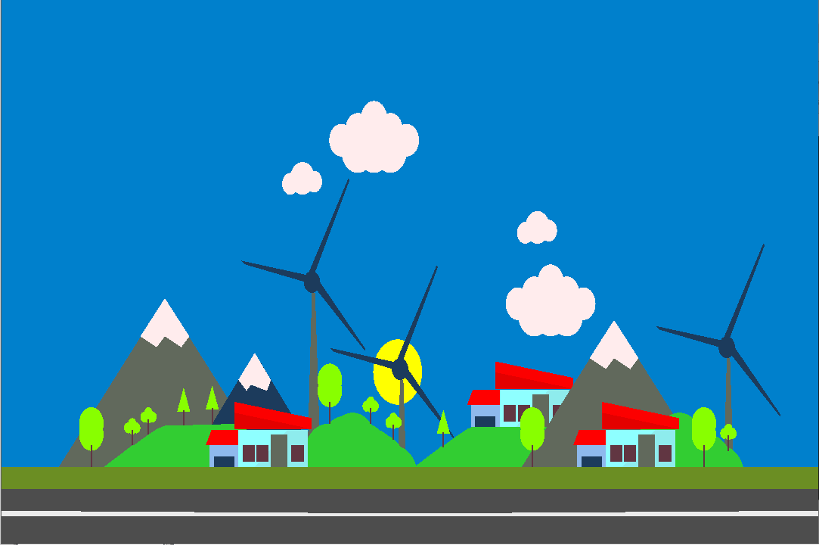 there and in the sky, [A wind turbine turns wind energy](https://www.energy.gov/eere/wind/animation-how-wind-turbine-works) into electricity using the aerodynamic force from the rotor blades ,which creates electricity. A **mountain** is a large landform that rises above the surrounding land in a limited area, a couple of **clouds** will be kept on moving in the sky and the **sun** will be there.

From the trees some birds will fly towards the sky we have designed a set of **birds** and we made them fly one set after the other to show the motion of some objects and also we have provided motion for the **clouds** too. Inside the house, we can turn on the light and turn off the light by the controls provided in the keyboard. There is a **night mode** in which there will be the **dark sky** and comets will be moving and the **airplane** these two objects will appear when the respective control is pressed on the keyboard and the mouse.

**Conclusion**

We have put in place a “**SMART VILLAGE**” which is a colorful and simple mini project. And this project includes a lot of options in it. We have given you the idea to implement the simple objects as we have used in this project you can also develop simple objects to this project and it will look even better. For the future implementations try to create a road and some vehicles moving in the road and etc.

Referencing :

1. <https://en.wikipedia.org/wiki/Smart_Village_India#:~:text=Smart%20Village%20is%20a%20concept,and%20Swaraj%20(Self%20Reliance)>.
2. <https://www.smartcity.press/smart-villages-project/>

**SCREENSHOT :**

**DAY MOOD WITH RAIN**

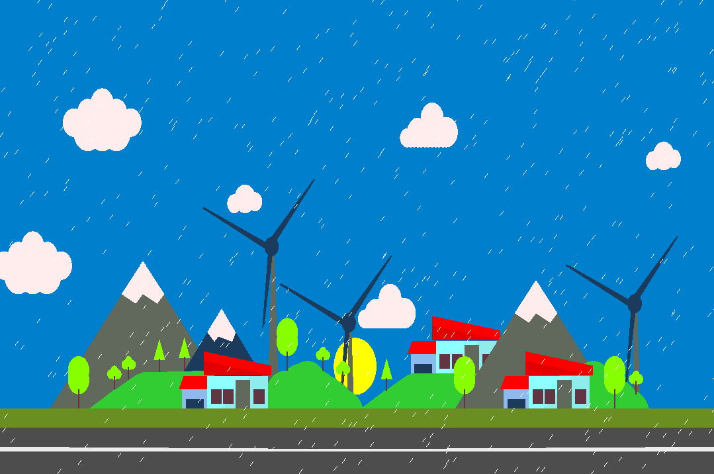

NIGHT MOOD WITH RAIN