**Exercise 1: Setting Up JUnit**

**File: pom.xml**

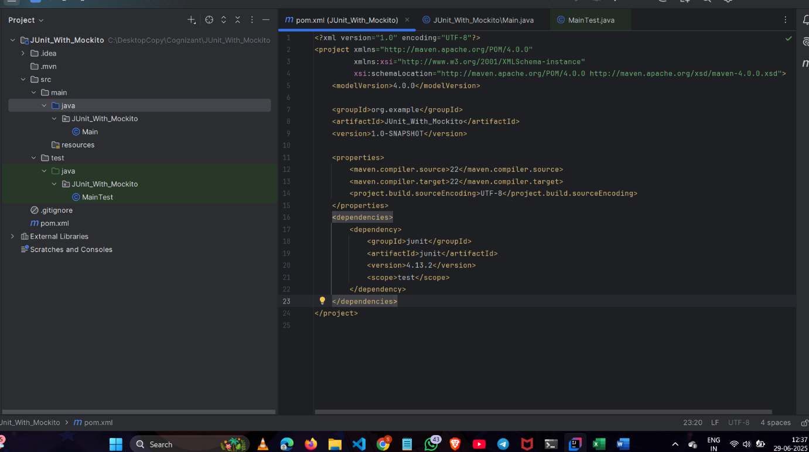

**FILE: MainTest.java**

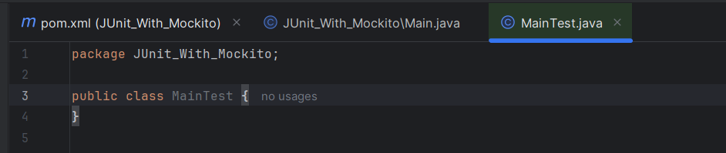

**Exercise 3: Assertions in Junit**

**File: AssertionsTest.java**

package JUnit_With_Mockito;  
import org.junit.Test;  
import static org.junit.Assert.*;  
  
public class AssertionsTest {  
 @Test  
 public void testAssertions() {  
 // Assert equals  
 *assertEquals*(5, 2 + 3);  
 // Assert true  
 *assertTrue*(5 > 3);  
 // Assert false  
 *assertFalse*(5 < 3);  
 // Assert null  
 *assertNull*(null);  
 // Assert not null  
 *assertNotNull*(new Object());}  
}

**OUTPUT:** 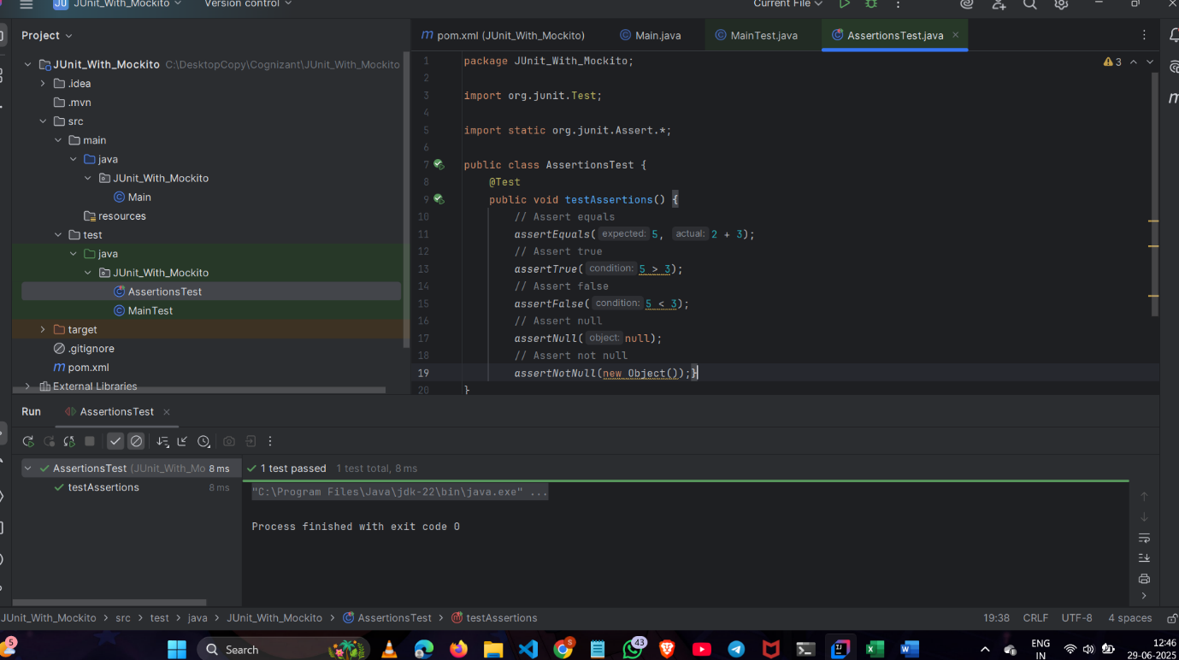

**Exercise 4: Arrange-Act-Assert (AAA) Pattern, Test Fixtures, Setup and Teardown Methods in Junit**

**FILE : MainTest.java**

package JUnit_With_Mockito;  
  
import org.junit.Test;  
import org.junit.Before;  
import org.junit.After;  
  
import static org.junit.Assert.*assertEquals*;  
  
public class MainTest {  
 //Arrange  
 private Main calculator;  
  
 @Before  
 public void setUp() {  
 calculator = new Main();  
 System.*out*.println("Setup complete");  
 }  
  
 @After  
 public void tearDown() {  
 calculator = null;  
 System.*out*.println("Teardown complete");  
 }  
  
 @Test  
 public void testAddition() {  
 //Arrange  
 int a = 5;  
 int b = 3;  
  
 //Act  
 int result = calculator.add(a, b);

//Assert  
 *assertEquals*(8, result);  
 }  
  
 @Test  
 public void testSubtraction() {  
 //Arrange  
 int a = 10;  
 int b = 4;  
 //Act  
 int result = calculator.subtract(a, b);  
 //Assert  
 *assertEquals*(6, result);  
 }  
  
}

**OUTPUT:**

