**Exercise 1: Mocking and Stubbing**

**File: MyServiceTest.java**

package JUnit_With_Mockito;  
  
import org.junit.Test;  
import org.junit.Before;  
import static org.junit.Assert.*assertEquals*;  
import static org.mockito.Mockito.*;  
  
  
public class MyServiceTest {  
  
 @Test  
 public void testExternalApi() {  
 // Arrange: Create a mock and stub its behavior  
 ExternalApi mockApi = *mock*(ExternalApi.class);  
 *when*(mockApi.getData()).thenReturn("Mock Data");  
  
 MyService service = new MyService(mockApi);  
  
 // Act  
 String result = service.fetchData();  
  
 // Assert  
 *assertEquals*("Mock Data", result);  
 }  
 @Test  
 public void testExternalApi2() {  
 // Arrange: Create a mock and stub its behavior  
 ExternalApi mockApi = *mock*(ExternalApi.class);  
 *when*(mockApi.getData()).thenReturn("Mock Data 2");  
  
 MyService service2 = new MyService(mockApi);  
  
 // Act  
 String result = service2.fetchData();  
  
 // Assert  
 *assertEquals*("Mock Data 2", result);  
 }  
}

**OUTPUT:**

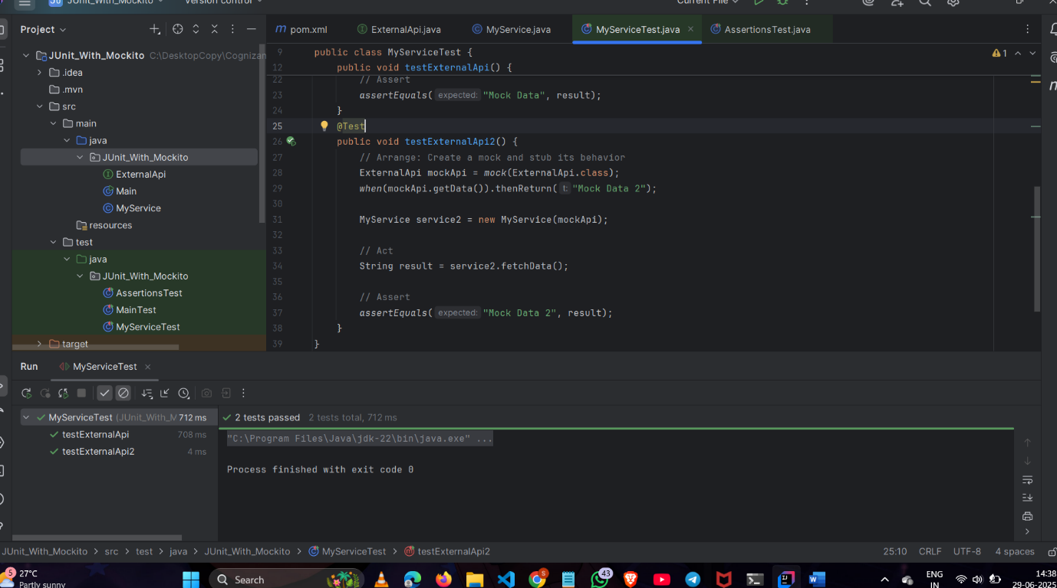

**Exercise 2: Verifying Interactions**

**File : MyServiceTest.java**

package JUnit_With_Mockito;  
  
import org.junit.Test;  
import static org.mockito.Mockito.*;  
  
  
public class MyServiceTest {  
  
 @Test  
 public void testVerifyInteraction() {  
 // Arrange  
 ExternalApi mockApi = *mock*(ExternalApi.class);  
 MyService service = new MyService(mockApi);  
  
 // Act  
 service.fetchData();  
  
 // Assert  
 *verify*(mockApi).getData();  
 }  
}

**OUTPUT:** 