**Hands on 1**

**Create a Spring Web Project using Maven**

OUTPUT:

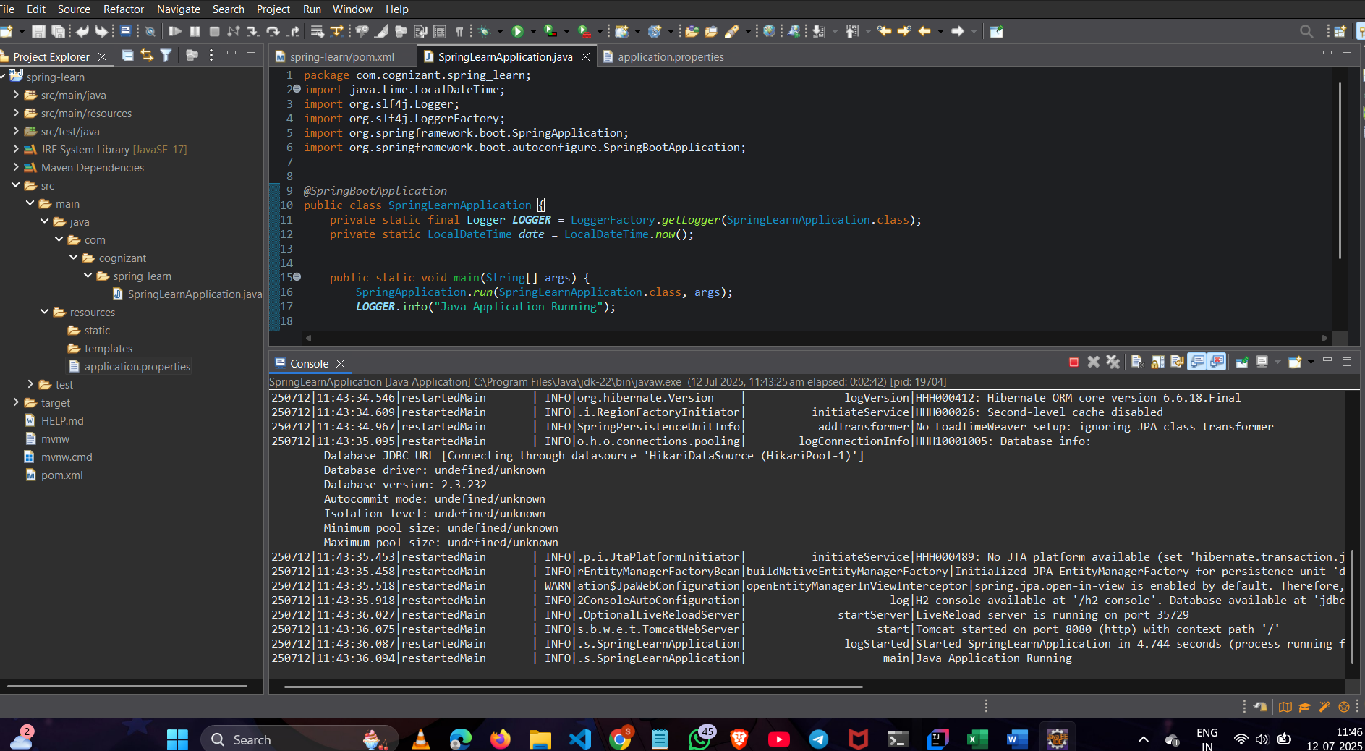

**Hands on 4**

**Spring Core – Load Country from Spring Configuration XML**

CODE:

FILE: Country.java

package com.cognizant.spring_learn;

import org.slf4j.Logger;

import org.slf4j.LoggerFactory;

public class Country {

private String code;

private String name;

private Logger LOGGER = LoggerFactory.*getLogger*(SpringLearnApplication.class);

public Country(String code, String name) {

LOGGER.debug("Inside Country Constructor");

this.code = code;

this.name = name;

}

public String getCode() {

return code;

}

public void setCode(String code) {

this.code = code;

}

public String getName() {

return name;

}

public void setName(String name) {

this.name = name;

}

*@Override*

public String toString() {

return code + " - " + name;

}

}

FILE :SpringLearnApplication.java

package com.cognizant.spring_learn;

import java.time.LocalDateTime;

import org.slf4j.Logger;

import org.slf4j.LoggerFactory;

import org.springframework.boot.SpringApplication;

import org.springframework.boot.autoconfigure.SpringBootApplication;

import org.springframework.context.ApplicationContext;

import org.springframework.context.support.AbstractApplicationContext;

import org.springframework.context.support.ClassPathXmlApplicationContext;

*@SpringBootApplication*

public class SpringLearnApplication {

private static final Logger ***LOGGER*** = LoggerFactory.*getLogger*(SpringLearnApplication.class);

private static LocalDateTime *date* = LocalDateTime.*now*();

public static void main(String[] args) {

SpringApplication.*run*(SpringLearnApplication.class, args);

***LOGGER***.info("Java Application Running");

*displayCountry*();

***LOGGER***.debug("Current date: {}", *date*);

}

FILE:country.xml

<?**xml** version=*"1.0"* encoding=*"UTF-8"*?>

<**beans** xmlns=*"http://www.springframework.org/schema/beans"*

xmlns:xsi=*"http://www.w3.org/2001/XMLSchema-instance"*

xsi:schemaLocation=*"*

*http://www.springframework.org/schema/beans*

*http://www.springframework.org/schema/beans/spring-beans.xsd"*>

<**bean** id=*"country"* class=*"com.cognizant.spring_learn.Country"*>

<**constructor-arg** value=*"IN"*/>

<**constructor-arg** value=*"India"*/>

</**bean**>

</**beans**>

OUTPUT:

