**Hello World RESTful Web Service**

FILE: HelloWorldRestfulWebService.java

package com.cognizant.spring_learn.controller;

import org.springframework.web.bind.annotation.GetMapping;

import org.springframework.web.bind.annotation.RestController;

*@RestController*

public class HelloWorldRestfulWebService {

*@GetMapping*("/hello")

public String sayHello() {

return "Hello World";

}

}

OUTPUT:

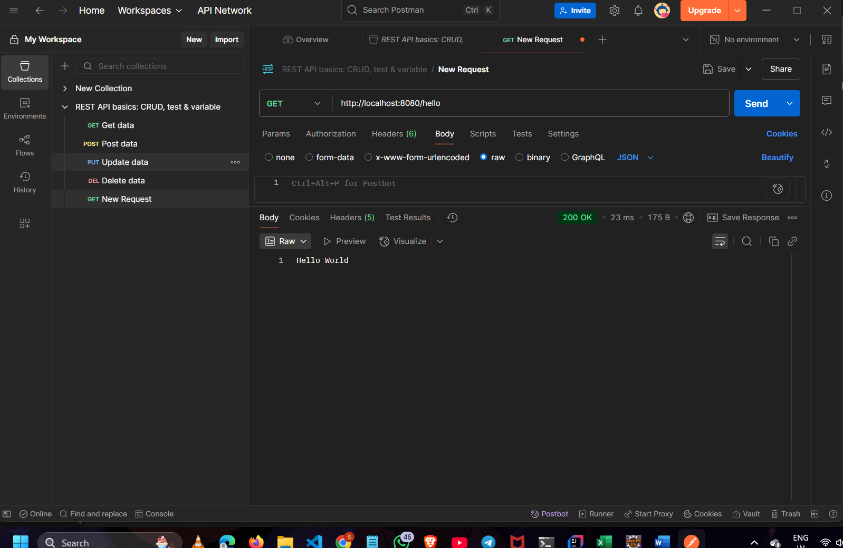

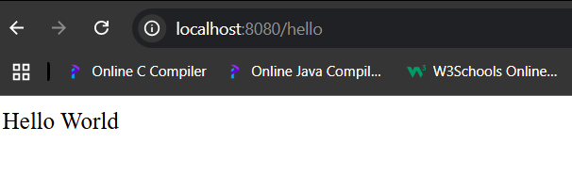

**REST - Country Web Service**

FILE: CountryController.java

package com.cognizant.spring_learn.controller;

import java.util.List;

import org.springframework.beans.factory.annotation.Autowired;

import org.springframework.context.support.ClassPathXmlApplicationContext;

import org.springframework.web.bind.annotation.GetMapping;

import org.springframework.web.bind.annotation.PathVariable;

import org.springframework.web.bind.annotation.RestController;

import com.cognizant.spring_learn.Country;

import com.cognizant.spring_learn.service.CountryService;

*@RestController*

public class CountryController {

*@Autowired*

private CountryService countryService;

*@GetMapping*("/country")

public Country getCountryIndia() {

ClassPathXmlApplicationContext context = new ClassPathXmlApplicationContext("/static/country.xml");

Country india = context.getBean("country", Country.class);

context.close();

return india;

}

OUTPUT:

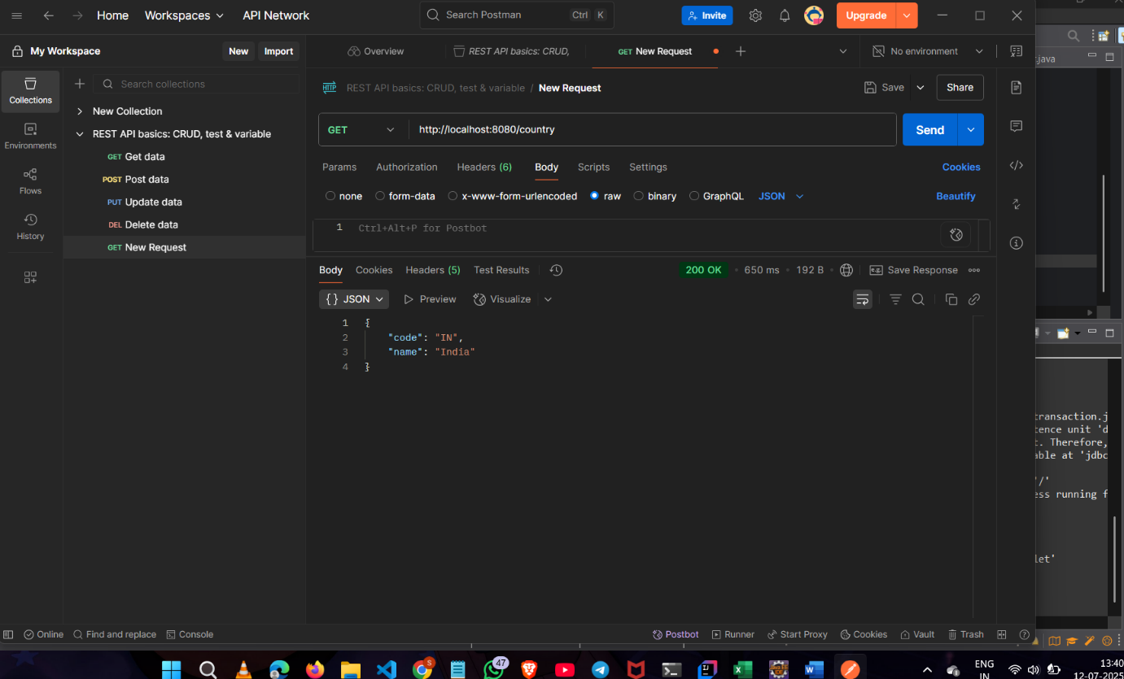

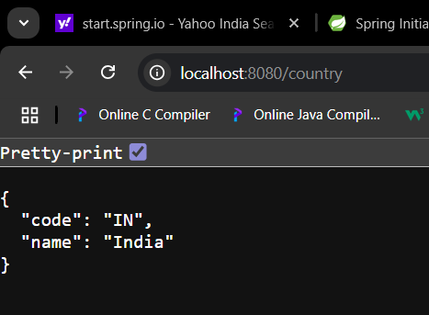

**REST - Get country based on country code**

FILE :country.xml

<?**xml** version=*"1.0"* encoding=*"UTF-8"*?>

<**beans** xmlns=*"http://www.springframework.org/schema/beans"*

xmlns:xsi=*"http://www.w3.org/2001/XMLSchema-instance"*

xsi:schemaLocation=*"*

*http://www.springframework.org/schema/beans*

*http://www.springframework.org/schema/beans/spring-beans.xsd"*>

<**bean** id=*"countryList"* class=*"java.util.ArrayList"*>

<**constructor-arg**>

<**list**>

<**bean** class=*"com.cognizant.spring_learn.Country"*>

<**constructor-arg** value=*"IN"*/>

<**constructor-arg** value=*"India"*/>

</**bean**>

<**bean** class=*"com.cognizant.spring_learn.Country"*>

<**constructor-arg** value=*"US"*/>

<**constructor-arg** value=*"United States"*/>

</**bean**>

<**bean** class=*"com.cognizant.spring_learn.Country"*>

<**constructor-arg** value=*"JP"*/>

<**constructor-arg** value=*"Japan"*/>

</**bean**>

<**bean** class=*"com.cognizant.spring_learn.Country"*>

<**constructor-arg** value=*"DE"*/>

<**constructor-arg** value=*"Germany"*/>

</**bean**>

</**list**>

</**constructor-arg**>

</**bean**>

</**beans**>

FILE:CountryService.java

package com.cognizant.spring_learn.service;

import java.util.List;

import org.springframework.context.support.ClassPathXmlApplicationContext;

import org.springframework.stereotype.Service;

import com.cognizant.spring_learn.Country;

*@Service*

public class CountryService {

public Country getCountry(String code) {

ClassPathXmlApplicationContext context = new ClassPathXmlApplicationContext("/static/country.xml");

List<Country> countries = (List<Country>) context.getBean("countryList");

context.close();

return countries.stream()

.filter(c -> c.getCode().equalsIgnoreCase(code))

.findFirst()

.orElse(null);

}

}

FILE:CountryController.java

package com.cognizant.spring_learn.controller;

import java.util.List;

import org.springframework.beans.factory.annotation.Autowired;

import org.springframework.context.support.ClassPathXmlApplicationContext;

import org.springframework.web.bind.annotation.GetMapping;

import org.springframework.web.bind.annotation.PathVariable;

import org.springframework.web.bind.annotation.RestController;

import com.cognizant.spring_learn.Country;

import com.cognizant.spring_learn.service.CountryService;

*@RestController*

public class CountryController {

*@Autowired*

private CountryService countryService;

*@GetMapping*("/countries")

public List<Country> getAllCountries() {

ClassPathXmlApplicationContext context = new ClassPathXmlApplicationContext("/static/country.xml");

List<Country> countryList = (List<Country>) context.getBean("countryList");

context.close();

return countryList;

}

*@GetMapping*("/countries/{code}")

public Country getCountry(*@PathVariable* String code) {

return countryService.getCountry(code);

}

}

OUTPUT:

