React JS HOL 1

Create a new React Application with the name “myfirstreact”, Run the application to print “welcome to the first session of React” as heading of that page.

File:App.js

*function* App() {

  return (

        <h1 > Welcome to the First Session of React!</h1>

  );

}

export default App;

Output:

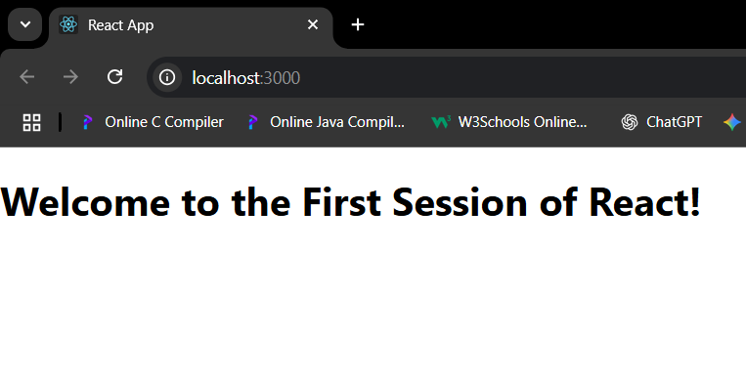

React JS HOL 2

File:App.js

import logo from './logo.svg';

import './App.css';

import Home from './components/Home';

import About from './components/About';

import Contact from './components/Contact';

*function* App() {

  return (

        <div className="container">

          <*Home*/>

          <*About*/>

          <*Contact*/>

        </div>

  );

}

export default App;

File:Home.js

import React , {Component} from 'react';

*class* Home extends Component {

  render(){

    return(

    <div>

        <h3>Welcome to the Home Page of Student Management Portal!</h3>

    </div>

    )

    };};

export default Home;

File:About.js

import React , {Component} from 'react';

*class* About extends Component {

  render(){

    return(

    <div>

        <h3>Welcome to the About Us Page of Student Management Portal!</h3>

    </div>

    )

    };

};

export default About;

File:Contact.js

import React , {Component} from 'react';

*class* Contact extends Component {

  render(){

    return(

    <div>

        <h3>Welcome to the Contact Page of Student Management Portal!</h3>

    </div>

    )

    };

};

export default Contact;

OUTPUT:

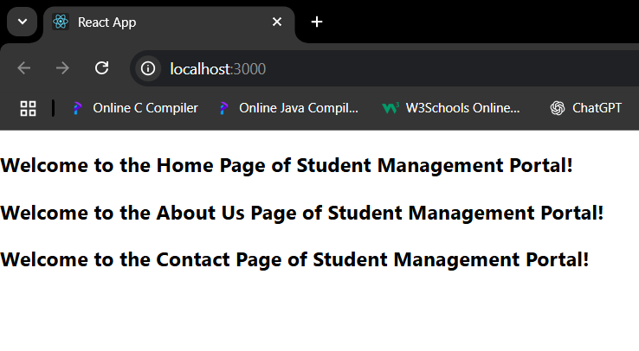

React JS HOL 3

File:App.js

import { CalculateScore } from './components/Calculatescore';

*function* App() {

  return (

        <*CalculateScore* Name="Steeve"

        School ="XYZ Public School"

        total={254}

        goal={3} />

  );

}

export default App;

File:CalculateScore.js

import '../stylesheets/mystyle.css';

*const* percentToDecimal = (*percent*) *=>*{

    return (*percent*.toFixed(2)+'%');

}

*const* calcScore = (*total*,*goal*) *=>* {

    return percentToDecimal(*total* / *goal*);

}

export *const* CalculateScore = ({*Name* ,*School*, *total*, *goal*}) *=>* {

    return(

<div className="format-style">

        <h1><font color="Brown">Student Details:</font></h1>

        <div className="Name">

            <b><span>Name: </span></b>

            <span>{*Name*}</span>

        </div>

        <div className="School">

            <b><span>School: </span></b>

            <span>{*School*}</span>

        </div>

        <div className="Total">

            <b><span>Total: </span></b>

            <span>{*total*}</span>

            <span>Marks: </span>

        </div>

        <div className="Score">

            <b>Score: </b>

            <span>

                {calcScore(*total*, *goal*)}

            </span>

        </div>

    </div>

    )

}

File:mystyle.css

.Name{

*font-weight*:300;

*color*:blue;

}

.School{

*color*:crimson;

}

.Total{

*color*:darkmagenta;

}

.format-style{

*text-align*: center;

*font-size*: large;

}

.Score{

*color*:forestgreen

}

OUTPUT:

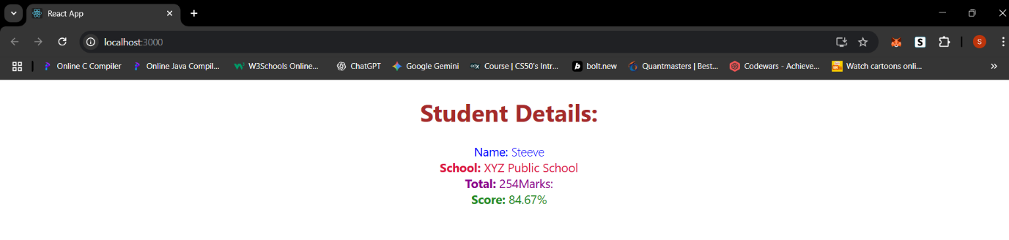

React JS HOL 4

File:App.js

import Posts from './components/Posts';

*function* App() {

  return (

    <div>

        <h1>Welcome to BlogApp</h1>

        <*Posts* />

    </div>

  );

}

export default App;

File:Post.js

*class* Post{

*constructor*(*id* , *title*, *body*){

        this.id = *id*;

        this.title = *title*;

        this.body = *body*;

    }

}

export default Post;

File:Posts.js

import React from 'react';

*class* Posts extends React.Component {

*constructor*(*props*){

        super(*props*);

        this.state = { posts: [], error: null };

    }

    loadPosts(){

        fetch("https://jsonplaceholder.typicode.com/posts")

            .then((*response*) *=>* {

                if(!*response*.ok){

                    throw new *Error*("Network response was not ok");

                }else{

                    return *response*.json();

                }

                })

            .then((*data*) *=>* {

                this.setState({ posts: *data* });

                })

            .catch((*error*) *=>* {

                this.setState({ error });

            });

    }

    componentDidMount(){

        this.loadPosts();

    }

    render(){

*const* { posts } = this.state;

        return(

            <div className="container">

                <h1>Posts</h1>

                <ul>

                    {posts.map((*post*) *=>* (

                        <li key={*post*.id}>

                            <h2>{*post*.title}</h2>

                            <p>{*post*.body}</p>

                        </li>

                    ))}

                </ul>

            </div>

        );

    }

      componentDidCatch(*error*, *info*) {

        console.error("Error occurred while loading posts:", *error*);

    }

}

export default Posts;

OUTPUT:

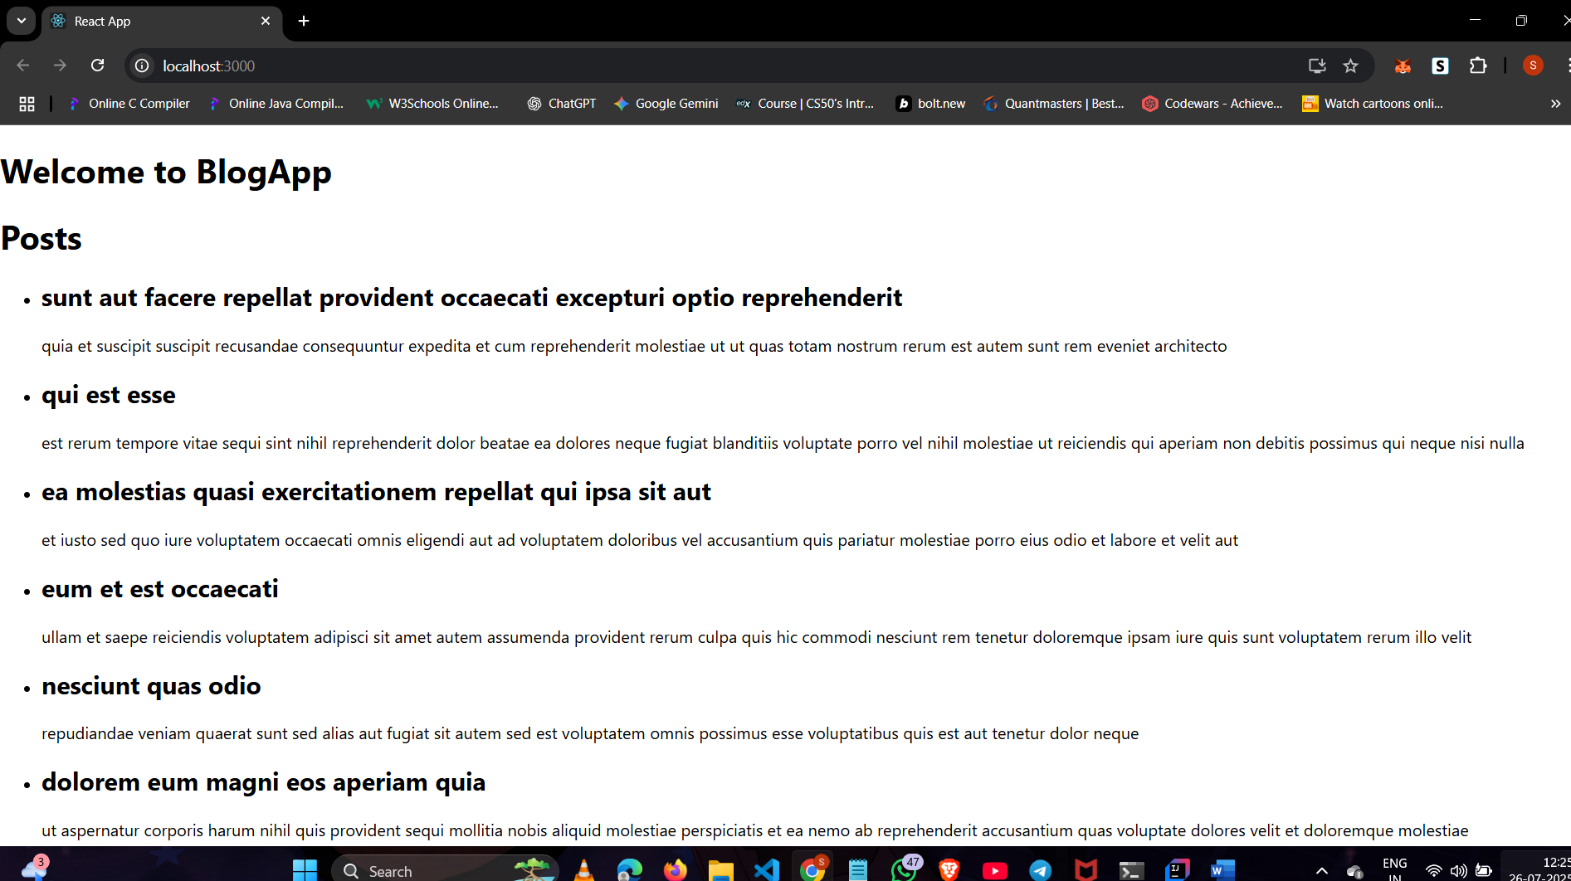

React JS HOL 5

File:App.js

import './App.css';

import { CohortsData} from './Cohort'

import CohortDetails from './CohortDetails';

*function* App() {

  return (

  <div >

    <h1>Cohorts Details</h1>

    {CohortsData.map(*cohort* *=>* <*CohortDetails* cohort={*cohort*}/>)}

  </div>

  );

}

export default App;

File:CohortDetails.js

import styles from  "./stylesheets/CohortDetails.module.css";

*function* CohortDetails(*props*) {

    return (

        <div className={styles.box}>

            <h3 style ={{color:*props*.cohort.currentStatus==='Ongoing' ?"green":"blue"}}>

                {*props*.cohort.cohortCode} -

                <span>{*props*.cohort.technology}</span>

            </h3>

            <dl>

                <dt>Started On</dt>

                <dd>{*props*.cohort.startDate}</dd>

                <dt>Current Status</dt>

                <dd>{*props*.cohort.currentStatus}</dd>

                <dt>Coach</dt>

                <dd>{*props*.cohort.coachName}</dd>

                <dt>Trainer</dt>

                <dd>{*props*.cohort.trainerName}</dd>

            </dl>

        </div>

    );

}

export default CohortDetails;

File:Cohort.js

*class* Cohort {

*constructor*(*cohortCode*,

*startDate*,

*technology*,

*trainerName*,

*coachName*,

*currentStatus*) {

        this.cohortCode = *cohortCode*;

        this.coachName = *coachName*;

        this.trainerName = *trainerName*;

        this.technology = *technology*;

        this.startDate = *startDate*;

        this.currentStatus = *currentStatus*;

    }

}

*const* CohortsData =[

    new Cohort('INTADMDF10','22-Feb-2022', '.NET FSD', 'Jojo Jose','Aathma', 'Scheduled'),

    new Cohort('ADM21JF014','10-Sep-2021', 'Java FSD', 'Elisa Smith','Apoorv', 'Ongoing'),

    new Cohort('CDBJF21025','24-Dec-2021', 'Java FSD', 'John Doe','Aathma', 'Ongoing'),

    new Cohort('INTADMJF12','22-Feb-2022', 'Java FSD', 'To Be Assigned','Ibrahim', 'Scheduled'),

    new Cohort('CDE22JF011','24-Dec-2021', 'Java FSD', 'Emma Swan','Apoorv', 'Ongoing'),

    new Cohort('INTADMDF09','22-Feb-2022', 'Dataware Housing', 'Babjee Rao','Aathma', 'Scheduled'),

    new Cohort('ADM22DF001','10-Sep-2021', '.NET FSD', 'Marie Curie','Ibrahim', 'Ongoing'),

];

export {Cohort, CohortsData};

File:CohortDetails.module.css

.box{

    /\* Width = 300px;

Display = inline block;

Overall 10px margin

Top and bottom padding as 10px

Left and right padding as 20px

1 px border in black color

A border radius of 10px \*/

*width*:300px;

*display*:inline-block;

*margin*:10px;

*padding-top*: 10px;

*padding-bottom*: 10px;

*padding-left*: 20px;

*padding-right*: 20px;

*border*: 1px solid black;

*border-radius*: 10px;

}

dt{

*font-weight*: 500;

}

OUTPUT:

