9 React JS HOL

File:App.js

import ListofPlayers from './components/ListOfPlayers';

import IndianPlayers from './components/IndianPlayers';

*function* App() {

*const* flag = false;

  return (

    <div>

         {flag ? <*ListofPlayers* /> : <*IndianPlayers* />}

    </div>

  );

}

export default App;

File:ListOfPLayers.js

import React from 'react';

*const* ListofPlayers = () *=>* {

*const* players = [

    { name: 'Virat Kohli', score: 85 },

    { name: 'Rohit Sharma', score: 214 },

    { name: 'MS Dhoni', score: 65 },

    { name: 'KL Rahul', score: 70 },

    { name: 'ABD', score: 149},

    { name: 'Hardik Pandya', score: 90 },

    { name: 'Ravindra Jadeja', score: 75 },

    { name: 'Chris Gayle ', score: 175 },

    { name: 'Sachin', score: 99 },

    { name: 'Gambhir', score: 95 },

    { name: 'Rayudu', score: 9 }

  ];

  return (

    <div>

      <h2 style={{margin:'20px'}}>List Of Players:</h2>

      <ul>

        {players.map((*player*, *index*) *=>* (

          <li key={*index*}> Mr. {*player*.name} - {*player*.score}</li>

        ))}

      </ul>

      <h2 style={{margin:'20px'}}>Players with Score below 70:</h2>

      <ul>

        {players.map((*player*, *index*) *=>*

*player*.score < 70 ? <li key={*index*}> Mr. {*player*.name} - {*player*.score}</li> : null

        )}

      </ul>

    </div>

  );

};

export default ListofPlayers;

File:IndianPlayers.js

import React from 'react';

import OddPlayers from './OddPlayers';

import EvenPlayers from './EvenPlayers';

*const* IndianPlayers = () *=>* {

*const* T20Players = ['First Player', 'Second Player', 'Third Player'];

*const* RanjiTrophyPlayers = ['Fourth Player', 'Fifth Player', 'Sixth Player'];

*const* allPlayers = [...T20Players, ...RanjiTrophyPlayers];

  return (

    <div>

      <h2 style={{margin:'20px'}}>Odd Team Players:</h2>

      <*OddPlayers* first="Sachin1" third="Virat3" fifth="Yuvaraj4" />

      <h2 style={{margin:'20px'}}>Even Team Players:</h2>

      <*EvenPlayers* second="Dhoni2" fourth="Rohit4" sixth="Raina6" />

      <h2 style={{margin:'20px'}}>List Of Indian Players Merged:</h2>

      <ul>

        {allPlayers.map((*player*, *index*) *=>*

          <li key={*index*}>Mr. {*player*}</li>

        )}

      </ul>

    </div>

  );

};

export default IndianPlayers;

File:OddPlayers.js

*function* OddPlayers({*first*, *third*, *fifth*}) {

    return (

      <ul>

        <li>First: {*first*}</li>

        <li>Third: {*third*}</li>

        <li>Fifth: {*fifth*}</li>

      </ul>

    );

  }

  export default OddPlayers;

File:EvenPlayers.js

*function* EvenPlayers({*second*, *fourth*, *sixth*}) {

    return (

      <ul>

        <li>Second: {*second*}</li>

        <li>Fourth: {*fourth*}</li>

        <li>Sixth: {*sixth*}</li>

      </ul>

    );

  }

  export default EvenPlayers;

OUTPUT:

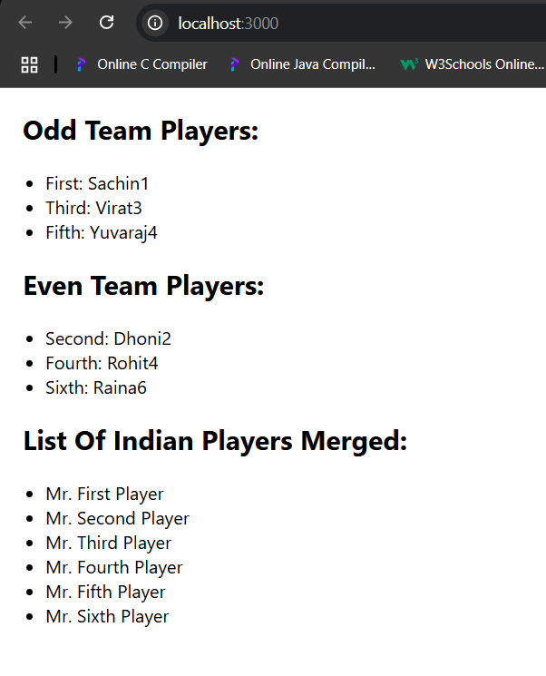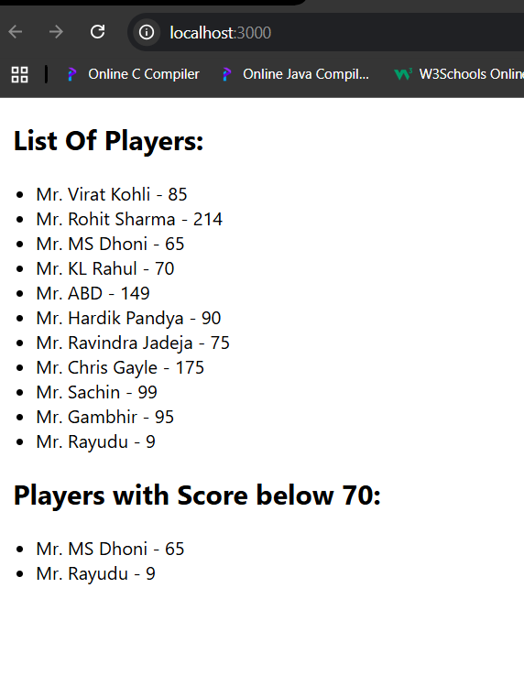

10 REACT JS HOL

File:App.js

*function* App() {

*const* element = "Office Space";

*const* ItemName ={Name:"Office Space", Price: 100000, Location: "Bengaluru"};

  return (

    <div className="d-flex justify-content-center align-items-center vh-100">

      <div className="container w-50 text-center border p-4 rounded shadow">

         <h1 >{element}, At Affordable Range</h1>

         <img className ='image-fluid my-2 w-30' src="p1.jpeg" alt="Office Space" />

          <h2 >Item Name: {ItemName.Name}</h2>

          <h2 style={{ color: ItemName.Price <= 60000 ? 'red' : 'green' }}>Price: Rs.{ItemName.Price}</h2>

          <h2 >Location: {ItemName.Location}</h2>

          </div>

    </div>

  );

}

export default App;

OUTPUT:

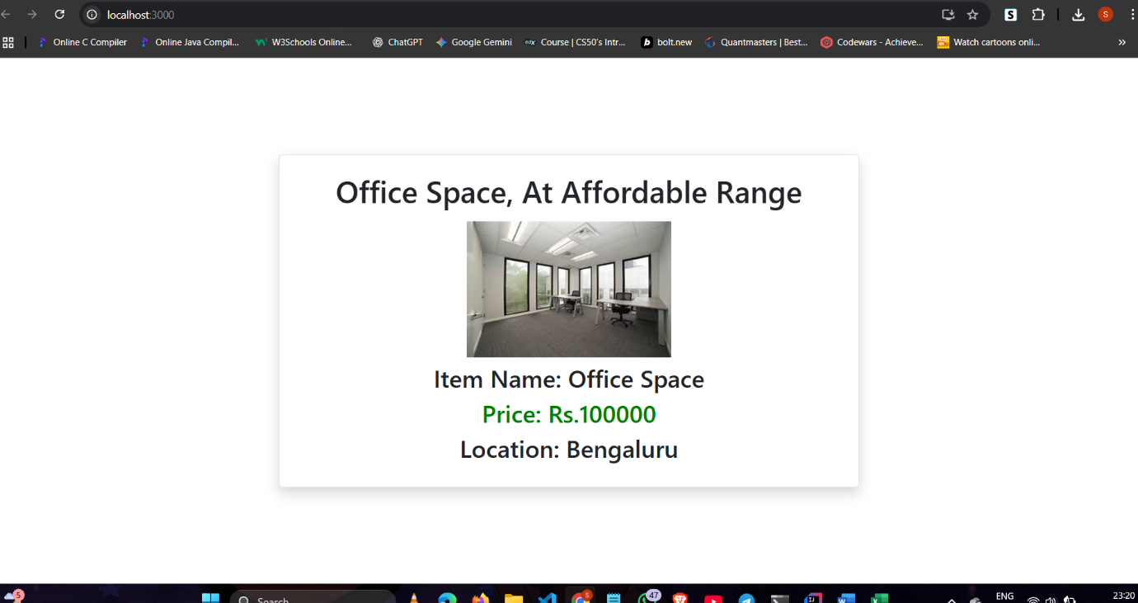

11 REACT JS HOL

File:App.js

import 'bootstrap/dist/css/bootstrap.min.css';

import React, { useState } from "react";

import CurrencyConvertor from './components/CurrencyConverter.js';

*function* App() {

*const* [count, setCount] = useState(0);

*const* increment = () *=>* {

    setCount(count + 1);

  };

*const* sayHello = () *=>* {

    alert("Hello! Welcome to Event Examples App");

  };

*const* handleIncrement = () *=>* {

    increment();

    sayHello();

  };

*const* sayWelcome = (*message*) *=>* {

    alert(*message*);

  };

*const* handlePress = (*e*) *=>* {

*e*.preventDefault();

    alert("I was clicked!");

  };

  return (

    <div className="container mt-5">

      {count}

      <button className="btn btn-success m-3" onClick={handleIncrement}>

        Increment

      </button>

      <button className="btn btn-danger m-3" onClick={() *=>* setCount(count - 1)}>

        Decrement

      </button>

        <button className="btn btn-primary m-3" onClick={() *=>* sayWelcome("Welcome to React Events!")}>

          Say Welcome

        </button>

        <button className="btn btn-warning m-3" onClick={handlePress}>

          OnPress (Synthetic Event)

        </button>

      <div className="mt-5">

        <*CurrencyConvertor* />

      </div>

    </div>

  );

}

export default App;

File:CurrencyConverter.js

import React, { useState } from "react";

*function* CurrencyConvertor() {

*const* [rupees, setRupees] = useState("");

*const* [euro, setEuro] = useState("");

*const*[currency,setCurrency] = useState("Euro");

*const* handleSubmit = (*e*) *=>* {

*e*.preventDefault();

*const* conversionRate = 90;

*const* convertedValue = (rupees / conversionRate).toFixed(2);

    setEuro(convertedValue);

  };

  return (

    <div className="border p-4 rounded shadow text-left w-50">

      <h3 >Currency Converter (INR--EUR)</h3>

      <form onSubmit={handleSubmit} >

       <div className="form-group d-flex align-items-center mb-4 mt-4">

        <label className="me-3 ">Amount:  </label>

          <input

          type="number"

          value={rupees}

          onChange={(*e*) *=>* setRupees(*e*.target.value)}

          placeholder="Enter amount in INR"

          className="form-control"

          required

          style={{ width: '200px' }} // control width

            />

      </div>

      <div className="form-group d-flex align-items-center mb-3 mt-3">

        <label className="me-2">Currency:</label>

        <input

          type="text"

          value={currency}

          onChange={(*e*) *=>* setCurrency(*e*.target.value)}

          placeholder="ENter currency (e.g., INR)"

          className="form-control "

          style={{ width: '200px' }}

        />

        </div>

        <button type="submit" className="btn btn-info " style={{marginLeft:'125px'}}>Submit</button>

      </form>

      {euro && (

        <h4 className="mt-3">

          € {euro} (from ₹ {rupees})

        </h4>

      )}

    </div>

  );

}

export default CurrencyConvertor;

OUTPUT:

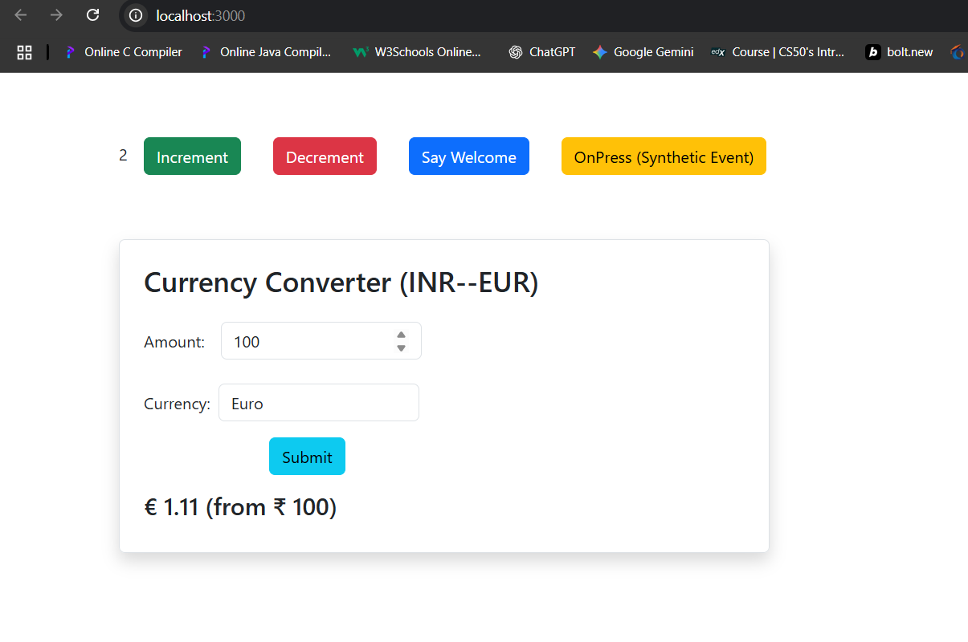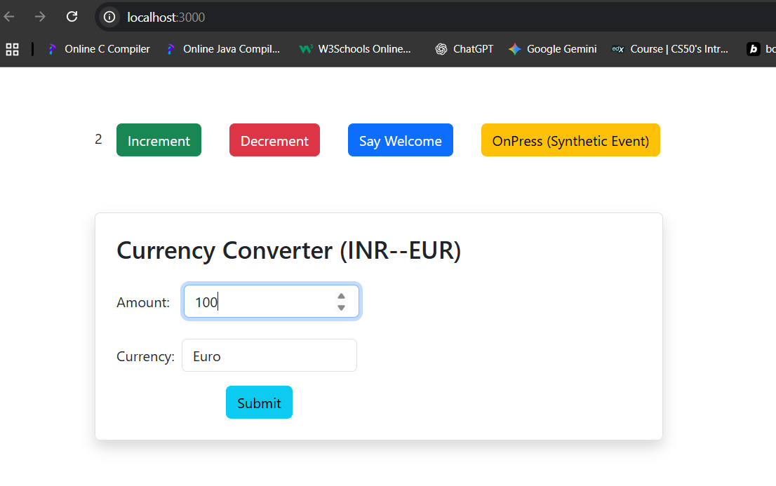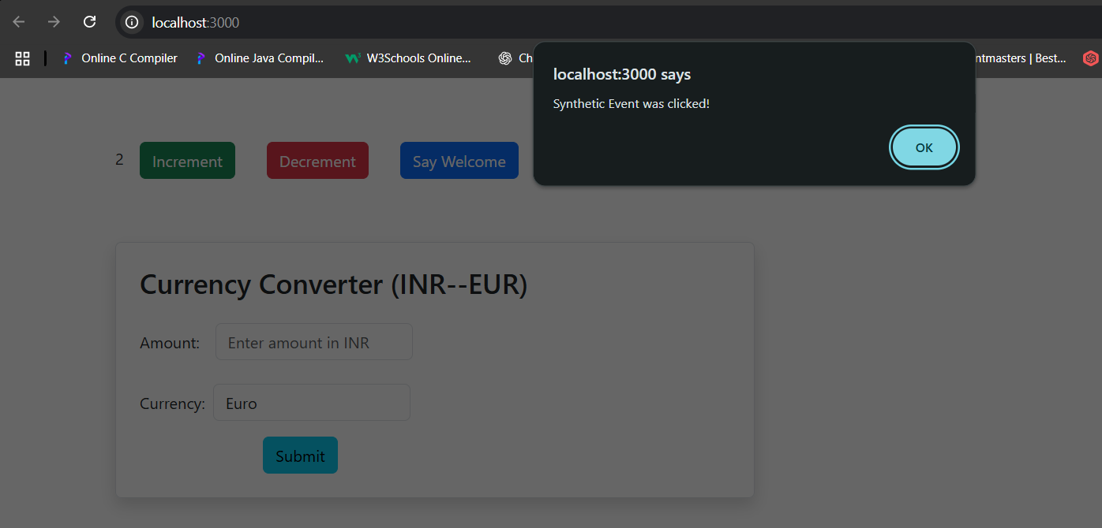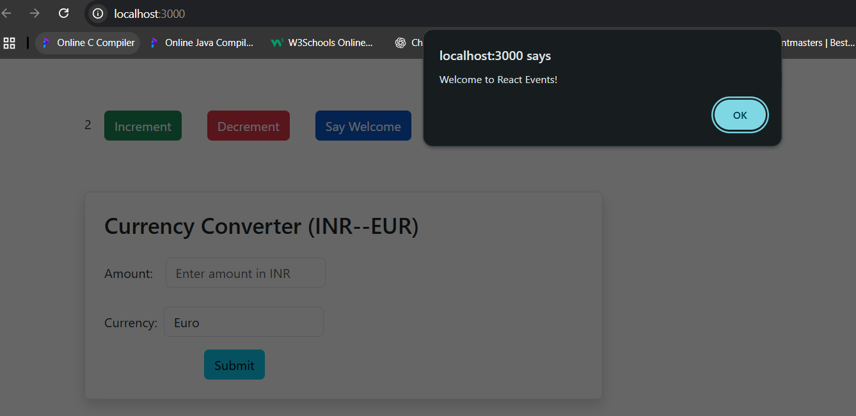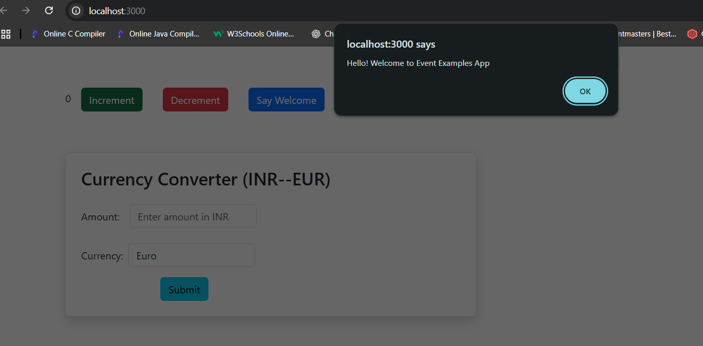

12 REACT JS HOL

FILE:App.js

import LoginButton from './components/LoginButton';

import LogoutButton from './components/LogoutButton';

import UserPage from './components/UserPage';

import GuestPage from './components/GuestPage';

import 'bootstrap/dist/css/bootstrap.min.css';

import React, { useState } from "react";

*function* App() {

*const* [isLoggedIn, setIsLoggedIn] = useState(false);

*const* handleLogin = () *=>* setIsLoggedIn(true);

*const* handleLogout = () *=>* setIsLoggedIn(false);

  return (

    <div style={{ textAlign: 'center', marginTop: '30px' }}>

      <h1>Ticket Booking App</h1>

      {isLoggedIn ? (

        <>

          <*UserPage* />

          <*LogoutButton* onLogout={handleLogout} />

        </>

      ) : (

        <>

          <*GuestPage* />

           <*LoginButton* onLogin={handleLogin} />

        </>

      )}

    </div>

  )

};

export default App;

File:GuestPage.js

import React from 'react';

*function* GuestPage() {

*const* flights = [

    { id: 1, flight: 'Air India AI101', route: 'Delhi → Mumbai', time: '08:00 AM' },

    { id: 2, flight: 'IndiGo 6E303', route: 'Bangalore → Hyderabad', time: '10:30 AM' },

    { id: 3, flight: 'SpiceJet SJ202', route: 'Chennai → Pune', time: '01:00 PM' }

  ];

  return (

    <div className='container d-flex flex-column align-items-center justify-content-center border p-3 shadow w-50 my-4'>

      <h2>Guest Page</h2>

      <h3>Browse Available Flights</h3>

      <ul className='list-group'>

        {flights.map((*f*) *=>* (

          <li key={*f*.id}>

            {*f*.flight} | {*f*.route} | {*f*.time}

          </li>

        ))}

      </ul>

      <p><i>Login to book tickets!</i></p>

    </div>

  );

}

export default GuestPage;

File:UserPage.js

import React, { useState } from 'react';

*function* UserPage() {

*const* [message, setMessage] = useState('');

*const* flights = [

    { id: 1, flight: 'Air India AI101', route: 'Delhi → Mumbai', time: '08:00 AM' },

    { id: 2, flight: 'IndiGo 6E303', route: 'Bangalore → Hyderabad', time: '10:30 AM' },

    { id: 3, flight: 'SpiceJet SJ202', route: 'Chennai → Pune', time: '01:00 PM' }

  ];

*const* bookTicket = (*flight*) *=>* {

    setMessage(`Ticket booked successfully for ${*flight*.flight}!`);

  };

  return (

    <div className='container d-flex flex-column align-items-center justify-content-center border p-3 shadow w-50 my-4'>

      <h2>User Page (Book Tickets)</h2>

      <ul className='list-group m-2'>

        {flights.map((*f*) *=>* (

          <li key={*f*.id}>

             {*f*.flight} | {*f*.route} | {*f*.time}

            <button className='btn btn-danger p-1 ms-3 mt-2 btn-sm' onClick={() *=>* bookTicket(*f*)}>

              Book Ticket

            </button>

          </li>

        ))}

      </ul>

      {message && <p style={{ color: 'green' }}>{message}</p>}

    </div>

  );

}

export default UserPage;

File:LogoutButton.js

import React from 'react';

*function* LogoutButton({ *onLogout* }) {

  return <button onClick={*onLogout*} className='btn btn-primary'> Logout</button>;

}

export default LogoutButton;

File:LoginButton.js

import React from 'react';

*function* LoginButton ( {*onLogin*} ) {

  return <button onClick={*onLogin*} className='btn btn-primary'> Login</button>;

}

export default LoginButton;

OUTPUT: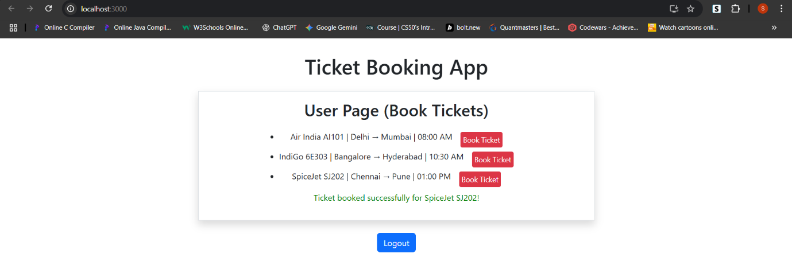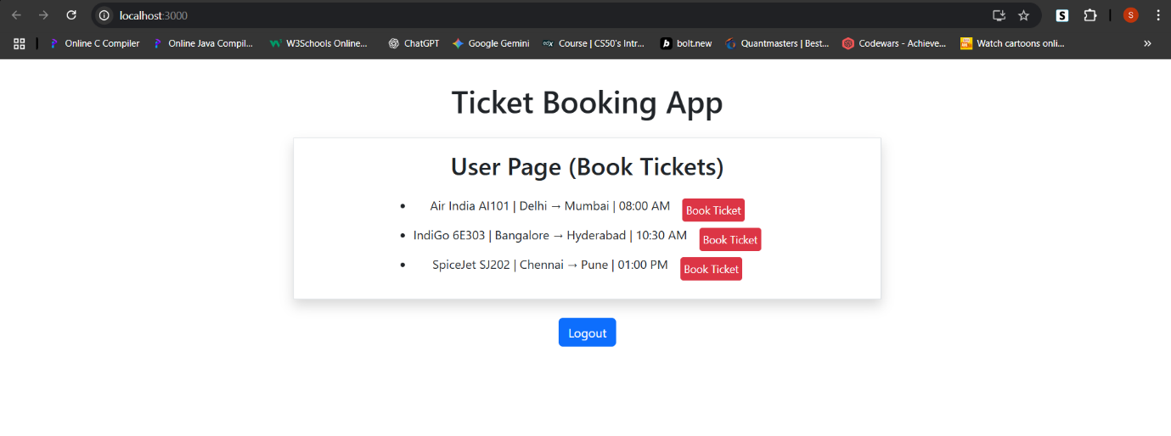

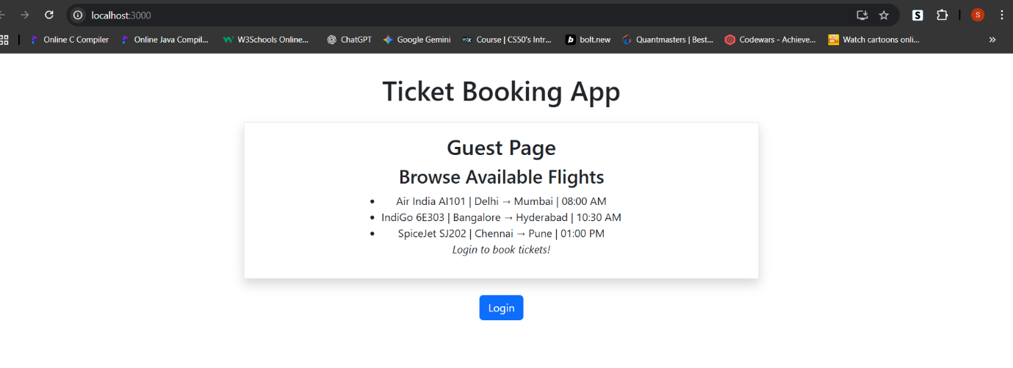

13 REACT JS HOL

File:CourseDetails.js

import React from 'react';

*function* CourseDetails() {

  return <h2>Course Details: "React Complete Guide" on Udemy</h2>;

}

export default CourseDetails;

File:BlogDetails.js

import React from 'react';

*function* BlogDetails() {

  return <h2> Blog Details: "Mastering React Conditional Rendering"</h2>;

}

export default BlogDetails;

File:BookDetails.js

import React from 'react';

function BookDetails() {

return <h2>Book Details: "Learning React" by Alex Banks</h2>;

}

export default BookDetails;

File:App.js(If -else Rendering)

import BookDetails from './components/BookDetails';

import BlogDetails from './components/BlogDetails';

import CourseDetails from './components/CourseDetails';

import 'bootstrap/dist/css/bootstrap.min.css';

import React, { useState } from "react";

*function* App() {

*const* [page, setPage] = useState("course");

  return (

    <div className='d-flex flex-column align-items-center m-3 border shadow-lg rounded p-3'>

      <h1> Blogger App</h1>

      <div className="mb-3">

        <button className="btn btn-primary mx-2 my-2" onClick={() *=>* setPage("course")}>Course</button>

        <button className="btn btn-success mx-2 my-2" onClick={() *=>* setPage("book")}>Book</button>

        <button className="btn btn-warning mx-2 my-2" onClick={() *=>* setPage("blog")}>Blog</button>

      </div>

      <div className="container mt-4">

        <div className="row text-center">

          <div className=" mb-3 align-items-center">

            {(() *=>* {

              if (page === "course") return <*CourseDetails* />;

              else if (page === "book") return <*BookDetails* />;

              else return <*BlogDetails* />;

            })()}

          </div>

        </div>

      </div>

    </div>

  );

}

export default App;

File:App.js(Ternary Operator)

import BookDetails from './components/BookDetails';

import BlogDetails from './components/BlogDetails';

import CourseDetails from './components/CourseDetails';

import 'bootstrap/dist/css/bootstrap.min.css';

import React, { useState } from "react";

*function* App() {

*const* [page, setPage] = useState("course");

  return (

    <div className='d-flex flex-column align-items-center m-3 border shadow-lg rounded p-3'>

      <h1> Blogger App</h1>

      <div className="mb-3">

        <button className="btn btn-primary mx-2 my-2" onClick={() *=>* setPage("course")}>Course</button>

        <button className="btn btn-success mx-2 my-2" onClick={() *=>* setPage("book")}>Book</button>

        <button className="btn btn-warning mx-2 my-2" onClick={() *=>* setPage("blog")}>Blog</button>

      </div>

       <div className="container mt-4">

        <div className="row text-center">

          <div className="align-items-center">

            {page === "course"

              ? <*CourseDetails* />

              : page === "book"

                ? <*BookDetails* />

                : <*BlogDetails* />}

          </div>

        </div>

      </div>

    </div>

  );

}

export default App;

File:App.js(Logical && Rendering)

import BookDetails from './components/BookDetails';

import BlogDetails from './components/BlogDetails';

import CourseDetails from './components/CourseDetails';

import 'bootstrap/dist/css/bootstrap.min.css';

import React, { useState } from "react";

*function* App() {

*const* [page, setPage] = useState("course");

  return (

    <div className='d-flex flex-column align-items-center m-3 border shadow-lg rounded p-3'>

      <h1> Blogger App</h1>

      <div className="mb-3">

        <button className="btn btn-primary mx-2 my-2" onClick={() *=>* setPage("course")}>Course</button>

        <button className="btn btn-success mx-2 my-2" onClick={() *=>* setPage("book")}>Book</button>

        <button className="btn btn-warning mx-2 my-2" onClick={() *=>* setPage("blog")}>Blog</button>

      </div>

       <div className="container mt-4">

        <div className="row text-center">

          <div className="align-items-center">

            {page === "course" && <*CourseDetails* />}

            {page === "book" && <*BookDetails* />}

            {page === "blog" && <*BlogDetails* />}

          </div>

        </div>

      </div>

    </div>

  );

}

export default App;

OUTPUT:

