**1. Creating and Renaming Files/Directories**

**i.** Create a directory named test_dir using mkdir.

**ii.** Inside test_dir, create an empty file called example.txt.

**iii.** Rename example.txt to renamed_example.txt using mv

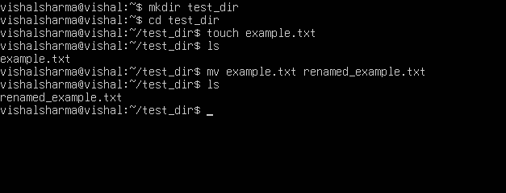

**Explanation:**

* mkdir test_dir: Creates a new directory named test_dir.
* touch test_dir/example.txt: Creates an empty file named example.txt inside test_dir.
* mv example.txt renamed_example.txt: Renames the file.

**2. Viewing File Contents**

**i.** Use cat to display the contents of /etc/passwd.

**ii.** Display only the first 5 lines of /etc/passwd using head.

**iii.** Display only the last 5 lines of /etc/passwd using tail.

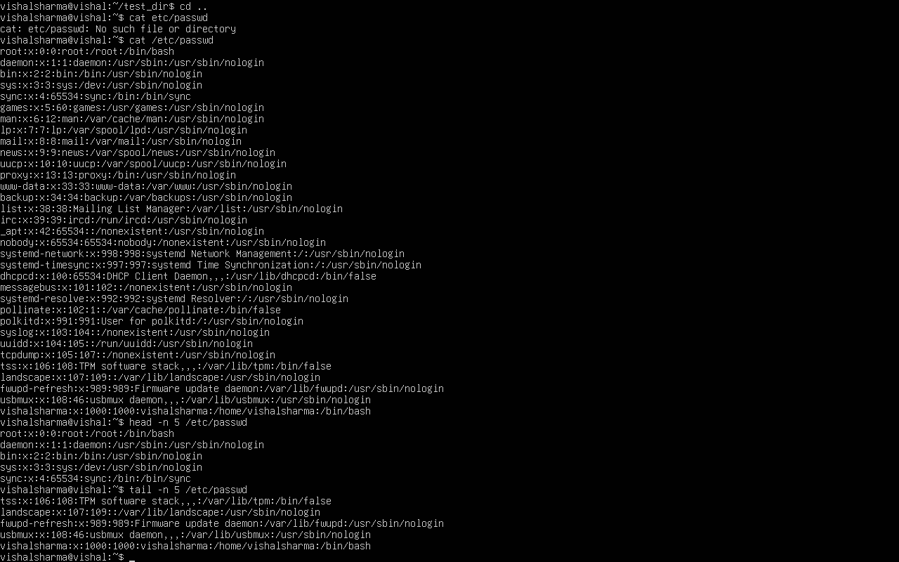

**Explanation:**

* cat: Displays the full content of the file.
* head -n 5: Shows the first 5 lines.
* tail -n 5: Shows the last 5 lines.

**3.Searching for Patterns**

Use grep to find all lines containing the word "root" in /etc/passwd.

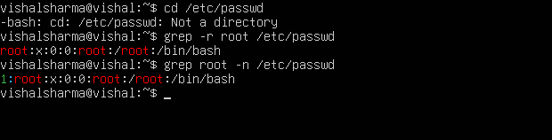

**Explanation:**

* Searches and prints lines containing the word "root" from /etc/passwd.

**4. Zipping and Unzipping**

**i.** Compress the test_dir directory into a file named test_dir.zip using zip.

**ii.** Unzip test_dir.zip into a new directory named unzipped_dir.

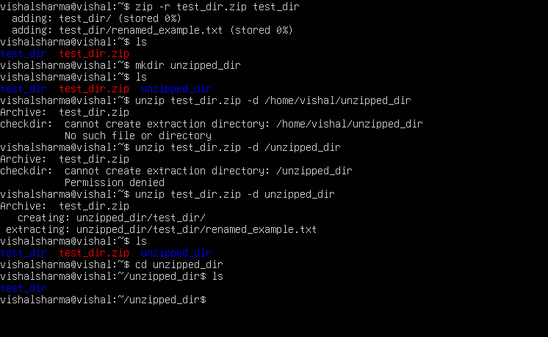

**Explanation:**

* zip -r: Compresses the directory into a zip file.
* mkdir: Creates a new folder.
* unzip -d: Extracts the zip file to a specified directory.

**5. Downloading Files**

Use wget to download a file from a URL (e.g., <https://example.com/sample.txt>).

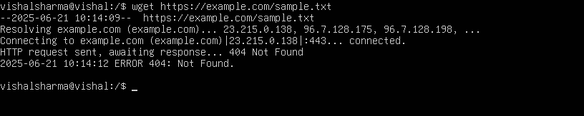

**Explanation:**

* wget: Downloads files from the web using the specified URL.

**6. Changing Permissions**

Create a file named secure.txt and change its permissions to read-only for everyone using chmod.

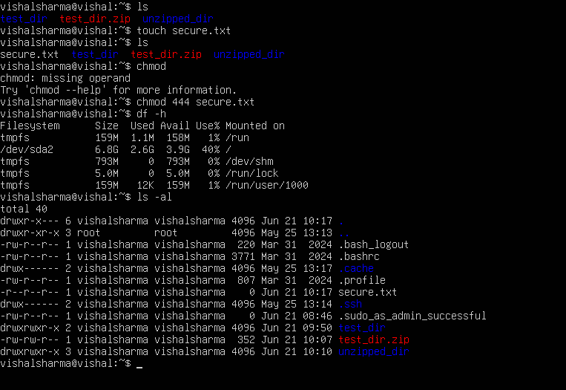

**Explanation:**

* chmod 444: Makes the file readable by everyone but not writable or executable.

**7. Working with Environment Variables**

Use export to set a new environment variable called MY_VAR with the value "Hello, Linux!".

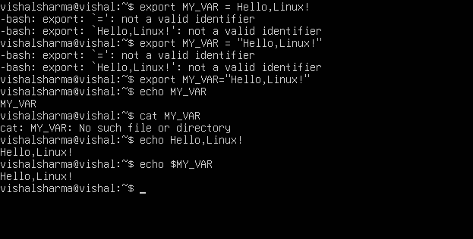

**Explanation:**

* export: Creates a temporary environment variable in the current terminal session.

**Submission Guidelines -:** Attach Screenshots or command along with explanation and submit in doc(google doc or microsoft doc) format also attach github repo link