**1. Grade Checker**

Take a score as input and print the grade based on the following:  
90+ : "A"  
80-89 : "B"  
70-79 : "C"  
60-69 : "D"  
Below 60 : "F"  
here we used a basic if else statement to carry out marks and all.

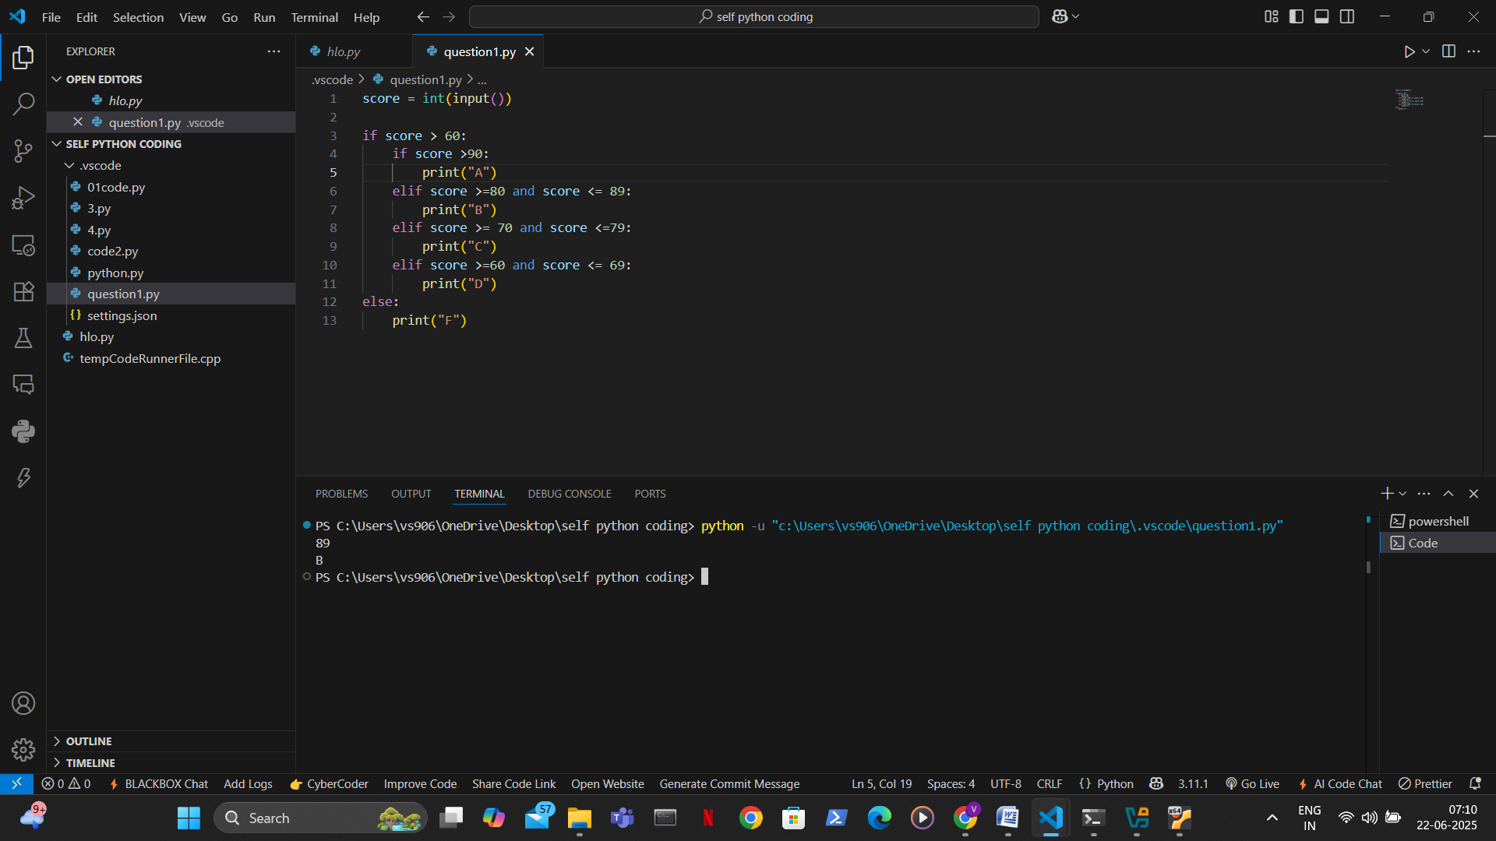

* In this first i sort the condition according to the question if score is less than 60 then it goes in else condition and print “ F ” grade .
* If the score is more than 60 then it goes in the “ if ” condition and in this there are more sub conditions according to the questions and print grade according to the criteria.

**2. Student Grades**

Create a dictionary where the keys are student names and the values are their grades. Allow the user to:

* Add a new student and grade.
* Update an existing student’s grade.
* Print all student grades.

Used dictionary and basic operations. Using if else:

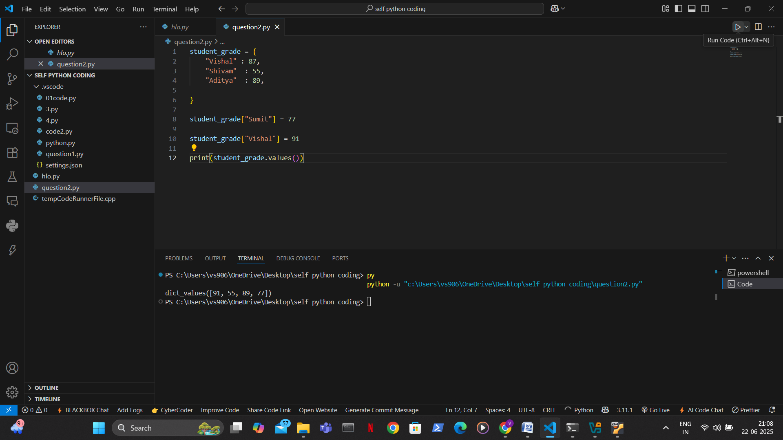

* In this first i created a Student_grade dictionary and then I add a student name and its grade if student name is not in the key then it added in the dictionary if it’s in the key that we did in the next like to upgrade the score for existing student name.

**3.Write to a File**

Write a program to create a text file and write some content to it.  
Using file functions like write and open.

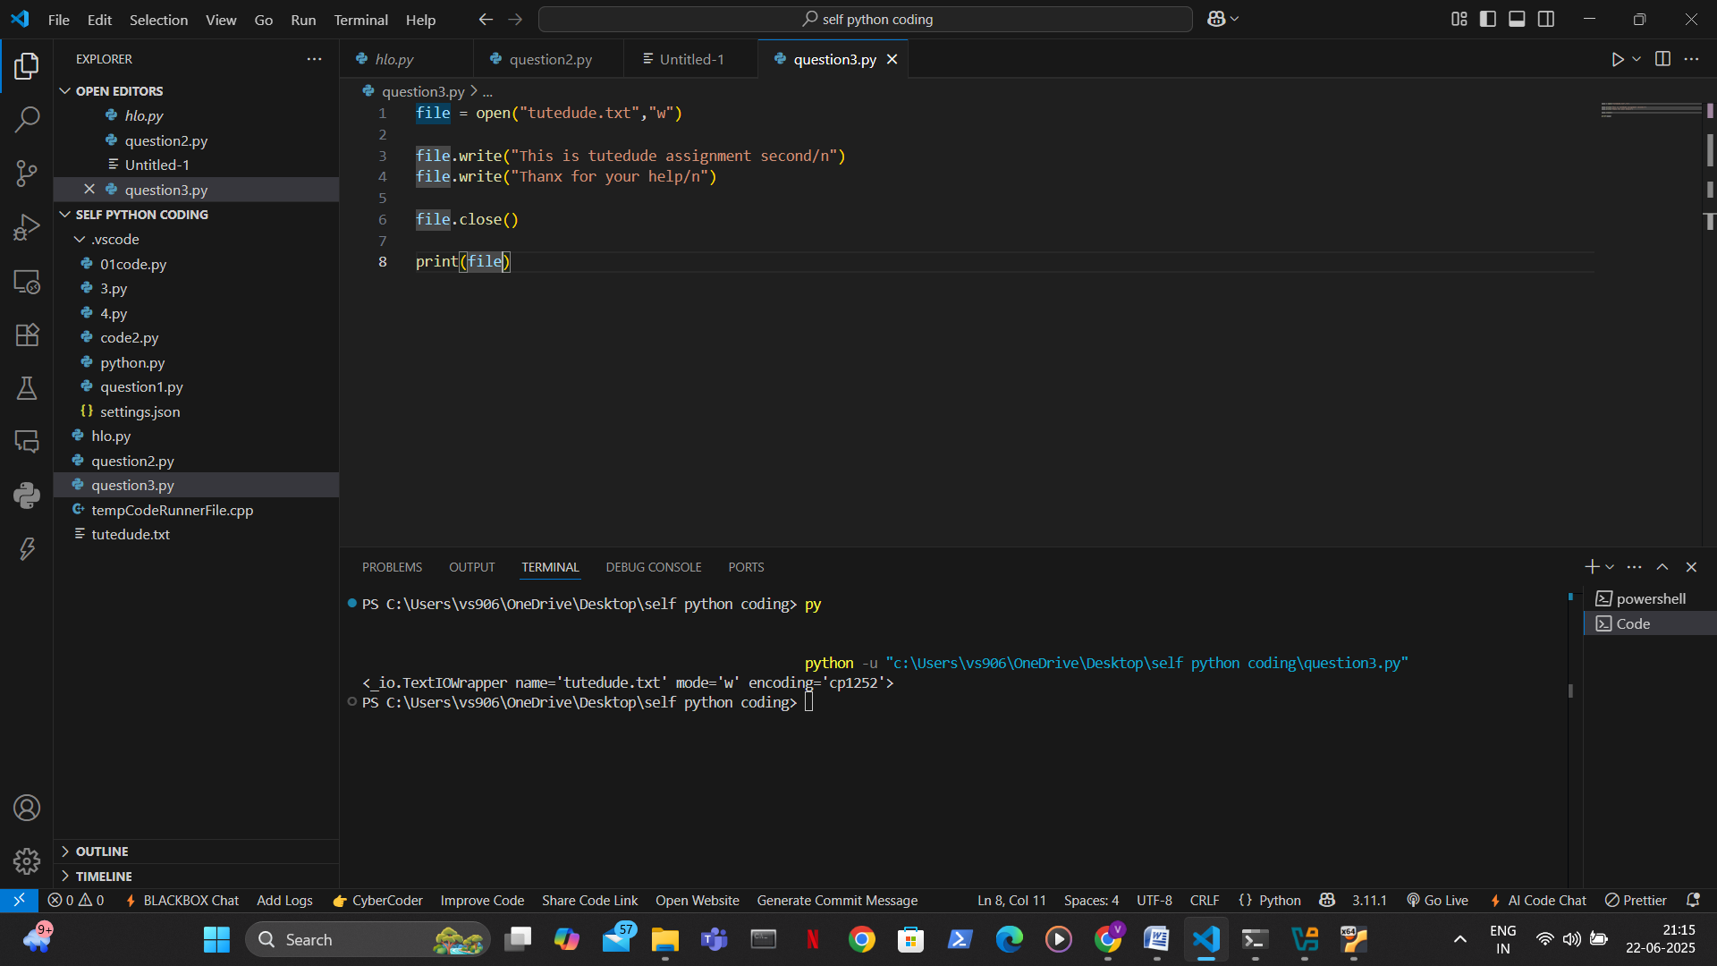

* In this question we first use open keyword to open a file if not exist it create a file then I use a write function to write something in a file and then close this .

**4. Read from a File**We used open in read mode and file.read to read and print to display.

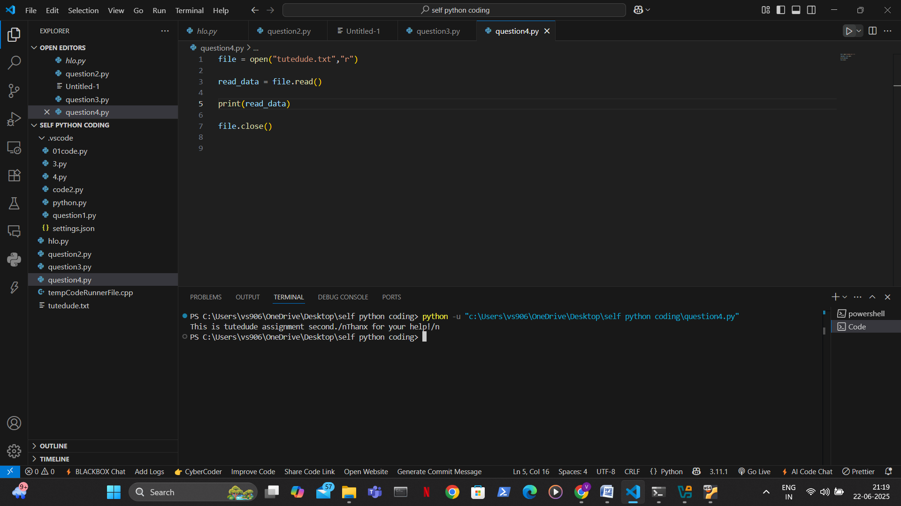

* In this question it the same as last one just we use read keyword to read our file and then I store in a variable to easily print the file.

**Submission Guidelines -:** Attach Screenshots or command along with explanation and submit in doc(google doc or microsoft doc) format or share github link