PL3 - LA2 PORTFOLIO WEBSITE

**T1 - 2019BTECS00024 - KSHITIJ AMIT SABALE**

**SS :-**

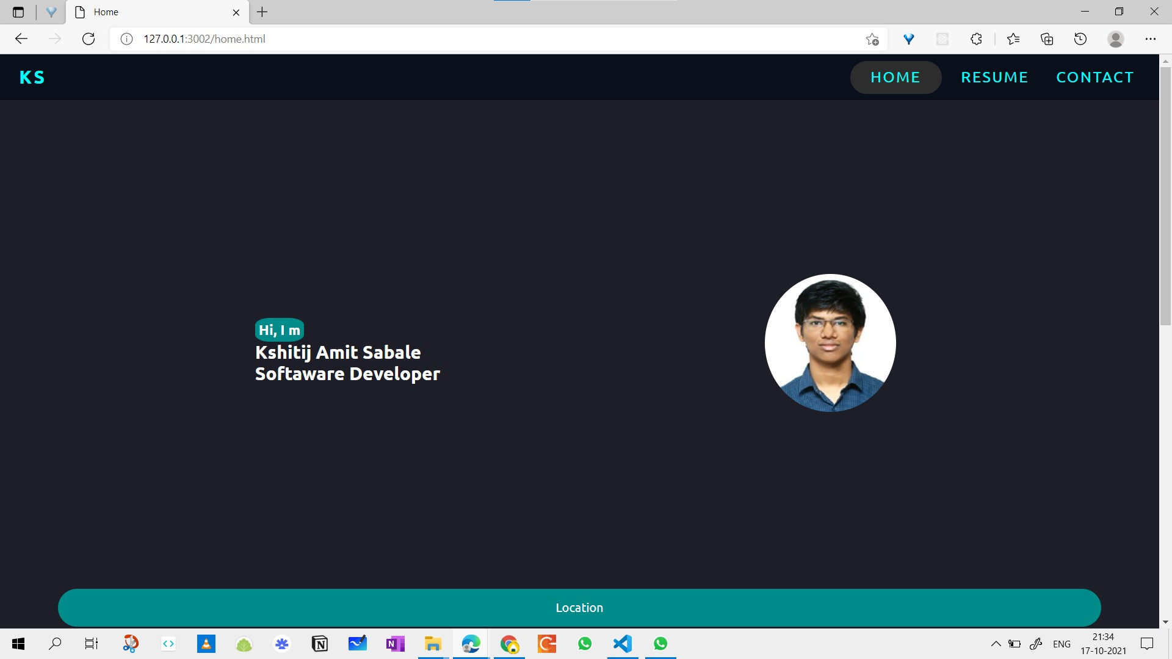

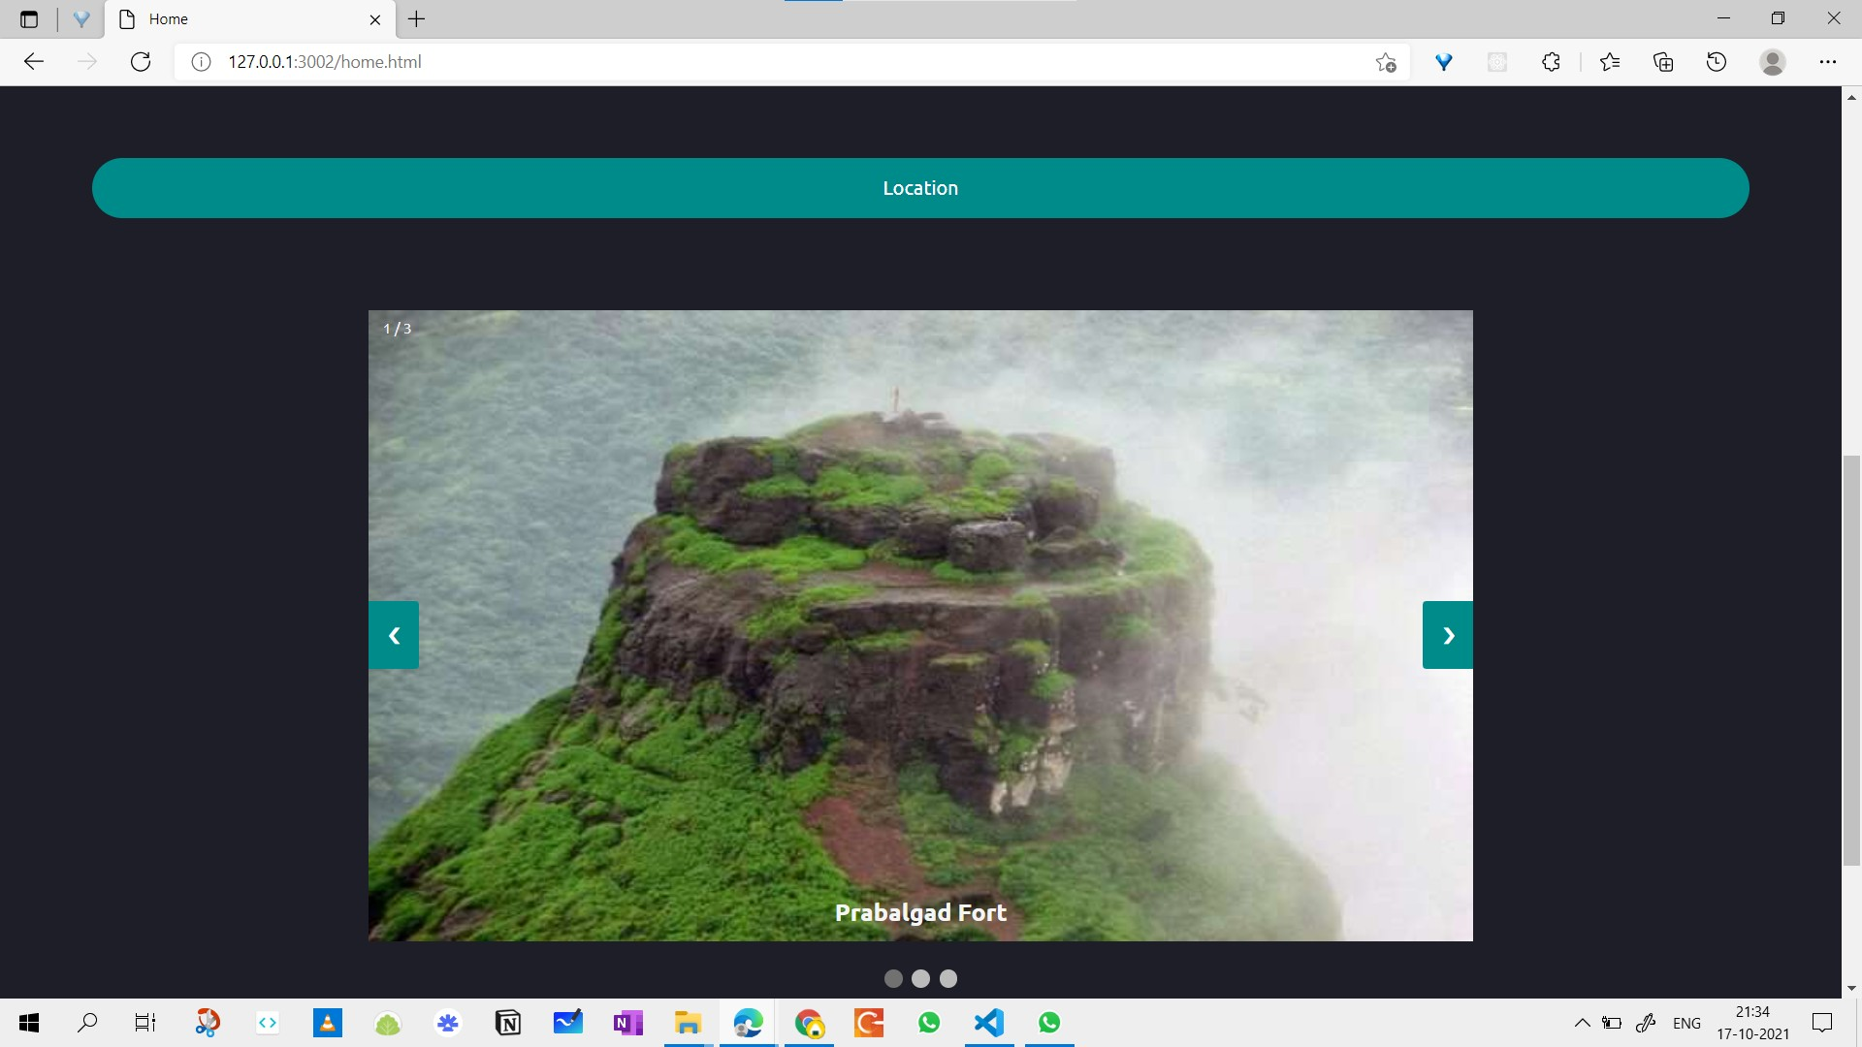

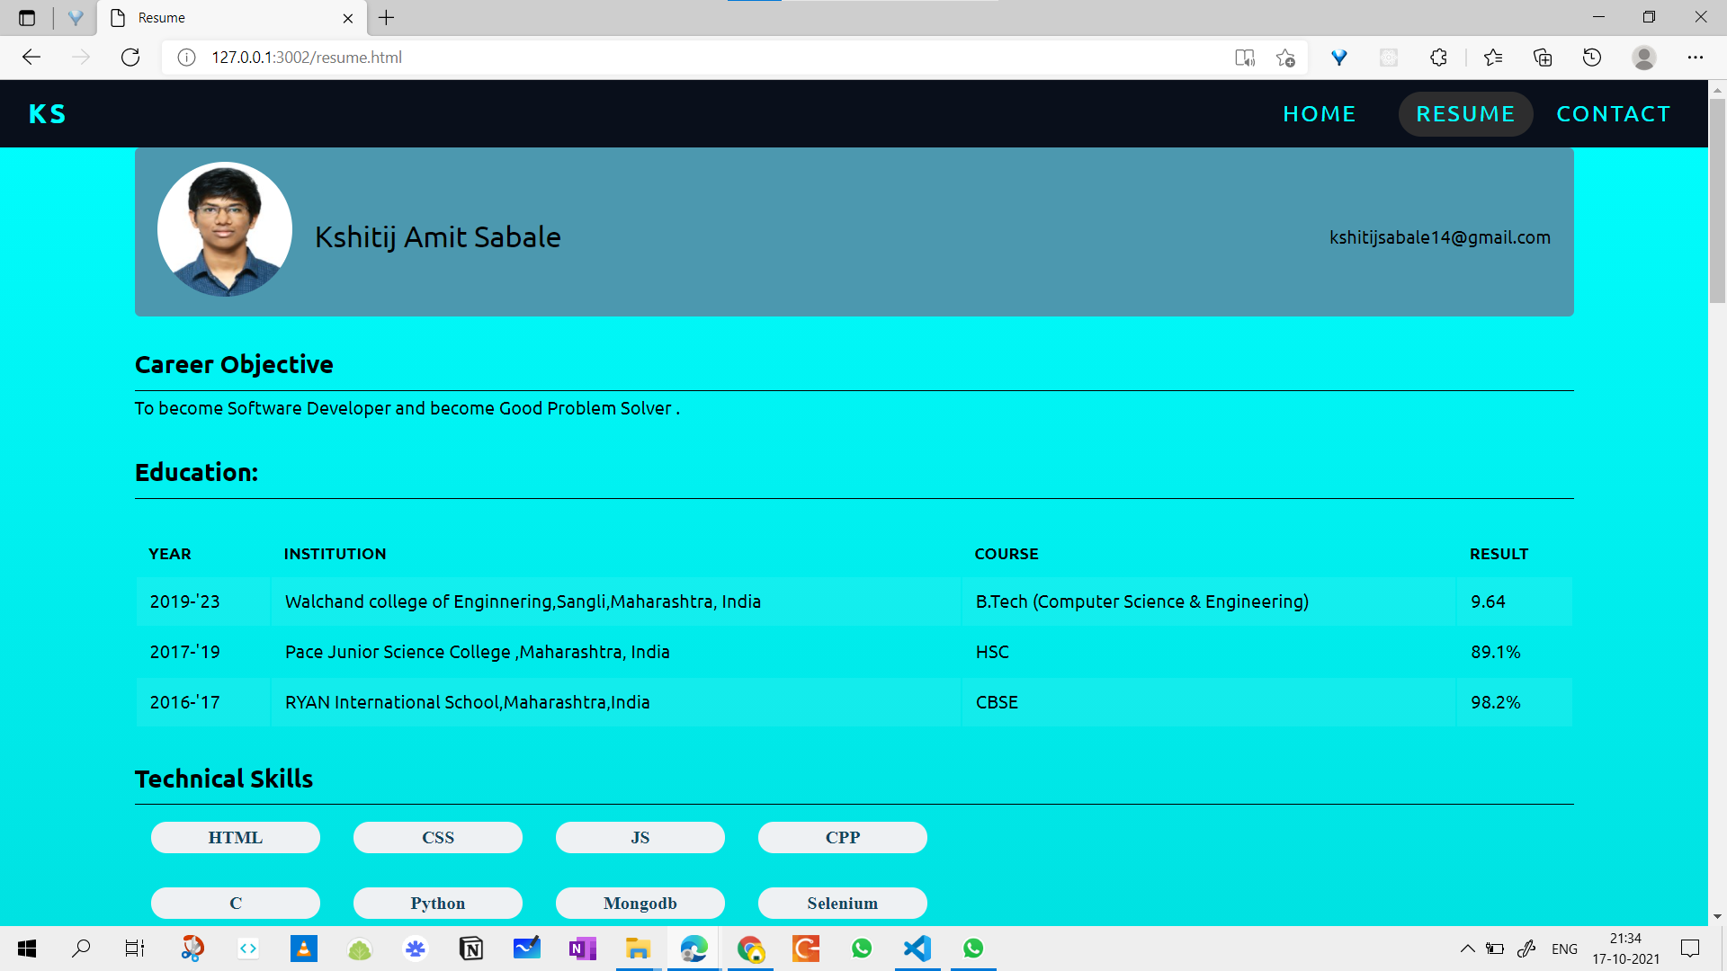

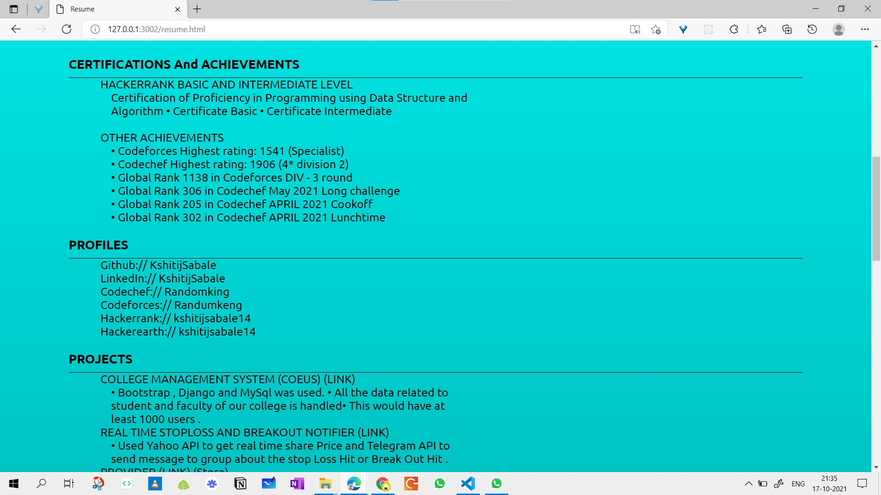

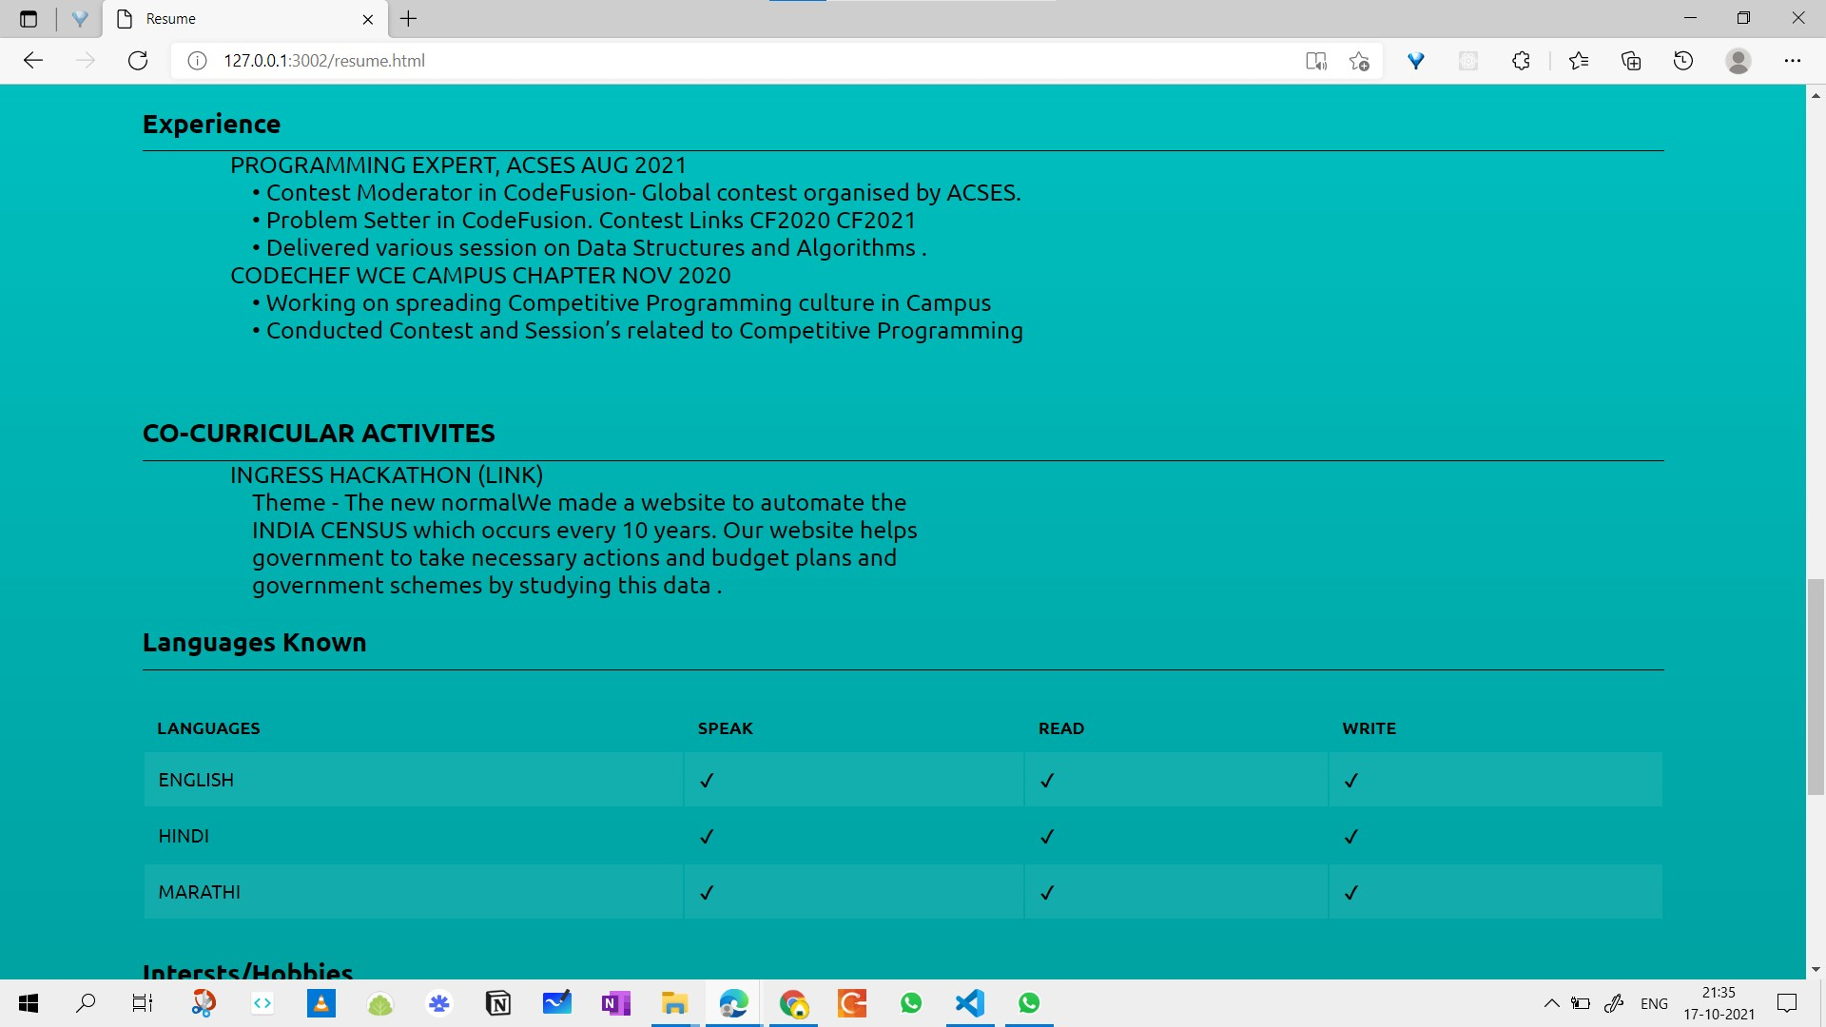

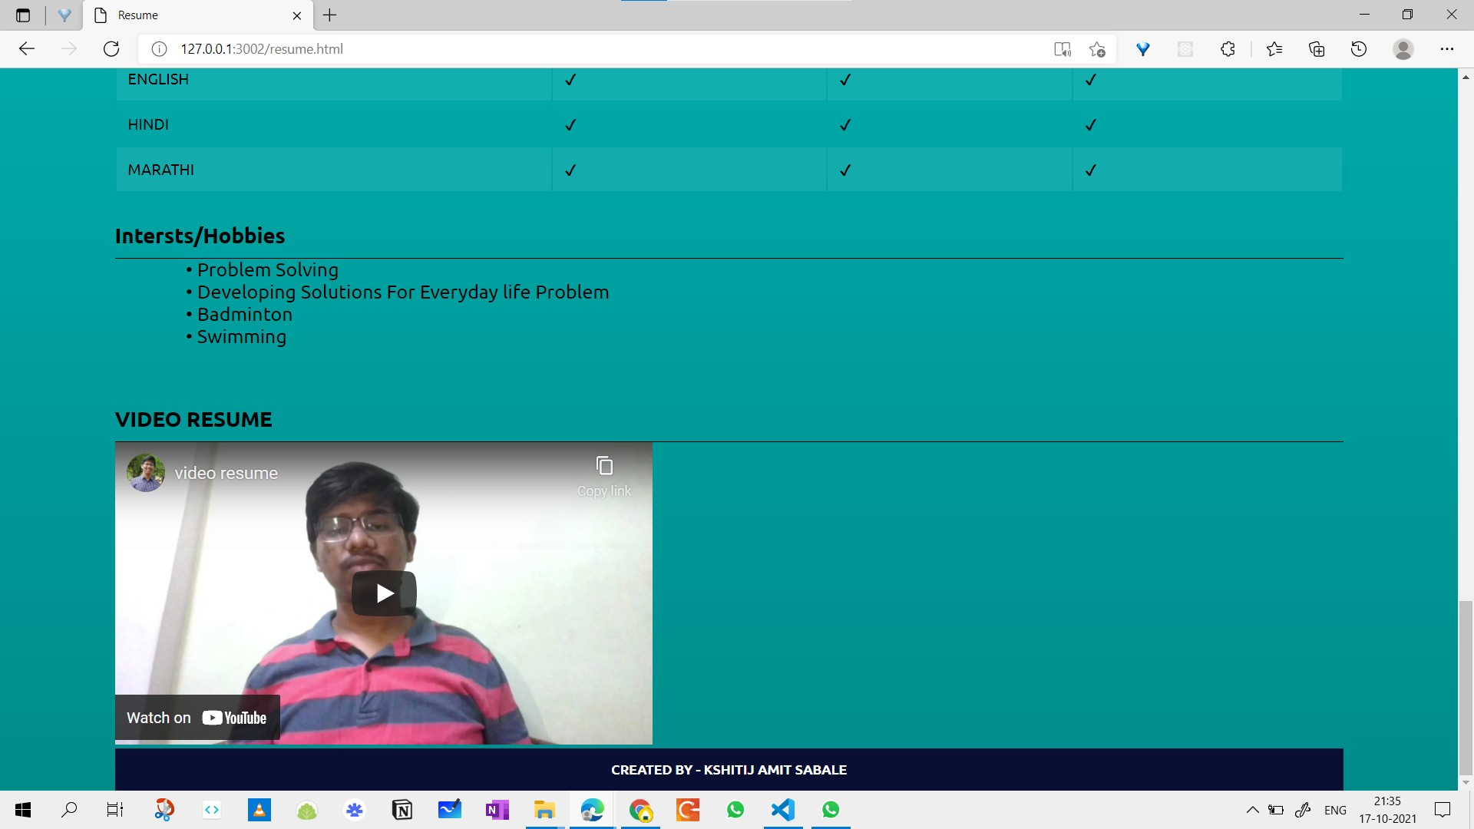

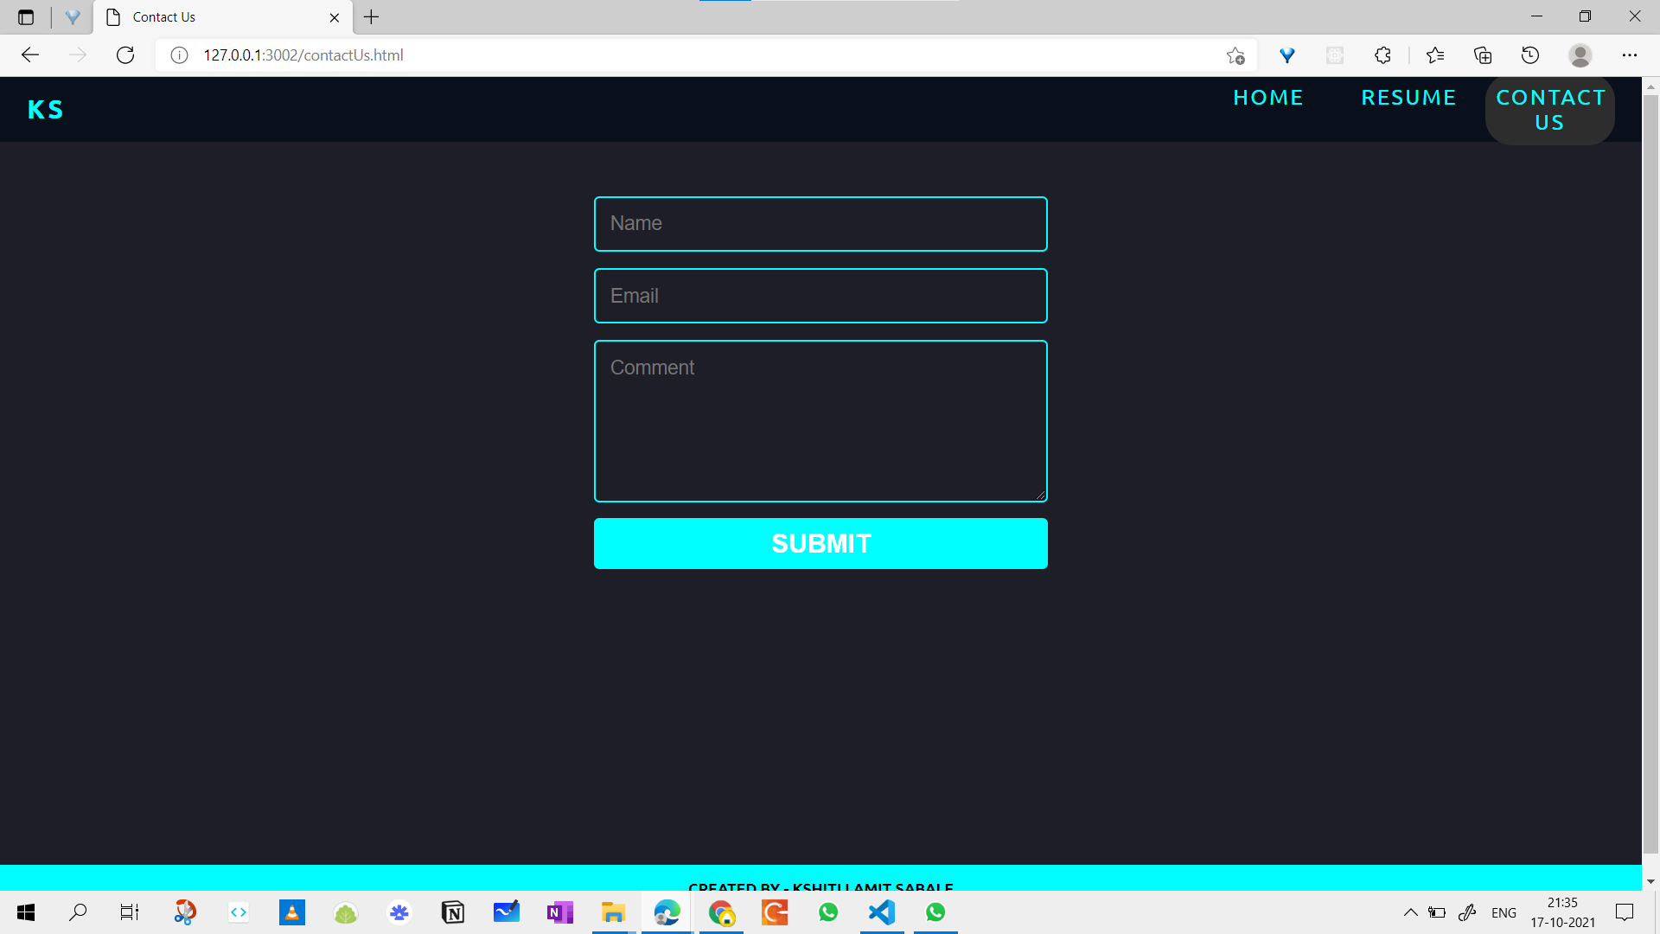

**GITHUB :-**

https://github.com/KshitijSabale/PL3-2019BTECS00024/tree/main/Portfolio