**Blockchain**

**Practical 7**

Aim

Program to implement Blockchain DAPP

Create two Python files

blockchain1.py

port – 5001

blockchain2.py

port – 5002

Code

**blockchain1.py**

import datetime

import hashlib

import json

from flask import Flask, jsonify, request

import requests

from uuid import uuid4

from urllib.parse import urlparse

class Blockchain:

    def __init__(self):

*self*.chain = []

*self*.transactions = []

*self*.create_block(proof=1,previous_hash=0)

*self*.nodes = set()

    def create_block(self,proof,previous_hash):

        block = {'index':len(*self*.chain)+1,

                 'timestamp':str(datetime.datetime.now()),

                 'proof':proof,

                 'previous_hash':previous_hash,

                 'transaction':*self*.transactions}

*self*.transactions = []

*self*.chain.append(block)

        return block

    def get_previous_block(self):

        return *self*.chain[-1]

    def proof_of_work(self,previous_proof):

        new_proof = 1

        check_proof = False

        while check_proof is False:

            hash_value=hashlib.sha256(str(new_proof**2-previous_proof**2).encode()).hexdigest()

            if hash_value[:5] == '00000':

                check_proof = True

            else:

                new_proof += 1

        return new_proof

    def hash(self,block):

        encoded_block = json.dumps(block, sort_keys=True).encode()

        return hashlib.sha256(encoded_block).hexdigest()

    def is_chain_valid(self,chain):

        previous_block = chain[0]

        block_index = 1

        while block_index < len(chain):

            block = chain[block_index]

            if block['previous_hash'] != *self*.hash(previous_block):

                return False

            previous_proof = previous_block['proof']

            new_proof = block['proof']

            hash_value=hashlib.sha256(str(new_proof**2-previous_proof**2).encode()).hexdigest()

            if hash_value[:5] != '00000':

                return False

            previous_block = block

            block_index += 1

        return True

    def add_transaction(self,sender,receiver,amount):

*self*.transactions.append({'sender':sender,

                                  'receiver':receiver,

                                  'amount':amount})

        previous_block = *self*.get_previous_block()

        return previous_block['index']+1

    def add_node(self, address):

        parsed_url = urlparse(address)

*self*.nodes.add(parsed_url.netloc)

    def replace_chain(self):

        network = *self*.nodes

        max_length = len(*self*.chain)

        longest_chain = None

        for node in network:

            response = requests.get(f'http://{node}/get_chain')

            if response.status_code==200:

                length=response.json()['length']

                chain = response.json()['chain']

                if length>max_length and *self*.is_chain_valid(chain):

                    max_length = length

                    longest_chain=chain

        if longest_chain:

*self*.chain = longest_chain

            return True

        return False

app = Flask(__name__)

blockchain = Blockchain()

@app.route('/mine_block',methods=['GET'])

def mine_block():

    previous_block = blockchain.get_previous_block()

    previous_proof = previous_block['proof']

    proof = blockchain.proof_of_work(previous_proof)

    previous_hash = blockchain.hash(previous_block)

    block = blockchain.create_block(proof,previous_hash)

    response = {'message':'block is mined',

                'index':block['index'],

                'timestamp':block['timestamp'],

                'proof':block['proof'],

                'previous_hash':block['previous_hash']}

    return jsonify(response), 200

@app.route('/get_chain',methods=['GET'])

def get_chain():

    response = {'chain': blockchain.chain,

                'length':len(blockchain.chain)}

    return jsonify(response), 200

@app.route('/is_valid',methods=['GET'])

def is_valid():

    is_valid=blockchain.is_chain_valid(blockchain.chain)

    if is_valid:

        response = {'message':'Your chain is validated'}

    else:

        response = {'message':'Your chain is not valid'}

    return jsonify(response), 200

@app.route('/add_transaction',methods=['POST'])

def add_transaction():

    json = request.get_json()

    transaction_keys = ['sender','receiver','amount']

    if not all(key in json for key in transaction_keys):

        return 'Some elements are missing', 400

    index = blockchain.add_transaction(json['sender'],

                                       json['receiver'],

                                       json['amount'])

    response = {'Message':f'The transaction is added to block {index}'}

    return jsonify(response), 201

@app.route('/connect_nodes',methods=['POST'])

def connect_nodes():

    json = request.get_json()

    nodes = json.get('nodes')

    print(nodes)

    if nodes is None:

        return 'No Nodes', 400

    for node in nodes:

        blockchain.add_node(node)

    response = {'message': 'all nodes are now connected',

                'Total nodes': list(blockchain.nodes)}

    return jsonify(response), 201

@app.route('/replace_chain',methods=['GET'])

def replace_chain():

    is_chain_replace = blockchain.replace_chain()

    if is_chain_replace:

        response = {'message': 'chain replaced',

                    'new_chain': blockchain.chain}

    else:

        response = {'message': 'chain not replaced',

                    'new_chain': blockchain.chain}

    return jsonify(response), 201

app.run(host='0.0.0.0',port = 5001)

**blockchain2.py**

import datetime

import hashlib

import json

from flask import Flask, jsonify, request

import requests

from uuid import uuid4

from urllib.parse import urlparse

class Blockchain:

    def __init__(self):

*self*.chain = []

*self*.transactions = []

*self*.create_block(proof=1,previous_hash=0)

*self*.nodes = set()

    def create_block(self,proof,previous_hash):

        block = {'index':len(*self*.chain)+1,

                 'timestamp':str(datetime.datetime.now()),

                 'proof':proof,

                 'previous_hash':previous_hash,

                 'transaction':*self*.transactions}

*self*.transactions = []

*self*.chain.append(block)

        return block

    def get_previous_block(self):

        return *self*.chain[-1]

    def proof_of_work(self,previous_proof):

        new_proof = 1

        check_proof = False

        while check_proof is False:

            hash_value=hashlib.sha256(str(new_proof**2-previous_proof**2).encode()).hexdigest()

            if hash_value[:5] == '00000':

                check_proof = True

            else:

                new_proof += 1

        return new_proof

    def hash(self,block):

        encoded_block = json.dumps(block, sort_keys=True).encode()

        return hashlib.sha256(encoded_block).hexdigest()

    def is_chain_valid(self,chain):

        previous_block = chain[0]

        block_index = 1

        while block_index < len(chain):

            block = chain[block_index]

            if block['previous_hash'] != *self*.hash(previous_block):

                return False

            previous_proof = previous_block['proof']

            new_proof = block['proof']

            hash_value=hashlib.sha256(str(new_proof**2-previous_proof**2).encode()).hexdigest()

            if hash_value[:5] != '00000':

                return False

            previous_block = block

            block_index += 1

        return True

    def add_transaction(self,sender,receiver,amount):

*self*.transactions.append({'sender':sender,

                                  'receiver':receiver,

                                  'amount':amount})

        previous_block = *self*.get_previous_block()

        return previous_block['index']+1

    def add_node(self, address):

        parsed_url = urlparse(address)

*self*.nodes.add(parsed_url.netloc)

    def replace_chain(self):

        network = *self*.nodes

        max_length = len(*self*.chain)

        longest_chain = None

        for node in network:

            response = requests.get(f'http://{node}/get_chain')

            if response.status_code==200:

                length=response.json()['length']

                chain = response.json()['chain']

                if length>max_length and *self*.is_chain_valid(chain):

                    max_length = length

                    longest_chain=chain

        if longest_chain:

*self*.chain = longest_chain

            return True

        return False

app = Flask(__name__)

blockchain = Blockchain()

@app.route('/mine_block',methods=['GET'])

def mine_block():

    previous_block = blockchain.get_previous_block()

    previous_proof = previous_block['proof']

    proof = blockchain.proof_of_work(previous_proof)

    previous_hash = blockchain.hash(previous_block)

    block = blockchain.create_block(proof,previous_hash)

    response = {'message':'block is mined',

                'index':block['index'],

                'timestamp':block['timestamp'],

                'proof':block['proof'],

                'previous_hash':block['previous_hash']}

    return jsonify(response), 200

@app.route('/get_chain',methods=['GET'])

def get_chain():

    response = {'chain': blockchain.chain,

                'length':len(blockchain.chain)}

    return jsonify(response), 200

@app.route('/is_valid',methods=['GET'])

def is_valid():

    is_valid=blockchain.is_chain_valid(blockchain.chain)

    if is_valid:

        response = {'message':'Your chain is validated'}

    else:

        response = {'message':'Your chain is not valid'}

    return jsonify(response), 200

@app.route('/add_transaction',methods=['POST'])

def add_transaction():

    json = request.get_json()

    transaction_keys = ['sender','receiver','amount']

    if not all(key in json for key in transaction_keys):

        return 'Some elements are missing', 400

    index = blockchain.add_transaction(json['sender'],

                                       json['receiver'],

                                       json['amount'])

    response = {'Message':f'The transaction is added to block {index}'}

    return jsonify(response), 201

@app.route('/connect_nodes',methods=['POST'])

def connect_nodes():

    json = request.get_json()

    nodes = json.get('nodes')

    print(nodes)

    if nodes is None:

        return 'No Nodes', 400

    for node in nodes:

        blockchain.add_node(node)

    response = {'message': 'all nodes are now connected',

                'Total nodes': list(blockchain.nodes)}

    return jsonify(response), 201

@app.route('/replace_chain',methods=['GET'])

def replace_chain():

    is_chain_replace = blockchain.replace_chain()

    if is_chain_replace:

        response = {'message': 'chain replaced',

                    'new_chain': blockchain.chain}

    else:

        response = {'message': 'chain not replaced',

                    'new_chain': blockchain.chain}

    return jsonify(response), 201

app.run(host='0.0.0.0',port = 5002)

Output

Run blockchain1.py

Port - 5001

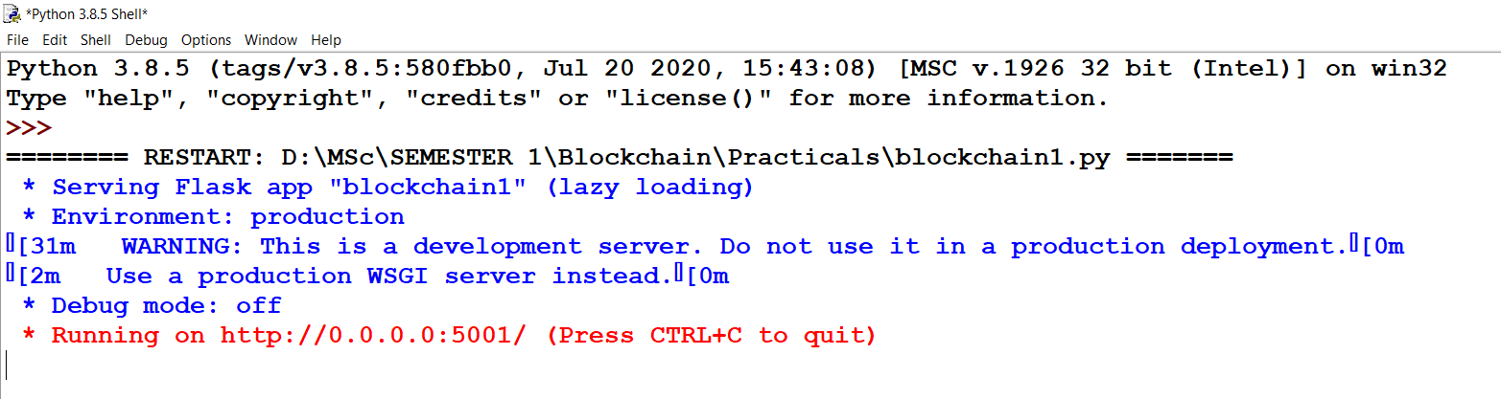

Run blockchain2.py

Port - 5002

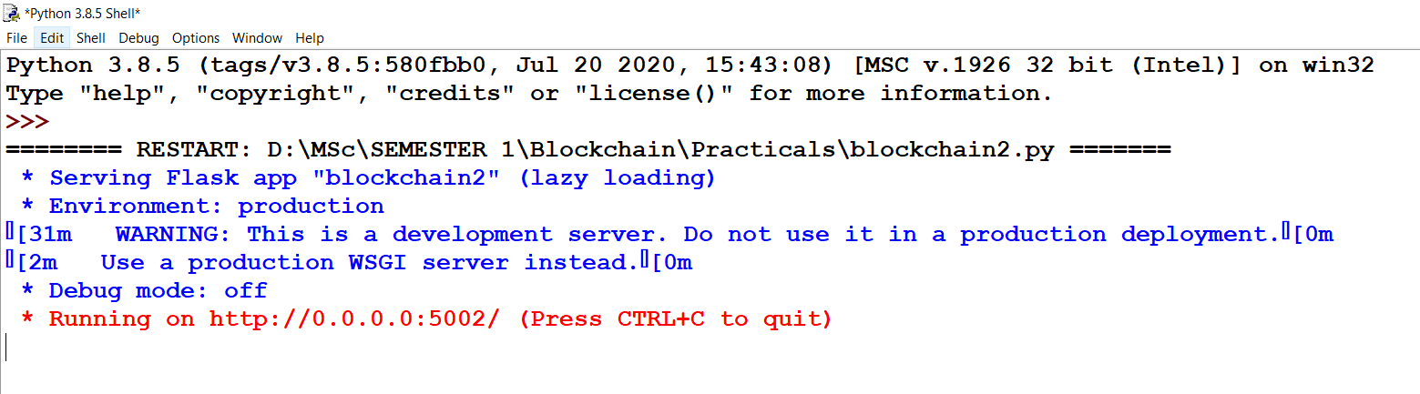

Start Postman

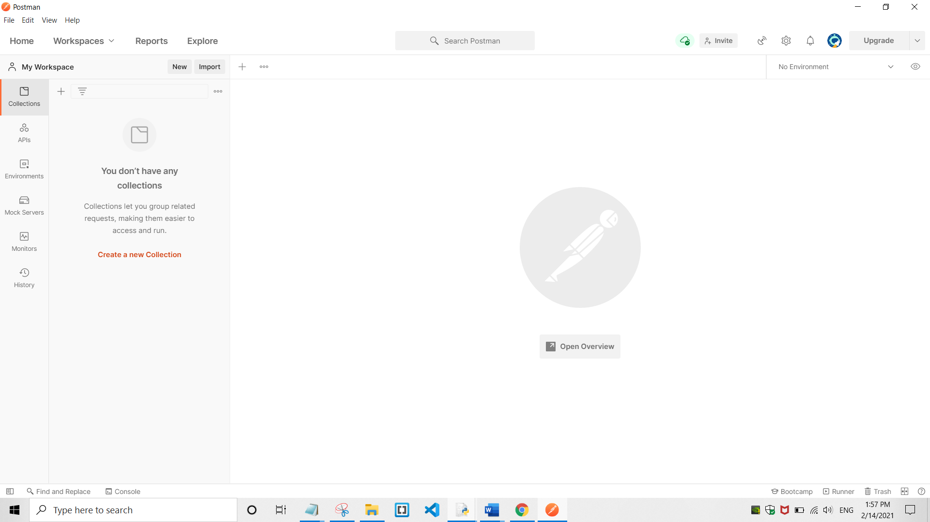

1) Connect node(5001) to node(5002)

Method - POST

Request URL - http://127.0.0.1:5001/connect_nodes

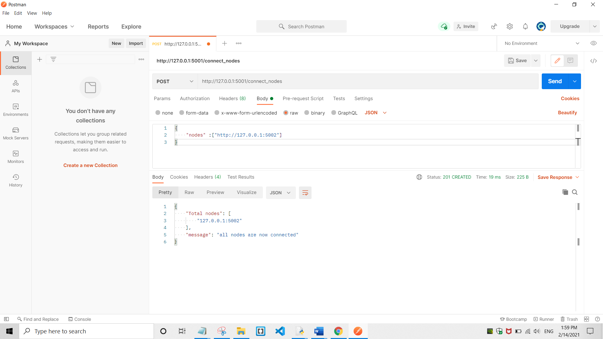

2) Connect node(5002) to node(5001)

Method - POST

Request URL - http://127.0.0.1:5002/connect_nodes

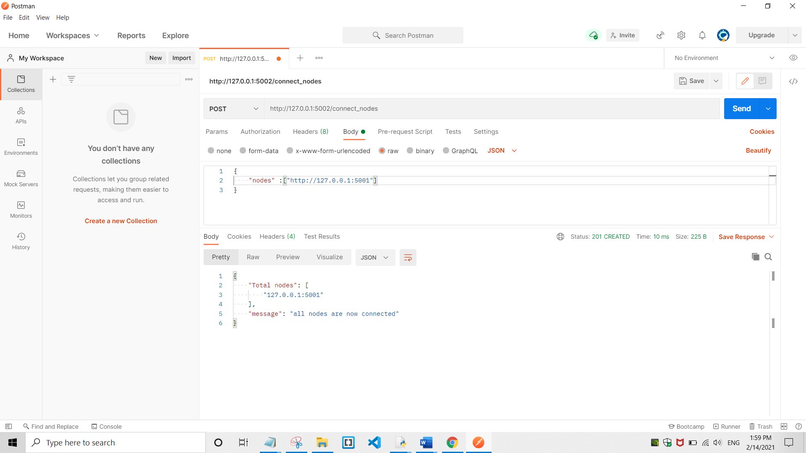

3) Get chain of node(5001)

Method - GET

Request URL - http://127.0.0.1:5001/get_chain

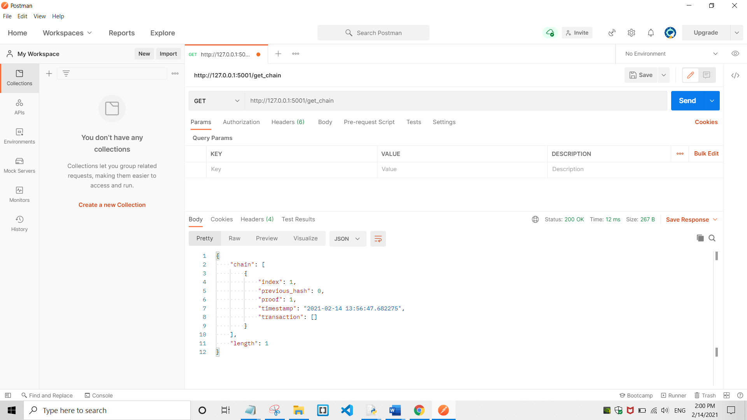

4) Add transaction on node(5001)

Method - POST

Request URL - http://127.0.0.1:5001/add_transaction

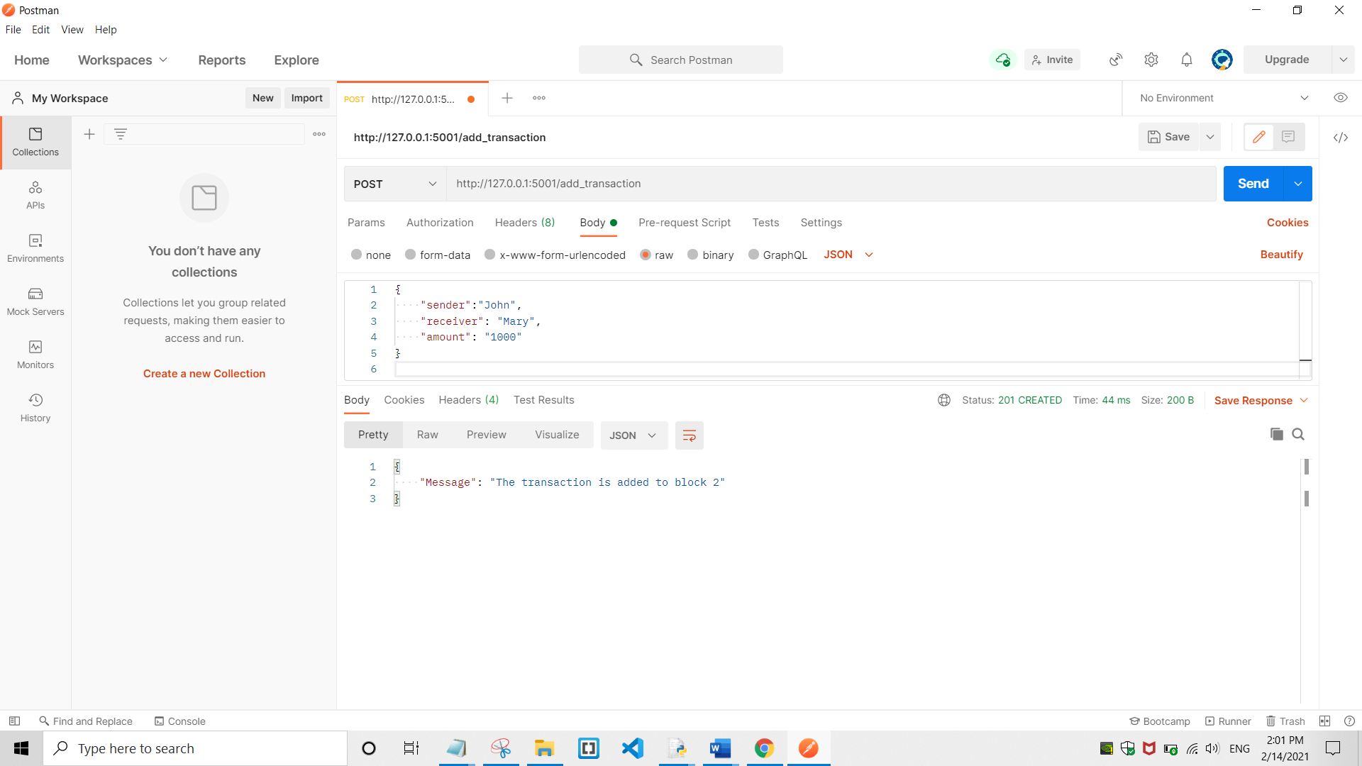

5) Mine block on node(5001)

Method - GET

Request URL - http://127.0.0.1:5001/mine_block

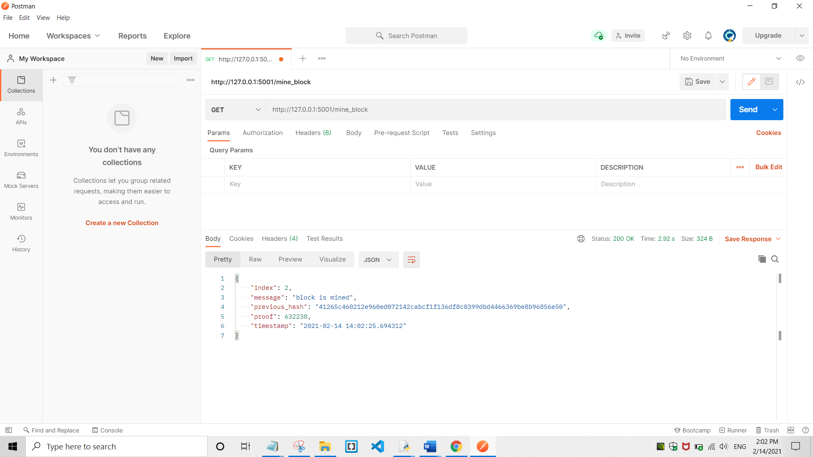

6) Get chain of node(5001)

Method - GET

Request URL - http://127.0.0.1:5001/get_chain

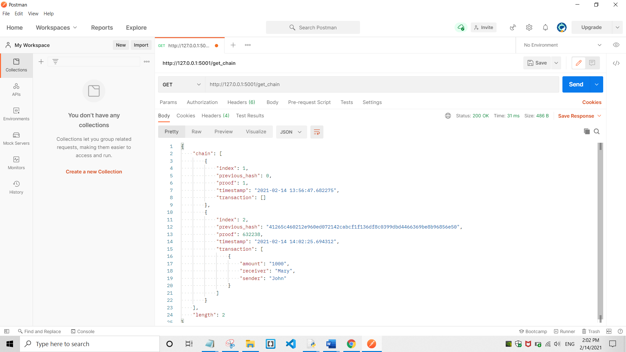

7) Get chain of node(5002)

Method - GET

Request URL - http://127.0.0.1:5002/get_chain

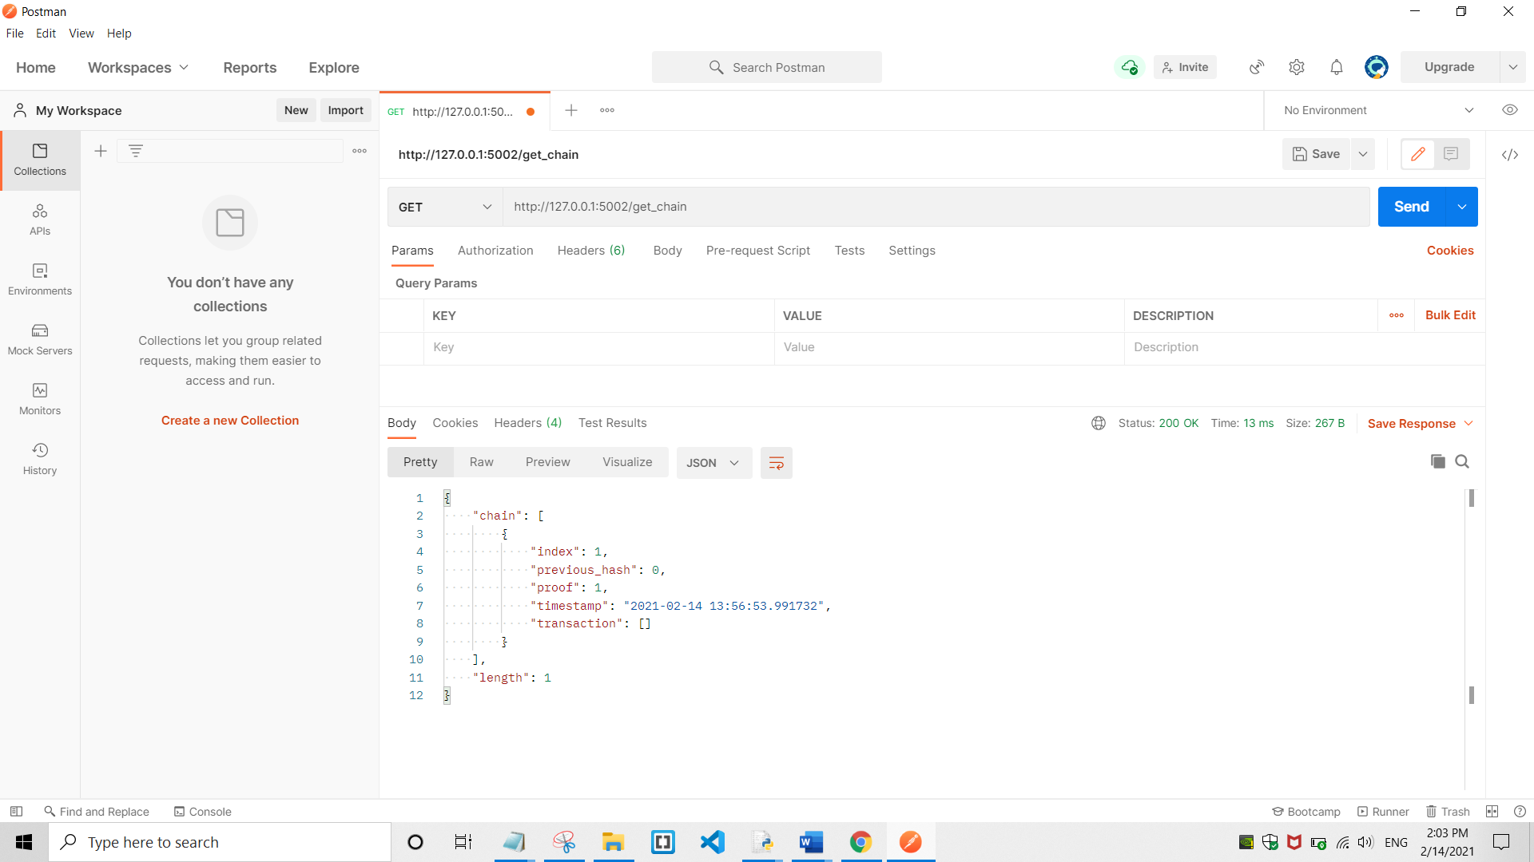

8) Replace chain on node(5002)

Method - GET

Request URL - http://127.0.0.1:5002/replace_chain

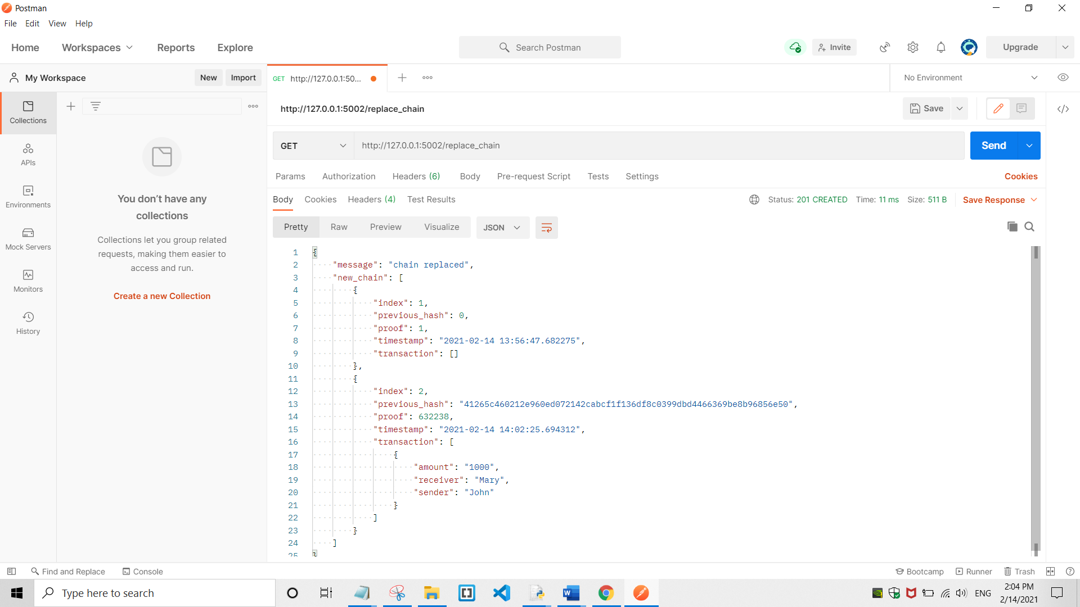

9) Add Transaction on node(5002)

Method - POST

Request URL - http://127.0.0.1:5002/add_transaction

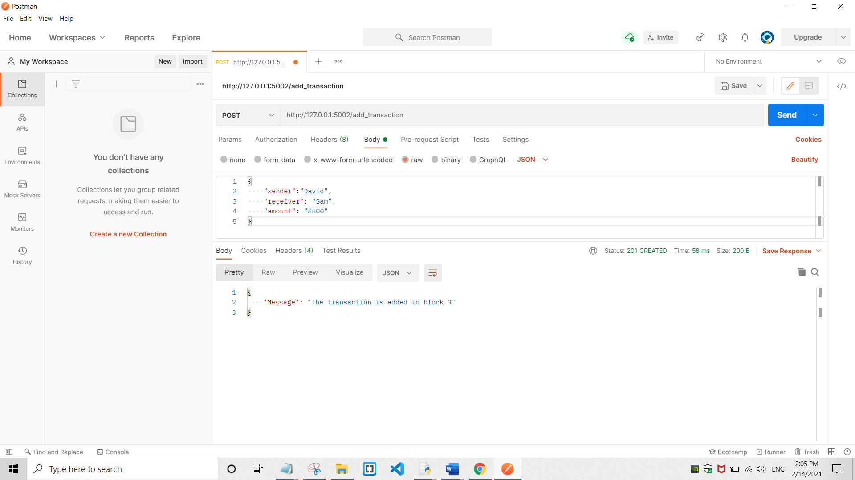

10) Mine block on node(5002)

Method - GET

Request URL - http://127.0.0.1:5002/mine_block

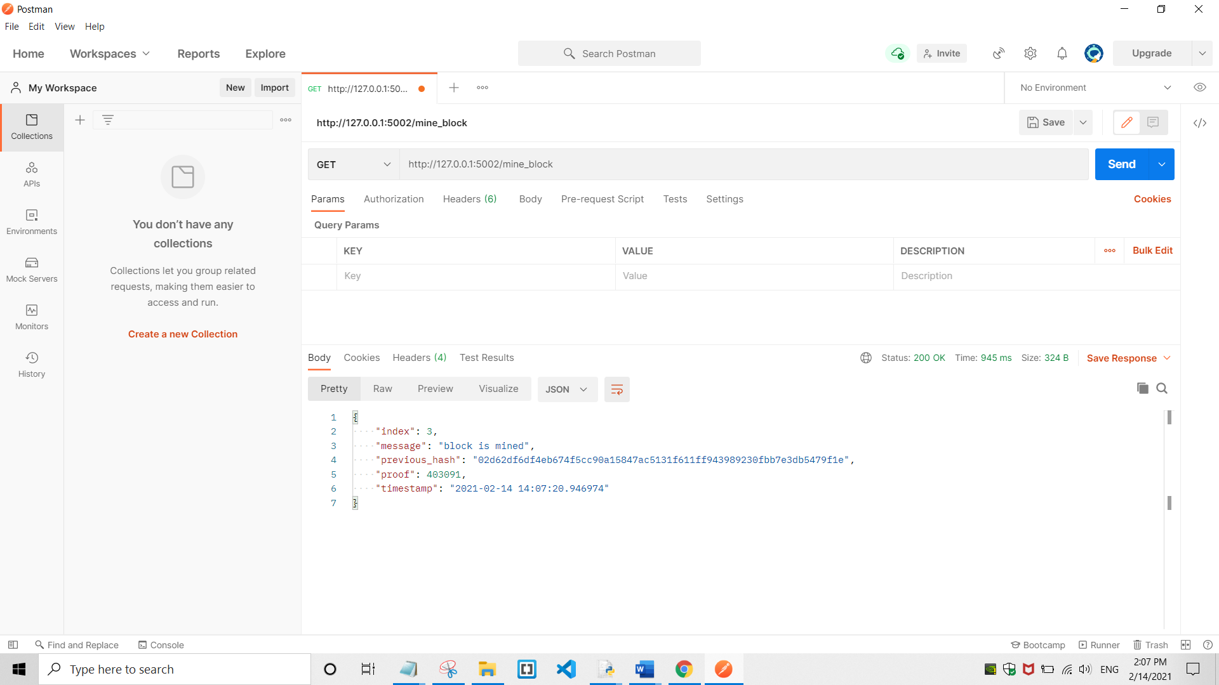

11) Get chain on node(5002)

Method - GET

Request URL - http://127.0.0.1:5002/get_chain

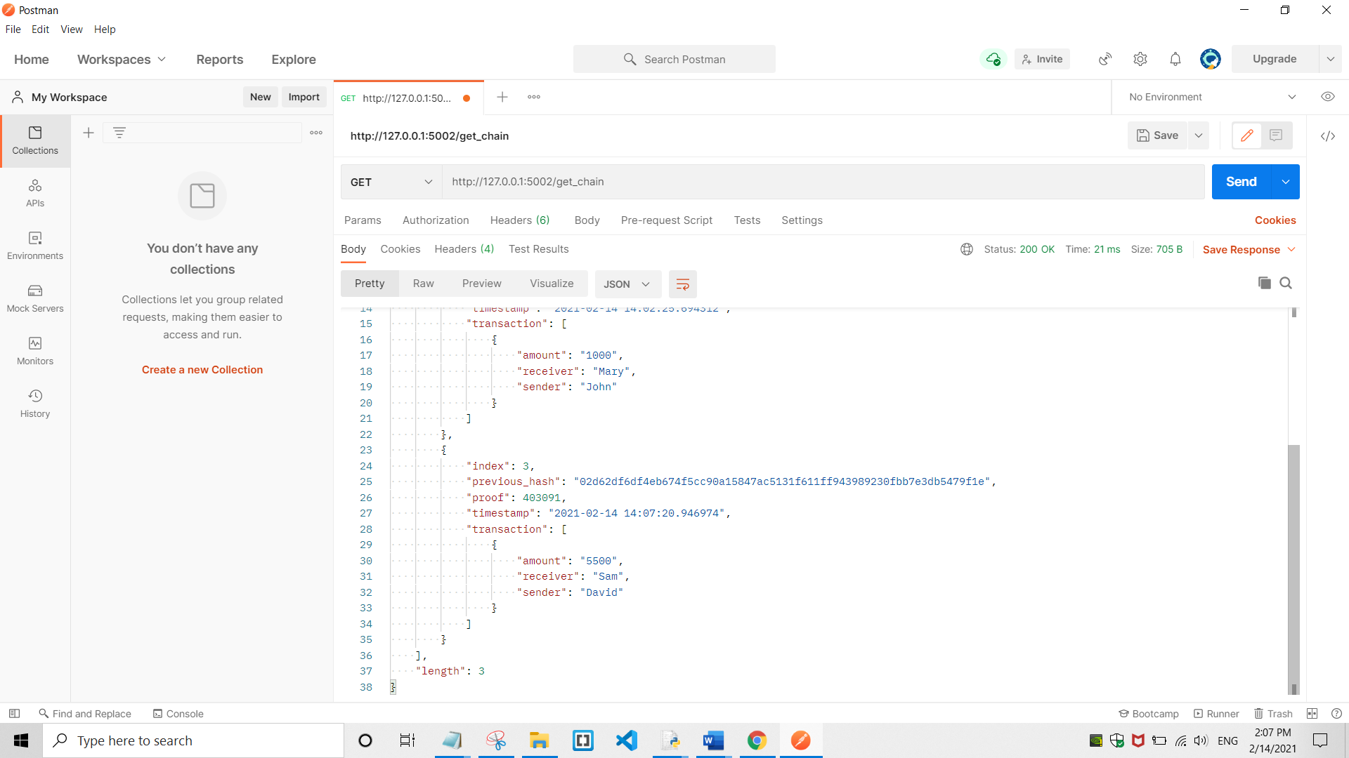

12) Get chain on node(5001)

Method - GET

Request URL - http://127.0.0.1:5001/get_chain

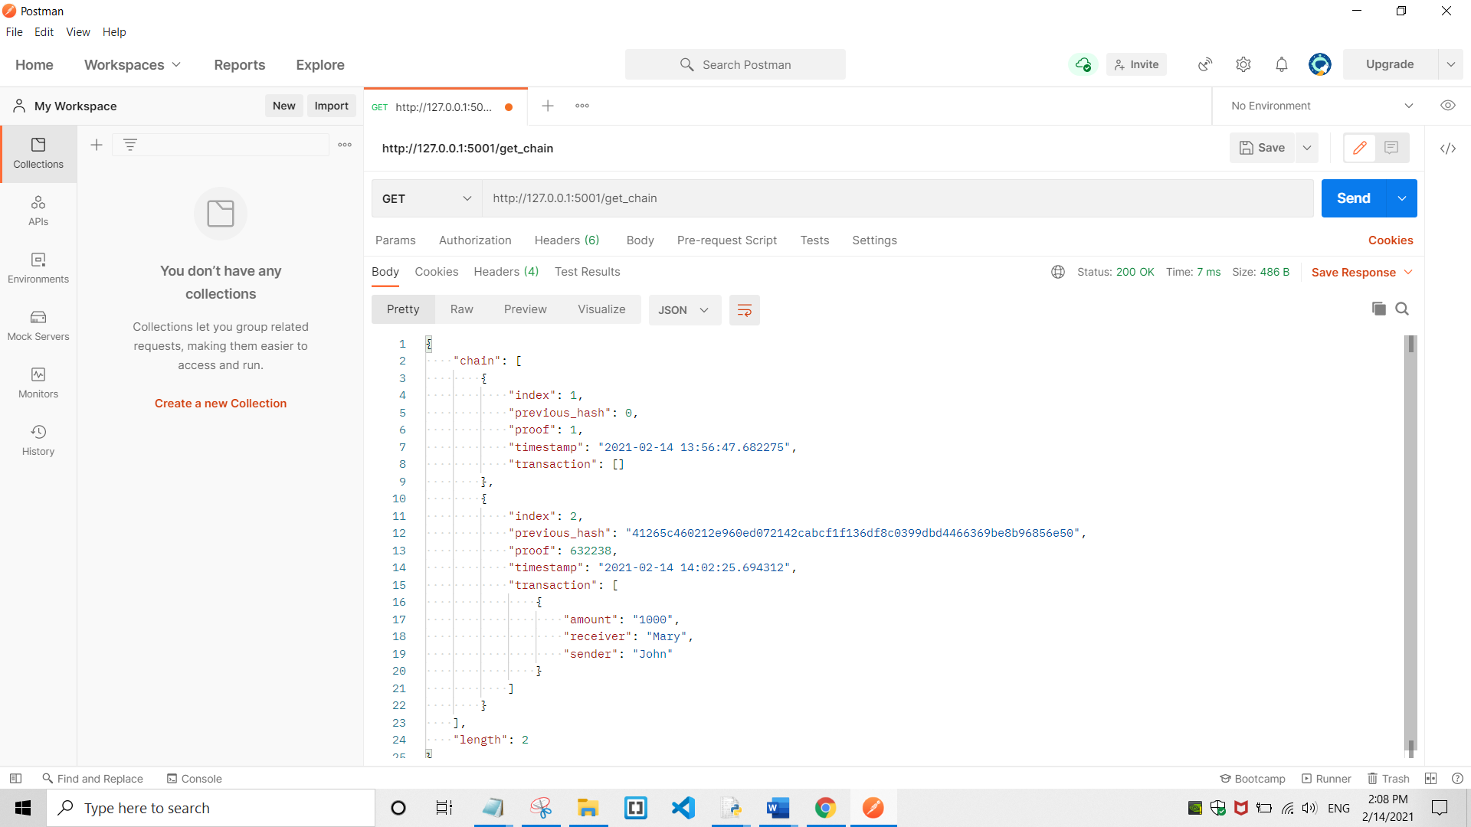

13) Replace chain on node(5001)

Method - GET

Request URL - http://127.0.0.1:5001/replace_chain

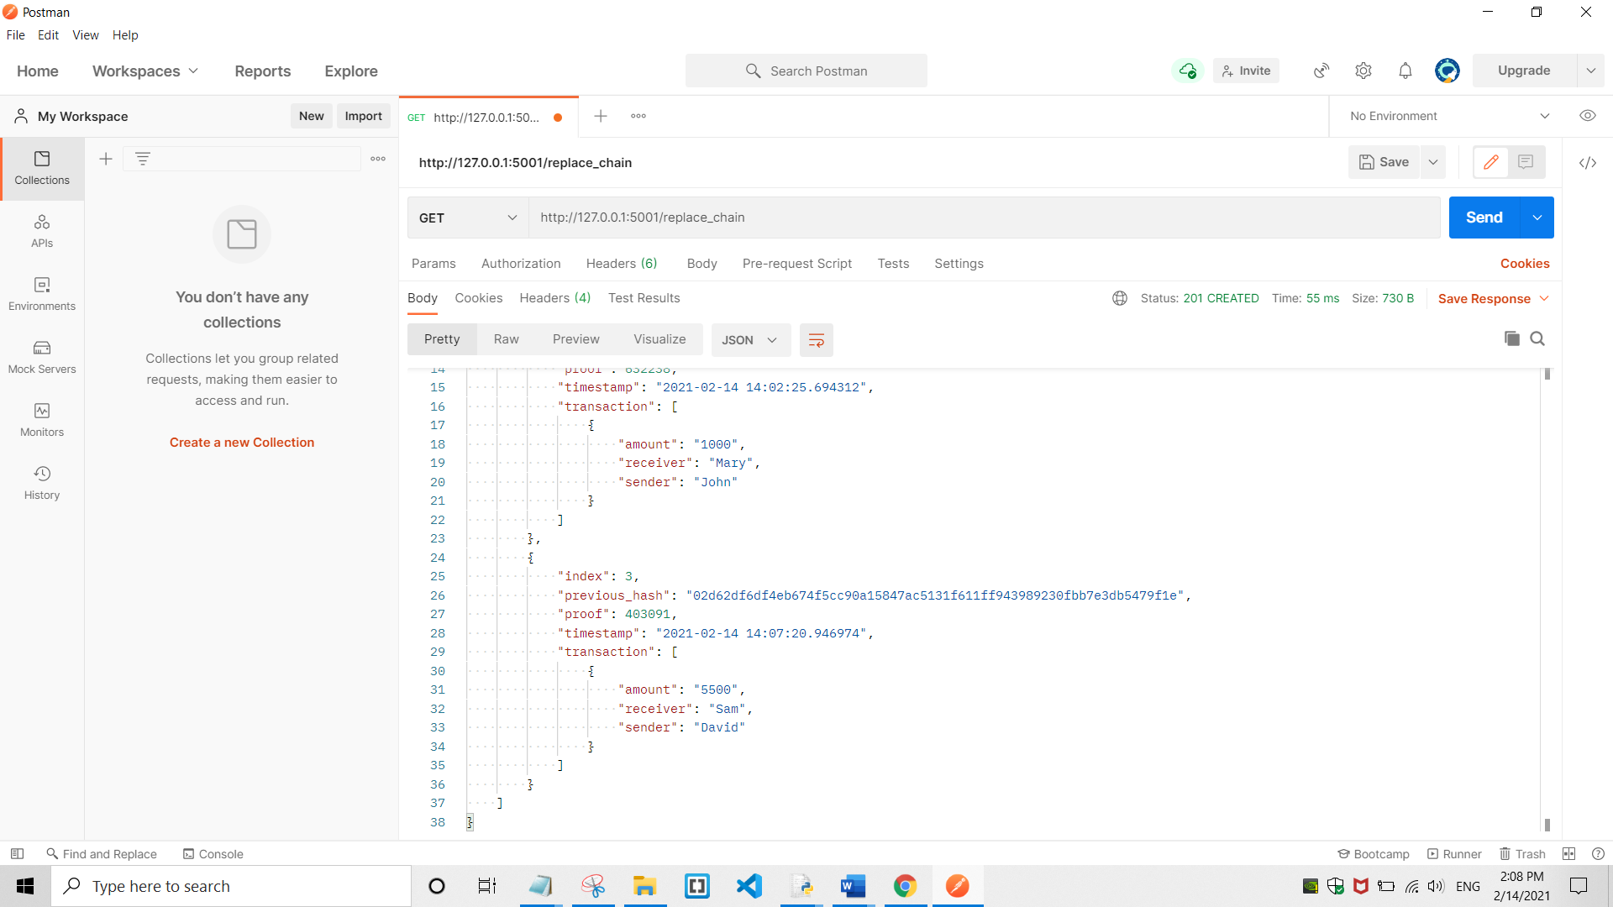

Requests are displayed

Port – 5001

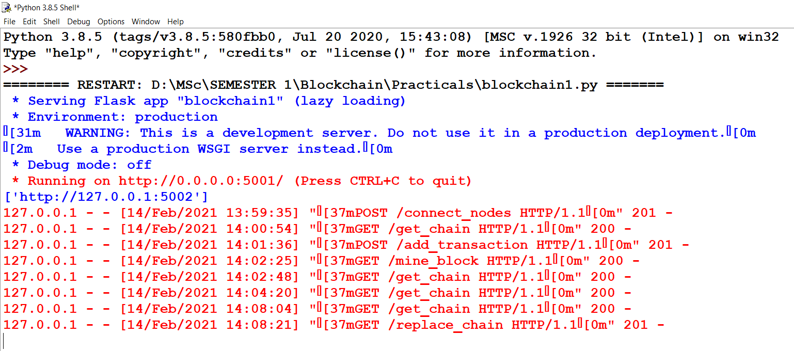

Port – 5002

