Practical-1 : Classification Using ML

SVM CLASSIFICATION

CODE :-

import pandas as pd
import numpy as np
from sklearn import datasets
from sklearn.model_selection import train_test_split
from sklearn.svm import SVC
from sklearn.datasets import make_classification
from sklearn import metrics

iris = datasets.load_iris()
X = iris.data
Y = iris.target

iris. Data

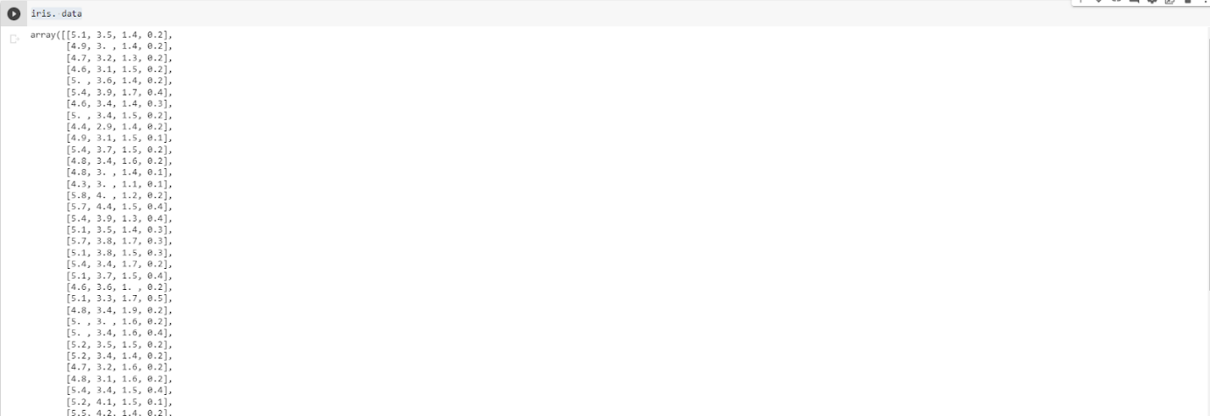

iris.target
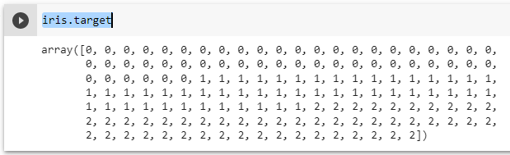
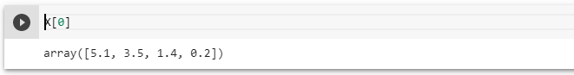

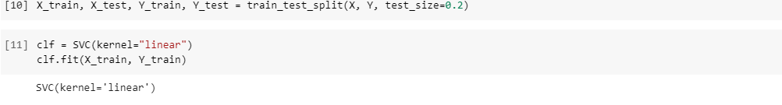
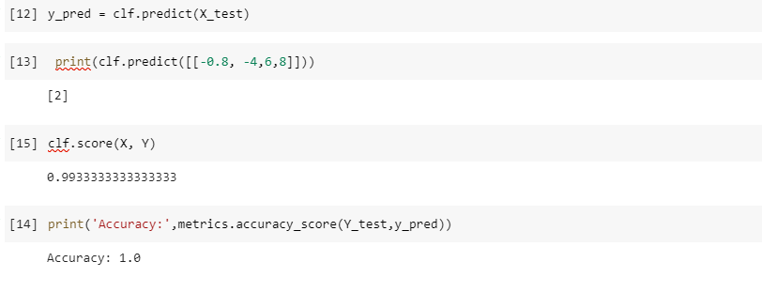
SVM CLASSIFIER LINK :-
https://colab.research.google.com/drive/1vJiap_yrDaswDK3zr9nj1i7LlKYO1nh8?usp=sharing
- The iris dataset is loaded using the datasets.load_iris() function. The data and target arrays are then extracted into X and y, respectively.
- The data is split into training and testing sets using the train_test_split function. The test_size parameter is set to 0.2, meaning that 20% of the data will be used for testing and 80% for training.
- An SVM classifier with a linear kernel is instantiated using SVC(kernel="linear") and trained on the training data using the fit method.
- The classifier is used to make predictions on the test data using the predict method. The resulting predictions are stored in y_pred.
- The accuracy of the classifier is evaluated using the accuracy_score function from the metrics module. The true labels (y_test) and the predicted labels (y_pred) are passed as arguments. The resulting accuracy is printed to the console.

LOGISTICS REGRESSION:-
The code first imports the necessary libraries and then loads the iris dataset using the load_iris function from sklearn.datasets. The data is then split into training and testing sets using the train_test_split function from sklearn.model_selection.
The logistic regression model is trained using the fit method from the LogisticRegression class from sklearn.linear_model. The model is then used to make predictions on the testing set using the predict method. Finally, the performance of the model is evaluated by computing the accuracy score using the accuracy_score function from sklearn.metrics.

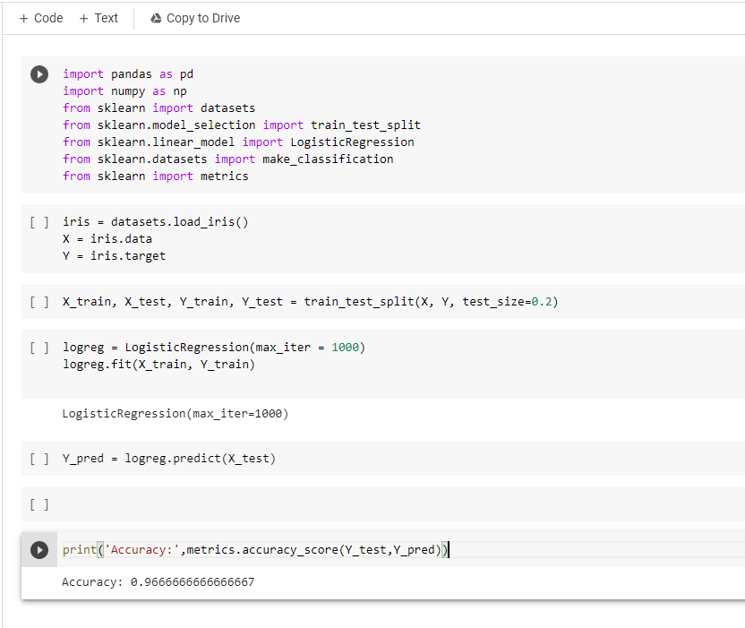

LOGISTIC REGRESSION LINK :-
https://colab.research.google.com/drive/1KYV-79qwsMy6Eq0AUXPL1dPBV3lNMvVQ?usp=sharing

PRACTICAL–2 : Classification Based on Association (CBA)

AIM- Demonstrate CBA for Given Dataset

CODE-
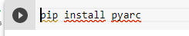
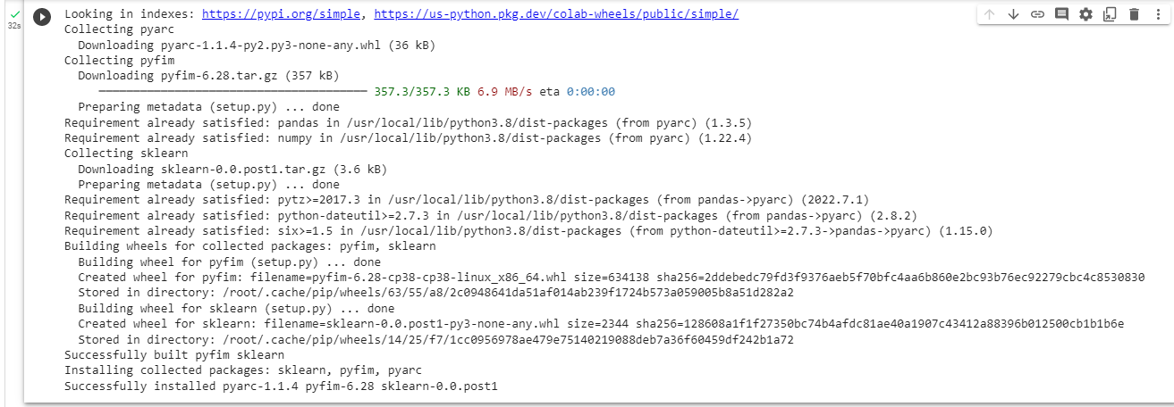
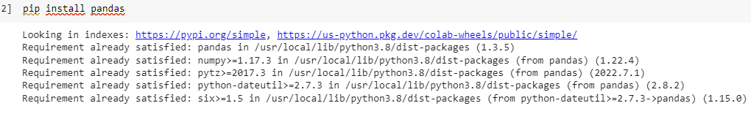
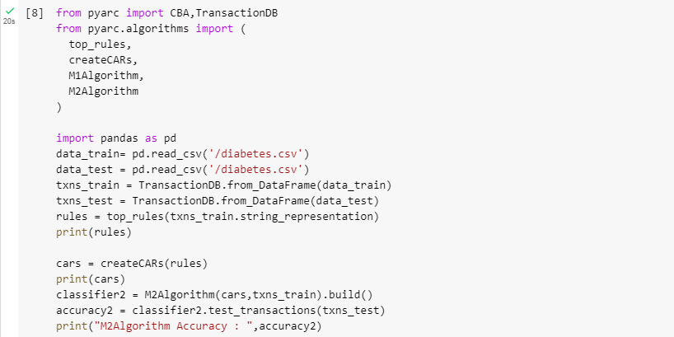
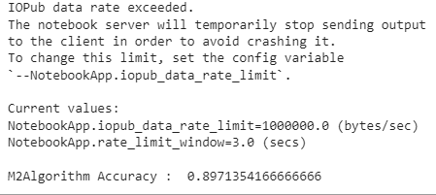

COLAB LINK: https://colab.research.google.com/drive/1kHhx_ICRZgxw6Gis4ZefctGcLfG1w8dG?usp=sharing

PRACTICAL-3 : Implement BIRCH Algorithm

AIM :- BIRCH Algorithm.

CODE:-
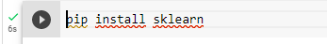
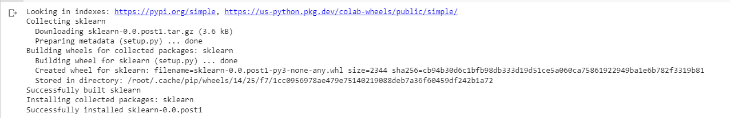

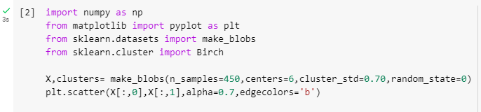
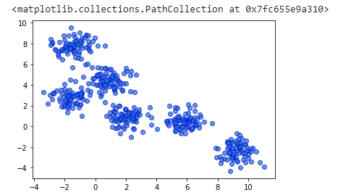

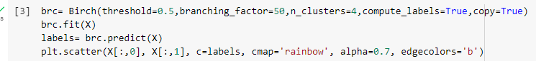
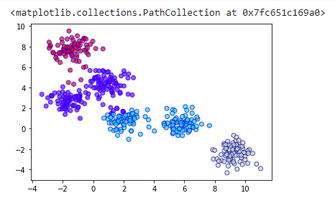

COLAB LINK :-
https://colab.research.google.com/drive/1As2swumX2cK5NNLmrWKxYFY3XJZBkmqu?usp=sharing

PRACTICAL – 04

AIM:- Market Basket Analysis implementation using Machine learning

Code :-
import pandas as pd
from mlxtend.frequent_patterns import apriori
from mlxtend.frequent_patterns import association_rules

df = pd.read_excel('http://archive.ics.uci.edu/ml/machine-learning-databases/00352/Online%20Retail.xlsx')
df.head()

df['Description'] = df['Description'].str.strip()
df.dropna(axis=0, subset=['InvoiceNo'], inplace=True)
df['InvoiceNo'] = df['InvoiceNo'].astype('str')
df = df[~df['InvoiceNo'].str.contains('C')]

basket = (df[df['Country'] =="France"]
.groupby(['InvoiceNo', 'Description'])['Quantity']
.sum().unstack().reset_index().fillna(0)
.set_index('InvoiceNo'))

def encode_units(x):
if x <= 0:
return 0
if x >= 1:
return 1

basket_sets = basket.applymap(encode_units)
basket_sets.drop('POSTAGE', inplace=True, axis=1)
frequent_itemsets = apriori(basket_sets, min_support=0.07, use_colnames=True)

rules = association_rules(frequent_itemsets, metric="lift", min_threshold=1)
rules.head()

rules[ (rules['lift'] >= 6) &
(rules['confidence'] >= 0.8) ]

basket2 = (df[df['Country'] =="Germany"]
.groupby(['InvoiceNo', 'Description'])['Quantity']
.sum().unstack().reset_index().fillna(0)
.set_index('InvoiceNo'))

basket_sets2 = basket2.applymap(encode_units)
basket_sets2.drop('POSTAGE', inplace=True, axis=1)
frequent_itemsets2 = apriori(basket_sets2, min_support=0.05, use_colnames=True)
rules2 = association_rules(frequent_itemsets2, metric="lift", min_threshold=1)

rules2[ (rules2['lift'] >= 4) &
(rules2['confidence'] >= 0.5)]

Output :-
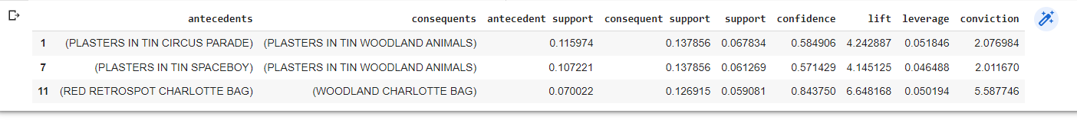

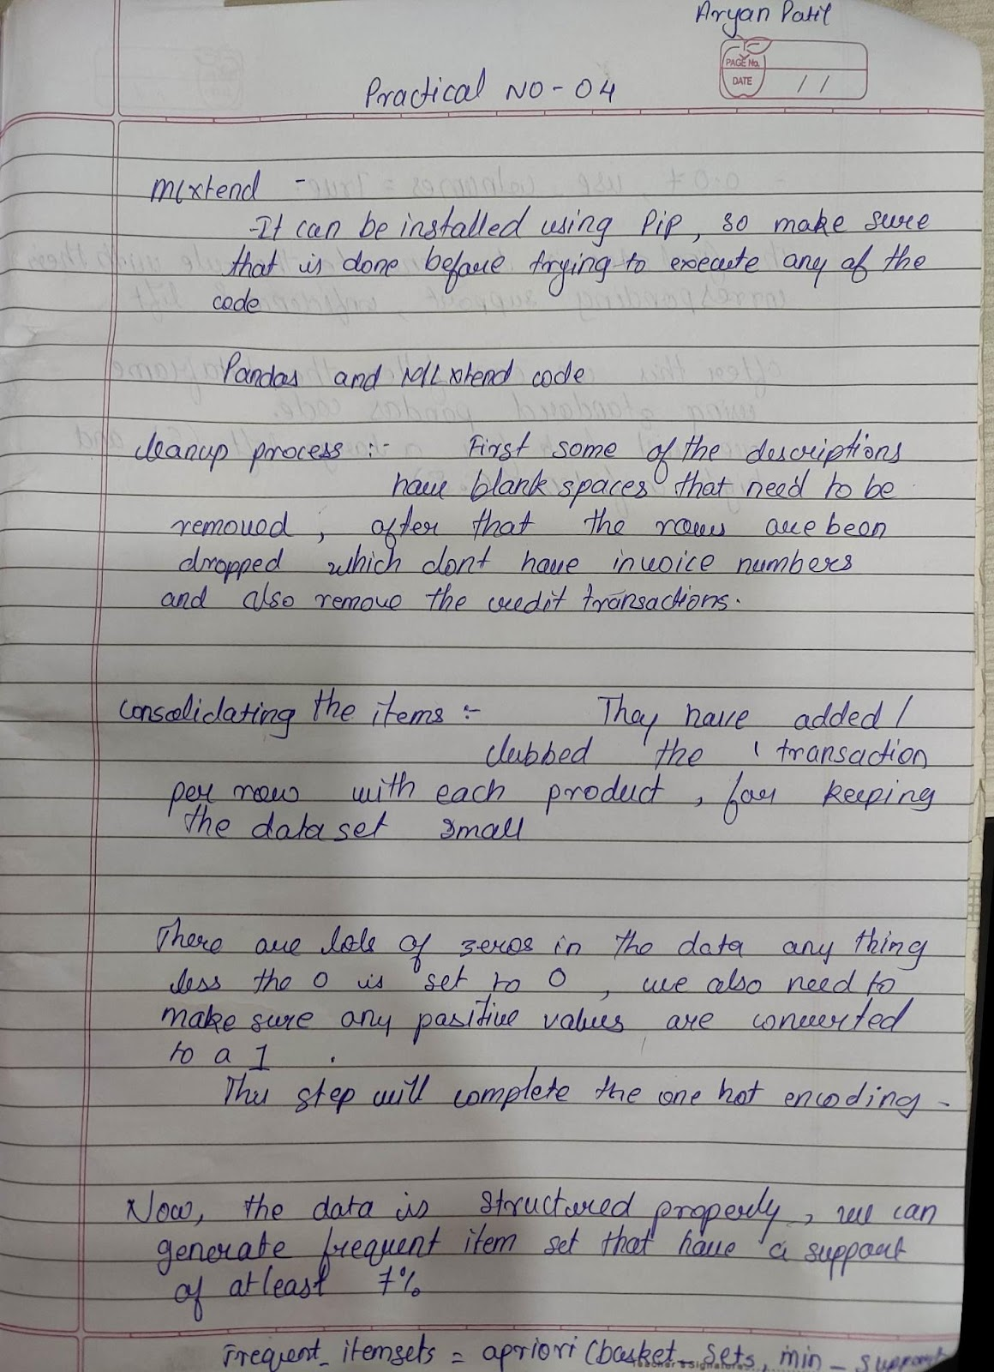
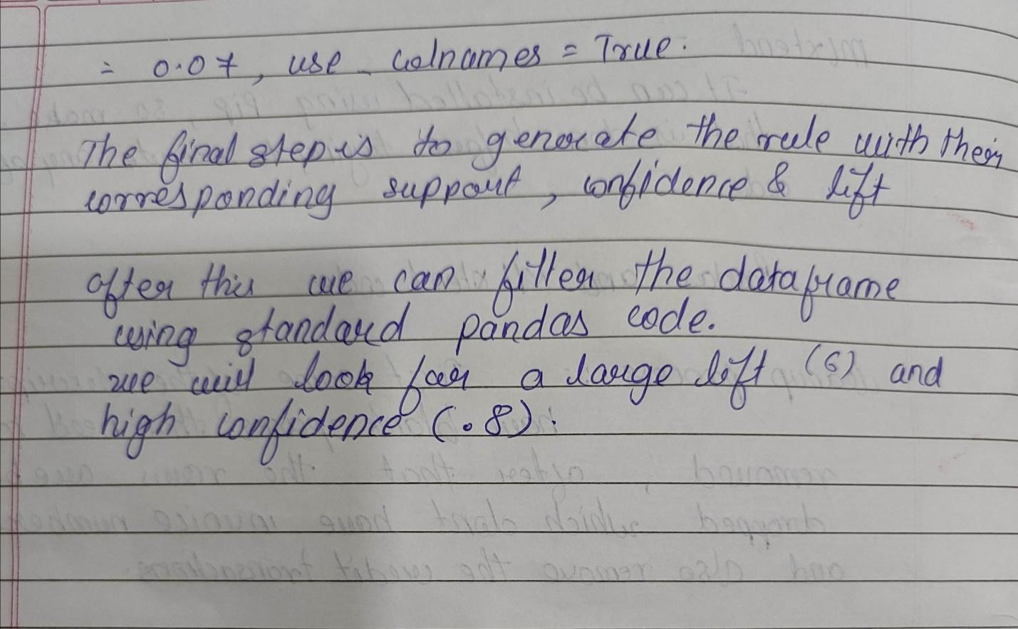

PRACTICAL NO- 5

Aim: Demonstrate Supervised Dimensionality Reduction
Code:
# a matrix using Cholesky
# Decomposition
import math
MAX = 100;

def Cholesky_Decomposition(matrix, n):

lower = [[0 for x in range(n + 1)]
for y in range(n + 1)];

# Decomposing a matrix
# into Lower Triangular
for i in range(n):
for j in range(i + 1):
sum1 = 0;

# sum1mation for diagnols
if (j == i):
for k in range(j):
sum1 += pow(lower[j][k], 2);
lower[j][j] = int(math.sqrt(matrix[j][j] - sum1));
else:

# Evaluating L(i, j)
# using L(j, j)
for k in range(j):
sum1 += (lower[i][k] *lower[j][k]);
if(lower[j][j] > 0):
lower[i][j] = int((matrix[i][j] - sum1) /
lower[j][j]);

# Displaying Lower Triangular
# and its Transpose
print("Lower Triangular\t\tTranspose");
for i in range(n):

# Lower Triangular
for j in range(n):
print(lower[i][j], end = "\t");
print("", end = "\t");

# Transpose of
# Lower Triangular
for j in range(n):
print(lower[j][i], end = "\t");
print("");

# Driver Code
n = 3;
matrix = [[4, 12, -16],
[12, 37, -43],
[-16, -43, 98]];
Cholesky_Decomposition(matrix, n);

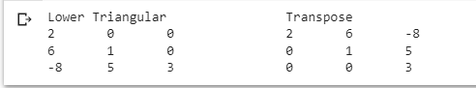
from sklearn.cross_decomposition import CCA
import matplotlib.pyplot as plt

X = [[0., 0., 1.], [1.,0.,0.], [2.,2.,2.], [3.,5.,4.]]
Y = [[0.1, -0.2], [0.9, 1.1], [6.2, 5.9], [11.9, 12.3]]
cca = CCA(n_components=1)
cca.fit(X, Y)
CCA(n_components=1)
X_c, Y_c = cca.transform(X, Y)
plt.scatter(X_c,Y_c)

Output:
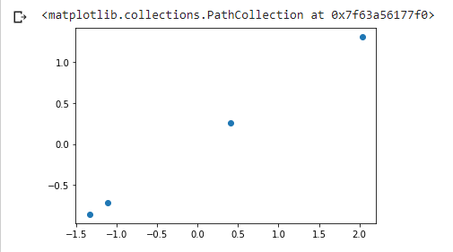

Practical no :- 06

Aim :- Spam Filter

Description :- use instance-based or memory-based learning methods to identify and classify incoming spam emails based on their resemblance to stored training examples of spam emails.
Code :-
