NAME :- Vishal Chaurasiya

MSC-IT

**AIM :-** BASICS OF ANGULAR JS USING ng-click, ng-model,ng-bind

(A.) BINDING THE DATA IN P TAG

**INPUT:-**

<!DOCTYPE html>

<html>

    <script src="https://ajax.googleapis.com/ajax/libs/angularjs/1.6.9/angular.min.js"></script>

<body>

    <div ng-app="">

        <p>Input something in the input box:</p>

        <p>Name: <input type="text" ng-model="name"></p>

        <p ng-bind="name"></p>

    </div>

        AngularJS extend HTML with ng-directives.

</body>

</html>

**OUTPUT :-**

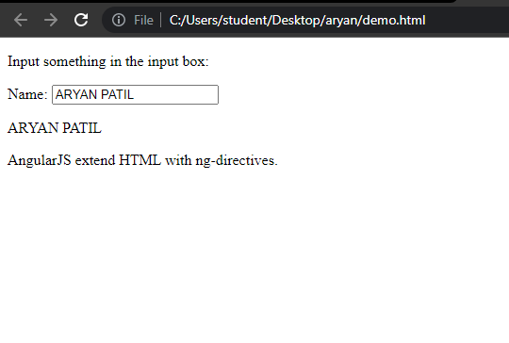

(B.) USING MODEL & PASSING DATA VIA $scope

**INPUT :-**

<!DOCTYPE html>

<html>

    <script src="https://ajax.googleapis.com/ajax/libs/angularjs/1.6.9/angular.min.js"></script>

    <body>

        <p>Try to change the names.</p>

        <div ng-app="myApp" ng-controller="myCtrl">

            First Name: <input type="text" ng-model="firstName"><br>

            Last Name: <input type="text" ng-model="lastName"><br>

            <br>

            Full Name: {{firstName + " " + lastName}}

        </div>

        <script>

            var app = angular.module('myApp', []);

            app.controller('myCtrl', function($scope) {

                $scope.firstName = "John";

                $scope.lastName = "Doe";

            });

        </script>

    </body>

</html>

**OUTPUT :-**

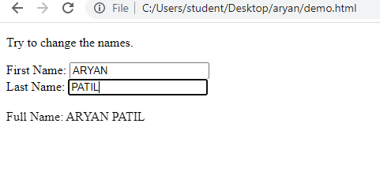

**(C.)** USING changename() function

**INPUT :-**

<!DOCTYPE html>

<html>

    <script src="https://ajax.googleapis.com/ajax/libs/angularjs/1.6.9/angular.min.js"></script>

    <body>

        <div ng-app="myApp" ng-controller="myCtrl">

            <h1 ng-click="changeName()">{{firstname}}</h1>

        </div>

        <script>

            var app = angular.module('myApp', []);

            app.controller('myCtrl', function($scope) {

                $scope.firstname = "Vishal";

                $scope.changeName = function(){

                    $scope.firstname = "aryan";

                }

            });

        </script>

        <p>Click on the header to run the "changeName" function.</p>

        <p>This example demostrates how to use the controller to change model data</p>

    </body>

</html>

**OUTPUT.1 :-**

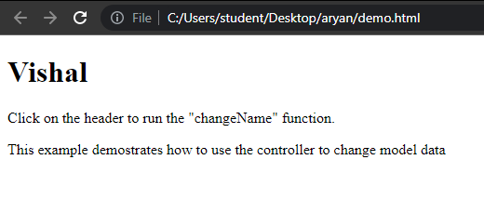

**OUTPUT.2**

